

#### **FIS Cross Asset Trading and Risk Platform (formerly Front Arena) Treasury Implementation Project**

#### **Technical Specifications Document**

**Version 1.2**

# **Confidentiality**

This document contains proprietary information that is confidential to Bank Mandiri. Disclosure of this document in full or in part, may result in material damage to Bank Mandiri. Written permission must be obtained from Bank Mandiri prior to the disclosure of this document to third party.

##### **PREFACE**

###### Purpose

This Technical Specification Document (TSD) provides a documentation of the technical specification, which derived from Functional Specification Document (FSD). It describes the overall technical design for development, which cover the technical attribute, technical architecture, technical flow diagram, technical logic, security and control design, user interface, operating specification, and reporting. The technical design will be based on the scope agreed in the project charter and FSD.

This document will form a baseline for the subsequent development activities such as programming, customization, and testing of the application module.

###### Document Change Control

|  |  |  |  |
| --- | --- | --- | --- |
| **Version** | **Date** | **Authors** | **Summary of Changes** |
| 1.0 | 09/16/2022 | Bank Mandiri – Petunjuk Teknis Operasional (PTO) System Development Life Cycle (SDLC) | First Release |
| 1.1 | 08/17/2023 | Bank Mandiri – Petunjuk Teknis Operasional (PTO) System Development Life Cycle (SDLC) | Updated with new interfaces |
| 1.2 | 09/07/2023 | FIS | Updated with new interfaces and review comments |

##### Table of Contents

Contents

Confidentiality 1

DESCRIPTION 15

TECHNICAL ATTRIBUTE 15

TECHNICAL ARCHITECTURE 17

1.1. High Availability Solution (Failover ADS) 21

1.2. Additional DC Center 21

1.3. Microservices 22

1.4. Hardware and Software 22

1.4.1. Hardware Specifications 24

1.4.2. Development and Customization 24

• BDS 26

• DESCRIPTION 26

Deal Code 26

Settlement Status 26

2. TECHNICAL ATTRIBUTE 27

3. TECHNICAL ARCHITECTURE 28

4. TECHNICAL FLOW DIAGRAM 28

Deal Code 28

Settlement Status 30

5. LOGIC AND CONFIGURATION 33

Deal Code 33

Settlement Status 33

6. SECURITY AND CONTROL DESIGN 35

6.1 Security Requirement Response 35

6.2 Preventive controls 46

6.3 Detective controls 46

6.4 Corrective controls 46

7. USER INTERFACE 47

8. OPERATING SPECIFICATION 48

9. REPORTING 49

9.1 Inventory of Reports 49

9.2 Report layout and definition 49

10. Communication 50

New / Existing*) system *) choose one 50

11. OTHERS 1

12. Appendix 1

• BI-SSSS 1

1. DESCRIPTION 1

2. TECHNICAL ATTRIBUTE 3

3. TECHNICAL ARCHITECTURE 4

4. TECHNICAL FLOW DIAGRAM 5

Price Feed 5

Holding Position 5

Settlements OUT 6

Settlements IN 7

5. LOGIC AND CONFIGURATION 7

5.1. Price Feed 7

5.2. Holding Position 10

5.3. Settlements OUT 14

5.4. Settlements IN 21

6. SECURITY AND CONTROL DESIGN 28

6.1 Security Requirement Response 28

6.2 Preventive controls 39

6.3 Detective controls 40

6.4 Corrective controls 40

7. USER INTERFACE 41

8. OPERATING SPECIFICATION 42

9. REPORTING 43

9.1 Inventory of Reports 43

9.2 Report layout and definition 43

10. Communication 44

New / Existing*) system *) choose one 44

11. OTHERS 1

12. Appendix 1

• BI-ETP 1

4. DESCRIPTION 1

4. TECHNICAL ATTRIBUTE 2

4. TECHNICAL ARCHITECTURE 3

4. TECHNICAL FLOW DIAGRAM 4

5. LOGIC AND CONFIGURATION 7

5.1. Flow Logic 7

5.2. Field Mapping 7

5.3. Configuration 9

5.4. Data Dictionary 10

6. SECURITY AND CONTROL DESIGN 48

6.1. Security Requirement Response 48

6.2. Preventive controls 57

6.3 Detective controls 57

6.4 Corrective controls 57

7. USER INTERFACE 59

7.1. Screen Navigation and Inventory of screens 59

7.2. Screen layout and field definition 59

7.3. Inventory of Forms 60

7.4. Form layout and definition 60

7.5. Interface to Database Relation 61

8. OPERATING SPECIFICATION 61

9. REPORTING 62

9.1 Inventory of Reports 62

9.2 Report layout and definition 62

10. Communication 64

N/A 64

11. API SPECIFICATIONS 1

12. APPENDIX 1

• BLOOMBERG 1

1 Bloomberg – Market data 1

1.1 DESCRIPTION 1

1.2 TECHNICAL ATTRIBUTE 2

1.3 TECHNICAL ARCHITECTURE 3

1.4 TECHNICAL FLOW DIAGRAM 4

1.5 LOGIC AND CONFIGURATION 5

.6 SECURITY AND CONTROL DESIGN 6

.7 USER INTERFACE 1

.8 OPERATING SPECIFICATION 4

• Bloomberg – Dealing System 5

2.1 DESCRIPTION 5

2.2 TECHNICAL ATTRIBUTE 6

2.3 TECHNICAL ARCHITECTURE 7

2.4 TECHNICAL FLOW DIAGRAM 8

2.5 LOGIC AND CONFIGURATION 8

2.6 SECURITY AND CONTROL DESIGN 9

2.7 USER INTERFACE 21

2.8 OPERATING SPECIFICATION 21

3 Communication 21

3.1 New / Existing*) system *) choose one 21

4 OTHERS 23

• BORIS 23

1. DESCRIPTION 23

2. TECHNICAL ATTRIBUTE 23

3. TECHNICAL ARCHITECTURE 25

• TECHNICAL FLOW DIAGRAM 26

BOND TRANACTIONS – IN 26

BOND TRANACTIONS – OUT 28

MTM PRICE 29

CIF 31

BROKER 31

RECAP DATA 33

RECON DATA 34

CTP 36

5. LOGIC AND CONFIGURATION 38

6. SECURITY AND CONTROL DESIGN 38

7. USER INTERFACE 50

8. OPERATING SPECIFICATION 51

9. REPORTING 52

9.1 Inventory of Reports 52

9.2 Report layout and definition 52

10. Communication 53

New / Existing*) system *) choose one 53

11. OTHERS 1

12. Appendix 1

• BPS NOSTRO GL 1

1. DESCRIPTION 1

2. TECHNICAL ATTRIBUTE 2

3. TECHNICAL ARCHITECTURE 3

4. TECHNICAL FLOW DIAGRAM 4

5. LOGIC AND CONFIGURATION 5

5.1 Flow Logic 5

5.2 Configuration 5

5.3 Data Dictionary 5

5.3.A Data Model 5

5.3.B Data Entity and Key Elements Definition 5

5.3.C Reference Code Table Definition 5

6. SECURITY AND CONTROL DESIGN 5

6.1 Security Requirement Response 5

6.2 Preventive controls 16

6.3 Detective controls 17

6.4 Corrective controls 17

8. OPERATING SPECIFICATION 19

TECHNICAL ATTRIBUTE 19

9. REPORTING 22

9.1 Inventory of Reports 22

9.2 Report layout and definition 22

10. Communication 23

New / Existing*) system *) choose one 23

11. OTHERS 1

12. Appendix 1

• CTP IMPORT EXPORT 1

2 CTP – import / export 2

2.1 TECHNICAL ATTRIBUTE 3

2.2 TECHNICAL ARCHITECTURE 4

2.3 TECHNICAL FLOW DIAGRAM 5

2.4 LOGIC AND CONFIGURATION 6

2.5 SECURITY AND CONTROL DESIGN 7

2.6 USER INTERFACE 20

2.7 OPERATING SPECIFICATION 21

3 Communication 22

3.1 New / Existing*) system *) choose one 23

4 OTHERS 1

CUSTODY SYSTEM 1

1 Custody System-OUT-BOND 1

1.1 TECHNICAL ATTRIBUTE 2

1.2 TECHNICAL ARCHITECTURE 3

1.3 TECHNICAL FLOW DIAGRAM 4

1.4 LOGIC AND CONFIGURATION 4

1.5 SECURITY AND CONTROL DESIGN 5

1.6 USER INTERFACE 1

1.7 OPERATING SPECIFICATION 2

2 Eurocleare In holding position 3

2.1 TECHNICAL ATTRIBUTE 4

2.2 TECHNICAL ARCHITECTURE 5

2.3 TECHNICAL FLOW DIAGRAM 6

2.4 LOGIC AND CONFIGURATION 8

2.5 SECURITY AND CONTROL DESIGN 9

2.6 USER INTERFACE 1

2.7 OPERATING SPECIFICATION 1

3 Custody System-IN-holding Position 2

3.1 TECHNICAL ATTRIBUTE 3

3.2 TECHNICAL ARCHITECTURE 4

3.3 TECHNICAL FLOW DIAGRAM 5

3.4 LOGIC AND CONFIGURATION 5

3.5 Configuration 5

3.6 SECURITY AND CONTROL DESIGN 6

3.7 USER INTERFACE 1

3.8 OPERATING SPECIFICATION 2

EMAS 2

1 Account Inquiry 3

1.1 TECHNICAL ATTRIBUTE 4

1.2 TECHNICAL ARCHITECTURE 5

1.3 TECHNICAL FLOW DIAGRAM 6

1.4 LOGIC AND CONFIGURATION 7

1.5 SECURITY AND CONTROL DESIGN 8

1.6 USER INTERFACE 1

1.7 OPERATING SPECIFICATION 1

2 eMAS – Accounting Settlement Export 1

2.1 DESCRIPTION 1

2.2 TECHNICAL ATTRIBUTE 2

2.3 TECHNICAL ARCHITECTURE 3

2.4 TECHNICAL FLOW DIAGRAM 4

2.5 LOGIC AND CONFIGURATION 5

2.6 SECURITY AND CONTROL DESIGN 7

2.7 USER INTERFACE 1

2.8 OPERATING SPECIFICATION 1

3 eMAS – HoldAmount 4

3.1 DESCRIPTION 4

3.2 TECHNICAL ATTRIBUTE 5

3.3 TECHNICAL ARCHITECTURE 6

3.4 TECHNICAL FLOW DIAGRAM 7

3.5 LOGIC AND CONFIGURATION 8

3.6 SECURITY AND CONTROL DESIGN 9

3.7 USER INTERFACE 1

3.8 OPERATING SPECIFICATION 1

4 eMAS – HoldAmountRelease 4

4.1 DESCRIPTION 4

4.2 TECHNICAL ATTRIBUTE 5

4.3 TECHNICAL ARCHITECTURE 6

4.4 TECHNICAL FLOW DIAGRAM 7

4.5 LOGIC AND CONFIGURATION 7

4.6 SECURITY AND CONTROL DESIGN 9

4.7 USER INTERFACE 1

4.8 OPERATING SPECIFICATION 1

5 eMAS - Accounting Export EOD 5

5.1 TECHNICAL ATTRIBUTE 6

5.2 TECHNICAL ARCHITECTURE 7

5.3 TECHNICAL FLOW DIAGRAM 8

5.4 LOGIC AND CONFIGURATION 9

5.5 SECURITY AND CONTROL DESIGN 10

5.6 USER INTERFACE 23

5.7 OPERATING SPECIFICATION 23

6 Communication 26

6.1 New / Existing*) system *) choose one 26

7 OTHERS 1

EXIMBILL 1

1 EXIMBILL – Book Rate 1

1.1 TECHNICAL ATTRIBUTE 2

1.2 TECHNICAL ARCHITECTURE 3

1.3 TECHNICAL FLOW DIAGRAM 4

1.4 LOGIC AND CONFIGURATION 5

1.5 SECURITY AND CONTROL DESIGN 9

1.6 USER INTERFACE 22

1.7 OPERATING SPECIFICATION 22

2 eMAS – Book Rate 22

2.1 TECHNICAL ATTRIBUTE 23

2.2 TECHNICAL ARCHITECTURE 24

2.3 TECHNICAL FLOW DIAGRAM 25

2.4 LOGIC AND CONFIGURATION 26

2.5 SECURITY AND CONTROL DESIGN 29

2.6 USER INTERFACE 42

2.7 OPERATING SPECIFICATION 42

3 EXIMBILL – Nostro GL Records 43

3.1 TECHNICAL ATTRIBUTE 43

3.2 TECHNICAL ARCHITECTURE 43

3.3 TECHNICAL FLOW DIAGRAM 44

3.4 LOGIC AND CONFIGURATION 44

3.5 SECURITY AND CONTROL DESIGN 45

3.6 USER INTERFACE 57

3.7 OPERATING SPECIFICATION 58

4 Communication 62

4.1 New / Existing*) system *) choose one 62

5 OTHERS 1

IAM 1

*1.1* DESCRIPTION 1

1.2 TECHNICAL ATTRIBUTE 2

1.3 TECHNICAL ARCHITECTURE 3

1.4 TECHNICAL FLOW DIAGRAM 4

1.4.1 Create User : 4

1.4.2 Update User : 4

1.5 LOGIC AND CONFIGURATION 6

1.5.1 Flow Logic 6

1.5.2 Configuration 6

1.5.3 Data Dictionary 7

1.5.4 A Data Model 7

1.5.5 B Data Entity and Key Elements Definition 8

1.5.6 C Reference Code Table Definition 8

1.6 SECURITY AND CONTROL DESIGN 8

1.6.1 Security Requirement Response 8

1.6.2 Preventive controls 19

1.6.3 Detective controls 19

1.6.4 Corrective controls 20

1.7 USER INTERFACE 1

OPERATING SPECIFICATION 1

IPS LIMIT 1

1 IPS - Limits 1

1.1 TECHNICAL ATTRIBUTE 2

1.2 TECHNICAL ARCHITECTURE 3

1.3 TECHNICAL FLOW DIAGRAM 4

1.4 LOGIC AND CONFIGURATION 5

1.5 SECURITY AND CONTROL DESIGN 6

1.6 USER INTERFACE 19

1.7 OPERATING SPECIFICATION 19

2 REPORTING 20

2.1 9.1 Inventory of Reports 20

2.2 9.2 Report layout and definition 20

3 Communication 22

3.1 New / Existing*) system *) choose one 22

4 OTHERS 1

IRS 1

1 IRS MT950 OUT 1

1.1 DESCRIPTION 1

1.2 TECHNICAL ATTRIBUTE 2

1.3 TECHNICAL ARCHITECTURE 4

1.4 TECHNICAL FLOW DIAGRAM 4

1.5 LOGIC AND CONFIGURATION 4

1.6 SECURITY AND CONTROL DESIGN 5

1.7 USER INTERFACE 1

1.8 OPERATING SPECIFICATION 1

2 IRS – MT950 Reconcillation 2

2.1 DESCRIPTION 2

2.2 TECHNICAL ATTRIBUTE 4

2.3 TECHNICAL ARCHITECTURE 5

2.4 LOGIC AND CONFIGURATION 7

2.5 SECURITY AND CONTROL DESIGN 8

2.6 USER INTERFACE 21

2.7 OPERATING SPECIFICATION 1

3 IRS Citynet – GL System 2

3.1 TECHNICAL ATTRIBUTE 3

3.2 TECHNICAL ARCHITECTURE 4

3.3 TECHNICAL FLOW DIAGRAM 5

3.4 LOGIC AND CONFIGURATION 6

3.5 SECURITY AND CONTROL DESIGN 7

3.6 USER INTERFACE 20

3.7 OPERATING SPECIFICATION 20

4 Communication 23

4.1 New / Existing*) system *) choose one 23

5 OTHERS 1

MBOX 1

1.1 TECHNICAL ATTRIBUTE 2

1.2 TECHNICAL ARCHITECTURE 3

1.3 TECHNICAL FLOW DIAGRAM 4

1.4 LOGIC AND CONFIGURATION 4

1.4.1 Flow Logic 4

1.4.2 Configuration 5

1.4.3 Data Dictionary 6

1.4.4 A Data Model 6

1.4.5 B Data Entity and Key Elements Definition 6

1.4.6 C Reference Code Table Definition 6

1.5 SECURITY AND CONTROL DESIGN 7

1.5.1 Security Requirement Response 7

1.5.2 Preventive controls 18

1.5.3 Detective controls 18

1.5.4 Corrective controls 19

1.6 USER INTERFACE 20

1.7 OPERATING SPECIFICATION 21

2 REPORTING 22

2.1 9.1 Inventory of Reports 22

2.2 9.2 Report layout and definition 23

3 Communication 24

3.1 New / Existing*) system *) choose one 24

4 OTHERS 1

REFINITIV 1

1 Market Data 1

2 Arena Trade Capture Interface – Refinitiv Dealing - IN 2

2.1 TECHNICAL ATTRIBUTE 3

2.2 TECHNICAL ARCHITECTURE 4

2.3 TECHNICAL FLOW DIAGRAM 5

2.4 LOGIC AND CONFIGURATION 6

2.5 SECURITY AND CONTROL DESIGN 8

2.6 USER INTERFACE 1

2.7 OPERATING SPECIFICATION 1

3 Refinitiv – Price Feed 1

3.1 TECHNICAL ATTRIBUTE 3

3.2 TECHNICAL ARCHITECTURE 4

3.3 TECHNICAL FLOW DIAGRAM 5

3.4 LOGIC AND CONFIGURATION 6

3.5 SECURITY AND CONTROL DESIGN 7

3.6 USER INTERFACE 20

3.7 OPERATING SPECIFICATION 20

4 Communication 23

4.1 New / Existing*) system *) choose one 23

5 OTHERS 24

SINVEST 25

1 FA – OUT/In – S-Invest 25

1.1 TECHNICAL ATTRIBUTE 25

1.2 TECHNICAL ARCHITECTURE 26

1.3 TECHNICAL FLOW DIAGRAM 27

1.4 LOGIC AND CONFIGURATION 29

1.5 SECURITY AND CONTROL DESIGN 31

1.6 USER INTERFACE 43

1.7 OPERATING SPECIFICATION 44

2 Communication 44

2.1 New / Existing*) system *) choose one 44

3 OTHERS 1

SMARTFX 1

1 Static Data 1

1.1 DESCRIPTION 1

1.2 TECHNICAL ATTRIBUTE 2

1.3 TECHNICAL ARCHITECTURE 3

1.4 TECHNICAL FLOW DIAGRAM 4

1.5 LOGIC AND CONFIGURATION 5

1.6 SECURITY AND CONTROL DESIGN 5

1.7 USER INTERFACE 17

2 Deal Posting 18

2.1 DESCRIPTION 18

2.2 TECHNICAL ATTRIBUTE 18

2.3 TECHNICAL ARCHITECTURE 20

2.4 TECHNICAL FLOW DIAGRAM 24

2.5 LOGIC AND CONFIGURATION 25

2.6 SECURITY AND CONTROL DESIGN 26

2.7 USER INTERFACE 1

3 Reconciliation 1

3.1 DESCRIPTION 1

3.2 TECHNICAL ATTRIBUTE 2

3.3 TECHNICAL ARCHITECTURE 5

3.4 TECHNICAL FLOW DIAGRAM 6

3.5 LOGIC AND CONFIGURATION 7

3.6 SECURITY AND CONTROL DESIGN 8

3.7 USER INTERFACE 1

4 Transaction Data 1

4.1 DESCRIPTION 1

4.2 TECHNICAL ATTRIBUTE 2

4.3 TECHNICAL ARCHITECTURE 3

4.4 TECHNICAL FLOW DIAGRAM 4

4.5 LOGIC AND CONFIGURATION 5

4.6 SECURITY AND CONTROL DESIGN 5

4.7 USER INTERFACE 18

5 OPERATING SPECIFICATION 18

6 REPORTING 19

6.1 9.1 Inventory of Reports 19

6.2 9.2 Report layout and definition 19

7 Communication 20

7.1 New / Existing*) system *) choose one 20

8 OTHERS 1

SWIFT 1

1 SWIFT - Confirmation 1

1.1 TECHNICAL ATTRIBUTE 2

1.2 TECHNICAL ARCHITECTURE 3

1.3 TECHNICAL FLOW DIAGRAM 4

1.4 LOGIC AND CONFIGURATION 5

1.5 SECURITY AND CONTROL DESIGN 7

1.6 USER INTERFACE 1

1.7 OPERATING SPECIFICATION 1

2 SWIFT - SETTLEMENT 1

2.1 TECHNICAL ATTRIBUTE 2

2.2 TECHNICAL ARCHITECTURE 3

2.3 TECHNICAL FLOW DIAGRAM 4

2.4 LOGIC AND CONFIGURATION 5

2.5 SECURITY AND CONTROL DESIGN 6

2.6 USER INTERFACE 19

2.7 OPERATING SPECIFICATION 19

3 Communication 20

3.1 New / Existing*) system *) choose one 20

4 OTHERS 1

TPS 1

1 TPS - OUT - RTGS 1

1.1 TECHNICAL ATTRIBUTE 3

1.2 TECHNICAL ARCHITECTURE 4

1.3 TECHNICAL FLOW DIAGRAM 5

1.4 LOGIC AND CONFIGURATION 6

1.5 SECURITY AND CONTROL DESIGN 8

1.6 USER INTERFACE 1

1.7 OPERATING SPECIFICATION 1

2 TPS – Nostro GL Records 3

2.1 DESCRIPTION 3

2.2 TECHNICAL ATTRIBUTE 4

2.3 TECHNICAL ARCHITECTURE 5

2.4 TECHNICAL FLOW DIAGRAM 6

2.5 LOGIC AND CONFIGURATION 6

2.6 SECURITY AND CONTROL DESIGN 7

2.7 USER INTERFACE 20

2.8 OPERATING SPECIFICATION 21

3 TPS – OUT - Settlements – Status Inquiry 22

3.1 DESCRIPTION 22

3.2 TECHNICAL ATTRIBUTE 23

3.3 TECHNICAL ARCHITECTURE 24

3.4 TECHNICAL FLOW DIAGRAM 25

3.5 LOGIC AND CONFIGURATION 26

3.6 SECURITY AND CONTROL DESIGN 27

3.7 USER INTERFACE 40

3.8 OPERATING SPECIFICATION 41

4 Communication 43

4.1 New / Existing*) system *) choose one 43

5 OTHERS 1

WEBEAI 1

1. DESCRIPTION 1

2. TECHNICAL ATTRIBUTE 4

3. TECHNICAL ARCHITECTURE 5

4. TECHNICAL FLOW DIAGRAM 6

5. LOGIC AND CONFIGURATION 7

5.1 Flow Logic 7

5.2 Configuration 7

5.3 Data Dictionary 7

5.3.A Data Model 7

5.3.B Data Entity and Key Elements Definition 7

5.3.C Reference Code Table Definition 7

6. SECURITY AND CONTROL DESIGN 7

6.1 Security Requirement Response 7

6.2 Preventive controls 18

6.3 Detective controls 18

6.4 Corrective controls 19

7. USER INTERFACE 20

8. OPERATING SPECIFICATION 21

9. REPORTING 22

9.1 Inventory of Reports 22

9.2 Report layout and definition 22

10. Communication 23

New / Existing*) system *) choose one 23

11. OTHERS 1

12. Appendix 1

# DESCRIPTION

This document defines the technical scope and deliverables of the Front Arena Treasury implementation project Phase 1B for Bank Mandiri and is based on SOW/PDR and Bank Mandiri’s known requirements as at the date of this document as communicated during discussions and workshops conducted between the FIS and Bank Mandiri teams.

# TECHNICAL ATTRIBUTE

|  |  |
| --- | --- |
| **Attribute** | **Description** |
| Program/Module Name | Treasury Core System |
| Program/Module Title | Front Arena |
| Program Type | Executable, Interface, Reporting |
| Transaction Code | - |
| Development Status | New |
| Application | Core Banking |
| Application Component refer to Block Application Architecture | ARENA Data Server(ADS), ARENA Data Model(ADM), ARENA Message Broker(AMB), ARENA Message Broker Adapter(AMBA), ARENA Task Server(ATS), ARENA Price Feed Handler(APH), PRIME |

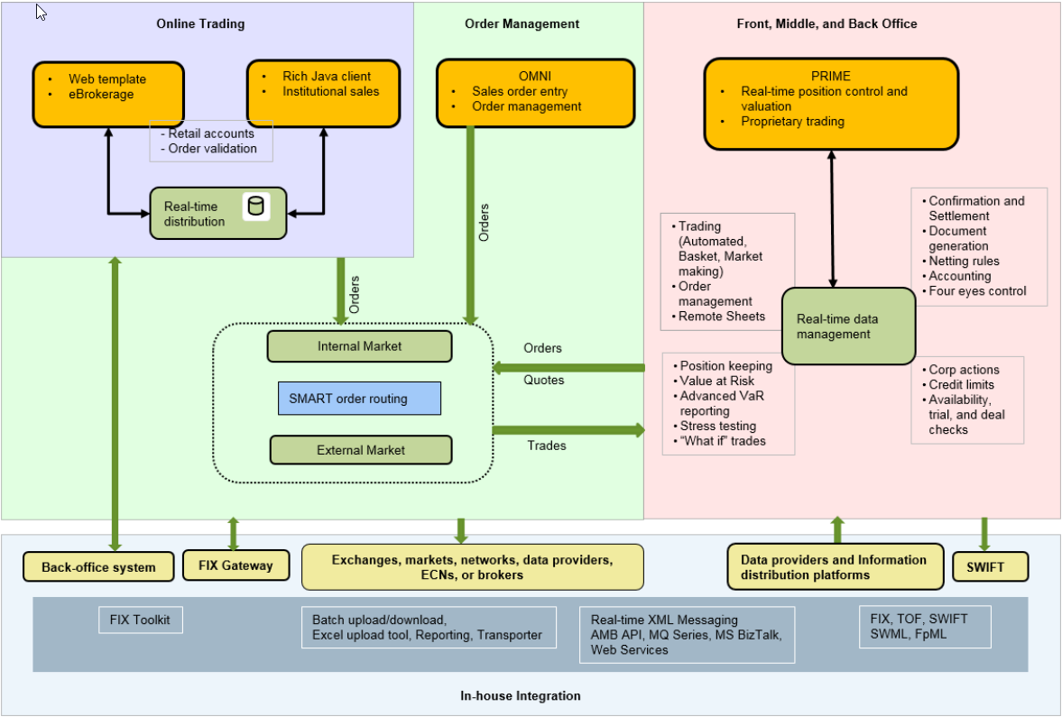

Details about technical attributes can be found in FIS Standard FA Documentation:

* FCA3598 – Front Arena Overview
* FCA1463 -- Front Arena System Architecture Diagram

# TECHNICAL ARCHITECTURE

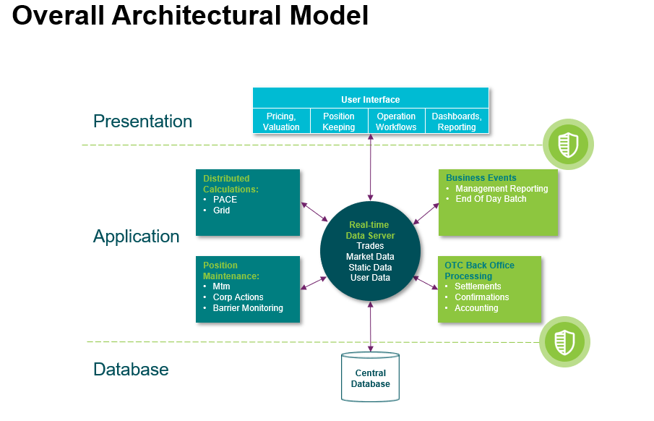

**System Architecture**

Front Arena uses multi-tier (or n-tier) architecture in which **presentation**, **application processing**, and **data management** functions are **physically separated**. Built on **loosely coupled components** that are self-contained. This model enables separation of components on multiple servers and facilitates **horizontal and vertical scalability** to manage server loads or manage redundancy.

**Single Database**

In Front Arena all business data is stored in a single database. This has the advantage that it is easy to control access, validate input, and take backups.

Secure connections, User authentication and password complexity policy for example min length (8 characters), alpha numeric characters, not using past passwords, repeated characters, login attempts etc. can be implemented with integration with Kerberos.

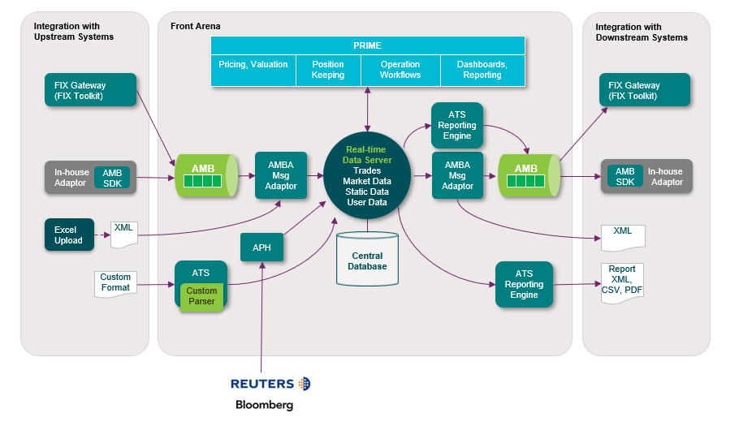

Some interfaces available out of the box – APH for live price feed, AFG_AMB for trade capture, Data Loader for static data, and SWIFT adaptor. For custom interfaces ARENA Integration Framework (AIF) allows to insert and extract any information handled by Front Arena, in real-time or batch using XML messaging, FIX messages, Excel Upload. same built in tools can be used to export the data contained within FA.

**Active Scenario**

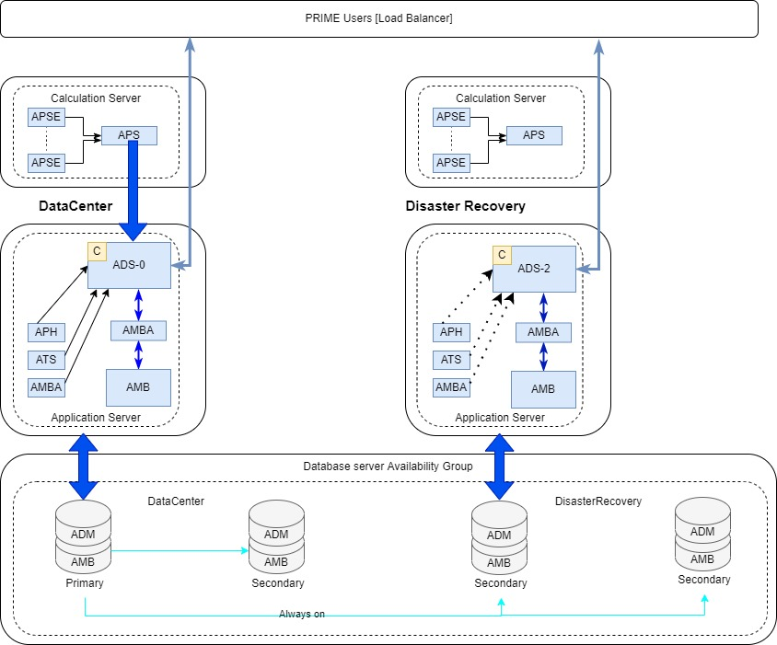

**Inactive Scenario**

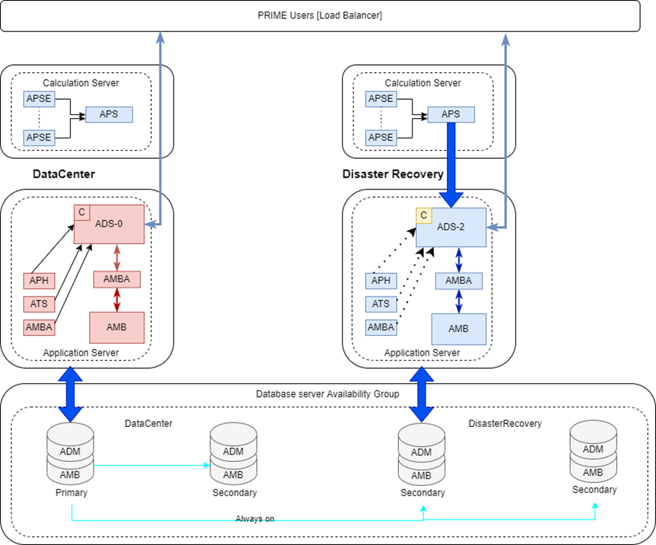

Based on discussion with Client, above active/inactive diagram is the agreed hardware architecture for the project.

ADS-0 covers Primary datacenter

ADS-2 covers Disaster recovery center

* 1. High Availability Solution (Failover ADS)

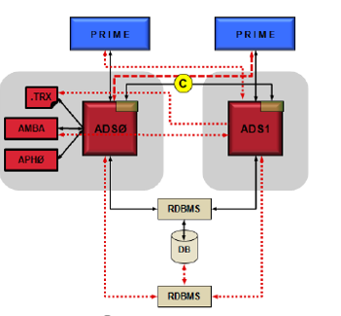

The purpose of the Failover ADS solution is to provide maximum system robustness. With this solution there is no single point of failure. This means that any one process or hardware server may fail, and full functionality will still be available.

The Failover solution assumes uninterrupted and continuous database service to be provided. Front Arena has no failover capabilities against the database layer. Instead, the solution relies on database server's native failover capabilities to be transparent to Front Arena.

For the solution to provide the highest possible availability there should be no single point of failure. This secure hosting of the database and audit file and that at least two of the ADS are on different hardware.

* 1. Additional DC Center

Bank can deploy additional DC center by replicating hardware size specification provided for DC in section 3.4. Both DC centers can be in Active –Active status and one DR in Active/Passive mode.

**Database layer:**

There are 2 ways to achieve active/active Microsoft database setup.

* 2 servers in DC1 with synchronous Always-On database replication. If standard license, commonly log shipping is used every x minute to a secondary datacenter for DR (DC2)
* 1 server in DC1 and 1 server in DC2 with synchronous replication.

It is important that the network between the two Data Centers is fast with minimal latency since transactions sent to DC2 need to be sent back to DC1. Not recommended for longer distances than 20KM between DC1 and DC2, no need for DR (in addition log shipping can be used in DC2 to a backup instance to support DR)

**Application layer:**

The Arena Data Server (ADS) is used as the backend for Front Arena having exclusive access to the database layer. It allows users access to the solution, permissions, and cash any required information to support subscriptions from physical end users and technical users (e.g., internal/external integrations, batch in/out put job Etc.)

The ADS can be installed in several instances to support a high availability setup, replicating data on the application layer in addition to the database replication.

Minimum requirements in a high availability solution are 2 instances on different underlying hardware.

Most of our customers leverage 3rd party software like VMware to support the solution.

* 1. Microservices

**Web Services**

A typical installation has a plethora of services running at any one time. These services are typically decoupled using the message broker. There are also adapters for bridging to other systems, such as MQ, and Arena Web Server for web service APIs. This makes Front Arena easy to integrate within a wider microservice landscape.

**Reactive**

Records can be published on the message broker automatically when created or modified.

Python code can listen for and react to events in real-time.

Data can be delivered or picked up automatically from a folder, SFTP server, from the message broker or MQ.

* 1. Hardware and Software

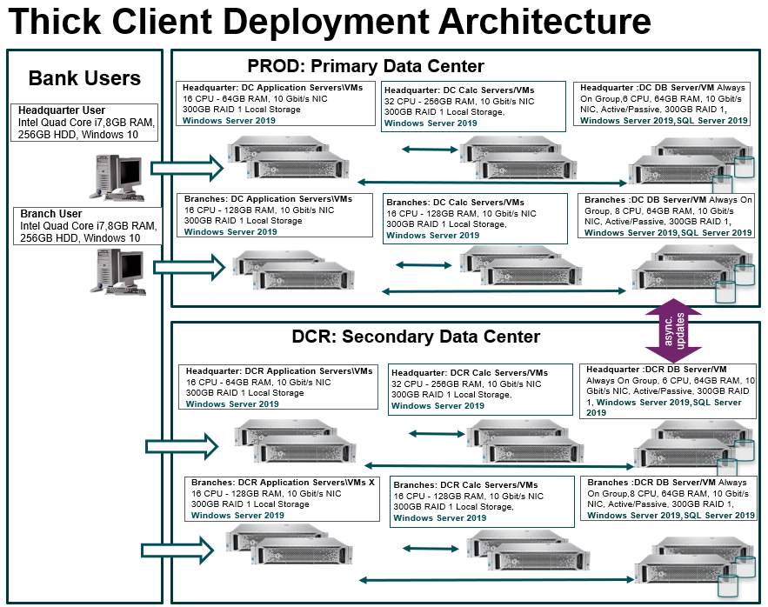

**Software list**

|  |  |
| --- | --- |
| **Software** | **Description** |
| MS Windows server 2019 | Server operating system |
| MS SQL Server 2019 | DB Server |
| Notepad++ | Editor, log viewer |
| Excel (v2019) | Reports export, import export utility |
| Word (v2019) | Documentation viewer, editor for long form confirmations |
| open-source libraries | For integration for e.g., pyodbc for python |

**Head Office Environment (Production)**

|  |  |  |  |  |
| --- | --- | --- | --- | --- |
| **PROD-DC** | **CPU** | **RAM (GB)** | **Disk (GB)** | **Network** |
| Application Server_1 | 16 | 64 | 300 | 10GBPS |
| Application Server_2 | 16 | 64 | 300 | 10GBPS |
| Calculation Server_1 | 32 | 256 | 300 | 10GBPS |
| Calculation Server_2 | 32 | 256 | 300 | 10GBPS |
| DB server_1 | 6 | 64 | 500 | 10 GBPS |
| DB server_2 | 6 | 64 | 500 | 10 GBPS |

**Overseas Branches Environment (Production)**

All overseas branches will share Application, Calculation and Database server\VM hardware. Individual instances of components will be installed for each overseas branch.

|  |  |  |  |  |
| --- | --- | --- | --- | --- |
| **PROD-DC** | **CPU** | **RAM (GB)** | **Disk (GB)** | **Network** |
| Application Server_1 | 16 | 128 | 300 | 10GBPS |
| Application Server_2 | 16 | 128 | 300 | 10GBPS |
| Calculation Server_1 | 16 | 128 | 300 | 10GBPS |
| Calculation Server_2 | 16 | 128 | 300 | 10GBPS |
| DB server_1 | 8 | 64 | 500 | 10GBPS |
| DB server_2 | 8 | 64 | 500 | 10GBPS |

* Server cores or CPU=VCPU=1:1
* Server Operating system Microsoft Windows Server 2019.
* Database server: Microsoft SQL server 2019 standard or Enterprise edition as per Always on support required.
* Disk recommendation: For Database server is high performance disk is recommended for example min IOPS 1000 or RPM above 10,000-15,000

**Head Office (Non-Production environments)**

|  |  |  |  |  |
| --- | --- | --- | --- | --- |
| **SIT/DEV/Penetration** | **CPU** | **RAM (GB)** | **Disk (GB)** | **Network** |
| Application Server | 8 | 32 | 300 | 10GBPS |
| Calculation Server | 16 | 124 | 300 | 10GBPS |
| DB server | 4 | 64 | 300 | 10 GBPS |

**Branches (Non-Production)**

All overseas branches will share Application, Calculation and Database server\VM hardware. Individual instances of components will be installed for each overseas branch.

|  |  |  |  |  |
| --- | --- | --- | --- | --- |
| **SIT/DEV/Penetration** | **CPU** | **RAM (GB)** | **Disk (GB)** | **Network** |
| Application Server(+ATF*) | 16 | 64 | 300 | 10GBPS |
| Calculation Server | 8 | 32 | 300 | 10GBPS |
| DB server | 4 | 64 | 300 | 10 GBPS |

*Hardware for ATF- Additional hardware to add in UAT or SIT Application server

|  |  |  |  |  |
| --- | --- | --- | --- | --- |
| **SIT/DEV/Penetration** | **CPU** | **RAM (GB)** | **Disk (GB)** | **Network** |
| Application Server | 1 | 16 | 10 | 10 GBPS |

|  |  |
| --- | --- |
| **Environments** | |
| PROD_DC | Production Environment |
| PROD_DRR | Same as Production Environment |
| UAT | Same as Production Environment. |
| SIT | Without failover, for failover reuse the specs per server for application, Database, calculation server etc. |
| DEV | Without failover, for failover reuse the specs per server for application, Database, calculation server etc. |
| Performance | Same as Production Environment. |
| Penetration Test | Same as Production Environment. Requirements specified by Bank Mandiri. |
| Data Migration | Same as Production Environment. Requirements specified by Bank Mandiri |

|  |  |  |  |  |
| --- | --- | --- | --- | --- |
| **User Equipment** | **User description** | **Core** | **RAM(GB)** | **Disk (GB)** |
| Prime Users\per process  minimum requirement | Advanced | 2 (3GHz) | 8 | 10 |
| Medium | 1 | 4 | 10 |
| Basic | 1 | 2 | 10 |

Users should have a 17" display or larger with at least 1280*1024 resolution.

Prime client recommended using high performance CPU for faster response. For medium and basic users lower power CPU can be used, for example 2.4GHz and above.

Reference data for hardware specification, please refer to Appendix 3

* + 1. Hardware Specifications

Hardware Specifications

| **Deliverables – Hardware and Software** | **Owner** |
| --- | --- |
| Purchase the recommended hardware. Client to be responsible for any delays due to delayed procurement or provision. | Client |

* + 1. Development and Customization

Most tools required for customisation are included with the base installation. Other tools can be downloaded for free. Examples below:

|  |  |  |
| --- | --- | --- |
| **Tool** | **Used for** | **Source** |
| **Python Editor** | Scripting in general | Included |
| **Extension Editor** | Front Arena extension development. | Included |
| **ASQL** | Real-time SQL with Python integration | Included |
| **Arena Dataflow Language** | Real-time calculations | Included |
| **Python 3** | Scripting in general | Included |
| **Calculations API** | Extracting real-time calculated values from Python. | Included |
| **GUI customization** | Layout changes, custom dialogs, custom apps in Python | Included |
| **Deal Package** | Structured product development | Included |
| **Task scheduler** | Scheduling Python scripts | Included |
| **XML module** | XML processing | Included with Python |
| **JSON module** | JSON processing | Included with Python |
| **CSV module** | CSV file processing | Included with Python |
| **Urllib module** | HTTPS requests | Included with Python |
| **Apache FOP** | Generating PDF documents. | Not included. Download for free from the internet. |

# BDS

## DESCRIPTION

### Deal Code

As per Dealers communication with client, Dealer books FX transaction in Front Arena. While creating the FX transaction dealer sets Dealer Code on trade in form of Additional information field – DealerCode.

BDS is Branch Delivery System, to perform various banking activity. One of the activities is to settle the Deal with Client. As settlement process, Teller or client encode the Dealer code and Special/agreed rate. This information will be sent to FA for validation. BDS inquiry the deal detail data in FA. With those data, then BDS will do the validation. If the validation is successful, then Deal is settled at BDS side. In case of any mismatch in deal code and rate, Dealer will follow the different process manually to settle the deal.

### Settlement Status

In continuation of BDS- Deal Code workflow, once the deal is settled at BDS side, it sends settlement status to Front Arena to store this status on respective FX transaction's Additional information field – 'BDS Settlement Status'

## 2. TECHNICAL ATTRIBUTE

This section provides the technical attributes and characteristic of designed module.

|  |  |
| --- | --- |
| **Attribute** | **Description** |
| Program/Module Name | Front Arena |
| Program/Module Title | Arena Extension Framework |
| Program Type | Executable, Interface, Conversion |
| Transaction Code |  |
| Development Status | New |
| Application | BDS |
| Application Component refer to Block Application Architecture | Arena Data Server, Arena Data Model, Arena Task Server |

## 3. TECHNICAL ARCHITECTURE

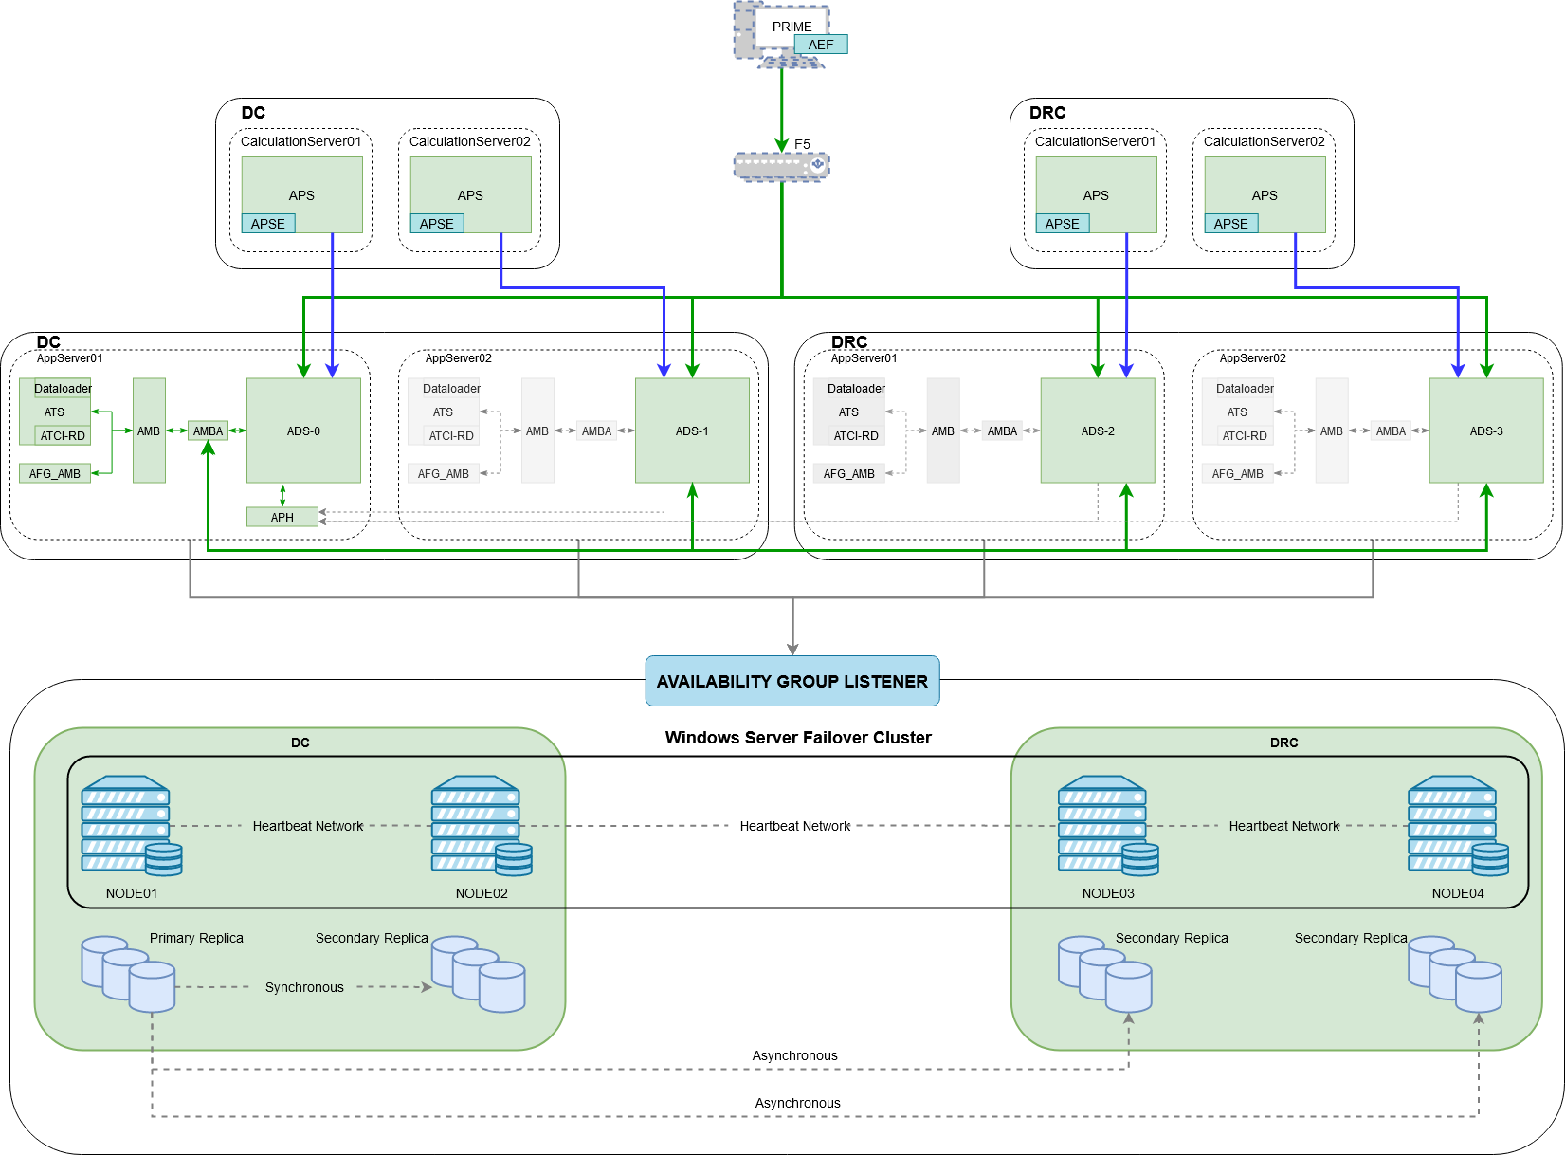

|  |  |  |
| --- | --- | --- |
| No. | Component | Description |
| 1. | PRIME | Desktop application, a client to which contains most of the business logic of the system. |
| 2. | AEF | Arena Extension Framework: Extend existing module, create new module. |
| 3. | ADS | Arena Data Server: Core of the FrontArena System |
| 4. | AMBA | Arena Message Broker Adapter: Adapter between AMB and ADS |
| 5. | AMB | Arena Message Broker: FrontArena Middleware layer |
| 6. | ATS | Arena Task Server: Scheduler related and publishing API |
| 7. | APH | Arena Price Handler: Retrieve Refinitiv Market Data |
| 8. | ADM | Arena Data Model |
| 9. | AFG | Arena FIX Gateway: Communication with Bloomberg FIX Protocol |
| 10. | ATCI-RD | Arena Trade Capture Interface for Refinitiv Dealing |

## TECHNICAL FLOW DIAGRAM

Please refer section - tECHNICAL aRCHITECTURE

### Deal Code

Following chart shows technical workflow for Deal Code service.

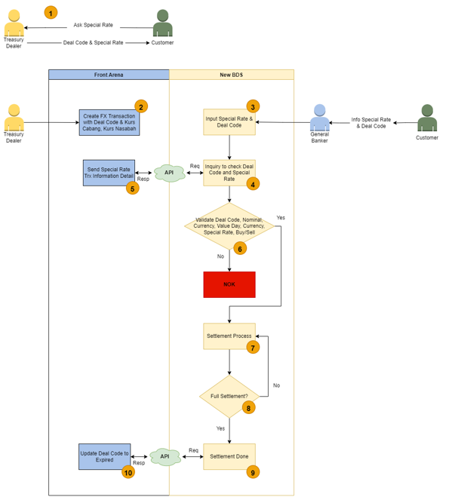

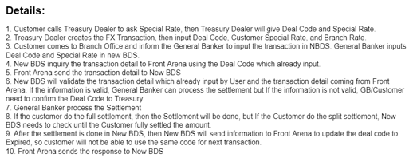

NOTE:

In this interface steps from 1 to 5 are covered for this interface service.

### Settlement Status

Following chart shows technical workflow for settlement status update service.





NOTE:

In this interface steps 9 and 10 are covered for this interface service.

## 5. LOGIC AND CONFIGURATION

### Deal Code

#### 5.1 Flow Logic

This logic flow is same as SmartFX Transaction Data. Please refer Smart FX TSD for this interface service.

#### 5.2 Configuration

NA

#### 5.3 Data Dictionary

NA

#### 5.3.A Data Model

Please refer AEF Browser document for details about Front Arena Data Model.

Document - FCA4033

#### 5.3.B Data Entity and Key Elements Definition

NA

#### 5.3.C Reference Code Table Definition

*NA*

### Settlement Status

#### 5.1 Flow Logic

In this workflow, New BDS systems consumes Front Arena’s web API to send the settlement status.

1. Upon web API call from New BDS, it executes the function mapped.
2. In that function, it extracts the reference number from JSON message received.
3. FX trade from FA identified from the reference number which is available in Trade’s Additional Infor field.
4. Once the FX trade is identified, then additional information field – DealCodeExpiryStat, is set to ‘Y’.
5. Web API call is responded with response code and response message. Response code and message is parameterized. In case of any error in updating BDS settlement status update in FA, corresponding Error code and description will get replied to BDS.

#### 5.2 Configuration

Configuration will be done in CDCA (Change Data Capture Agent). Queries required to capture the data need to be implemented as per data mapping mentioned in data mapping document.

|  |  |
| --- | --- |
| Delivery Items | |
| Extension Context | +Integration  +BDS |
| Extension Module | PS_BDSSettlementStatus |
| Web Service | https://localhost:8085/dealExpiryStatus |
|  |  |
|  |  |
| FA Component | |
| ATS | ATS_BDS_SETTLEMENT_STATUS  This ATS is used to host web service for this interface. |
|  |  |
| Deployment and Manual Configuration | |
| This service is deployed through FA standard deployment process. | |
|  |  |
| Additional Information |  |
| DealCodeExpiryStat | To store the BDS settlement status |
| FParameters |  |
| CertificateFile | C:\Projects\FADealPostingWebServer\test_cer.crt |
| KeyFile | C:\Projects\FADealPostingWebServer\test_key.key |
| Task Parameter | |
| NA |  |
|  |  |
|  |  |
| Pre-requisites |  |
| Additional Information field | DealCodeExpiryStat  This additional information field must be present in system. |
| ATS service | ATS service for this interface must be running to work this interface. |
| Instrument Alias from BI-SSSS should be mapped to Instruments | Instrument Alias field used to identify the Front Arena instrument. |

#### 5.3 Data Dictionary

Please refer attached Data Mapping file in section Appendix - SYNONIM REVERENCE_FieldMapping_TSD.xlsx

#### 5.3.A Data Model

Please refer AEF Browser document for details about Front Arena Data Model.

Document - FCA4033

#### 5.3.B Data Entity and Key Elements Definition

All required details are available in AEF Browser document.

#### 5.3.C Reference Code Table Definition

*<This sub-section describes the reference code tables and the codes within each table. Only describes those reference code tables that affect the users>.*

*Template is the same as 5.3.B*

## 6. SECURITY AND CONTROL DESIGN

### 6.1 Security Requirement Response

|  |  |  |
| --- | --- | --- |
| **Security Domain** | **Security Requirement** | **Response** |
| User Management | The system must identify users using a unique user identification code before allowing a log-on. | It will be controlled through CDCA application |
| The system must suspend access to a user session after a specified interval of inactivity. | Inactivity of user session will not be applicable  as the integration is in Realtime |
| The system must require user authentication before re-enabling the session. | It will be controlled through CDCA application |
| The system must display a warning message indicating that only authorised use is permitted before allowing users to perform a log-on. | It will be controlled through CDCA application |
| The system must display system information to a user, only after a successful log-on. |  |
| After a successful log-on, the system must display information concerning the previous successful attempt to perform a log-on. | It will not be possible in real-time connections. |
| The system must allow a user account to be manually disabled. | NA |
| The system must disable the user account following 3 (three) consecutive failures to perform a successful log-on. | It will be controlled through CDCA application |
| The system must automatically disable the user account following a configurable period (90 days) without use. |  |
| Password Management | The system must authenticate users using a password before allowing access to any system functions. | Not applicable at Front Arena Database side. |
| The system must ensure that passwords used by system users for log-on consist of at least 8 (eight) characters. | Not applicable at Front Arena Database side. |
| The system must enforce the use of complex passwords for all users. (Aplhanumieric & Special Characters) | Not applicable at Front Arena Database side. |
| The system must use cryptographic techniques to protect the confidentiality of user authentication data during transmission. | Not applicable at Front Arena Database side. |
| The system must enforce a password change when a password is first issued or re-issued. |  |
| The system must allow system users to change the password used for log-on. | Not applicable at Front Arena Database side. |
| The system must ensure that passwords do not remain valid for more than 90 (ninety) days. | Not applicable at Front Arena Database side. |
| The system must ensure that passwords may not be changed to any of the last 5 (five) passwords used. | Not applicable at Front Arena Database side. |
| The system must ensure that passwords are not displayed in clear text during entry. | Not applicable at Front Arena Database side. |
| Multi Factor Authentication | The system must enforce dual factor authentication of all users (system that related to financial, faced to customer directly & only use for external purposes) | Not applicable at Front Arena Database side. |
| Data Storage | The system must use cryptographic techniques to protect the storage of authentication data. | NA |
| The system must use cryptographic techniques to protect the integrity of stored critical data. | NA |
| The system must use cryptographic techniques to protect the confidentiality of stored sensitive data. | NA |
| Logging | The system must support the recording of security events in one or multiple specific security event logs. 2 weeks in minimum must be available at the Production Environment | It will be controlled through CDCA application |
| The system must include the Logical Account identity, event type and timestamp in each entry in the security event logs. | It will be controlled through CDCA application |
| The system must record when each security event lo fills to a configurable limit. | It will be controlled through CDCA application |
| The system must protect the integrity of the information in the security event logs | It will be controlled through CDCA application |
| The system must allow access to the security event logs to be limited to the authorised security staff. | It will be controlled through CDCA application |
| The system must record if the integrity of the security event logs is compromised | NA |
| The system must record all instances that system event logs are cleared. | It will be controlled through CDCA application |
| The system must record when a change is made to the system log settings (e.g. logs for certain events are turned off). | It will be controlled through CDCA application |
| The system must record when any system security policy is modified. | NA |
| The system must record all creations of Logical Accounts. | It will be controlled through CDCA application |
| The system must record all deletions of Logical Accounts. |  |
| The system must record all de-activation of Logical Accounts. |  |
| The system must record all unsuccessful attempts to log-on to the system using invalid credentials. |  |
| The system must record all successful attempts to log-on to the system. |  |
| The system must record all successful and unsuccessful attempts to change passwords. |  |
| The system must automatically build and maintain a normal usage pattern for each Logical Account. |  |
| The system must record all activation of disabled Logical Accounts. |  |
| The system must record all attempts to change any account attribute affecting authentication of the Logical Account |  |
| The system must record all allocations of system access rights. |  |
| The system must record all removals of system access rights. |  |
| The system must record all unauthorised attempts to access a system function. |  |
| The system must record when a configurable deviation from a Logical Account's normal pattern is detected. |  |
| The system must record all failures of the check on the timestamp of payment and settlement orders. |  |
| The system must record all attempts to mutually authenticate interface connections that handle critical data |  |
| The system must record all events that may indicate an attempt to cause denial of service. |  |
| The system must record all access to functions processing critical information within the system. |  |
| The system must record all access to sensitive information within the system. |  |
| The system must record all start-up and shut down events. |  |
| The system must have been integrated in the SIEM, Identity Management System & Privilege Identity Management System |  |
| Remote Access | The system logical access control mechanism must be able to discretely grant remote access capability to specific users and user groups. |  |
| The system must strictly limit user access rights to their minimum requirements when they access the system remotely. |  |
| All relevant approvals must be obtained if this application is to be made available for remote use (E.g. on the RCA-portal) by Users |  |
| System Interfaces | The system must use a logical access control mechanism to control system to system data communications, in order to avoid anonymous data transfers (for all interfaces) |  |
| The system must ensure that system to system mutual authentication takes place before data communications are allowed (for all interfaces) |  |
| System to system mutual authentication must be based on cryptographic techniques (for all interfaces) |  |
| The system must use cryptographic techniques to protect the integrity of critical data during transmission (for all interfaces) |  |
| The system must use cryptographic techniques to protect the confidentiality of sensitive data during transmission (for all interfaces) |  |
| All 'critical data' must have been identified, documented and approved by the Business |  |
| All 'confidential data' must have been identified, documented and approved by the Business |  |
| Availability | The system must have a documented and successfully tested disaster recovery plan in place | It will be managed through Front Arena Database DR setup. |
| The system must enforce quotas limiting the maximum resources that an individual user can use simultaneously. |  |
| The system must provide adequate resources to support the required number of users or concurrent users. |  |
| The system should have a documented capacity monitoring process in-place with regular reporting on its use |  |
| Security Testing | The system must be tested for specific technical security flaws where it faces the public internet, prior to release into production. |  |
| The system must only be released into production, where it faces the public internet, once all identified key findings from the security test have been rectified, or if this is not possible, the risks must be formally reviewed and signed off |  |
| The system must be tested for specific technical security flaws prior to release into production. |  |
| The system must only be released into production once all the identified key findings from the security tests have been rectified or if this is not possible, the risks must be formally reviewed and signed off |  |

### 6.2 Preventive controls

*<This sub-section describe the technical specification for preventive controls that are specific to this module. This includes logical access control, physical security control, encryption, PIN generation and validation, etc>*

*<Sample of list of Role Table and Authorization Matrix>*

|  |  |  |  |
| --- | --- | --- | --- |
| **No** | **Role** | **Authorization** | **Object** |
| 1 | Role1 | ZXXXX | Maintain |
| 2 | Role2 | ZYYYY | Display |
| 3 |  |  |  |

|  |  |  |  |  |  |  |
| --- | --- | --- | --- | --- | --- | --- |
| **No** | **User Group** | **Role1** | **Role2** | **Role3** | **Role4** | **Role5** |
| 1 | User Group1 | X | X |  | X |  |
| 2 | User Group2 |  | X | X |  | X |
|  |  |  |  |  |  |  |

### 6.3 Detective controls

*<This sub-section describe the technical specification for detective controls that are specific to this module. This includes audit trail, exception reports, reconciliation, balancing & control totals, validations, etc>.*

### 6.4 Corrective controls

*<This sub-section describe the technical specification for corrective controls that are specific to this module. This includes automated error corrections, backup, recovery & restart, etc>.*

## 7. USER INTERFACE

*NA*

## 8. OPERATING SPECIFICATION

The connection between WebEAI and FA is database to database integration using CDC Agent, the interface is for extract data from FA to WebEAI.

Front Arena Base and CDCA will have real-time live connection.

## REPORTING

### 9.1 Inventory of Reports

*<This sub-section provides a list of operational reports relevant to this module. It is assumed that MIS/EIS module will produce the executive management and regulatory related reports>.*

*<Sample of report definition>*

|  |  |  |
| --- | --- | --- |
| **No** | **Report Name** | **Description** |
|  |  | <Description> |
|  |  |  |

*<if there is data integrity checking requirement, please provide any additional supporting information>.*

### 9.2 Report layout and definition

*<This sub-section describes each of the reports in the inventory list. Report Layout and It’s selection screen must be drawn clearly in this subsection>*

*<Sample of Selection Screen:>*

Selection Field 1

Selection Field 2

to

*<Sample of Report Layout>*

**Report Title**

Report Header

LOGO

Report Footer

Page No.

**Column1**

**Column2**

**Column3**

**Column4**

**Column5**

**Column6**

**Total1**

## Communication

*<This section provides the communication line that will be used in this system>*

### New / Existing*) system *) choose one

|  |  |  |  |  |  |  |  |  |  |
| --- | --- | --- | --- | --- | --- | --- | --- | --- | --- |
| **NO** | **NEW / SURROUNDING SYSTEM** | **HOSTNAME SOURCE** | **IP SOURCE** | **PORT SOURCE** | **HOSTNAME DESTINATION** | **IP DESTINATION** | **PORT DESTINATION** | **PROTOCOL (TCP /UDP /ICMP)** | **ALLOW / DENY** |
| 1 | *<new / surrounding status>* | *<isi nama host source>* | *<isi IP source>* | *<isi port source>* | *<isi nama host destination>* | *<isi IP destination>* | *<isi port destination>* | *<isi protocol>* | *<allow / deny status>* |
| 2 |  |  |  |  |  |  |  |  |  |
| 3 |  |  |  |  |  |  |  |  |  |
| 4 |  |  |  |  |  |  |  |  |  |
| 5 |  |  |  |  |  |  |  |  |  |
| 6 |  |  |  |  |  |  |  |  |  |
| 7 |  |  |  |  |  |  |  |  |  |
| 8 |  |  |  |  |  |  |  |  |  |
| … |  | … | … | … | … | … |  | … | … |

*< For a new developed system, if there are some undefined hostnames/ ip addresses/ ports yet, then should be written with* ***TBC*** *notes and will be completely defined in SDN contract review form >*

*< For an existing system and surrounding, please define and write its hostnames/ ip addresses/ ports >*

## OTHERS

*<This section provides other technical specifications that have not been address in previous section>.*

## Appendix



# BI-SSSS

## 1. DESCRIPTION

**Price Feed**

BI-SSSS system sends Central Bank closing Prices to Front Arena. Prices will send in file over FTPS.

Script will be created to read the file from FTPS and upload prices in FA. Interface will identify the Bond Instrument based on ISIN or Alias to update price.

**Holding Position**

For reporting purpose, holding positions from BI-SSSS custody will bring into FA. BI-SSSS system sends details in file format over FTPS. Interface will read that file and store holding position and holding position update time in additional information fields on Bond Instrument.

The file should contain, Instrument identifier (such as ISIN or Alias) and holding position. Interface will identify the Bond Instrument based on ISIN or Alias to update position on that Instrument. Alias is the Instrument Aliases field on Instrument level (please refer section - Bond Aliases) and assuming it will be already setup by BO user.

**Settlements Out**

BI-SSSS settlement records from Front Area will be sent to BI-SSSS system. Once the settlement is Released, interface will check if the settlement is eligible to send to BI-SSSS, and send the settlement records in Fixed length file format (Gen 1 system format) to FTPS. Settlement records (transformed) for each trade in FA, will be sent in separate request message. There will be single settlement for each trade for BI-SSSS.

Settlement eligibility criteria:

Settlement counterparty network should be BI-SSSS

Settlement status should be Release

Additional information field – SentToBIS4, should be blank. Following additional information field will be created:

SentToBIS4 – To indicate if the settlement is already sent.

**Settlements IN**

BI-SSSS sends debit confirmation (acknowledgement) message file to FA. FA need to update the settlement status based on message from BI-SSSS over FTPS

Interface will read the file from BI-SSSS in proprietary (Gen 1) format and update the settlement standard settlement to ACK or NACK.

Acknowledgement file should contain FA settlement number, so interface can update the respective settlement status. FA settlement will be identified based on Buyer Reference or Seller Reference in Incoming file. Buyer and Seller reference field should contain FA settlement number.

## 2. TECHNICAL ATTRIBUTE

This section provides the technical attributes and characteristic of designed module.

|  |  |
| --- | --- |
| **Attribute** | **Description** |
| Program/Module Name | Front Arena |
| Program/Module Title | Arena Extension Framework |
| Program Type | Executable, Interface, Conversion |
| Transaction Code |  |
| Development Status | New |
| Application | BI SSSS |
| Application Component refer to Block Application Architecture | Arena Data Server, Arena Data Model, Arena Task Server |

## 3. TECHNICAL ARCHITECTURE



|  |  |  |
| --- | --- | --- |
| No. | Component | Description |
| 1. | PRIME | Desktop application, a client to which contains most of the business logic of the system. |
| 2. | AEF | Arena Extension Framework: Extend existing module, create new module. |
| 3. | ADS | Arena Data Server: Core of the FrontArena System |
| 4. | AMBA | Arena Message Broker Adapter: Adapter between AMB and ADS |
| 5. | AMB | Arena Message Broker: FrontArena Middleware layer |
| 6. | ATS | Arena Task Server: Scheduler related and publishing API |
| 7. | APH | Arena Price Handler: Retrieve Refinitiv Market Data |
| 8. | ADM | Arena Data Model |
| 9. | AFG | Arena FIX Gateway: Communication with Bloomberg FIX Protocol |
| 10. | ATCI-RD | Arena Trade Capture Interface for Refinitiv Dealing |

## TECHNICAL FLOW DIAGRAM

### Price Feed

|  |  |  |  |
| --- | --- | --- | --- |
| Interface – BI-SSSS - Price Feed | | | |
| Interface name | BI-SSSS - Price Feed | | |
| Type of data | Prices | Frequency | Batch |
| Source | BI SSSS | Direction | IN |
| Format | File | Transfer mechanism | FTPS |
| Response Required | NA | Dependencies on other processes | NA |
| Purpose | Closing Price from central Bank to Front Arena | | |

This functionality triggers based on its scheduled. In this task prices are received from BI-SSSS systems, so it is scheduled as part of EOD process.

1. Front Arena task created for this functionality connects to FTPS service to get the input file from shared location. A separate service ATS_INTEGRATIONS handles download of the files.
2. Input file contains BI-SSSS Alias
3. Task updates price from incoming file for that BI-SSSS Alias.
4. In case price for that BI-SSSS Alias is not present, then new price entry created in FA.

### Holding Position

|  |  |  |  |
| --- | --- | --- | --- |
| Interface – BI-SSSS - In – Holding Position | | | |
| Interface name | BI-SSSS – In - Holding Position | | |
| Type of data | Holding Position | Frequency | Batch |
| Source | BI SSSS | Direction | IN |
| Format | File | Transfer mechanism | FTPS |
| Response Required | NA | Dependencies on other processes | NA |
| Purpose | Holding position from BI-SSSS custody to Front Arena | | |

1. In this functionality BI-SSSS system sends Holding position information in form of file.
2. File is available at shared location from FTPS. A separate service ATS_INTEGRATIONS handles download of the files.
3. Front Arena task created for this functionality reads Holding Position for the Alias mentioned in that file.
4. Front Arena instrument is identified based on the Alias from input file.
5. Once the FA Instrument found, the Holding position data is stored on that instrument in the form of Additional information.
6. As Front Arena task is created for this functionality, this task can be triggered on server manually to update the Holding position information from BISSSS system to Front Arena.

### Settlements OUT

|  |  |  |  |
| --- | --- | --- | --- |
| Interface – BI-SSSS – Out - Settlements | | | |
| Interface name | BI-SSSS – Out - Settlements | | |
| Type of data | Settlement | Frequency | Realtime |
| Source | FA | Direction | OUT |
| Format | File | Transfer mechanism | FTPS |
| Response Required | NA | Dependencies on other processes |  |
| Purpose | Payment information to BI-SSSS system. | | |

1. AMBA service is setup to capture the settlement events.
2. AMBA hook function get called once there is settlement update action happens.
3. In AMBA hook function, settlement is checked for criteria to send to BI-SSSS.
4. Predefined query folder is used to design the selection criteria and the settlement in hook function is checked with that query folder.
5. If settlement is eligible to send to BI-SSSS, the all required information is extracted from Front Arena
6. Extracted details are transferred into Gen1 format. Gen 1 format is Bank Mandiri proprietary fix length format. It contains three sections namely header, body and footer. The settlement data is mainly mapped to the body part of the file.
7. Formatted data is written into output file.
8. Output file name and path is parameterized in this functionality.

**Technical workflow:**

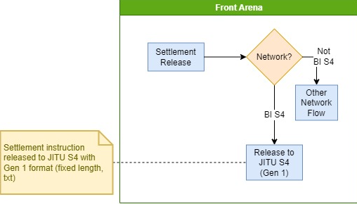

### Settlements IN

|  |  |  |  |
| --- | --- | --- | --- |
| Interface – BI-SSSS - In - Settlements | | | |
| Interface name | BI-SSSS - In - Settlements | | |
| Type of data | Settlement | Frequency | Realtime |
| Source | BI-SSSS | Direction | IN |
| Format | File | Transfer mechanism | FTPS |
| Response Required | NA | Dependencies on other processes |  |
| Purpose | BI-SSSS sends debit confirmation (acknowledgement) message file to FA. FA need to update the settlement status based on message from BI-SSSS | | |

1. In settlement inbound process, input file from specified location is processed.

A separate service ATS_INTEGRATIONS handles download of the files.

1. Front Arena settlement records are mentioned in that file.
2. This functionality task reads the settlement id from incoming file and update the FA standard status to ACK or NACK based on response code received in that file.
3. This task configured in Task Mode ATS to read settlement status and update it on Front Arena settlements.
4. Separate ATS is configured in Task Module which executes this task. Please refer configuration section for more details on ATS setup.
5. Once the incoming file is processed, then that file is archived in specified archive folder path in Task parameter.

## LOGIC AND CONFIGURATION

### Price Feed

#### Flow Logic

1. On execution of this Task, it reads the incoming file from the location specified on Task parameter. Multiple files present on the location can be read by the script. A separate service ATS_INTEGRATIONS which runs a task ,handles download of the files from FTP.
2. For each row available in file, program reads Instrument Alias, Closing price, date.
3. Then program identifies the Front Arena instrument from the Alias.
4. If the instrument found, then it checks if price records is already available in Market – BI-SSSS, for this identified instrument and given date.
5. If price record is already present, then that record is updated with the closing price received in input file.
6. If the price record is not present, then new price entry is created for that instrument for give data and closing price in BI-SSSS market.

#### Configuration

|  |  |
| --- | --- |
| Delivery Items | |
| Extension Context | +Integration |
| Extension Module | BM_InPriceFeed |
| Task | BIS4_In_PriceFeed |
|  |  |
|  |  |
| FA Component | |
| ATS | This task is Grouped under EOD group. So EOD ATS will trigger this task as per schedule or dependency. |
|  |  |
| Deployment and Manual Configuration | |
| This service is deployed through FA standard deployment process. | |
|  |  |
| Additional Information |  |
|  |  |
| FParameters |  |
| logFilename | BIS4_InPriceFeed_LOG_{}.txt  Log file name. Date and time stamp added to filename. |
| Task Parameter | |
| Input – Folder Path | Folder path of incoming file |
| Archive – Folder Path | Folder path to archive the processed file. |
| Logging | Logging parameters to log details. |
| Pre-requisites |  |
| Price Market | BI-SSSS market must be present in FA to update the prices from BI-SSSS system. |
| ATS service | ATS service for this interface must be running to work this interface. |
| Instrument Alias from BI-SSSS should be mapped to Instruments | Instrument Alias field used to identify the Front Arena instrument. |

Task

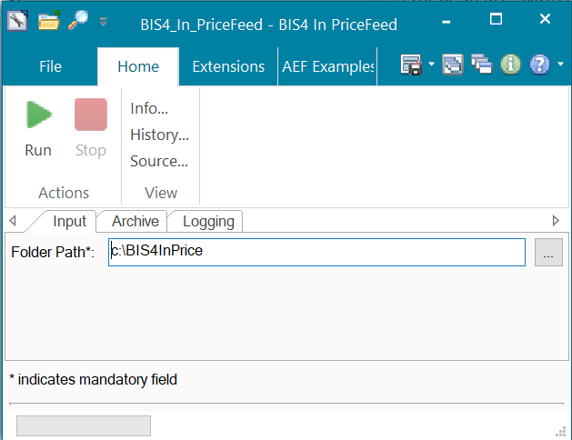

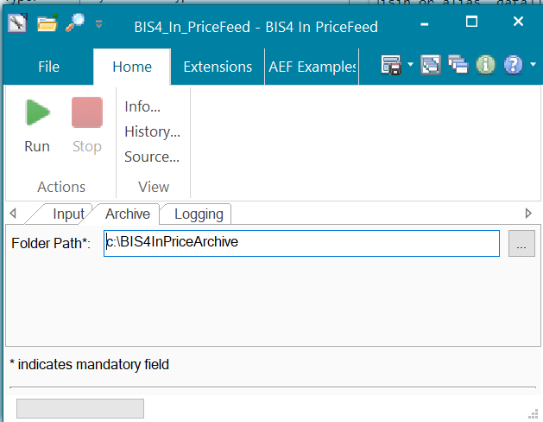

The following ask is used to download the files from FTP

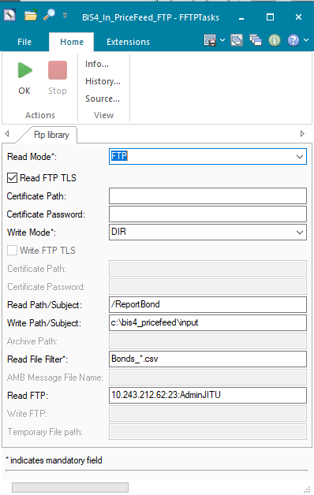

FTP password can be configured using the following extension.

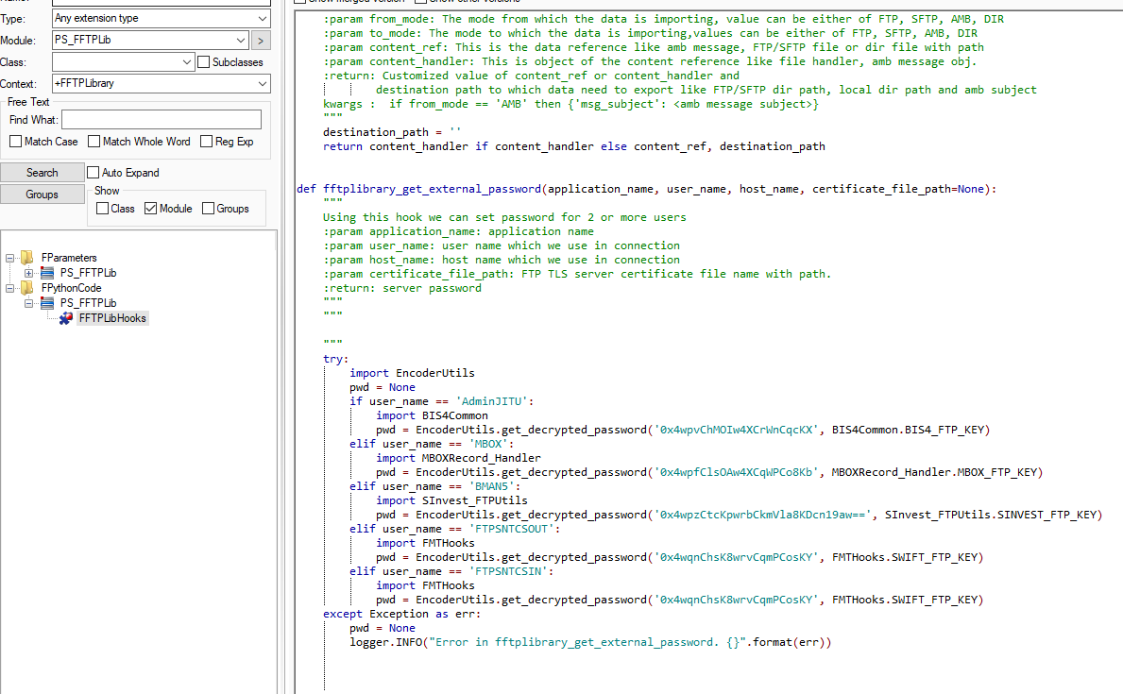

To generate a new encrypted password string run a script as follows:

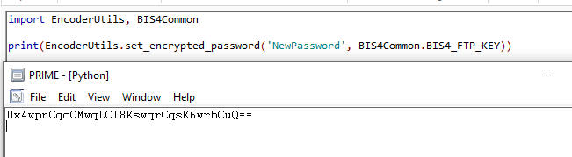

#### Data Dictionary

Please refer attached document for data format.



#### A Data Model

Following fields are available in input file.

|  |  |  |  |  |
| --- | --- | --- | --- | --- |
| Seccode | Price | Currcode | Trade Date | Issue Id |
| SPNS15012016 | 99.998 | IDR | 2021-04-28 | 154 |

#### B Data Entity and Key Elements Definition

Front Arena field mappings*.*

|  |  |
| --- | --- |
| Seccode | BI-SSSS alias code. |
| Price | Closing Price from BI-SSS |
| Currcode | Currency Code |
| Trade Date | Date for the Price |
| Issue Id | Id from BI-SSSS |

#### C Reference Code Table Definition

Table code references for the tables are available in AEF Browser and ADM data model document. FCA - 4033

### Holding Position

#### Flow Logic

1. A separate service ATS_INTEGRATIONS running a separate task handle downloading of the files.
2. Once this task is triggered, it reads CSV file from FTPS.
3. Input folder path is provided as task parameter.
4. File parsing is performed to extract Instrument from the Alias information available in that input file.
5. Along with Instrument Alias, holding position amount and the date is retrieved from file. There is a probability to receive data with same bis4 alias, but the sub-balance is different, the implementation will sum the amount in all file in one batch.
6. Once the instrument is found in FA, the Holding Amount and Date from the file, set as Additional information field - HoldPosBIS4
7. Additional information value format is - YYYYMMDD_<HoldingPositionAmount>
8. If the Instrument with retrieved Instrument Alias not found in FA, then that record is not updated in FA and message is logged at location provided in Task parameter.

#### Configuration

|  |  |
| --- | --- |
| Delivery Items | |
| Extension Context | +Integration |
| Extension Module | BM_InHoldingPosition |
| Task | BIS4_In_HoldingPosition |
|  |  |
|  |  |
| FA Component | |
| ATS | This task is Grouped under EOD group. So EOD ATS will trigger this task as per schedule or dependency. |
|  |  |
| Deployment and Manual Configuration | |
| This service is deployed through FA standard deployment process. | |
|  |  |
| Additional Information |  |
| HoldPosBIS4 | Store Holding Position Amount and date |
| FParameters |  |
| logFilename | BIS4_InHoldingPosition_LOG_{}.txt  Log file name. Date and time stamp added to filename. |
| Task Parameter | |
| Input – Folder Path | Folder path of incoming file |
| Archive – Folder Path | Folder path to archive the processed file. |
| Logging | Logging parameters to log details. |
| Pre-requisites |  |
| Additional Information field | Additional information field must be present to store Holding Position on |
| ATS service | ATS service for this interface must be running to work this interface. |
| Instrument Alias from BI-SSSS should be mapped to Instruments | Instrument Alias field used to identify the Front Arena instrument. |

**Task:**

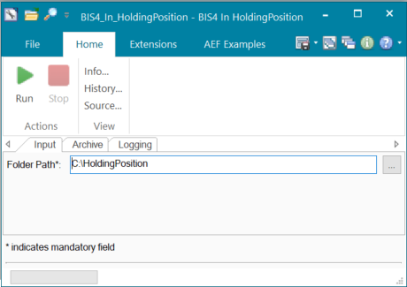

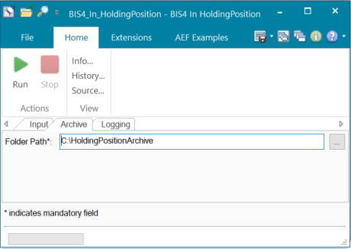

The following task handles the download of the files from FTP.

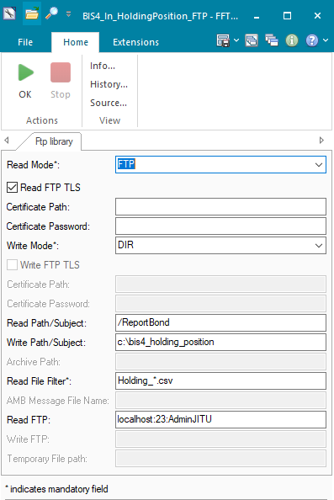

Refer to section 5.1 Price Feed for how to configure the password.

#### Data Dictionary

#### A Data Model

|  |  |  |
| --- | --- | --- |
| BI-SSSS Alias | Holding position | Date |
| SPNS15012016 | 100000 | 3/29/2023 |

#### B Data Entity and Key Elements Definition

Instrument Alias setup and Additional information field on Instrument level.

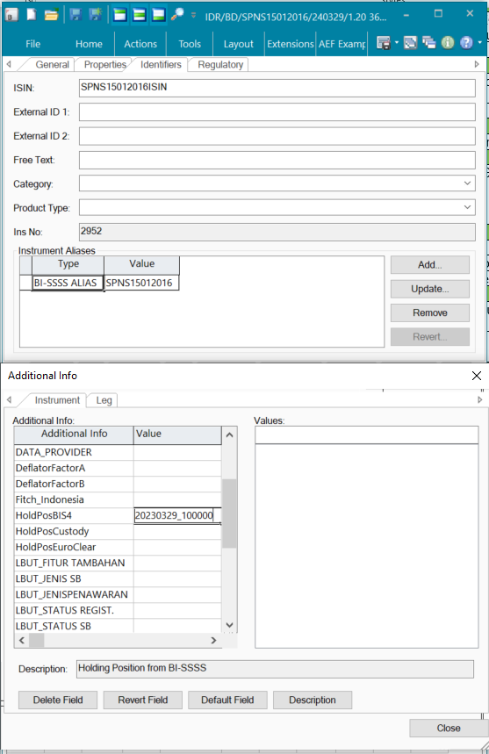

|  |  |
| --- | --- |
| Field | Description |
| BI-SSSS Alias | Alias from BI-SSSS system. It should be already mapped to instrument. |
| Holding Position | Holding position amount |
| Date | Date of Holding position |

#### C Reference Code Table Definition

Table code references for the tables are available in AEF Browser and ADM data model document. FCA - 4033

### Settlements OUT

#### Flow Logic

1. In AMBA hook function, settlement event is captured and checked is the respective settlement is matching the predefined query folder. Please refer configuration section for more details on Query folder.
2. If the settlement is matched the query folder criteria, then that settlement is considered for sending details to BI-SSSS
3. All required information’s are extracted from FA and transformed all details into Gen1 format.
4. After extracting information, settlement’s additional information - SentToBIS4, set to True indicating that the settlement is processed for this interface.
5. Formatted data written into output file at specified location. Output file is fix length format.
6. Output location is parameterized in this script.
7. The script writes the generated output file FTPS location.

**Output file sample:**

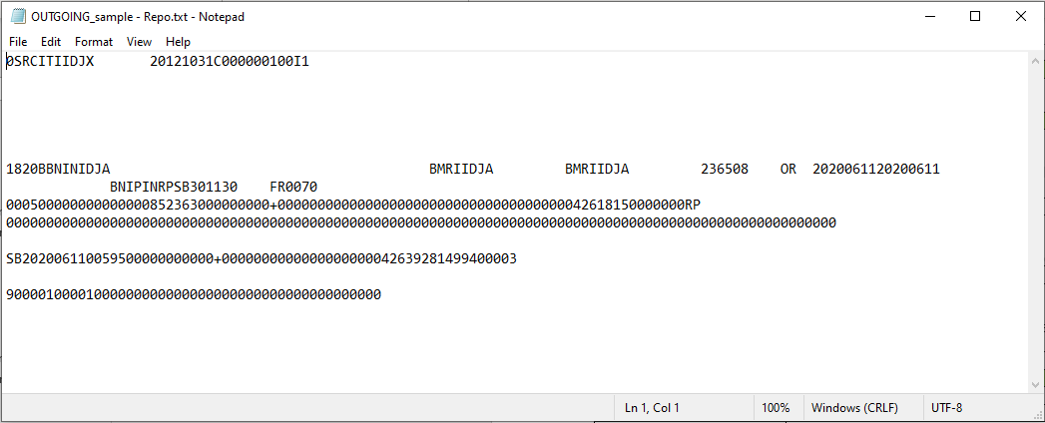

#### Configuration

|  |  |
| --- | --- |
| Delivery Items | |
| Extension Context | +Integration |
| Extension Module | PS_OutSettlements |
| AMBA service | AMBA_BIS4_OUT_SETTLEMENT |
|  |  |
|  |  |
| FA Component | |
| AMBA | AMBA service is installed to validate and transfer settlement details to BI_SSS system in output file format. |
|  |  |
| Deployment and Manual Configuration | |
| This service is deployed through FA standard deployment process. | |
|  |  |
| Additional Information |  |
| SentToBIS4 | To indicate if that settlement is already sent to BI-SSSS system. |
| FParameters |  |
| **OutSettlementsParams** | |
| logFilename | BIS4_InHoldingPosition_LOG_{}.txt  Log file name. Date and time stamp added to filename. |
| logFolder | c:\temp |
| outputFileName | BIS4OutSettlement_{}  Date and timestamp will be added in filename. |
| outputFolder | c:\temp |
| outSettlementQuery | BIS4OutSettlementQuery  Query folder is used to match the settlement selection criteria |
| **Bis4OutFtpParams** | |
| cert_password |  |
| certificate |  |
| ftp_dest_dir | out |
| host | 10.243.212.62 |
| password | 0x4wqnChMOKw4HCqmTCo8Kc |
| port | 23 |
| user | AdminJITU |
|  |  |
| Task Parameter | |
| NA |  |
|  |  |
|  |  |
| Pre-requisites |  |
| Additional Information field | SentToBIS4  Must be present to indicate the settlement is processed. |
| AMBA | AMBA_BIS4_OUT_SETTLEMENT  AMBA service must be running to run this interface in real-time. |

Refer to section 5.1 Price Feed for how to configure the password.

#### Data Dictionary

#### A Data Model

**Header Section**

|  |  |  |
| --- | --- | --- |
| Field Desc | Length | start index |
|  | 0 | 0 |
| Record Type | 1 | 1 |
| Member Code | 17 | 2 |
| Crediton Date | 8 | 19 |
| Batch Reference | 10 | 27 |
| Message Type | 1 | 37 |
| Batch type | 1 | 38 |
| Reserved | 662 | 39 |

**Payload section**

|  |  |  |
| --- | --- | --- |
| Field Desc | Length | start index |
|  | 0 | 0 |
| Record Type | 1 | 1 |
| Transaction Code | 3 | 2 |
| Initiate Party | 1 | 5 |
| Seller Member Code | 17 | 6 |
| Seller Agent Code | 17 | 23 |
| Seller Reference | 10 | 40 |
| Seller Custody Code | 2 | 50 |
| Seller Investor Type | 2 | 52 |
| Buyer Member Code | 17 | 54 |
| Buyer Agent Code | 17 | 71 |
| Buyer Reference | 10 | 88 |
| Buyer Custody Code | 2 | 98 |
| Buyer Investor Type | 2 | 100 |
| Transaction Date | 8 | 102 |
| Value Date | 8 | 110 |
| Beneficiary / By Order Of | 24 | 118 |
| Agreement Code | 20 | 142 |
| Securities Code | 16 | 162 |
| Nominal Amount | 17 | 178 |
| Clean Price/Disc | 8 | 195 |
| Yield | 8 | 203 |
| Repo Option | 1 | 211 |
| Accrued Interest/Bonus | 17 | 212 |
| Misc | 17 | 229 |
| Total Proceed | 17 | 246 |
| Transaction Type | 2 | 263 |
| Settlement Type | 1 | 265 |
| Tax I Date | 8 | 266 |
| Tax I Nominal Amount | 17 | 274 |
| Tax I Price | 8 | 291 |
| Tax II Date | 8 | 299 |
| Tax II Nominal Amount | 17 | 307 |
| Tax II Price | 8 | 324 |
| Tax III Date | 8 | 332 |
| Tax III Nominal Amount | 17 | 340 |
| Tax III Price | 8 | 357 |
| Tax Percentage | 5 | 365 |
| Seller To Buyer Information | 140 | 370 |
| Repo Type | 2 | 510 |
| Repo Maturity Date | 8 | 512 |
| Repo Rate (%) | 8 | 520 |
| Repo Yield (%) | 8 | 528 |
| Sign | 1 | 536 |
| Repo Accrued Interest/Bonus | 17 | 537 |
| Repo Maturity Total Proceed | 17 | 554 |
| Repo Tenure | 3 | 571 |
| Seller AID | 20 | 574 |
| Buyer AID | 20 | 594 |
| Name for Seller Customer | 60 | 614 |
| Name for Buyer Customer | 60 | 674 |
| NPWP for Seller Customer | 24 | 734 |
| NPWP for Buyer Customer | 24 | 758 |
| Address for Seller | 60 | 782 |
| Address for Buyer | 60 | 842 |
| Reserved | 17 | 902 |
| Reserved2 | 82 | 919 |

**Footer Section**

|  |  |  |
| --- | --- | --- |
| Field Desc | Length | start index |
|  | 0 | 0 |
| Record Type | 1 | 1 |
| Total SSTS 1st Count | 5 | 2 |
| Total SSTS 1st Nominal Amount | 18 | 7 |
| Total SSTS 2nd Count | 5 | 25 |
| Total SSTS 2nd Nominal Amount | 18 | 30 |
| Reserved | 653 | 48 |

#### B Data Entity and Key Elements Definition

*All required details are available in AEF Browser document.*

**Header Section**

|  |  |
| --- | --- |
| Field Desc | Mapping |
|  | 0 |
| Record Type | Fixed value |
| Member Code | Settlement Acquirer SWIFT code |
| Crediton Date | Date today |
| Batch Reference | Settlement ID |
| Message Type | S – Fixed value |
| Batch type | 1 – Fixed value |
| Reserved | Blank space |

**Payload section**

|  |  |
| --- | --- |
| Field Desc | Mapping |
|  | 0 |
| Record Type | 1 – Fixed value |
| Transaction Code | Custom logic. Please refer Table – Transaction code |
| Initiate Party | B - Settlement Amount > 0  S – Settlement Amount < 0 |
| Seller Member Code | If S (Settlement Amount < 0)   * Acquirer SWIFT code   If B (Settlement Amount > 0)   * Counterparty SWFT code |
| Seller Agent Code | If S (Settlement Amount < 0)   * BIC code from Acquirer Account   If B (Settlement Amount < 0)   * BIC code from Counterparty Account |
| Seller Reference | Settlement id with prefix à <Parameterized prefix><Settlement ID> |
| Seller Custody Code | EMPTY_VALUE_BLANK |
| Seller Investor Type | EMPTY_VALUE_BLANK |
| Buyer Member Code | If S (Settlement Amount < 0)   * Counterparty SWIFT code   If B (Settlement Amount > 0)   * Acquirer SWIFT code |
| Buyer Agent Code | If S (Settlement Amount < 0)   * BIC code from Counterparty Account   If B (Settlement Amount > 0)   * BIC code from Acquirer Account |
| Buyer Reference | Settlement id with prefix à <Parameterized prefix><Settlement ID> |
| Buyer Custody Code | EMPTY_VALUE_BLANK |
| Buyer Investor Type | EMPTY_VALUE_BLANK |
| Transaction Date | Settlement à Trade à Trade Date  If No trade on settlement, then Settlement Create time |
| Value Date | Settlement Value date |
| Beneficiary / By Order Of | EMPTY_VALUE_BLANK |
| Agreement Code | Trade Additional Info à CTPNumber |
| Securities Code | Instrument Alias of type – BI-SSSS Alias  For Basket Repo Instrument à Instrument Alias is capture from Collateral trade’s Instrument. |
| Nominal Amount | Settlement Trade Nominal |
| Clean Price/Disc | Settlement trade price |
| Yield | EMPTY_NUMBER_ZERO |
| Repo Option | 2 – Fixed Value |
| Accrued Interest/Bonus | Value from FA standard column - 'Standard Calculations Quote Conversion Accrued'.  It is mapped only for outright trade only for outright DVP and is zero if transaction is repo/reverse repo. |
| Misc | EMPTY_NUMBER_ZERO |
| Total Proceed | Custom Logic –  Basket Repo Instrument-   * total_proceed = nominal_amt * clean_price + accrued_interest - tax_amount   Other Instrument type-   * total_proceed = settlement_obj.Amount() * clean_price + accrued_interest - tax_amoun |
| Transaction Type | Custom logic. Please refer Table – Transaction code |
| Settlement Type | EMPTY_VALUE_BLANK |
| Tax I Date | Mapped from additional payment on the trade for Repo and outright trades. |
| Tax I Nominal Amount | Mapped from additional payment on the trade for Repo and outright trades. |
| Tax I Price | EMPTY_NUMBER_ZERO |
| Tax II Date | EMPTY_NUMBER_ZERO |
| Tax II Nominal Amount | EMPTY_NUMBER_ZERO |
| Tax II Price | EMPTY_NUMBER_ZERO |
| Tax III Date | EMPTY_NUMBER_ZERO |
| Tax III Nominal Amount | EMPTY_NUMBER_ZERO |
| Tax III Price | EMPTY_NUMBER_ZERO |
| Tax Percentage | EMPTY_NUMBER_ZERO |
| Seller To Buyer Information | EMPTY_VALUE_BLANK |
| Repo Type | If Basket Repo Instrument à SB  If Other Instrument à BLANK |
| Repo Maturity Date | If Basket Repo à Instrument End Date  If Other Instrument à BLANK |
| Repo Rate (%) | If Basket Repo Instrument  àfor Leg type – Fixed, Fixed Accretive, Fixed Adjustable à Fixed Rate from Instrument Leg  àfor leg type – Float à Spread value from Instrument Leg |
| Repo Yield (%) | 0 – Fixed value |
| Sign | + - Fixed value |
| Repo Accrued Interest/Bonus | EMPTY_NUMBER_ZERO |
| Repo Maturity Total Proceed | Value from FA standard column - "Standard Calculations Projected Factor". For settlement Trade |
| Repo Tenure | For Basket Repo – Is it difference between Repo start and end date. |
| Seller AID | EMPTY_VALUE_BLANK |
| Buyer AID | EMPTY_VALUE_BLANK |
| Name for Seller Customer | EMPTY_VALUE_BLANK |
| Name for Buyer Customer | EMPTY_VALUE_BLANK |
| NPWP for Seller Customer | EMPTY_VALUE_BLANK |
| NPWP for Buyer Customer | EMPTY_VALUE_BLANK |
| Address for Seller | EMPTY_VALUE_BLANK |
| Address for Buyer | EMPTY_VALUE_BLANK |
| Reserved | EMPTY_VALUE_BLANK |

**Transaction Code**

|  |  |  |
| --- | --- | --- |
| Field | Transaction Type | Transaction Code |
| Instrument type = Basket Repo | RP | 820 |
| Settlement Delivery type = Delivery versus Payment | SL | 700 |
| Settlement Delivery type = Delivery Free of Payment | TF | 720 |

**Footer Section**

|  |  |
| --- | --- |
| Field Desc | Length |
|  | 0 |
| Record Type | 9 – Fixed value |
| Total SSTS 1st Count | 1 – Fixed value |
| Total SSTS 1st Nominal Amount | Settlement amount |
| Total SSTS 2nd Count | EMPTY_NUMBER_ZERO |
| Total SSTS 2nd Nominal Amount | EMPTY_NUMBER_ZERO |
| Reserved | EMPTY_NUMBER_ZERO |

#### C Reference Code Table Definition

Table code references for the tables are available in AEF Browser and ADM data model document. FCA - 4033

### Settlements IN

#### Flow Logic

1. A separate service ATS_INTEGRATIONS running a separate task handle downloading of the files.
2. Script reads the input file and exclude Header and Footer lines.
3. Only Payload records from the file are considered for processing.
4. Each payload represents the single settlement information.
5. For each payload record, process extracts
   1. Auth Error leg
   2. Seller reference
   3. Buyer reference
   4. Transaction code
6. Front Arena settlement is identified from the settler reference, if there is no settlement found from seller reference, then settlement search based on buyer reference.
7. If there is error status in file i.e. Auth Error Flag == Y, then Front Arena settlement is moved to NACK i.e Not Acknowledged standard status.
8. If transaction code is 7, then settlement status is not changed. The text from the field reserved is extracted to update in settlement diary. Please refer Data Model section for details on Response code.
9. If transaction code is 8, then settlement get moved to status - Acknowledged, and response code get updated in settlement diary.
10. After processing the input file, it gets moved in Archive folder. Archive folder path is available through Task parameter.
11. All settlement records which are processed and failed get logged in log file.

**Workflow**

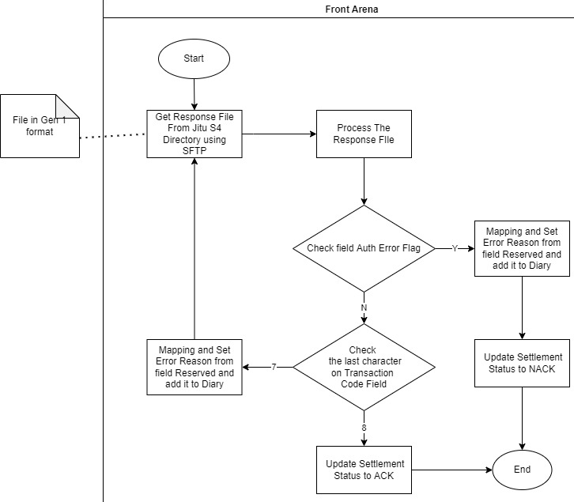

**Input file sample**

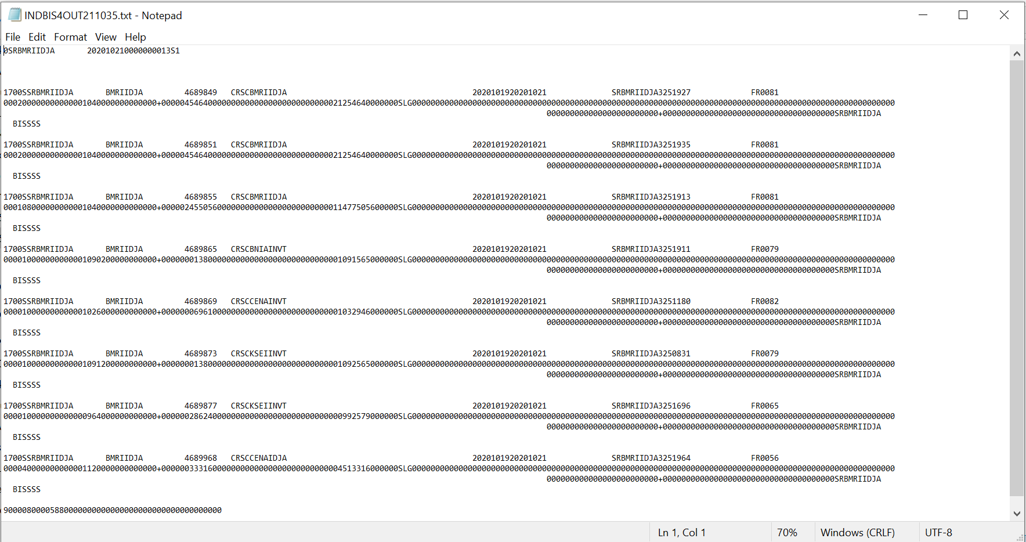

#### Configuration

|  |  |
| --- | --- |
| Delivery Items | |
| Extension Context | +Integration |
| Extension Module | PS_InSettlements |
| Task | BIS4_In_Settlements |
| ATS | ATS_BIS4_IN_SETTLEMENT |
|  |  |
| FA Component | |
| ATS | ATS service is installed and configured to run in Task mode. Interface task is mapped in configuration to keep running through this ATS. |
|  |  |
| Deployment and Manual Configuration | |
| This service is deployed through FA standard deployment process. | |
|  |  |
| Additional Information |  |
|  |  |
| FParameters |  |
| logFilename | BIS4_InSettlements_LOG_{}.txt  Log file name. Date and time stamp added to filename. |
|  |  |
| Task Parameter | |
| Input – Folder Path | Folder path of incoming file |
| Archive – Folder Path | Folder path to archive the processed file. |
| Logging | Logging parameters to log details. |
| Pre-requisites |  |
| ATS | ATS service must be running. |
| Input folder and Output folder access | Folder locations must be accessible. |
|  |  |

**Task**

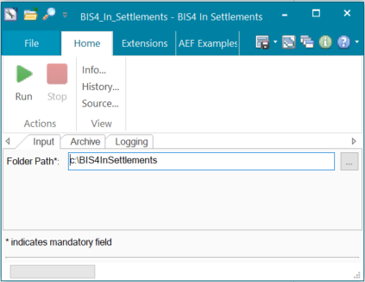

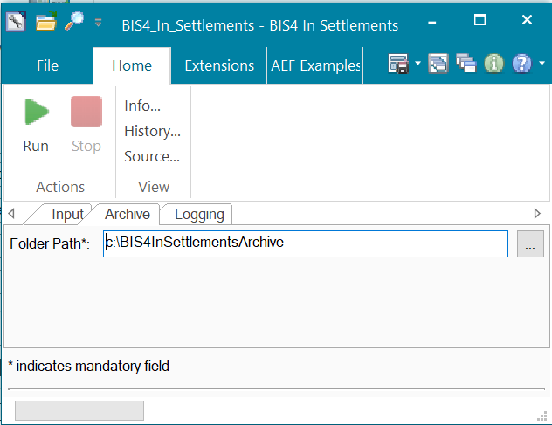

The following task downloads the file from FTP site.

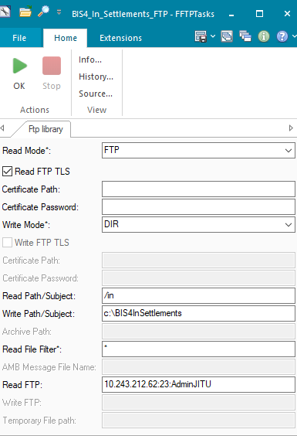

Refer to section 5.1 Price Feed for how to configure the password.

#### Data Dictionary

#### A Data Model

*Please refer AEF Browser document for details about Front Arena Data Model.*

*Document - FCA4033*

Header Section

|  |  |
| --- | --- |
| Field Desc | Length |
|  | 0 |
| Record Type | 1 |
| Member Code | 17 |
| Crediton Date | 8 |
| Batch Reference | 10 |
| Message Type | 1 |
| Batch type | 1 |
| Reserved | 663 |

Payload section

|  |  |
| --- | --- |
| Field Desc | Length |
|  | 0 |
| Record Type | 1 |
| Transaction Code | 3 |
| MOR | 6 |
| URN Information | 14 |
| Auth Error Flag | 1 |
| OSN | 6 |
| Initiate Party | 1 |
| Seller Member Code | 17 |
| Seller Agent Code | 17 |
| Seller Reference | 10 |
| Seller Custody Code | 2 |
| Seller Investor Type | 2 |
| Buyer Member Code | 17 |
| Buyer Agent Code | 17 |
| Buyer Reference | 10 |
| Buyer Custody Code | 2 |
| Buyer Investor Type | 2 |
| Transaction Date | 8 |
| Value Date | 8 |
| Beneficiary / By Order Of | 24 |
| Agreement Code | 20 |
| Securities Code | 16 |
| Nominal Amount | 17 |
| Clean Price/Disc | 8 |
| Yield | 8 |
| Sign/Repo Option | 1 |
| Accrued Interest/Bonus | 17 |
| Misc | 17 |
| Total Proceed | 17 |
| Tax I Date | 8 |
| Tax I Nominal Amount | 17 |
| Tax I Price | 8 |
| Tax II Date | 8 |
| Tax II Nominal Amount | 17 |
| Tax II Price | 8 |
| Tax III Date | 8 |
| Tax III Nominal Amount | 17 |
| Tax III Price | 8 |
| Tax Percentage | 5 |
| Tax Value | 17 |
| Seller To Buyer Information / Buyer To Seller Information | 140 |
| Repo Type | 2 |
| Repo Maturity Date | 8 |
| Repo Rate (%) | 8 |
| Repo Yield | 8 |
| Sign | 1 |
| Repo Accrued Interest/Bonus | 17 |
| Repo Total Proceed | 17 |
| Repo Tenure | 3 |
| Seller AID | 20 |
| Buyer AID | 20 |
| Name for Seller Customer | 60 |
| Name for Buyer Customer | 60 |
| NPWP for Seller Customer | 24 |
| NPWP for Buyer Customer | 24 |
| Address for Seller | 60 |
| Address for Buyer | 60 |
| Reserved | 59 |

Footer Section

|  |  |
| --- | --- |
| Field Desc | Length |
|  | 0 |
| Record Type | 1 |
| Total SSTS 1st Count | 5 |
| Total SSTS 1st Nominal Amount | 18 |
| Total SSTS 2nd Count | 5 |
| Total SSTS 2nd Nominal Amount | 18 |
| Reserved | 653 |

#### B Data Entity and Key Elements Definition

|  |  |
| --- | --- |
| Field Desc | Mapping |
|  |  |
| Record Type | NOT USED |
| Transaction Code | This code used update the text in settlement diary and status |
| MOR | NOT USED |
| URN Information | NOT USED |
| Auth Error Flag | Y / "N" N=Not Error, Y=Error(error code at Field Reserved) |
| OSN | NOT USED |
| Initiate Party | NOT USED |
| Seller Member Code | NOT USED |
| Seller Agent Code | NOT USED |
| Seller Reference | Settlement ID |
| Seller Custody Code | NOT USED |
| Seller Investor Type | NOT USED |
| Buyer Member Code | NOT USED |
| Buyer Agent Code | NOT USED |
| Buyer Reference | Settlement ID |
| Buyer Custody Code | NOT USED |
| Buyer Investor Type | NOT USED |
| Transaction Date | NOT USED |
| Value Date | NOT USED |
| Beneficiary / By Order Of | NOT USED |
| Agreement Code | NOT USED |
| Securities Code | NOT USED |
| Nominal Amount | NOT USED |
| Clean Price/Disc | NOT USED |
| Yield | NOT USED |
| Sign/Repo Option | NOT USED |
| Accrued Interest/Bonus | NOT USED |
| Misc | NOT USED |
| Total Proceed | NOT USED |
| Tax I Date | NOT USED |
| Tax I Nominal Amount | NOT USED |
| Tax I Price | NOT USED |
| Tax II Date | NOT USED |
| Tax II Nominal Amount | NOT USED |
| Tax II Price | NOT USED |
| Tax III Date | NOT USED |
| Tax III Nominal Amount | NOT USED |
| Tax III Price | NOT USED |
| Tax Percentage | NOT USED |
| Tax Value | NOT USED |
| Seller To Buyer Information / Buyer To Seller Information | NOT USED |
| Repo Type | NOT USED |
| Repo Maturity Date | NOT USED |
| Repo Rate (%) | NOT USED |
| Repo Yield | NOT USED |
| Sign | NOT USED |
| Repo Accrued Interest/Bonus | NOT USED |
| Repo Total Proceed | NOT USED |
| Repo Tenure | NOT USED |
| Seller AID | NOT USED |
| Buyer AID | NOT USED |
| Name for Seller Customer | NOT USED |
| Name for Buyer Customer | NOT USED |
| NPWP for Seller Customer | NOT USED |
| NPWP for Buyer Customer | NOT USED |
| Address for Seller | NOT USED |
| Address for Buyer | NOT USED |
| Reserved | * If Auth Error Flag =N, content of Reserved->Membercode +Currency  * If Auth Error Flag=Y, content of Reserved ->Error Code from BI |

#### C Reference Code Table Definition

Table code references for the tables are available in AEF Browser and ADM data model document. FCA - 4033

## 6. SECURITY AND CONTROL DESIGN

### 6.1 Security Requirement Response

|  |  |  |
| --- | --- | --- |
| **Security Domain** | **Security Requirement** | **Response** |
| User Management | The system must identify users using a unique user identification code before allowing a log-on. | It will be controlled through CDCA application |
| The system must suspend access to a user session after a specified interval of inactivity. | Inactivity of user session will not be applicable  as the integration is in Realtime |
| The system must require user authentication before re-enabling the session. | It will be controlled through CDCA application |
| The system must display a warning message indicating that only authorised use is permitted before allowing users to perform a log-on. | It will be controlled through CDCA application |
| The system must display system information to a user, only after a successful log-on. |  |
| After a successful log-on, the system must display information concerning the previous successful attempt to perform a log-on. | It will not be possible in real-time connections. |
| The system must allow a user account to be manually disabled. | NA |
| The system must disable the user account following 3 (three) consecutive failures to perform a successful log-on. | It will be controlled through CDCA application |
| The system must automatically disable the user account following a configurable period (90 days) without use. |  |
| Password Management | The system must authenticate users using a password before allowing access to any system functions. | Not applicable at Front Arena Database side. |
| The system must ensure that passwords used by system users for log-on consist of at least 8 (eight) characters. | Not applicable at Front Arena Database side. |
| The system must enforce the use of complex passwords for all users. (Aplhanumieric & Special Characters) | Not applicable at Front Arena Database side. |
| The system must use cryptographic techniques to protect the confidentiality of user authentication data during transmission. | Not applicable at Front Arena Database side. |
| The system must enforce a password change when a password is first issued or re-issued. |  |
| The system must allow system users to change the password used for log-on. | Not applicable at Front Arena Database side. |
| The system must ensure that passwords do not remain valid for more than 90 (ninety) days. | Not applicable at Front Arena Database side. |
| The system must ensure that passwords may not be changed to any of the last 5 (five) passwords used. | Not applicable at Front Arena Database side. |
| The system must ensure that passwords are not displayed in clear text during entry. | Not applicable at Front Arena Database side. |
| Multi Factor Authentication | The system must enforce dual factor authentication of all users (system that related to financial, faced to customer directly & only use for external purposes) | Not applicable at Front Arena Database side. |
| Data Storage | The system must use cryptographic techniques to protect the storage of authentication data. | NA |
| The system must use cryptographic techniques to protect the integrity of stored critical data. | NA |
| The system must use cryptographic techniques to protect the confidentiality of stored sensitive data. | NA |
| Logging | The system must support the recording of security events in one or multiple specific security event logs. 2 weeks in minimum must be available at the Production Environment | It will be controlled through CDCA application |
| The system must include the Logical Account identity, event type and timestamp in each entry in the security event logs. | It will be controlled through CDCA application |
| The system must record when each security event lo fills to a configurable limit. | It will be controlled through CDCA application |
| The system must protect the integrity of the information in the security event logs | It will be controlled through CDCA application |
| The system must allow access to the security event logs to be limited to the authorised security staff. | It will be controlled through CDCA application |
| The system must record if the integrity of the security event logs is compromised | NA |
| The system must record all instances that system event logs are cleared. | It will be controlled through CDCA application |
| The system must record when a change is made to the system log settings (e.g. logs for certain events are turned off). | It will be controlled through CDCA application |
| The system must record when any system security policy is modified. | NA |
| The system must record all creations of Logical Accounts. | It will be controlled through CDCA application |
| The system must record all deletions of Logical Accounts. |  |
| The system must record all de-activation of Logical Accounts. |  |
| The system must record all unsuccessful attempts to log-on to the system using invalid credentials. |  |
| The system must record all successful attempts to log-on to the system. |  |
| The system must record all successful and unsuccessful attempts to change passwords. |  |
| The system must automatically build and maintain a normal usage pattern for each Logical Account. |  |
| The system must record all activation of disabled Logical Accounts. |  |
| The system must record all attempts to change any account attribute affecting authentication of the Logical Account |  |
| The system must record all allocations of system access rights. |  |
| The system must record all removals of system access rights. |  |
| The system must record all unauthorised attempts to access a system function. |  |
| The system must record when a configurable deviation from a Logical Account's normal pattern is detected. |  |
| The system must record all failures of the check on the timestamp of payment and settlement orders. |  |
| The system must record all attempts to mutually authenticate interface connections that handle critical data |  |
| The system must record all events that may indicate an attempt to cause denial of service. |  |
| The system must record all access to functions processing critical information within the system. |  |
| The system must record all access to sensitive information within the system. |  |
| The system must record all start-up and shut down events. |  |
| The system must have been integrated in the SIEM, Identity Management System & Privilege Identity Management System |  |
| Remote Access | The system logical access control mechanism must be able to discretely grant remote access capability to specific users and user groups. |  |
| The system must strictly limit user access rights to their minimum requirements when they access the system remotely. |  |
| All relevant approvals must be obtained if this application is to be made available for remote use (E.g. on the RCA-portal) by Users |  |
| System Interfaces | The system must use a logical access control mechanism to control system to system data communications, in order to avoid anonymous data transfers (for all interfaces) |  |
| The system must ensure that system to system mutual authentication takes place before data communications are allowed (for all interfaces) |  |
| System to system mutual authentication must be based on cryptographic techniques (for all interfaces) |  |
| The system must use cryptographic techniques to protect the integrity of critical data during transmission (for all interfaces) |  |
| The system must use cryptographic techniques to protect the confidentiality of sensitive data during transmission (for all interfaces) |  |
| All 'critical data' must have been identified, documented and approved by the Business |  |
| All 'confidential data' must have been identified, documented and approved by the Business |  |
| Availability | The system must have a documented and successfully tested disaster recovery plan in place | It will be managed through Front Arena Database DR setup. |
| The system must enforce quotas limiting the maximum resources that an individual user can use simultaneously. |  |
| The system must provide adequate resources to support the required number of users or concurrent users. |  |
| The system should have a documented capacity monitoring process in-place with regular reporting on its use |  |
| Security Testing | The system must be tested for specific technical security flaws where it faces the public internet, prior to release into production. |  |
| The system must only be released into production, where it faces the public internet, once all identified key findings from the security test have been rectified, or if this is not possible, the risks must be formally reviewed and signed off |  |
| The system must be tested for specific technical security flaws prior to release into production. |  |
| The system must only be released into production once all the identified key findings from the security tests have been rectified or if this is not possible, the risks must be formally reviewed and signed off |  |

### 6.2 Preventive controls

*<This sub-section describe the technical specification for preventive controls that are specific to this module. This includes logical access control, physical security control, encryption, PIN generation and validation, etc>*

*<Sample of list of Role Table and Authorization Matrix>*

|  |  |  |  |
| --- | --- | --- | --- |
| **No** | **Role** | **Authorization** | **Object** |
| 1 | Role1 | ZXXXX | Maintain |
| 2 | Role2 | ZYYYY | Display |
| 3 |  |  |  |

|  |  |  |  |  |  |  |
| --- | --- | --- | --- | --- | --- | --- |
| **No** | **User Group** | **Role1** | **Role2** | **Role3** | **Role4** | **Role5** |
| 1 | User Group1 | X | X |  | X |  |
| 2 | User Group2 |  | X | X |  | X |
|  |  |  |  |  |  |  |

### 6.3 Detective controls

*<This sub-section describe the technical specification for detective controls that are specific to this module. This includes audit trail, exception reports, reconciliation, balancing & control totals, validations, etc>.*

### 6.4 Corrective controls

*<This sub-section describe the technical specification for corrective controls that are specific to this module. This includes automated error corrections, backup, recovery & restart, etc>.*

## 7. USER INTERFACE

*NA*

## 8. OPERATING SPECIFICATION

The connection between WebEAI and FA is database to database integration using CDC Agent, the interface is for extract data from FA to WebEAI.

Front Arena Base and CDCA will have real-time live connection.

## REPORTING

### 9.1 Inventory of Reports

*<This sub-section provides a list of operational reports relevant to this module. It is assumed that MIS/EIS module will produce the executive management and regulatory related reports>.*

*<Sample of report definition>*

|  |  |  |
| --- | --- | --- |
| **No** | **Report Name** | **Description** |
|  |  | <Description> |
|  |  |  |

*<if there is data integrity checking requirement, please provide any additional supporting information>.*

### 9.2 Report layout and definition

*<This sub-section describes each of the reports in the inventory list. Report Layout and It’s selection screen must be drawn clearly in this subsection>*

*<Sample of Selection Screen:>*

Selection Field 1

Selection Field 2

to

*<Sample of Report Layout>*

**Report Title**

Report Header

LOGO

Report Footer

Page No.

**Column1**

**Column2**

**Column3**

**Column4**

**Column5**

**Column6**

**Total1**

## Communication

*<This section provides the communication line that will be used in this system>*

### New / Existing*) system *) choose one

|  |  |  |  |  |  |  |  |  |  |
| --- | --- | --- | --- | --- | --- | --- | --- | --- | --- |
| **NO** | **NEW / SURROUNDING SYSTEM** | **HOSTNAME SOURCE** | **IP SOURCE** | **PORT SOURCE** | **HOSTNAME DESTINATION** | **IP DESTINATION** | **PORT DESTINATION** | **PROTOCOL (TCP /UDP /ICMP)** | **ALLOW / DENY** |
| 1 | *<new / surrounding status>* | *<isi nama host source>* | *<isi IP source>* | *<isi port source>* | *<isi nama host destination>* | *<isi IP destination>* | *<isi port destination>* | *<isi protocol>* | *<allow / deny status>* |
| 2 |  |  |  |  |  |  |  |  |  |
| 3 |  |  |  |  |  |  |  |  |  |
| 4 |  |  |  |  |  |  |  |  |  |
| 5 |  |  |  |  |  |  |  |  |  |
| 6 |  |  |  |  |  |  |  |  |  |
| 7 |  |  |  |  |  |  |  |  |  |
| 8 |  |  |  |  |  |  |  |  |  |
| … |  | … | … | … | … | … |  | … | … |

*< For a new developed system, if there are some undefined hostnames/ ip addresses/ ports yet, then should be written with* ***TBC*** *notes and will be completely defined in SDN contract review form >*

*< For an existing system and surrounding, please define and write its hostnames/ ip addresses/ ports >*

## OTHERS

*<This section provides other technical specifications that have not been address in previous section>.*

## Appendix

# BI-ETP

## DESCRIPTION

Bank Mandiri, as one of the largest banks in Indonesia, is committed to continue improving the quality of services, including services in the field of treasury transactions. For supporting treasury business volume growth of 10% per year with a minimum market share of 25% and to achieve revenue targets with growth of at least 15% per year, a treasury system from the front, middle and front is required to a comprehensive and reliable back office. The treasury system will facilitate treasury activities, namely plain vanilla and derivative transactions and structured products through a strong treasury function and appropriate risk management tools. With adequate treasury and risk management systems, banks can run a more prudent business and create added value for both the bank and client.

Therefore, it is necessary to develop a single core treasury in order to increase speed and accuracy of transaction data and reporting. In addition, the development of the treasury system as well needed so that treasury transactions can be properly recorded from the front, middle to with back office.

One of the requirements needed for the Front Office is to have a module in which front-office users may store the Bank Indonesia-Electronic Trading Platform (BI-ETP) Transaction into Treasury Core System. BI-ETP Transaction only can be exported into an XML File, therefore the treasury core system will need a module that can store BI-ETP transactions from an XML file.

## TECHNICAL ATTRIBUTE

This section provides the technical attributes and characteristic of designed module/. Program

|  |  |
| --- | --- |
| **Attribute** | **Description** |
| Program/Module Name | Front Arena |
| Program/Module Title | Arena Extension Framework |
| Program Type | Executable, Interface, Conversion |
| Transaction Code |  |
| Development Status | New |
| Application | Core Banking |
| Application Component refer to Block Application Architecture | Arena Data Server, Arena Data Model, Arena Task Server |

## TECHNICAL ARCHITECTURE



|  |  |  |
| --- | --- | --- |
| No. | Component | Description |
| 1. | PRIME | Desktop application, a client to which contains most of the business logic of the system. |
| 2. | AEF | Arena Extension Framework: Extend existing module, create new module. |
| 3. | ADS | Arena Data Server: Core of the FrontArena System |
| 4. | AMBA | Arena Message Broker Adapter: Adapter between AMB and ADS |
| 5. | AMB | Arena Message Broker: FrontArena Middleware layer |
| 6. | ATS | Arena Task Server: Scheduler related and publishing API |
| 7. | APH | Arena Price Handler: Retrieve Refinitiv Market Data |
| 8. | ADM | Arena Data Model |
| 9. | AFG | Arena FIX Gateway: Communication with Bloomberg FIX Protocol |
| 10. | ATCI-RD | Arena Trade Capture Interface for Refinitiv Dealing |

## TECHNICAL FLOW DIAGRAM

BI-ETP Trade Import

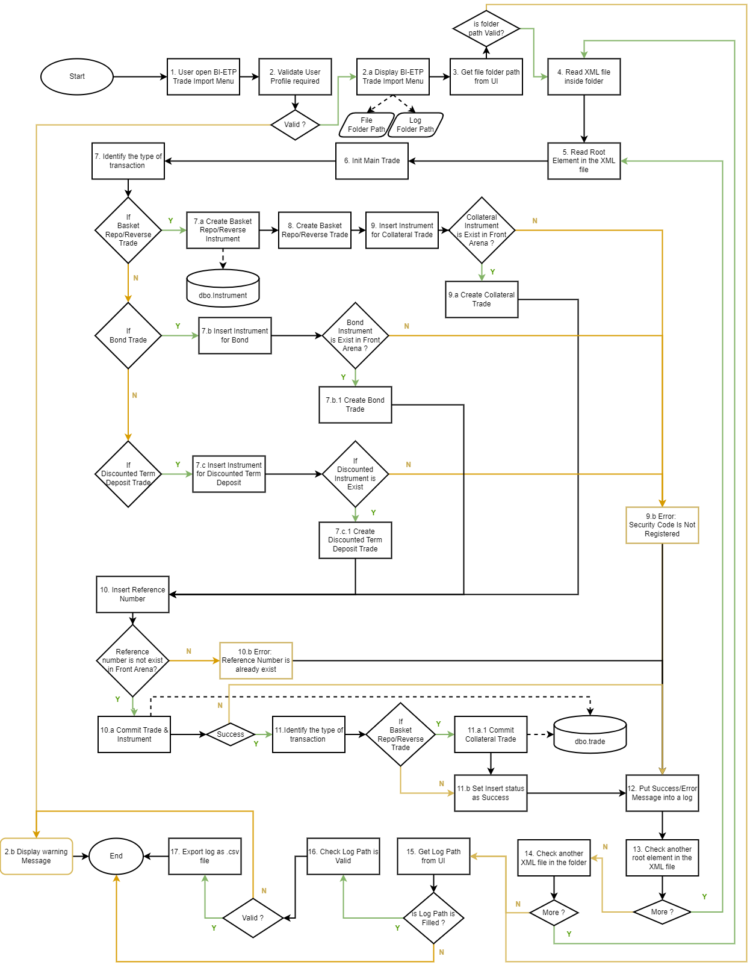

Descriptions:

1. User opens BI-ETP Trade Import Menu
2. Validate user :
3. Display the BIETP Trade Import menu if the user has a **BIETP_DEAL** user profile
4. Display warning message and block the user form accessing BIETP Trade Import menu if user doesn’t have **BIETP_DEAL** user profile
5. Get the **File Folder Path** which the user inputted from BIETP Trade Import menu
6. If the folder path is valid, continue to step number 4
7. If the folder path is not valid, continue to the step number 15
8. Read all XML files in folder based on **File Folder Path**
9. Read the Root Element in the XML file
10. Initiate Main field for Trade
11. Identify the type of transaction
12. If Basket Repo/Reverse Trade, Create an Instrument for Basket Repo/Reverse. The Instrument will be stored to ***dbo.instrument***. then go to step number 8
13. If Bond Trade, Insert Instrument for Bond
    1. If an Instrument does exist in Front Arena, Create Bond Trade
    2. If an Instrument does not exist in Front Arena,
       1. If Y, Create Bond Trade. Then go to step number 10
       2. If N, Go the step number 9.b
14. If Discounted Term Deposit Trade
    1. Check If a Discounted Term Deposit Instrument is Exist in Front Arena,
       1. If Y, Create Discounted Term Deposit Trade. Then go to step number 10
       2. If N, Go the step number 9.b
15. Create Basket Repo/Reverse trade
16. Insert Collateral Instrument
17. If Collateral Instrument is exist in Front Arena, Create Collateral Trade
18. If Collateral Instrument is existed not in Front Arena, set Error as ***Security Code does not exist in Front Arena***
19. Insert the reference number
    1. If the Reference Number does not exist in Front Arena, Commit the Trade.
       1. If Commit Trade is Success, continue to step number 11
       2. If Commit Trade is Failed, Rollback the Trade and continue to step number 12
    2. If the Reference Number does exist in Front Arena, Set ***Error as Reference Number already Exists.*** Then continue to step number 12.
20. Identify If the type of transaction is Basket Repo/Reverse Trade
    1. If Y, Commit Collateral Trade. The Collateral Trade will be stored in ***dbo.trade*** table. Then continue to step number 11.b
    2. Set insert trade status as Success
21. Save Success/Error Log Message into Variable
22. Check if is there another root element in the XML file
23. If Y, continue to process number 5
24. If N, continue to step number 14
25. Check if is there another XML file in another folder
26. If Y, continue to process number 5
27. If N, continue to step number 15
28. Get the log path from the UI
29. If the log path is not blank, continue to step number 16
30. If the log path is blank, End process
31. Check if Log path is valid
32. If Y, continue to step number 17
33. If N, Display Warning Message that the log path is not valid

Export the log as csv File. Then End Process

## LOGIC AND CONFIGURATION

### Flow Logic

#### BIETP Trade Import

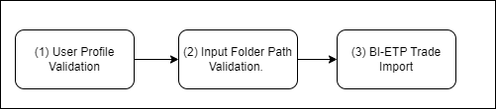

These are flow logic which implemented in Customer Registration menu:

1. User Profile Validation.
   1. Check whether user that access the menu have **BIETP Dealer** user profile.
   2. If User did not have the user profile, prime will display warning message
   3. If User have the user profile, prime will display BIETP Trade Import UI.
2. Input Folder Path Validation. Validate BIETP Input Folder should not be Empty. If Empty, prime will display error message
3. Trade Import:
   1. Read all .xml file from Input folder path
   2. Read all trade inside the xml file
   3. Trade Type logic selection.

* If ins_type equal to IDR, then the trade type will be Basket Repo/Reverse
* If ins_type equal to LLG, then the trade type will be Bond
* Else, the trade type will be Discounted Term Deposit
  1. Trigger data mapping. Set all required Trade detail into ACM Object which FTrade, FInstrument, and FLeg.
  2. Commit the DB Transaction, if one of the commit processes is failed then rollback the transaction and then go to the next transaction.
  3. Commit the DB.
  4. Generate Log Report CSV File based on Log Path. Log path is empty, then Log Report will not be generated.

### Field Mapping

#### Bond

|  |  |  |  |  |  |  |
| --- | --- | --- | --- | --- | --- | --- |
| **No** | **FA Field** | **FA UI Field** | **BI-ETP Field** | **Field Category** | **Type** | **Description** |
| 1 | TradeTime | Trd Time | bidding_time | Trade – General | Datetime |  |
| 2 | ValueDay | Value Day | value_date | Date |  |
| 3 | AcquireDay | Acquire Day | value_date | Date |  |
| 4 | Premium | Premium | iss_cash_value | Double (logic) | iss_cash_value * -1 |
| 5 | Price | Price | clean_price | Double |  |
| 6 | FaceValue | Face Value | nominal_awarded | Double |  |
| 7 | OptionalKey | External ID | trn | Trade - Identifier | String |  |

#### Discounted Term Deposit

|  |  |  |  |  |  |  |
| --- | --- | --- | --- | --- | --- | --- |
| **No** | **FA Field** | **FA UI Field** | **BI-ETP Field** | **Field Category** | **Type** | **Description** |
| 1 | TradeTime | Trd Time | bidding_time | Trade - General | Datetime |  |
| 2 | ValueDay | Value Day | value_date | Date |  |
| 3 | AcquireDay | Acquire Day | value_date | Date |  |
| 4 | Premium | Premium | iss_cash_value | Double (logic) | iss_cash_value * -1 |
| 5 | Price | Price | clean_price & nominal_awarded | Double (logic) | 100 * (clean_price / nominal_awarded) |
| 6 | FaceValue | Face Value | nominal_awarded | Double |  |
| 7 | OptionalKey | External ID | trn | Trade - Identifier | String |  |

#### Basket Repo/ Reverse

|  |  |  |  |  |  |  |
| --- | --- | --- | --- | --- | --- | --- |
| **No** | **FA Field** | **FA UI Field** | **BI-ETP Field** | **Field Category** | **Type** | **Description** |
| 1 | TradeTime | Trd Time | bidding_time | Trade - General | Datetime |  |
| 2 | ValueDay | Value Day | value_date | Date |  |
| 3 | AcquireDay | Acquire Day | value_date | Date |  |
| 4 | Premium | Premium | iss_cash_value | Double (logic) | iss_cash_value * -1 |
| 5 | Price | Price | clean_price & nominal_awarded | Double (logic) | 100 * (clean_price / nominal_awarded) |
| 6 | FaceValue | Face Value | nominal_awarded | Double |  |
| 7 | OptionalKey | External ID | trn | Trade - Identifier | String |  |
| 8 | Acquirer | Acquirer | agent_bank_name | Collateral Trade - General | String (Query) FParty |  |
| 9 | TradeTime | Trd Time | bidding_time | Datetime |  |
| 10 | ValueDay |  | value_date | Time |  |
| 11 | AcquireDay | Acquire Day | value_date | Time |  |
| 12 | Price | IDR Price | total_iss_cash_value & nominal_awarded | Double (logic) | 100 * (total_iss_cash_value / nominal_awarded) |
| 13 | Haircut | Haircut | coll_haircut | Double |  |
| 14 | StartDate | Start | auction_date | Instrument - General | Date |  |
| 15 | EndDate | End | maturity_date | Date |  |
| 16 | AmortStartDay | - | auction_date | Date |  |
| 17 | AmortEndDay | - | maturity_date | Date |  |
| 18 | RollingPeriodBase | Rolling | maturity_date | Date |  |
| 19 | FixedRate | Repo rate | repo_rate | Float |  |

### Configuration

#### BIETP Trade Import

These are the configuration used for CIF Registration Module which include Extension Module. The module name for this extension is BM_BIETP which located under +BIETP context.

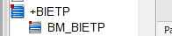

|  |  |
| --- | --- |
| Extension Name | Type |
| BIETP Trade Import | FMenuExtension |
| BIETPParam | FParameters |
| BIETP_TradeImport | FPythonCode |
| BIETPUtil | FPythonCode |

### Data Dictionary

#### Data Model

This is the Data Model used for BI-ETP Trade Import:

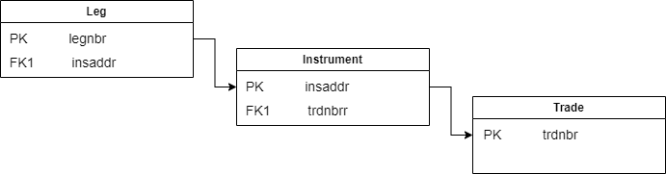

#### Data Entity and Key Element Definition

Table: Trade

|  |  |  |  |  |
| --- | --- | --- | --- | --- |
| Column Name | Data Type | Length | Allow Nulls | Description |
| acquire_day | datetime | 8 | yes | Day when instrument is acquired. |
| acquirer_ptynbr | bigint | 8 | yes | Reference to a party of type 'Intern Dept', the department which is the acquirer for this trade. |
| aggregate | int | 4 | yes | If non-zero, this trade is an aggregate trade. The aggregated trades reference this trade in their aggregate_trdnbr field. |
| aggregate_pl | float | 8 | yes | Contains the aggregated profit and loss if the trade is an aggregate trade. |
| aggregate_trdnbr | bigint | 8 | yes | Reference to a trade, which is the aggregate trade for this trade. |
| archive_status | int | 4 | yes | If 1, this record is marked as archived. |
| assinf | nchar | 70 | yes | Assignment id for trade. Not used. |
| authorizer_usrnbr | bigint | 8 | yes | Reference to the user who is the authoriser of this record. |
| base_cost_dirty | float | 8 | yes | The quantity denominated in the base currency (as defined by the valuation parameters setting FX Holiday Observance Base Currency). |
| bo_fx_rate | float | 8 | yes | FX rate stored for BO purposes. |
| bo_trdnbr | bigint | 8 | yes | Unique trade number allocated on all external trades which have ever been given the trade status of BO_CONFIRMED. This results in all trades actually done against external counterparties being included in this unbroken number series. Internal trades, trades on exchanges, and simulated trades are NOT included in this number series. Trades with trade status TERMINATED that were once confirmed are therefore included in this number series. |
| book_day | datetime | 8 | yes | Day when last book value was determined. Not used. |
| book_value | float | 8 | yes | Last book value of this trade. Not used. |
| broker_ptynbr | bigint | 8 | yes | Reference to a party of type 'Broker', the broker for this trade. |
| calcagent | int | 4 | yes | Information field mainly intended for indicating the organization responsible for calculations of settlement values. |
| category | int | 4 | yes | Indicates if the trade is of a specific category, for example Collateral, which will affect how the trade is treated in calculations throughout the system. |
| cfnetting | int | 4 | yes | If selected cash flows are assumed netted before they are paid between the counterparties. Not used. |
| clearing_info | nchar | 80 | yes | Free text describing Clearing Party, Clearing Reference and Clearing Account Number for a SAX orderbook and Account and Service Type for a HEX orderbook. Not used. |
| clearing_location_chlnbr | bigint | 8 | yes | Reserved for future use. Not used. |
| clearing_type_chlnbr | bigint | 8 | yes | Reserved for future use. Not used. |
| cls_status | int | 4 | yes | Used to store the cls status. |
| connected_trdnbr | bigint | 8 | yes | General reference field used for connected trade, for example for a FX Cash Swap. Holds the own trade number if such references are not applicable (or if a standard trade action reference field already describes the linkage). |
| contract_trdnbr | bigint | 8 | yes | Reference to parent trade number if actions such as close, novation, exercise, splitting, or stripping has been applied. Else this field holds the own trade number. |
| correction_trdnbr | bigint | 8 | yes | Reference to a original (corrected/voided) trade if a Correct Trade action has been applied to such trade. |
| counterparty_ptynbr | bigint | 8 | yes | Reference to a party, either the counterparty for this trade, or the market on which trade was done. |
| creat_time | datetime | 8 | yes | Time when record was created. |
| creat_usrnbr | bigint | 8 | yes | Reference to the user who created this record. |
| credit_netting | int | 4 | yes | If selected credit utilisation netting is applied for this trade. Not used. |
| curr | bigint | 8 | no | Reference to an instrument of type 'Curr', denoting the currency in which this trade was done. |
| disc_type_chlnbr | bigint | 8 | yes | Reference to an entry in the Choice List table of type 'DiscType', used to group trades for trade payment discounting purposes. |
| discount | float | 8 | yes | The funding spread applied for historic prolong or early termination. Used only for FXCash trades. |
| document_type_chlnbr | bigint | 8 | yes | Reference to an entry in the Choice List table of type 'Standard Document'. This is used to generate a confir- mation in the correct format for this counterparty. This, if given, overrides the choice in the document_type_chlnbr field in the Party table entry for the counterparty to this trade. |
| execution_time | datetime | 8 | yes | This field is set to the current date and time when the trade status moves from 'Simulated' to any other status apart from 'Reserved'. If the status changes to 'Simulated' and the new status is saved in the database, the Exec Time field is cleared. This field cannot be edited. |
| fee | float | 8 | yes | Broker fee paid for this trade, not including fees entered as additional payments. |
| flat_accrued | tinyint | 1 | yes | If selected the trade premium excludes accrued (flat-of-accrued). |
| four_eye_on | int | 4 | yes | Is four eye check on for record. |
| group_trdnbr | bigint | 8 | yes | Reference to parent trade for back-to-back sales cover and FX constellation trades (for example Split/Spot Cover). |
| guarantor_ptynbr | bigint | 8 | yes | Reference to a party who is the guarantor for the counterparty of this trade. |
| haircut | float | 8 | yes | Haircut applied for this trade. This is used typically for repo trades. For FXCash trades, this is the interest rate used for calculating the funding cost for historic prolong or early termination. |
| haircut_type | int | 4 | yes | Type of haircut applied for this trade. This is used typically for repo trades. |
| hedge_cfwnbr | bigint | 8 | yes | Reference to a record in the CashFlow table for which this trade is a hedge. Not used. |
| hedge_trdnbr | bigint | 8 | yes | Trade number of trade for which this trade is a hedge. Used for hedge accounting calculations. |
| ias_class_chlnbr | bigint | 8 | yes | Reference to an entry in the Choice List table of type 'IASClassification. Not used. |
| insaddr | bigint | 8 | no | Instrument Address for instrument in which this trade was done. |
| interest_rate_at_trade_time | float | 8 | yes | The interest rate captured at trade time. |
| ipa_ptynbr | bigint | 8 | yes | Not used. (replaced by ipa_ptynbr in Instrument table) |
| market_ptynbr | bigint | 8 | yes | Reference to a record in the Party table. |
| match_day | datetime | 8 | yes | Used to group tax lots. If set it overrides trade time. |
| matching_trade_link_count | int | 4 | yes | True if MatchingTradeLink exists. Set by database trigger. |
| mirror_trdnbr | bigint | 8 | yes | Reference to the first trade in a mirror pair if such pair was created by defining a Counterparty Portfolio. |
| net_premium | tinyint | 1 | yes | Not used. |
| net_price | float | 8 | yes | Used to store the price of the trade including fees and commissions. Not used. |
| opening_bo_trdnbr | bigint | 8 | yes | Used for example when closing, novating, and exercising trades. If the original (opening) trade has a back office trade number this number will be copied into this field. |
| opening_deal_package_seqnbr | bigint | 8 | yes | Reference to the opening Deal Package if any. |
| optional_key | nchar | 62 | yes | Optional unique key used to identify this trade with trades in other systems. Shown in Trade Entry as External ID. |
| optkey1_chlnbr | bigint | 8 | yes | Reference to an entry in the Choice List table of type *trade key*, where *trade key* is the first entry in the Choice List table of type 'Trade Keys'. |
| optkey2_chlnbr | bigint | 8 | yes | Reference to an entry in the Choice List table of type *trade key*, where *trade key* is the second entry in the Choice List table of type 'Trade Keys'. |
| optkey3_chlnbr | bigint | 8 | yes | Reference to an entry in the Choice List table of type *trade key*, where *trade key* is the third entry in the Choice List table of type 'Trade Keys'. |
| optkey4_chlnbr | bigint | 8 | yes | Reference to an entry in the Choice List table of type *trade key*, where *trade key* is the fourth entry in the Choice List table of type 'Trade Keys'. |
| order_uuid | nchar | 126 | yes | A Universally Unique Identifier for the originating order for this trade. |
| ordnbr | bigint | 8 | yes | Reference to a record in the OwnOrder table. |
| origin | int | 4 | yes | Not used. |
| original_curr | bigint | 8 | yes | Reference to an instrument of type 'Curr', denoting the original currency of the trade before conversion to euros. |
| owner_usrnbr | bigint | 8 | yes | Reference to the user who is the owner of this record. |
| pay1_accnbr | bigint | 8 | yes | Reference to bank account for payments. Not used. |
| pay2_accnbr | bigint | 8 | yes | Reference to bank account for payments. Not used. |
| payment_count | int | 4 | yes | True if payment exists. |
| points_sales_margin | float | 8 | yes | Stores how much of the forward points consists of sales margin. |
| position_currency_pair | bigint | 8 | yes | Reference to a Currency Pair for the position. |
| post_trade_report_seqnbr | bigint | 8 | yes | Reference to post trade report in PostTradeReport table. |
| premium | float | 8 | yes | Premium paid for the trade, excluding premiums entered as additional payments and excluding fees. |
| premium_calculation_method | int | 4 | yes | The method with which the calculation of premium is performed for a trade. |
| prfnbr | bigint | 8 | yes | Reference to a record in the Portfolio table, to which this trade belongs. |
| price | float | 8 | yes | Price paid per contract for this trade. This price is expressed in the quotation of the instrument. |
| primary_issuance | int | 4 | yes | Used to decide counterparty when generating TradeAccountLinks. |
| protection | int | 4 | yes | Internal code representing protections set on this record. |
| quantity | float | 8 | yes | Number of contracts traded. Positive number is a buy, negative number is a sell. Total amount given by (quantity * Instrument.contr_size). |
| quantity_is_derived | tinyint | 1 | yes | When used for capturing FX deals, indicates if the premium was the entered amount and the quantity is calculated from premium and price. For FX NDF, indicates if the quantity is derived from settlement currency amount and price. |
| quotation_seqnbr | bigint | 8 | yes | The quotation of the price. Used for trades where the price is expressed in other quotation type than defined for the instrument. Not used. |
| re_acquire_day | datetime | 8 | yes | Specifies when the security will be returned for a Collateral category trade. |
| rec1_accnbr | bigint | 8 | yes | Reference to bank account for receipts. Not used. |
| rec2_accnbr | bigint | 8 | yes | Reference to bank account for receipts. Not used. |
| reference_price | float | 8 | yes | The reference price from which the trade price is derived. For FX deals, this is the spot rate at dealt time. |
| right_of_substitution | int | 4 | yes | A bit vector where the bits indicate if the trade has the right to substitute and/or reprice. Applicable for collateral, repo/reverse and securityLoan trades. |
| sales_credit | float | 8 | yes | If the sales person should get credit from the trade, the amount (or price, depending on the user organisation) is stored here. |
| sales_margin | float | 8 | yes | Stores how much of the trade rate that consists of sales margin (sales spread). |
| sales_person_usrnbr | bigint | 8 | yes | Reference to a user to denote a sales person who may have been involved with this trade. Used for information purposes only. |
| settle_category_chlnbr | bigint | 8 | yes | Reference to an entry in the Choice List table of type 'TradeSettleCategory', can be used to classify trades for Settle and/or Confirmation Instructions. |
| special_terms | int | 4 | yes | If selected special terms apply to this deal. Not used. |
| spread_first_period | float | 8 | yes | Spread for the first period of a security trade connected to a portfolio swap. If not set the spread stored in the portfolio swap will be used for the first period. |
| status | int | 4 | yes | Shows the current stage in the life of a trade. The possibility to change the trade status is regulated by the privileges of the user. |
| tax | float | 8 | yes | Tax for this trade. Not used. |
| text1 | nchar | 78 | yes | Free text entered by the user. |
| text2 | nchar | 78 | yes | Free text entered by the user. |
| time | datetime | 8 | yes | Time at which trade was done. |
| trade_curr | bigint | 8 | yes | Reserved for future use. Not used. |
| trade_process | int | 4 | yes | A bit vector where the bits indicate various processes the trade has been through. |
| trader_usrnbr | bigint | 8 | yes | Reference to the user who made this trade. This is not necessarily the user who created this trade record. |
| trdnbr | bigint | 8 | no | Unique internal number identifying this trade, generated automatically in sequential order. |
| trx_trdnbr | bigint | 8 | yes | Trade number of first trade in a series of trades belonging to the same transaction. |
| type | int | 4 | yes | Type Of Trade |
| unique_trade_identifier | nchar | 104 | yes | The Unique Trade Identifier (UTI) is used to uniquely identify a trade or contract for regulatory reporting. |
| updat_time | datetime | 8 | yes | Last time when record was updated. |
| updat_usrnbr | bigint | 8 | yes | Reference to the user who made last update. |
| value_day | datetime | 8 | yes | Day when Premium or Broker Fee for this trade is paid. |
| version_id | int | 4 | yes | An object version id, which is automatically increased when the trade is updated and is used to detect update collisions. |
| your_ref | nchar | 62 | yes | Free text describing counterparty reference (e.g. their trader). |

Table Name : Instrument

|  |  |  |  |  |
| --- | --- | --- | --- | --- |
|  |  |  |  |  |
| Column Name | Data Type | Length | Allow Nulls | Description |
| accrued_arrear | tinyint | 1 | yes | If selected the interest is accrued in arrears for the first coupon, taken from the date of acquisition. A new holder of the instrument will not acquire the interest accrued from the last payment date to the acquisition date. |
| archive_status | int | 4 | yes | If 1, this record is marked as archived. |
| authorizer_usrnbr | bigint | 8 | yes | Reference to the user who is the authoriser of this record. |
| barrier | float | 8 | yes | The value at which the barrier option is knocked in or out, that is the value when the option starts or ends being alive. Applicable for options or warrants where the exotic type is 'Down & Out', 'Down & In', 'Up & Out' or 'Up & In'. |
| beta | float | 8 | yes | Not used. |
| bond_future_market | int | 4 | yes | This is the market method for a future/forward. The value is stored in the notional bond. |
| call_option | tinyint | 1 | yes | If 'YES', this is a call option; if 'NO', it is a put option. Not used (replaced by 'option_type'), synchronization between 'call_option' and 'option_type' is though enforced when possible. |
| callable | tinyint | 1 | yes | If selected this instrument is callable. |
| category_chlnbr | bigint | 8 | yes | Reference to an entry in the Choice List table of type 'Category'. All entries in the 'Category' choice list can be used to classify instruments in a user-defined manner. |
| comb_category_chlnbr | bigint | 8 | yes | Reference to an entry in the Choice List table of type 'Comb Category', used for classifying instruments of type 'Combination'. |
| contr_size | float | 8 | yes | Specifies trading lot size for instrument. For cash flow instruments this field will contain the nominal amount, expressed in the instrument's currency. |
| conversion_ratio | float | 8 | yes | Conversion ratio for Convertibles and Commodity Variants. |
| coup_rate | float | 8 | yes | Not used. |
| coupons | int | 4 | yes | Not used. |
| creat_time | datetime | 8 | yes | Time when record was created. |
| creat_usrnbr | bigint | 8 | yes | Reference to the user who created this record. |
| curr | bigint | 8 | yes | Reference to an instrument of type 'Curr', denoting the currency or the main currency of this instrument. |
| date_from | datetime | 8 | yes | Used for historical valuation. date_from marks the start date of an interval of constant value of an instrument's combination links. |
| date_to | datetime | 8 | yes | Used for historical valuation. date_to marks the end date of an interval of constant value for an instrument's combination links. If date is 9999-12-31 it means that it has not yet got an end day. Not used. |
| daycount_method | int | 4 | yes | The day count method used for the instrument. Mainly used for Buy-Sellbacks (cash flow instruments will use Leg data). |
| digital | tinyint | 1 | yes | If selected the instrument is assigned a digital payout structure. Applicable for options and warrants. |
| digital_asset | tinyint | 1 | yes | If set to true the instrument only exist in digital form and is typically settled using blockchain rather than traditional settlement. |
| digital_cash_payout_type | int | 4 | yes | Specifies payout type for instruments with digital payout settled in cash. |
| disc_type_chlnbr | bigint | 8 | yes | Reference to an entry in the Choice List table of type 'DiscType', used to group instruments for discounting/ forwarding purposes. |
| dividend_adjustment_type | int | 4 | yes | Specifies type of dividend adjustment applied for Variance/Volatility swaps. |
| dividend_factor | float | 8 | yes | Defines a tax withholding/refunding scaling factor that affects all dividends and dividend estimates attached to the instrument. |
| dividend_settlement | int | 4 | yes | Describes how the dividends attached to the underlying instrument settles. |
| ex_coup_exclude_amort | tinyint | 1 | yes | If set to true ex coupon day calculations will not be applied on amortisation cash flows. |
| ex_coup_method | int | 4 | yes | Ex coupon method for coupon bearing instruments. |
| ex_coup_period_count | int | 4 | yes | Ex coupon period for coupon bearing instruments. This part is the count of units in which ex_coup_period is counted. |
| ex_coup_period_unit | int | 4 | yes | Ex coupon period for coupon bearing instruments. This part is the unit in which ex_coup_period is counted. |
| exercise_type | int | 4 | yes | Describes type of option exercise. |
| exotic_type | int | 4 | yes | Describes what kind of barrier instrument this is. |
| exp_day | datetime | 8 | yes | Expiry date for non-generic instruments. |
| exp_period_count | int | 4 | yes | Expiry date for generic instruments. This part is the count of units in exp_period. |
| exp_period_unit | int | 4 | yes | Expiry date for generic instruments. This part is the unit in which exp_period is counted. |
| exp_time | datetime | 8 | yes | The expiration date and time of a derivative instrument (options, warrants and futures/forwards). |
| extern_id1 | nchar | 126 | yes | A unique external identity to be used freely. |
| extern_id2 | nchar | 126 | yes | A unique external identity to be used freely. |
| face_value | float | 8 | yes | Used to for example represent Cash Amount in Call Deposits. |
| first_notice_day | datetime | 8 | yes | The first notice day of the instrument. Applicable to physically settled Futures. This is the first day the buyer of the Futures contract can be assigned delivery of the underlying. |
| fix_fx | tinyint | 1 | yes | Not used. |
| fix_fx_rate | float | 8 | yes | Fixed exchange rate applicable to a 'quanto' type instrument (that is, where the instrument and its underlying are in different currencies). |
| fixed_end_day | tinyint | 1 | yes | If selected the generic instrument will have a fixed end day. |
| fixing_lag_date_rule | bigint | 8 | yes | Fixing date rule determining a Fixing Lag for rate index instruments. |
| fixing_source_ptynbr | bigint | 8 | yes | Reference to a record in the Party table, denoting the party used for Fixing. |
| four_eye_on | int | 4 | yes | Is four eye check on for record. |
| free_text | nchar | 78 | yes | Free text available to user in the instrument definition application. |
| fund_prfnbr | bigint | 8 | yes | The link identifying which portfolio contains the trades that make up the position for a Fund instrument. |
| funding_group_chlnbr | bigint | 8 | yes | Reference to an entry in the Choice List table of type 'Funding Group', used to group instruments for funding purposes. |
| generic | tinyint | 1 | yes | If selected all date references are made through Date Period fields instead of fixed Date fields. |
| has_credit_event_spec | int | 4 | yes | Set to true if the instrument has a linked Credit Event Specification. |
| historical_dividend_source | int | 4 | yes | States where historical dividends should be taken. Applicable for Equity Index and Combination. |
| incomplete | int | 4 | yes | Indicator flag to determine for example how complete definition is. |
| index_factor | float | 8 | yes | Factor used to determine contribution to index of this instrument. |
| index_type | int | 4 | yes | Used for index linked instruments to describe the type of index. |
| insaddr | bigint | 8 | no | Unique internal number identifying this instrument, generated automatically in sequential order. |
| insid | nchar | 126 | yes | Unique name of instrument. Used to select instrument in applications. |
| instype | int | 4 | yes | Specifies the type of instrument. |
| ipa_ptynbr | bigint | 8 | yes | Issuing Paying Agent. Reference to a record in the Party table. |
| isin | nchar | 40 | yes | Unique ISIN identifier. |
| issuance_type | int | 4 | yes | Specifies the issuance type of the instrument. |
| issue_day | datetime | 8 | yes | Issue day for securities. |
| issuer | nchar | 58 | yes | On standardised instruments, the ptyid of the issuing party. Not used. |
| issuer_ptynbr | bigint | 8 | yes | On standardised instruments, reference to the issuing party. |
| last_coup_day | datetime | 8 | yes | Not used. |
| last_trading_day | datetime | 8 | yes | The final day that a contract may trade or be closed out. |
| maturity_type | int | 4 | yes | Determines the maturity type for this instrument. |
| minimum_incremental | float | 8 | yes | Minimum incremental amount for a security. |
| minimum_piece | float | 8 | yes | Minimum tradeable amount for a security. |
| month_char | nchar | 2 | yes | Month character, if applicable, for expiry of this instrument. Not used. |
| mtm_from_feed | int | 4 | yes | If selected the Mark-To-Market price is taken from the feed. If not a theoretical price is used as MtM price. |
| non_deliverable | int | 4 | yes | If selected cash flows are paid in the selected Settlement Currency for legs where this currency deviates from the Non-Deliverable Currency (original currency). |
| notice_period_count | int | 4 | yes | The notice period for open ended repo instruments. This period can vary depending on counterparty, underlying and so on. This field is used when suggesting termination date when terminating an open ended repo. This part is the number of units for the notice_period. |
| notice_period_unit | int | 4 | yes | The notice period for open ended repo instruments. This period can vary depending on counterparty, underlying and so on. This field is used when suggesting termination date when terminating an open ended repo. This part is the unit in which notice_period is counted. |
| notional | tinyint | 1 | yes | If selected this is a notional instrument that is used as underlying to bond futures, where a set of real bonds are deliverable. These bonds can be found through the deliverable link which also contains the conversion factor. |
| open_end | int | 4 | yes | End date of contract is not yet fixed. Applicable for deposit/loans, collaterals, repo/reverses, security loans, portfolio swaps and CFDs. |
| option_type | int | 4 | yes | Determines the option type for this instrument. Used for instrument types Option, Warrant, and FX ODF. |
| original_curr | bigint | 8 | yes | Reference to an instrument of type 'Curr', denoting the original currency of the instrument before conversion to euros. |
| original_insaddr | bigint | 8 | yes | Referring to the corresponding live entity, used for historical valuation and the retrieval of historical combination links for equity indices. Not used. |
| otc | tinyint | 1 | yes | If selected this is an over-the-counter instrument. |
| owner_usrnbr | bigint | 8 | yes | Reference to the user who is the owner of this record. |
| pay_day_offset | int | 4 | yes | Settle days for derivatives, that is, the pay offset between expiry and pay date. |
| pay_offset_method | int | 4 | yes | Determines for example if cash flow Pay Offset (or derivative Settle) days should be interpreted as business days or calendar days. |
| pay_period_count | int | 4 | yes | Settlement date for generic instruments. This part is the count of units in pay_period. |
| pay_period_unit | int | 4 | yes | Settlement date for generic instruments. This part is the unit in which pay_period is counted. |
| payout | float | 8 | yes | Intended for digital options. Not used. |
| paytype | int | 4 | yes | Describes how this instrument pays. All non-derivative instruments should be specified as spot payment. |
| phys_contr_size | float | 8 | yes | If the contract size has been adjusted, this is the physical contract size (for exercise/assign). |
| price_date_adjust_method | int | 4 | yes | Day method used to adjust price date when the price date is on a holiday. |
| price_diff_limit_abs | float | 8 | yes | The maximum absolute price difference between traded price and "instrument price" which does not raise a warning. |
| price_diff_limit_rel | float | 8 | yes | The maximum relative price difference between traded price and "instrument price" which does not raise a warning. |
| price_finding_chlnbr | bigint | 8 | yes | Reference to an entry in the Choice List table of type 'PriceFindingGroup', used to group instruments for price finding purposes. |
| price_publication_time | int | 4 | yes | Determines when a instrument price is published. |
| product_chlnbr | bigint | 8 | yes | Reference to an entry in the Choice List table of type 'ValGroup', used to group instruments for valuation purposes. |
| product_type_chlnbr | bigint | 8 | yes | Reference to an entry in the Choice List table of type 'Product Type'. The entries in the 'Product Type' choice list can be used to classify instruments in a user-defined manner. The field is intended to be used as finer classification of instruments than the instype. In particular, this field can be used for selecting the appropriate confirmation document in the confirmation processing since the corresponding field also exists in the Agreement and ContactRule tables. |
| protection | int | 4 | yes | Internal code representing protections set on this record. |
| putable | tinyint | 1 | yes | If selected this instrument is putable. |
| quanto_option_type | int | 4 | yes | Applicable for 'quanto' type derivatives (that is, where the instrument and its underlying are in different currencies). |
| quotation_seqnbr | bigint | 8 | no | Reference to a Quotation record where information about how quotes should be interpreted are stored. |
| quote_type | int | 4 | yes | Not used. |
| rate | float | 8 | yes | Repo rate for Buy-Sellbacks. |
| rate_type | int | 4 | yes | Type of rate used in quotation and trading; Valid when the quote type is QUOTE_YIELD. Not used. |
| rating1_chlnbr | bigint | 8 | yes | Reference to an entry in the Choice List table of type 'Ratings' with Sort Order set to '1'. Used for credit risk rating. |
| rating2_chlnbr | bigint | 8 | yes | Reference to an entry in the Choice List table of type 'Ratings' with Sort Order set to '2'. Used for credit risk rating. |
| rating3_chlnbr | bigint | 8 | yes | Reference to an entry in the Choice List table of type 'Ratings' with Sort Order set to '3'. Used for credit risk rating. |
| realize_type | int | 4 | yes | Specifies the realize settlement type of the instrument. |
| rebate | float | 8 | yes | The cash amount to be paid for knock out barrier options that are knocked out or for knock in barrier options that are never knocked in. For digital barrier options this is the cash amount to be paid out if the digital criteria is fulfilled. |
| redemption_type | int | 4 | yes | The partial redemption type. Used by a subset of Securities. |
| ref_price | float | 8 | yes | Reference price for security loans and repo/reverses. End price for buy/sellbacks. Issue Price for bills. |
| ref_value | float | 8 | yes | Reference value for security loans. End cash for buy/sellbacks. Face value for Repo/Reverse. |
| reference_date_type | int | 4 | yes | Used for price index instruments to describe conversion type from the price date and value date. |
| right_transfer_date | int | 4 | yes | Date type when right to cash flows is transferred. |
| round_accrued | int | 4 | yes | Number of decimals on accrued interest. Not used. |
| round_clean | int | 4 | yes | Number of decimals on clean price. Not used. |
| round_premium | int | 4 | yes | Number of decimals on premium. Not used. |
| rounding_spec_seqnbr | bigint | 8 | yes | Reference to a RoundingSpec record where information about rounding rules are specified. |
| seniority_chlnbr | bigint | 8 | yes | Reference to an entry in the Choice List table of type 'Seniority'. |
| settle_calnbr | bigint | 8 | yes | Reference to additional calendar for instrument settle/spot date calculation. Also used for trade acquire and value day calculations. |
| settle_category_chlnbr | bigint | 8 | yes | Reference to an entry in the Choice List table of type 'Settle Category', can be used to classify instruments for Settle and/or Confirmation Instructions. |
| settlement | int | 4 | yes | Describes how this instrument settles. |
| short_dividend_factor | float | 8 | yes | Defines the dividend factor for a short position. Only applicable for CFDs. |
| short_sell | int | 4 | yes | Short sell handling. |
| spot_banking_days_offset | int | 4 | yes | The number of days in trading differing from standard banking days. |
| start_day | datetime | 8 | yes | Start day for non-generic instruments. For example used by Buy-Sellback and Portfolio Swap (cash flow instruments will use Leg data). |
| strike_curr | bigint | 8 | yes | Define the strike currency of a "quanto" type option or warrant, for example a foreign equity option. |
| strike_inclusion | int | 4 | yes | Determines where in the payoff the strike is included. Used for derivatives. |
| strike_price | float | 8 | yes | Strike price, applicable for options and warrants. |
| strike_quotation_seqnbr | bigint | 8 | yes | Reference to a Quotation record where information about how the strike quotes should be interpreted are stored. |
| strike_type | int | 4 | yes | Strike type for options. |
| suspended | tinyint | 1 | yes | If selected this exchange-traded instrument is currently suspended from trading. Not used. |
| termination_date | datetime | 8 | yes | The date when the contract was terminated and thus no longer need to be valued. |
| total_issued | float | 8 | yes | Total issue size for a security. |
| und_insaddr | bigint | 8 | yes | Reference to an instrument, denoting the underlying instrument of this instrument, applicable to derivatives. |
| und_instype | int | 4 | yes | Type of the underlying instrument. |
| updat_time | datetime | 8 | yes | Last time when record was updated. |
| updat_usrnbr | bigint | 8 | yes | Reference to the user who made last update. |
| version_id | int | 4 | yes | An object version id, which is automatically increased when the instrument is updated and used is to detect update collisions. |
| ytm_method | int | 4 | yes | Determines Yield formula for this instrument. If 'None' is selected the valuation parameter default value is used. |

Table Name : Leg

|  |  |  |  |  |
| --- | --- | --- | --- | --- |
| Column Name | Data Type | Length | Allow Nulls | description |
| accrued_daycount_method | int | 4 | yes | The daycount method used for accrued calculations. |
| accrued_included | tinyint | 1 | yes | Accrued included for CDS credit reference in the event of default. |
| agg_rolling_base_date | datetime | 8 | yes | If set used to generate aggregation dates for multi-period reset types in need of separate aggregation days. |
| aggregated_fixing_type | int | 4 | yes | Type of aggregated fixings to generate for cash flows on leg. |
| amort_daycount_method | int | 4 | yes | Daycount method used for amortising calculations. |
| amort_end_day | datetime | 8 | yes | Amortising end day for a non-generic instrument. |
| amort_end_nominal_factor | float | 8 | yes | Percent of the nominal factor used when deciding the end amount in an amortising structure. |
| amort_end_period_count | int | 4 | yes | Amortising end period if the instrument is generic. |
| amort_end_period_unit | int | 4 | yes | Amortising end period if the instrument is generic. |
| amort_fixed_amount | float | 8 | yes | Fixed amount used for fixed amount amortising structures. Expressed in percentage of contract size. |
| amort_flow_generation | int | 4 | yes | Defines how amortizing flows should be generated. |
| amort_generation | int | 4 | yes | Amortising generation method (Target end/Initial amort rate). |
| amort_period_count | int | 4 | yes | The time period for linear amortisation. This part is the count of units in amort_period. |
| amort_period_unit | int | 4 | yes | The time period for linear amortisation. This part is the unit in which reset_period is counted. |
| amort_start_day | datetime | 8 | yes | Amortising start day for a non-generic instrument. |
| amort_start_period_count | int | 4 | yes | Amortising start period if the instrument is generic. |
| amort_start_period_unit | int | 4 | yes | Amortising start period if the instrument is generic. |
| amort_type | int | 4 | yes | The type of amortising structure applied to the instrument. |
| annuity_rate | float | 8 | yes | Annuninty rate used when building amortising structures. |
| archive_status | int | 4 | yes | If 1, this record is marked as archived. |
| autocallable_type | int | 4 | yes | Type of autocallable payoff. |
| barrier | float | 8 | yes | Knock out/in barrier level. |
| barrier2 | float | 8 | yes | Barrier used for Nth-Loss CDS structures. |
| calc_period_agg_method | int | 4 | yes | Determines the method of aggregation over calculation periods. |
| calc_period_calnbr | bigint | 8 | yes | Reference to a calculation period calendar to use with this leg. Calculation period calendars are used for generating start and end dates for multi-period (aggregating) reset types. |
| calc_period2_calnbr | bigint | 8 | yes | Reference to an optional second calculation period calendar to use with this leg. |
| calc_period3_calnbr | bigint | 8 | yes | Reference to an optional third calculation period calendar to use with this leg. |
| calc_period4_calnbr | bigint | 8 | yes | Reference to an optional forth calculation period calendar to use with this leg. |
| calc_period5_calnbr | bigint | 8 | yes | Reference to an optional fifth calculation period calendar to use with this leg. |
| calc_type_chlnbr | bigint | 8 | yes | Reference to an entry in the Choice List table of type 'CalculationType'. Entries like 'JGB' and 'RSA' are used for valuation purposes. |
| calculation_period_count | int | 4 | yes | Used when ResetType is "Compound of Weighted". Dictates the period with which the rates should be weighted before being compounded. |
| calculation_period_date_rule | bigint | 8 | yes | If set the calculation period date rule will be applied to the rolling dates to determine the calculation period dates. |
| calculation_period_unit | int | 4 | yes | Used when ResetType is "Compound of Weighted". Dictates the period with which the rates should be weighted before being compounded. |
| calculation_rolling_at_end | tinyint | 1 | yes | Used when ResetType is 'Compound of Weighted'. Dictates whether the rolling for the calculation period should be performed from the cashflow start or the end date. Not used if leg field agg_rolling_base_date has been set. |
| category_chlnbr | bigint | 8 | yes | Reference to an entry in the Choice List table of type 'Leg Category'. Used in synthetic prime solution on portfolio swap legs. |
| common_cf_fixing_period | int | 4 | yes | The number of cash flows with common fixing period for variable float legs. |
| comparison_type | int | 4 | yes | Comparison Type |
| constant_start_reset | tinyint | 1 | yes | If selected the first reset of the return resets should use the leg start date as fixing date. |
| corr_barrier_level | float | 8 | yes | Barrier level for the corridor reference. |
| corr_barrier_type | int | 4 | yes | Barrier type for the corridor reference. |
| corr_observation_criteria | int | 4 | yes | The observation criteria for the corridor reference. |
| corr_ref_fixing_date_rule | bigint | 8 | yes | Fixing date rule for the corridor reference. |
| corr_ref_fixing_src_ptynbr | bigint | 8 | yes | Fixing source for the corridor reference. |
| corridor_ref | bigint | 8 | yes | Reference used for corridor payoffs. |
| corridor_type | int | 4 | yes | The type of corridor to apply in the payoff. |
| creat_time | datetime | 8 | yes | Time when record was created. |
| creat_usrnbr | bigint | 8 | yes | Reference to the user who created this record. |
| credit_ref | bigint | 8 | yes | Reference to an instrument, denoting the credit reference instrument for this leg. |
| curr | bigint | 8 | no | Reference to an instrument of type 'Curr', denoting the (settlement) currency of all cash flows in this leg. |
| daycount_method | int | 4 | yes | Day count method used for the leg. |
| decimals | int | 4 | yes | Number of decimal places used for rounding of float leg cash flow rates/prices calculated from fixed resets. |
| digital | tinyint | 1 | yes | If selected a digital ("cash or nothing") cash flow payoff structure is created. |
| digital_payoff | float | 8 | yes | Percentage (settle) rate paid to holder of credit protection. |
| digital_type | int | 4 | yes | Digital Type |
| dynamic_obs_lag_rule | bigint | 8 | yes | Rule used to control the minimum offset between the last reference observation and the cash flow pay date. |
| embed_options | tinyint | 1 | yes | If set to true optionality is included in float rate cash flows for capped/floored float legs. Else separate caplet/floorlet cash flows are used for the same purpose. |
| end_date_method | int | 4 | yes | Method used to calculate leg end date. |
| end_day | datetime | 8 | yes | End date for cash flow sequence for non-generic instruments. |
| end_period_count | int | 4 | yes | End period for cash flow sequence for generic instruments. Interpreted according to the end_date_method leg field. This part is the count of units in end_period. |
| end_period_unit | int | 4 | yes | End period for cash flow sequence for generic instruments. Interpreted according to the end_date_method leg field. This part is the unit in which end_period is counted. |
| event_bits | int | 4 | yes | A bit array to indicate at what events an interest payment should be forced at. Since a rolling period different from '0d' specifies a schedule interest period the bit array only needs to handle events such as balance adjustment and interest rate change. First bit - Balance Adjustments (1 on / 0 off). Second bit - Interest Rate Change (1 on / 0 off). This is modeled as a bit array to avoid cases where some customers might only want it for balance adjustments and others not. If this feature is not needed on an initial basis, since it makes the GUI a little bit more complicated, a basic Event Driven selection could be implemented. In such case the store value would either be 0 or 3 (both bits on). |
| exclude_first_period | tinyint | 1 | yes | If selected first period in cash flow options (such as Caps and Floors) should be excluded. |
| exotic_number | int | 4 | yes | Used for Nth-to-default (int = n) CDS. Also used for non vanilla IRDs. |
| exotic_type | int | 4 | yes | Exotic type for legs. |
| extended_final_cf | tinyint | 1 | yes | If selected the final cash flow's period will include the leg's end_day. I.e. the cash flow's end_day will extend to one day later. Used for CDS instruments. |
| extern_id | nchar | 58 | yes | Sequence number used by external system to uniquely identify legs. |
| fixed_aggregation_dates | int | 4 | yes | If set to true aggregation dates, for multi-period (aggregating) reset types, will not be calendar adjusted. |
| fixed_coupon | tinyint | 1 | yes | If selected cash flow start and end dates will not be business day adjusted. Cash flow pay dates will not be affected by this setting. |
| fixed_period_scaling_factor | float | 8 | yes | The scaling factor of a cashflow payoff with fixed period scaling. |
| fixed_rate | float | 8 | yes | Fixed rate (coupon) for fixed rate type of cash flows. |
| fixing_cutoff_date_rule | bigint | 8 | yes | Rule used to control the offset between the end of the cash flow period and the fixing cutoff date. |
| float_rate | bigint | 8 | yes | Reference to an instrument of for example type 'RateIndex' or 'Swap', the floating rate instrument for this leg. |
| float_rate_factor | float | 8 | yes | Factor by which the floating rate is multiplied. |
| float_rate_factor2 | float | 8 | yes | Factor by which the second floating rate is multiplied. |
| float_rate_offset | float | 8 | yes | Value deducted from floating rate. |
| float_rate2 | bigint | 8 | yes | Reference to an instrument of for example type 'RateIndex' or 'Swap', a possible second floating rate instrument for this leg. |
| float_ref_dimension | int | 4 | yes | Describes what dimension (metric space type) of the float reference that should be observed. |
| float_ref_div_adjustment_type | int | 4 | yes | Determines the type of dividend adjustment applicable for the float reference. |
| float_ref_fixing_src_ptynbr | bigint | 8 | yes | Reference to an entry in the Party table, representing a market. |
| float_ref_fx_fixing_date_rule | bigint | 8 | yes | If set a Fixing Date Rule, used for determining the fixing date will be used for Float Ref FX Resets. |
| float_ref_fx_scaling_type | int | 4 | yes | Type of float ref fx scaling used on the leg. |
| generate_spread_fixings | tinyint | 1 | yes | Determines if spread fixings should be generated for leg. |
| generate_tax_fixing_type | int | 4 | yes | Determines whether the cash flows of the leg generates tax fixings. |
| ignore_pay_calendars | int | 4 | yes | Leg dates that should ignore pay calendar adjustments. |
| index_ref | bigint | 8 | yes | Reference to an instrument, used as the index reference for this leg. |
| index_ref_fixing_date_rule | bigint | 8 | yes | Fixing date rule that determines how reset dates, related to the index reference, will be generated. |
| index_ref_fx_fixing_type | int | 4 | yes | The FX fixing type to use for index references. |
| inf_base_value | float | 8 | yes | Base inflation value used for inflation related nominal scalings. |
| inf_scal_ref | bigint | 8 | yes | Reference to an instrument, used as the inflation scaling index for this leg. The referenced instrument is of type 'Price Index'. |
| inf_scal_type | int | 4 | yes | Type of inflation scaling used on the leg. |
| inflation_apportioning | int | 4 | yes | Determines how the inflation base level should be adjusted in inflation scaling calculations (base adjustment). If set to None no adjustment is made and the fixed inf_base_value is used. |
| initial_amort_rate | float | 8 | yes | Not used. Replaced by amort_end_nominal_factor. |
| initial_index_value | float | 8 | yes | Initial Index Value |
| insaddr | bigint | 8 | no | Reference to an instrument to which this leg belongs. |
| interest_payment_time | int | 4 | yes | Dictates how pay dates for interest cash flows will be generated. Default is 'In Arrears' except for FRAs where 'In Advance' is used. |
| internal_rate_of_return | float | 8 | yes | The internal rate of return of Chilean index linked bonds, also known as TERA. |
| is_locked | tinyint | 1 | yes | If selected FX Swap Instruments, or FX Nominaml Scaling legs, uses a constant nominal. Also used in Total Return Swaps. |
| legnbr | bigint | 8 | no | Unique internal number identifying this leg, generated automatically in sequential order. |
| lock_cf_regeneration | tinyint | 1 | yes | If selected cash flows will not be regenerated for this specific leg if a cash flow regeneration for the instrument is triggered. |
| long_stub | int | 4 | yes | Determines if any cash flow stubs should be merged with the corresponding full period at the Start and/or End of the cash flow sequence. |
| lower_corridor | float | 8 | yes | Value of the lower corridor level. |
| memory_coupon | int | 4 | yes | Dictates if Autocallable coupons have a memory feature or not. |
| nom_scaling_fx_apportioning | int | 4 | yes | Specifies the fixing used for nominal FX scaling. |
| nominal_at_end | tinyint | 1 | yes | If selected nominal amount is to be paid at end. |
| nominal_at_start | tinyint | 1 | yes | If selected nominal amount is to be paid at start. |
| nominal_factor | float | 8 | yes | Factor to apply on nominal amount for rate-dependent cash. If leg currency is the same as the instrument currency this factor is normally 1.0. When leg currency is different, this factor should be equal to the exchange rate used. |
| nominal_scaling | int | 4 | yes | Defines how the cash flow nominal should be scaled when calculating the size of a cash flow. |
| nominal_scaling_period_count | int | 4 | yes | Dictates the periodicity of intra cash flow nominal scalings to be generated for a leg. |
| nominal_scaling_period_unit | int | 4 | yes | Dictates the periodicity of intra cash flow nominal scalings to be generated for a leg. |
| observation_lag_rule | bigint | 8 | yes | Rule used to control the offset between the cash flow period and the reset observation period. |
| optionality_method | int | 4 | yes | Determines if optionality, typically for multi-period reset types used with caplets/floorlets, should be applied pre or post aggregation. That is, per each individual reset or only per each cash flow. |
| original_curr | bigint | 8 | yes | Reference to an instrument of type 'Curr', denoting the original currency of the leg before conversion to euros. Also used to indicate Non-Deliverable Currency for the leg. |
| passing_type | int | 4 | yes | Defines how dividends or amortising cashflows are passed through. |
| pay_calnbr | bigint | 8 | yes | Reference to a payment calendar to use with this leg. |
| pay_day_method | int | 4 | yes | Determines day method used to adjust cash flow dates if a date is not a valid banking day. |
| pay_day_offset_count | int | 4 | yes | Defines an offset in payment dates for cash flows. A negative number indicates prior payment, a positive number a delay in payment. This part is the count of units in pay_day_offset. |
| pay_day_offset_unit | int | 4 | yes | This part is the unit in which pay_day_offset is counted. |
| pay2_calnbr | bigint | 8 | yes | Reference to an optional second payment calendar to use with this leg. |
| pay3_calnbr | bigint | 8 | yes | Reference to an optional third payment calendar to use with this leg. |
| pay4_calnbr | bigint | 8 | yes | Reference to an optional fourth payment calendar to use with this leg. |
| pay5_calnbr | bigint | 8 | yes | Reference to an optional fifth payment calendar to use with this leg. |
| payleg | tinyint | 1 | yes | If YES, this is a pay leg, so the sign on all cash flows for this leg will be reversed. |
| payout_spread | float | 8 | yes | Add spread to payout. |
| period_scale | int | 4 | yes | Determines how cash flows are to be scaled with their period. |
| price_interpret_type | int | 4 | yes | Defines if Initial Price and Fixed Resets should be interpreted as All in or according to underlying quote type. |
| principal_guaranteed | int | 4 | yes | Determines whether or not the principal and interest for legs with any type of scaling is guaranteed. Also applicable for Loss Protection CDS fee legs. |
| redemption_curr | bigint | 8 | yes | Denoting the currency of the redemption for Dual Currency Bonds. |
| redemption_nominal_factor | float | 8 | yes | Factor to apply on nominal amount of redemption for Dual Currency Bonds. If leg redemption currency is the same as the instrument currency this factor is normally 1.0. When leg redemption currency is different, this factor should be equal to the exchange rate used. |
| reinvest | tinyint | 1 | yes | Applicable for deposit loans to define reinvesting call deposits. |
| replication_ref | bigint | 8 | yes | Reference used for replicated legs. |
| reset_adjust_method | int | 4 | yes | Defines adjustment method if a reset fixing date is generated on a reset (fixing) calendar non-banking day. |
| reset_calnbr | bigint | 8 | yes | Reference to a reset (fixing) calendar to use with this leg. Fixing calendars are used when generating reset fixing dates given the reset_day_offset value. |
| reset_day_method | int | 4 | yes | Reset day method used mainly to adjust reset start and or end dates, for multi-period reset types, to valid banking day in used calculation period calendars. |
| reset_day_offset | int | 4 | yes | Number of days from the reset period beginning that the reset should be done (fixing offset). A negative number indicates days prior, a positive number days following. |
| reset_in_arrear | tinyint | 1 | yes | If selected fixings should be done in arrear. |
| reset_period_count | int | 4 | yes | The time period between two resets. This part is the count of units in reset_period. |
| reset_period_unit | int | 4 | yes | The time period between two resets. Is less than, or equal to, the rolling period. This part is the unit in which reset_period is counted. |
| reset_rolling_at_end | tinyint | 1 | yes | Not generally used (replaced by 'rolling_base_day' usage). |
| reset_rolling_base | int | 4 | yes | Determines how the rolling base date used for generating intra cash flow calculation periods (reset start and end dates for aggregating reset types) is sourced. Not applicable if the reset period is set to 1d. |
| reset_rolling_base_date | datetime | 8 | yes | Used as base date when generating intra cash flow calculation periods (reset start and end dates). If not set the same base date is sourced from rolling_base_day. Not applicable if the instrument is generic, or reset_rolling_base is set to Cash Flow Start or Cash Flow End, or if reset period equals 1d. |
| reset_type | int | 4 | yes | Describes how single or multiple reset values are used to calculate non-deterministic cash flow values for floating type of legs. |
| reset2_calnbr | bigint | 8 | yes | Reference to an optional second reset (fixing) calendar to use with this leg. |
| reset3_calnbr | bigint | 8 | yes | Reference to an optional third reset (fixing) calendar to use with this leg. |
| reset4_calnbr | bigint | 8 | yes | Reference to an optional fourth reset (fixing) calendar to use with this leg. |
| reset5_calnbr | bigint | 8 | yes | Reference to an optional fifth reset (fixing) calendar to use with this leg. |
| return_calculation_type | int | 4 | yes | Specifies the type of difference used in return payoff calculation. |
| rolling_base_day | datetime | 8 | yes | The rolling base date, generation of the cash flow sequence for the leg starts from this date. |
| rolling_convention | int | 4 | yes | The rolling convention to use for cash flow generation. |
| rolling_period_count | int | 4 | yes | Period between cash flows. This part is the count of units in rolling_period. |
| rolling_period_unit | int | 4 | yes | Period between cash flows. This part is the unit in which rolling_period is counted. |
| rounding | int | 4 | yes | Rounding rule used for float leg cash flow rates/prices calculated from fixed resets. |
| set_scal_fx_fixing_date_rule | bigint | 8 | yes | If set a Fixing Date Rule, used for determining the fixing date will be used for Settlement Scaling FX Resets. |
| spread | float | 8 | yes | Spread to be added onto the resulting forward rates. |
| spread_fixing_period_count | int | 4 | yes | Dictates the periodicity of Spread fixing resets for a leg. |
| spread_fixing_period_unit | int | 4 | yes | Dictates the periodicity of Spread fixing resets for a leg. |
| spread2 | float | 8 | yes | Spread to be added onto the resulting forward rates corresponding to the second float reference. |
| start_day | datetime | 8 | yes | Start date for cash flow sequence for non-generic instruments. |
| start_period_count | int | 4 | yes | Start date for cash flow sequence for generic instruments. This part is the count of units in start_period. |
| start_period_unit | int | 4 | yes | Start date for cash flow sequence for generic instruments. This part is the unit in which start_period is counted. |
| step_up_day | datetime | 8 | yes | The Step Up Spread/2nd Rate is replacing any previous Spread/Fixed Rate for cash flows with a payday >= this date (if step_up_day > 00-01-01). |
| step_up_value | float | 8 | yes | This is the Spread/Fixed Rate that is replacing any previous Spread/Fixed Rate for cash flows where pay day >= step_up_day. |
| strike | float | 8 | yes | Strike for optional rates. |
| strike_limit | float | 8 | yes | Strike limit value used for exotic caps/floors and coupon amount limit value for Target Redemption legs. |
| strike_step | float | 8 | yes | Strike step value used for exotic caps/floors. |
| strike_type | int | 4 | yes | The strike type of the leg. |
| strike2 | float | 8 | yes | Floor Strike |
| stub_handling | int | 4 | yes | Determines which types of fixings and estimations that should be applicable for the reset of the First and/or Last float cash flow of this leg. |
| trig_ref_fixing_date_rule | bigint | 8 | yes | If set a Fixing Date Rule, used for determining fixing dates for resets linked to the Trigger Reference. |
| trig_ref_fixing_src_ptynbr | bigint | 8 | yes | Reference to an entry in the Party table, representing a market. |
| trigger_ref | bigint | 8 | yes | Reference used for triggering payoffs. |
| type | int | 4 | yes | Type Of Leg |
| ultimo | tinyint | 1 | yes | Not used. (replaced by leg Rolling Conv 'Preserve EOM') |
| updat_time | datetime | 8 | yes | Last time when record was updated. |
| updat_usrnbr | bigint | 8 | yes | Reference to the user who made last update. |
| upper_corridor | float | 8 | yes | Value of the upper corridor level. |

#### Reference Code Table Definition

These are the referenced code table definition which used for BI-ETP Trade Import:

|  |  |  |  |
| --- | --- | --- | --- |
| Table Name | Column Name | Referenced Table Name | Referenced Column Name |
| trade | trdnbr | instrument | insaddr |
| instrument | insaddr | leg | legnbr |

## 6. SECURITY AND CONTROL DESIGN

### Security Requirement Response

|  |  |  |
| --- | --- | --- |
| **Security Domain** | **Security Requirement** | **Response** |
| User Management | The system must identify users using a unique user identification code before allowing a log-on. |  |
| The system must suspend access to a user session after a specified interval of inactivity. |  |
| The system must require user authentication before re-enabling the session. |  |
| The system must display a warning message indicating that only authorised use is permitted before allowing users to perform a log-on. |  |
| The system must display system information to a user, only after a successful log-on. |  |
| After a successful log-on, the system must display information concerning the previous successful attempt to perform a log-on. |  |
| The system must allow a user account to be manually disabled. |  |
| The system must disable the user account following 3 (three) consecutive failures to perform a successful log-on. |  |
| The system must automatically disable the user account following a configurable period (90 days) without use. |  |
| Password Management | The system must authenticate users using a password before allowing access to any system functions. |  |
| The system must ensure that passwords used by system users for log-on consist of at least 8 (eight) characters. |  |
| The system must enforce the use of complex passwords for all users. (Aplhanumieric& Special Characters) |  |
| The system must use cryptographic techniques to protect the confidentiality of user authentication data during transmission. |  |
| The system must enforce a password change when a password is first issued or re-issued. |  |
| The system must allow system users to change the password used for log-on. |  |
| The system must ensure that passwords do not remain valid for more than 90 (ninety) days. |  |
| The system must ensure that passwords may not be changed to any of the last 5 (five) passwords used. |  |
| The system must ensure that passwords are not displayed in clear text during entry. |  |
| Multi Factor Authentication | The system must enforce dual factor authentication of all users (system that related to financial, faced to customer directly & only use for external purposes) |  |
| Data Storage | The system must use cryptographic techniques to protect the storage of authentication data. |  |
| The system must use cryptographic techniques to protect the integrity of stored critical data. |  |
| The system must use cryptographic techniques to protect the confidentiality of stored sensitive data. |  |
| Logging | The system must support the recording of security events in one or multiple specific security event logs. 2 weeks in minimum must be available at the Production Environment |  |
| The system must include the Logical Account identity, event type and timestamp in each entry in the security event logs. |  |
| The system must record when each security event lo fills to a configurable limit. |  |
| The system must protect the integrity of the information in the security event logs |  |
| The system must allow access to the security event logs to be limited to the authorised security staff. |  |
| The system must record if the integrity of the security event logs is compromised |  |
| The system must record all instances that system event logs are cleared. |  |
| The system must record when a change is made to the system log settings (e.g. logs for certain events are turned off). |  |
| The system must record when any system security policy is modified. |  |
| The system must record all creations of Logical Accounts. |  |
| The system must record all deletions of Logical Accounts. |  |
| The system must record all de-activation of Logical Accounts. |  |
| The system must record all unsuccessful attempts to log-on to the system using invalid credentials. |  |
| The system must record all successful attempts to log-on to the system. |  |
| The system must record all successful and unsuccessful attempts to change passwords. |  |
| The system must automatically build and maintain a normal usage pattern for each Logical Account. |  |
| The system must record all activation of disabled Logical Accounts. |  |
| The system must record all attempts to change any account attribute affecting authentication of the Logical Account |  |
| The system must record all allocations of system access rights. |  |
| The system must record all removals of system access rights. |  |
| The system must record all unauthorised attempts to access a system function. |  |
| The system must record when a configurable deviation from a Logical Account's normal pattern is detected. |  |
| The system must record all failures of the check on the timestamp of payment and settlement orders. |  |
| The system must record all attempts to mutually authenticate interface connections that handle critical data |  |
| The system must record all events that may indicate an attempt to cause denial of service. |  |
| The system must record all access to functions processing critical information within the system. |  |
| The system must record all access to sensitive information within the system. |  |
| The system must record all start-up and shut down events. |  |
| The system must have been integrated in the SIEM, Identity Management System & Privilege Identity Management System |  |
| Remote Access | The system logical access control mechanism must be able to discretely grant remote access capability to specific users and user groups. |  |
| The system must strictly limit user access rights to their minimum requirements when they access the system remotely. |  |
| All relevant approvals must be obtained if this application is to be made available for remote use (E.g. on the RCA-portal) by Users |  |
| System Interfaces | The system must use a logical access control mechanism to control system to system data communications, in order to avoid anonymous data transfers (for all interfaces) |  |
| The system must ensure that system to system mutual authentication takes place before data communications are allowed (for all interfaces) |  |
| System to system mutual authentication must be based on cryptographic techniques (for all interfaces) |  |
| The system must use cryptographic techniques to protect the integrity of critical data during transmission (for all interfaces) |  |
| The system must use cryptographic techniques to protect the confidentiality of sensitive data during transmission (for all interfaces) |  |
| All 'critical data' must have been identified, documented and approved by the Business |  |
| All 'confidential data' must have been identified, documented and approved by the Business |  |
| Availability | The system must have a documented and successfully tested disaster recovery plan in place |  |
| The system must enforce quotas limiting the maximum resources that an individual user can use simultaneously. |  |
| The system must provide adequate resources to support the required number of users or concurrent users. |  |
| The system should have a documented capacity monitoring process in-place with regular reporting on its use |  |
| Security Testing | The system must be tested for specific technical security flaws where it faces the public internet, prior to release into production. |  |
| The system must only be released into production, where it faces the public internet, once all identified key findings from the security test have been rectified, or if this is not possible, the risks must be formally reviewed and signed off |  |
| The system must be tested for specific technical security flaws prior to release into production. |  |
| The system must only be released into production once all the identified key findings from the security tests have been rectified or if this is not possible, the risks must be formally reviewed and signed off |  |

### Preventive controls

1. User Access

Users need to have BIETP Dealer user profile to access BIETP Trade Import module.

### 6.3 Detective controls

Refer to FCA1012 - User Guide - ADS Audit Tool

### 6.4 Corrective controls

Suggested FIS best practices:

1. Daily Database backup before EOD and after EOD.
2. Ensure DR is in sync with the main server.
3. Daily restart of ATS services.
4. Periodic archive of the data content in the AMB database (Optional) – If the volume of interface data is too large, it is suggested to archive this at periodic intervals.
5. Periodic archive the log files generated from AMBA and ATS services.
6. Front Arena component version should be in sync.

## 7. USER INTERFACE

### Screen Navigation and Inventory of screens

*<This sub-section provides a list of screens and it’s navigation relevant to this module. The screens should be grouped by processes/sub-processes>.*

*<Sample of list of Screen>*

|  |  |  |  |  |
| --- | --- | --- | --- | --- |
| **No** | **Screen Code** | **Screen Name** | **Process Group** | **Description** |
|  |  |  |  |  |
|  |  |  |  |  |

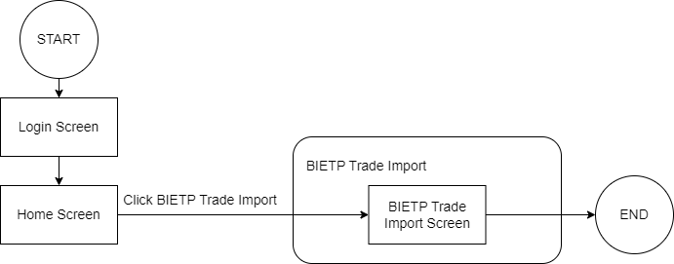

### Screen layout and field definition

|  |  |  |  |  |
| --- | --- | --- | --- | --- |
| **No** | **Screen Name** | **Field** | **Type** | **Description** |
| 1 | BIETP Trade Import |  | Anchor Menu | Anchor menu which contains of BIETP Trade Import module |
| 2 | BIETP Trade Import | Input Folder | File Chooser | User may select folder that contain BI-ETP Trade File in their local machine |
| Log File | File Chooser | User may select where should FrontArena put the Log Report File in their local machine |

1. *BIETP Trade Import*

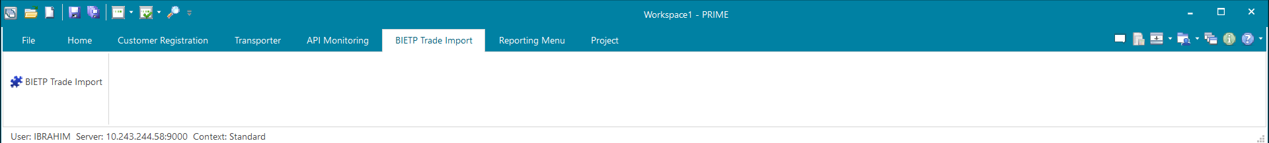

1. *BIETP Trade Import*

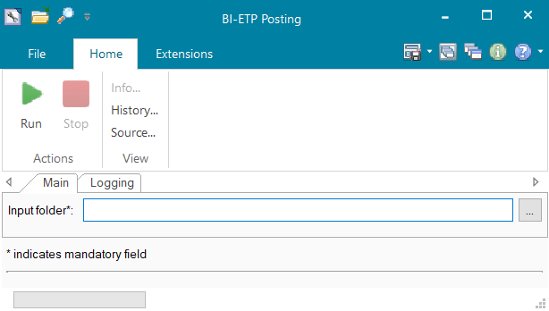

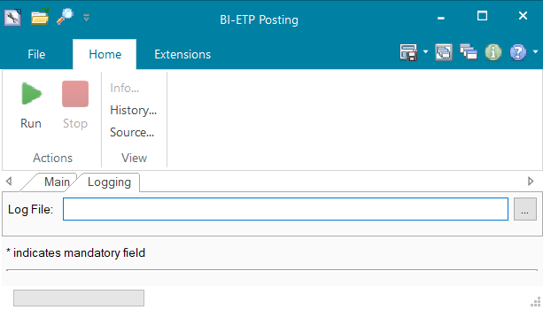

### Inventory of Forms

N.A.

### Form layout and definition

N.A.

### Interface to Database Relation

N. A

## OPERATING SPECIFICATION

*<This section describes operating specification of this module or program.*

*Operating specification:*

* *Operating Type: Dialog/Batch*
* *Operating Time: Day/Night*
* *Operating Frequency: Ad hoc/Daily/ Weekly/Monthly/Yearly>*

## REPORTING

### 9.1 Inventory of Reports

|  |  |  |
| --- | --- | --- |
| **No** | **Report Name** | **Description** |
| 1 | BI ETP Log Report | This report generated once BIETP Trade Import process is done to inform User which BI-ETP Trade is succeed and which one if failed |

### 9.2 Report layout and definition

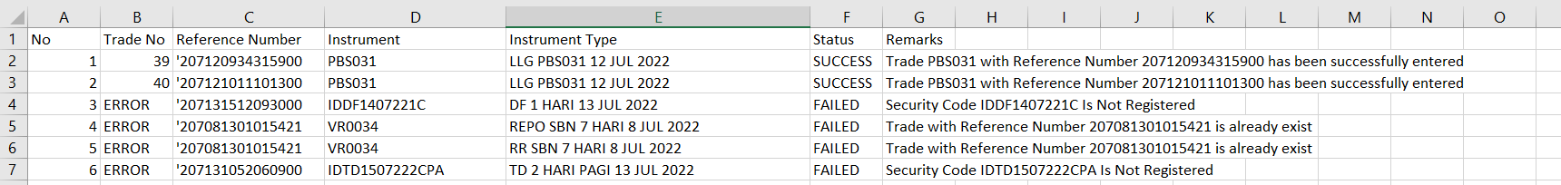

1. *BIETP Trade Import Log Report*

|  |  |  |
| --- | --- | --- |
| No | Field | Description |
| 1 | No | Number |
| 2 | Trade No | Trade Number in the Front Arena |
| 3 | Reference Number | BI-ETP Transaction Number |
| 4 | Instrument | BI-ETP Security Code and Front Arena Instrument |
| 5 | Instrument Type | BI-ETP Auction Code |
| 6 | Status | Result status of the import trade |
| 7 | Remarks | The explanation of the results |

## Communication

### N/A

## API SPECIFICATIONS

## APPENDIX

# BLOOMBERG

## Bloomberg – Market data

### DESCRIPTION

|  |  |  |  |
| --- | --- | --- | --- |
| Interface name | Bloomberg – Market Data | | |
| Type of data | Bond Definition Prices - Bond prices,  Yield Curve Interest Volatility Ratings - PEFINDO, FITCH, S&P, MOODY'S, FITCH INDO | Frequency | Batch |
| Source | Bloomberg | Direction | IN |
| Format | File | Transfer mechanism | SFTP |
| Response Required | N/A | Dependencies on other processes | N/A |
| Purpose | Market data from Bloomberg | | |

Front Arena component Bloomberg data loader is installed and configured to get mentioned data in batch mode.

### TECHNICAL ATTRIBUTE

|  |  |
| --- | --- |
| **Attribute** | **Description** |
| Extension Module | DataLoader  DataLoader_Bloomberg  DataLoader_Custom |
| AMBA | AMBA_DATALOADER |
| ATS | ATS_DATALOADER |

### TECHNICAL ARCHITECTURE

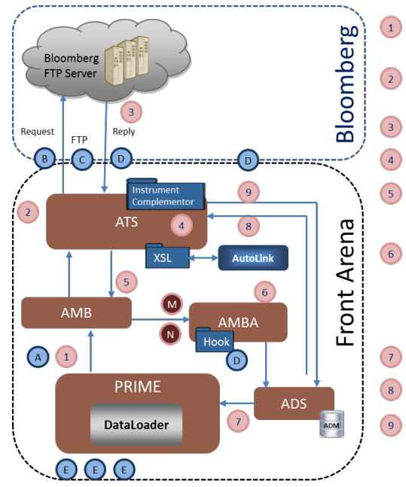

### TECHNICAL FLOW DIAGRAM

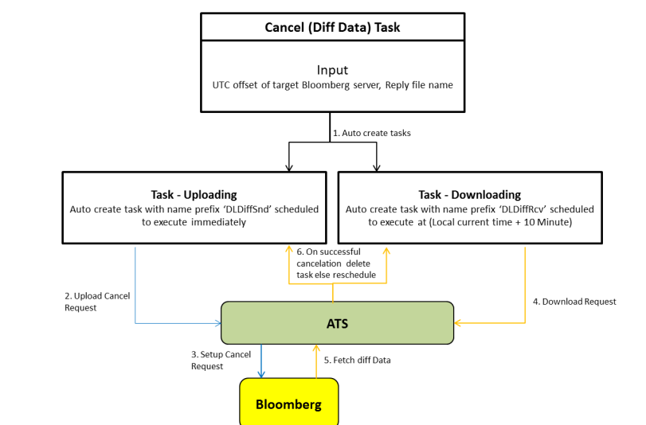

### LOGIC AND CONFIGURATION

#### Flow Logic

1. Front Arena standard component Bloomberg Data Loader is installed and configured to get the data mentioned in DESCRIPTION.
2. BOND price will be captured from following resources:
   * 1. BGN
     2. EXCH
     3. BVAL
     4. IBPA
3. There will be one user connection to get prices from sources BGN, BVAL, EXCH and IBPA.

#### Configuration

Front Arena standard component installation and configuration.

Bloomberg Market data:

**Reference**

* FCA4503 DataLoader User Guide
* FCA499 Data Loader System Admin

|  |  |
| --- | --- |
| Delivery Items | |
| Extension Context | +Dataloader |
| Extension Module | DataLoader  DataLoader_Bloomberg  DataLoader_Custom |
| AMBA service | AMBA_DATALOADER |
| ATS Service | ATS_DATALOADER |
| AMB Service |  |
| FA Component | |
| AMBA | AMBA_DATALOADER |
|  |  |
|  |  |
| Deployment and Manual Configuration | |
| This service is deployed through FA standard deployment process.  Manual configuration may be required to update the configuration in FParameter in extension module. | |
|  |  |
| Additional Information | |
| CALC_TYP_DES | AdditionalInfo on Instrument |
| CURVE_ID | AdditionalInfo on YieldCurve |
|  |  |
| FParameters | |
| FDLConfigAMBSettings | |
| FDLConfigFileSettings | |
| FDLConfigFTPSettings | |
| FDLConfigOpenFIGISettings | |
| FDLConfigSystemSettings | |
| Pre-requisites |  |
| AMBA service | AMBA service for this interface must be running to work this interface. |
| ATS service | ATS service for this interface must be running to work this interface. |

#### Data Dictionary

NA

#### A Data Model

Please refer AEF Browser document for details about Front Arena Data Model.

Document - FCA4033

#### B Data Entity and Key Elements Definition

All required details are available in AEF Browser document.

#### C Reference Code Table Definition

Please refer AEF Browser document for details about Front Arena Data Model.

Document - FCA4033

### SECURITY AND CONTROL DESIGN

#### Security Requirement Response

|  |  |  |
| --- | --- | --- |
| **Security Domain** | **Security Requirement** | **Response** |
| User Management | The system must identify users using a unique user identification code before allowing a log-on. | It will be controlled through CDCA application |
| The system must suspend access to a user session after a specified interval of inactivity. | Inactivity of user session will not be applicable  as the integration is in Realtime |
| The system must require user authentication before re-enabling the session. | It will be controlled through CDCA application |
| The system must display a warning message indicating that only authorized use is permitted before allowing users to perform a log-on. | It will be controlled through CDCA application |
| The system must display system information to a user, only after a successful log-on. |  |
| After a successful log-on, the system must display information concerning the previous successful attempt to perform a log-on. | It will not be possible in real-time connections. |
| The system must allow a user account to be manually disabled. | NA |
| The system must disable the user account following 3 (three) consecutive failures to perform a successful log-on. | It will be controlled through CDCA application |
| The system must automatically disable the user account following a configurable period (90 days) without use. |  |
| Password Management | The system must authenticate users using a password before allowing access to any system functions. | Not applicable at Front Arena Database side. |
| The system must ensure that passwords used by system users for log-on consist of at least 8 (eight) characters. | Not applicable at Front Arena Database side. |
| The system must enforce the use of complex passwords for all users. (Aplhanumieric & Special Characters) | Not applicable at Front Arena Database side. |
| The system must use cryptographic techniques to protect the confidentiality of user authentication data during transmission. | Not applicable at Front Arena Database side. |
| The system must enforce a password change when a password is first issued or re-issued. |  |
| The system must allow system users to change the password used for log-on. | Not applicable at Front Arena Database side. |
| The system must ensure that passwords do not remain valid for more than 90 (ninety) days. | Not applicable at Front Arena Database side. |
| The system must ensure that passwords may not be changed to any of the last 5 (five) passwords used. | Not applicable at Front Arena Database side. |
| The system must ensure that passwords are not displayed in clear text during entry. | Not applicable at Front Arena Database side. |
| Multi Factor Authentication | The system must enforce dual factor authentication of all users (system that related to financial, faced to customer directly & only use for external purposes) | Not applicable at Front Arena Database side. |
| Data Storage | The system must use cryptographic techniques to protect the storage of authentication data. | NA |
| The system must use cryptographic techniques to protect the integrity of stored critical data. | NA |
| The system must use cryptographic techniques to protect the confidentiality of stored sensitive data. | NA |
| Logging | The system must support the recording of security events in one or multiple specific security event logs. 2 weeks in minimum must be available at the Production Environment | It will be controlled through CDCA application |
| The system must include the Logical Account identity, event type and timestamp in each entry in the security event logs. | It will be controlled through CDCA application |
| The system must record when each security event lo fills to a configurable limit. | It will be controlled through CDCA application |
| The system must protect the integrity of the information in the security event logs | It will be controlled through CDCA application |
| The system must allow access to the security event logs to be limited to the authorised security staff. | It will be controlled through CDCA application |
| The system must record if the integrity of the security event logs is compromised | NA |
| The system must record all instances that system event logs are cleared. | It will be controlled through CDCA application |
| The system must record when a change is made to the system log settings (e.g. logs for certain events are turned off). | It will be controlled through CDCA application |
| The system must record when any system security policy is modified. | NA |
| The system must record all creations of Logical Accounts. | It will be controlled through CDCA application |
| The system must record all deletions of Logical Accounts. |  |
| The system must record all de-activation of Logical Accounts. |  |
| The system must record all unsuccessful attempts to log-on to the system using invalid credentials. |  |
| The system must record all successful attempts to log-on to the system. |  |
| The system must record all successful and unsuccessful attempts to change passwords. |  |
| The system must automatically build and maintain a normal usage pattern for each Logical Account. |  |
| The system must record all activation of disabled Logical Accounts. |  |
| The system must record all attempts to change any account attribute affecting authentication of the Logical Account |  |
| The system must record all allocations of system access rights. |  |
| The system must record all removals of system access rights. |  |
| The system must record all unauthorised attempts to access a system function. |  |
| The system must record when a configurable deviation from a Logical Account's normal pattern is detected. |  |
| The system must record all failures of the check on the timestamp of payment and settlement orders. |  |
| The system must record all attempts to mutually authenticate interface connections that handle critical data |  |
| The system must record all events that may indicate an attempt to cause denial of service. |  |
| The system must record all access to functions processing critical information within the system. |  |
| The system must record all access to sensitive information within the system. |  |
| The system must record all start-up and shut down events. |  |
| The system must have been integrated in the SIEM, Identity Management System & Privilege Identity Management System |  |
| Remote Access | The system logical access control mechanism must be able to discretely grant remote access capability to specific users and user groups. |  |
| The system must strictly limit user access rights to their minimum requirements when they access the system remotely. |  |
| All relevant approvals must be obtained if this application is to be made available for remote use (E.g. on the RCA-portal) by Users |  |
| System Interfaces | The system must use a logical access control mechanism to control system to system data communications, in order to avoid anonymous data transfers (for all interfaces) |  |
| The system must ensure that system to system mutual authentication takes place before data communications are allowed (for all interfaces) |  |
| System to system mutual authentication must be based on cryptographic techniques (for all interfaces) |  |
| The system must use cryptographic techniques to protect the integrity of critical data during transmission (for all interfaces) |  |
| The system must use cryptographic techniques to protect the confidentiality of sensitive data during transmission (for all interfaces) |  |
| All 'critical data' must have been identified, documented and approved by the Business |  |
| All 'confidential data' must have been identified, documented and approved by the Business |  |
| Availability | The system must have a documented and successfully tested disaster recovery plan in place | It will be managed through Front Arena Database DR setup. |
| The system must enforce quotas limiting the maximum resources that an individual user can use simultaneously. |  |
| The system must provide adequate resources to support the required number of users or concurrent users. |  |
| The system should have a documented capacity monitoring process in-place with regular reporting on its use |  |
| Security Testing | The system must be tested for specific technical security flaws where it faces the public internet, prior to release into production. |  |
| The system must only be released into production, where it faces the public internet, once all identified key findings from the security test have been rectified, or if this is not possible, the risks must be formally reviewed and signed off |  |
| The system must be tested for specific technical security flaws prior to release into production. |  |
| The system must only be released into production once all the identified key findings from the security tests have been rectified or if this is not possible, the risks must be formally reviewed and signed off |  |

#### Preventive controls

*<This sub-section describe the technical specification for preventive controls that are specific to this module. This includes logical access control, physical security control, encryption, PIN generation and validation, etc>*

*<Sample of list of Role Table and Authorization Matrix>*

|  |  |  |  |
| --- | --- | --- | --- |
| **No** | **Role** | **Authorization** | **Object** |
| 1 | Role1 | ZXXXX | Maintain |
| 2 | Role2 | ZYYYY | Display |
| 3 |  |  |  |

|  |  |  |  |  |  |  |
| --- | --- | --- | --- | --- | --- | --- |
| **No** | **User Group** | **Role1** | **Role2** | **Role3** | **Role4** | **Role5** |
| 1 | User Group1 | X | X |  | X |  |
| 2 | User Group2 |  | X | X |  | X |
|  |  |  |  |  |  |  |

#### Detective controls

*<This sub-section describe the technical specification for detective controls that are specific to this module. This includes audit trail, exception reports, reconciliation, balancing & control totals, validations, etc>.*

#### Corrective controls

*<This sub-section describes the technical specification for corrective controls that are specific to this module. This includes automated error corrections, backup, recovery & restart, etc>.*

### USER INTERFACE

If required, the user can trigger the process, by using the various task GUis

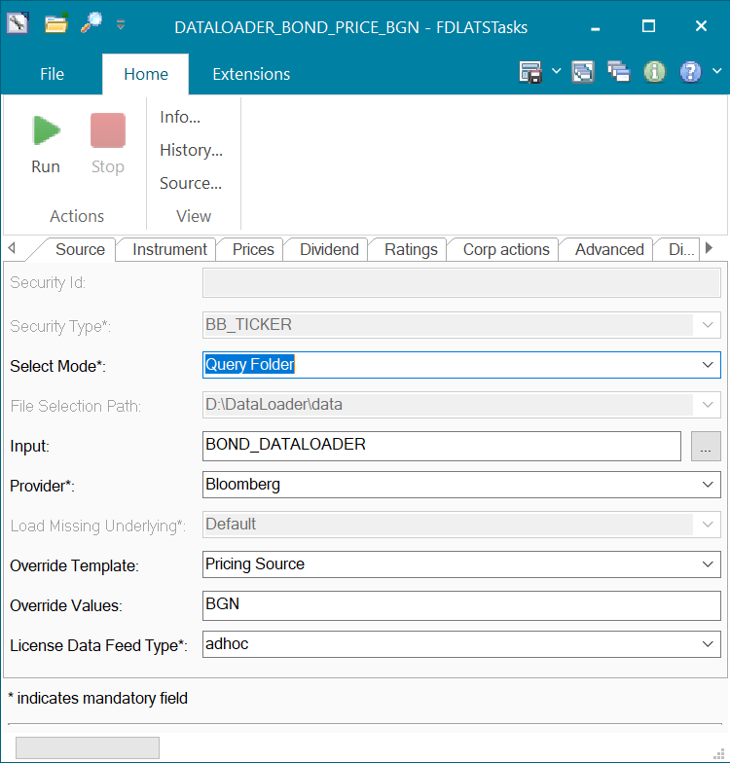

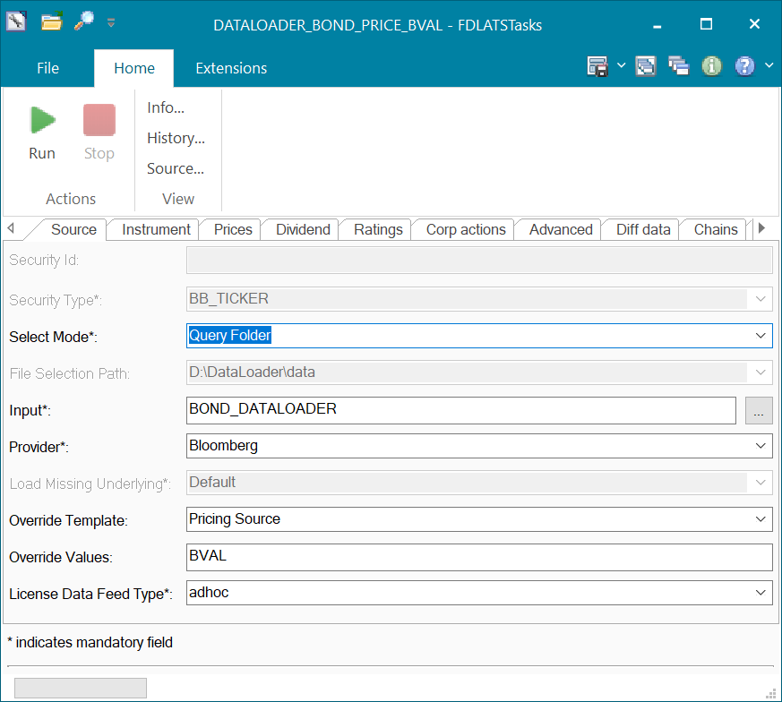

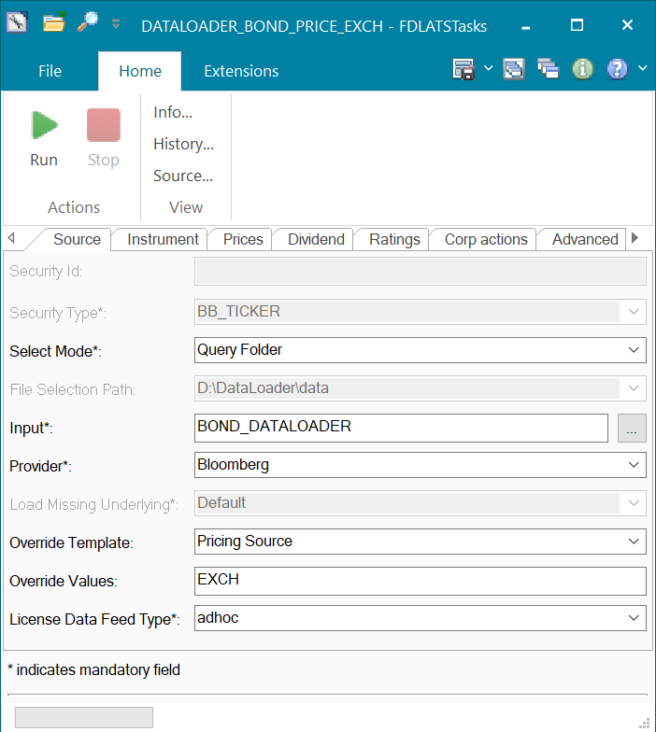

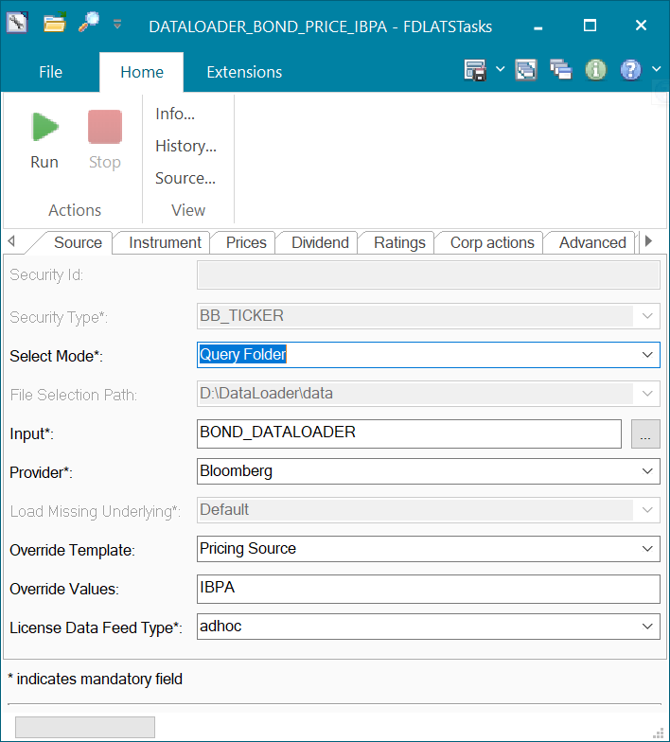

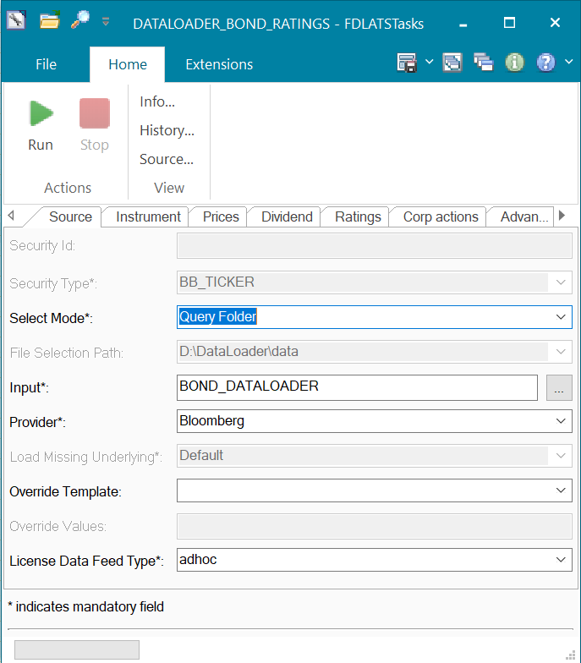

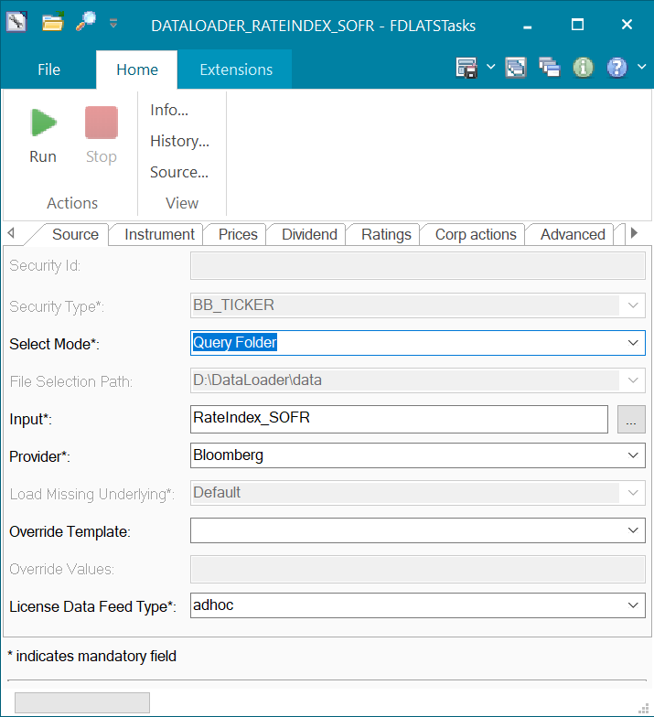

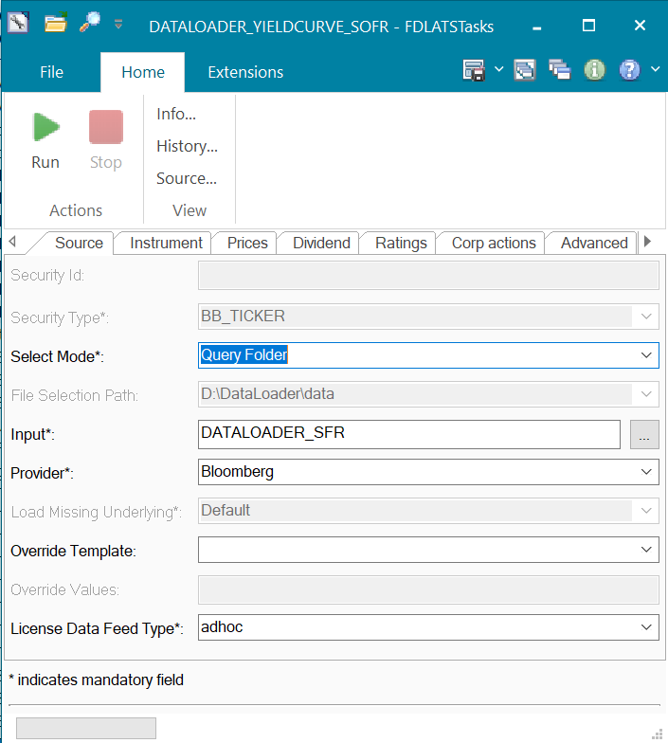

### OPERATING SPECIFICATION

Front Arena’s standard component Data Loader will be installed and configured for this market data operations.

Specification details are part for standard configuration process specified in respective FCA document.

Additional logic required for Bond prices from different sources will be managed through standard configuration.

Following additional information will be used.





## Bloomberg – Dealing System

### DESCRIPTION

|  |  |  |  |
| --- | --- | --- | --- |
| **Interface name** | Bloomberg – Dealing System | | |
| **Type of data** | Trades | **Frequency** | Realtime |
| **Source** | Bloomberg | **Direction** | IN |
| **Format** | FIX | **Transfer mechanism** | BBG FIX |
| **Response Required** | N/A | **Dependencies on other processes** | AFG-AMB with customization |
| **Purpose** | All trades from the Bloomberg Dealing System need to be captured in Front Arena | | |

Note – Please Note that this interface is still under discussion and FIS is still waiting for inputs from Bank Mandiri. Please expect some changes on this section with the progress on Interface.

### TECHNICAL ATTRIBUTE

|  |  |
| --- | --- |
| **Attribute** | **Description** |
| AFG_AMB | Fetch FIX messages from FIX provider |
| BBG VCON-FIT | MAP-VCON Prepack |
| BBG-FXGO | FXGO Prepack |

### TECHNICAL ARCHITECTURE

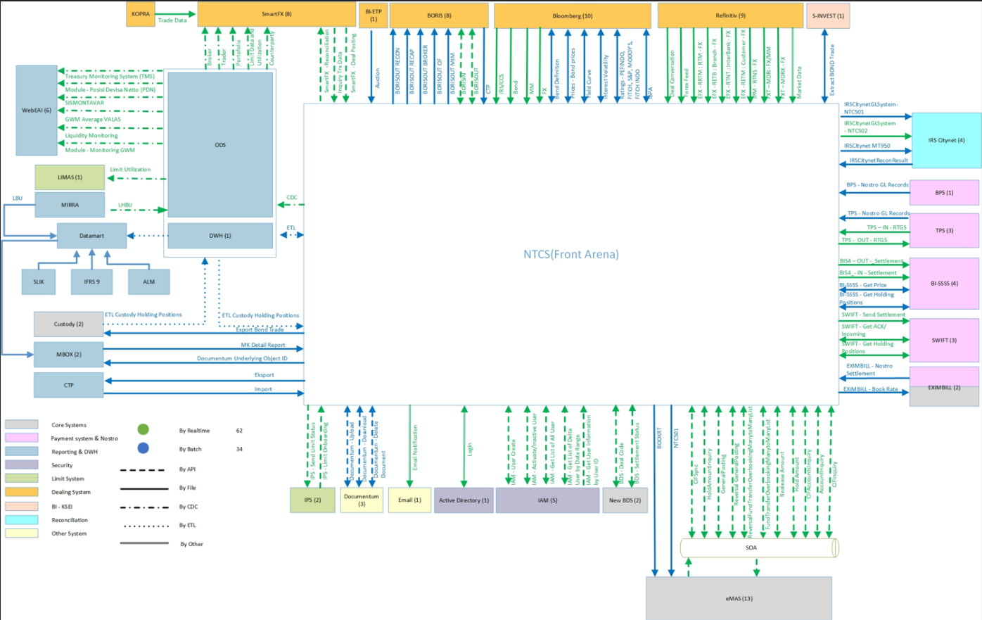

**Architecture - Bloomberg Connectivity**

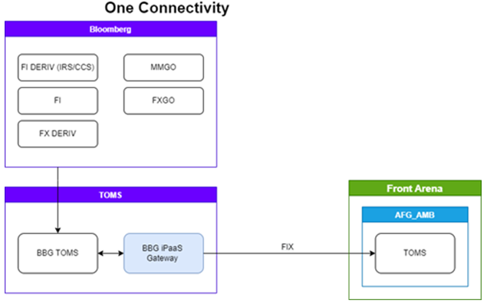

### TECHNICAL FLOW DIAGRAM

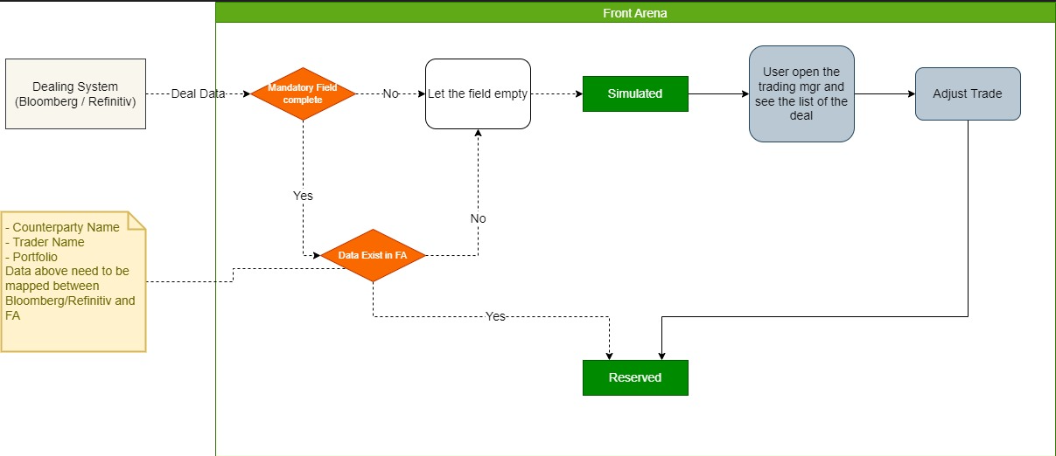

### LOGIC AND CONFIGURATION

#### Flow Logic

It is Front Arena standard component integration. More details are available in FCA document specified in respective sections.

* Incoming trade messages will be processed in Front Arena and the following fields mapped:
  + 1. Counterparty – Based on dealing code setup in FA party. Please refer FCA 1452
    2. Trader – Based on principal mapping
    3. Portfolio – Received from Bloomberg in FIX tag with same name as FA portfolio
    4. Trade status – Refer technical flow diagram
    5. External ID – Reference number from Bloomberg stored in this field
    6. Optional Key2 – Source will be stored as ‘Bloomberg’.

#### Configuration

|  |  |
| --- | --- |
| FA Component | |
| AFG_AMB | Fetch FIX messages from FIX provider |
|  |  |
| Deployment and Manual Configuration | |
| The task is deployed through FA standard deployment process.  Manual configuration may be required to update the configuration in FParameter and task GUI in extension module. | |
|  |  |

Please refer installation guide for configuration details



#### Data Dictionary

N/A

#### A Data Model

Please refer AEF Browser document for details about Front Arena Data Model.

Document - FCA4033

#### B Data Entity and Key Elements Definition

All required details are available in AEF Browser document.

#### C Reference Code Table Definition

Please refer AEF Browser document for details about Front Arena Data Model.

Document - FCA4033

### SECURITY AND CONTROL DESIGN

#### Security Requirement Response

|  |  |  |
| --- | --- | --- |
| **Security Domain** | **Security Requirement** | **Response** |
| User Management | The system must identify users using a unique user identification code before allowing a log-on. | It will be controlled through CDCA application |
| The system must suspend access to a user session after a specified interval of inactivity. | Inactivity of user session will not be applicable  as the integration is in Realtime |
| The system must require user authentication before re-enabling the session. | It will be controlled through CDCA application |
| The system must display a warning message indicating that only authorized use is permitted before allowing users to perform a log-on. | It will be controlled through CDCA application |
| The system must display system information to a user, only after a successful log-on. |  |
| After a successful log-on, the system must display information concerning the previous successful attempt to perform a log-on. | It will not be possible in real-time connections. |
| The system must allow a user account to be manually disabled. | NA |
| The system must disable the user account following 3 (three) consecutive failures to perform a successful log-on. | It will be controlled through CDCA application |
| The system must automatically disable the user account following a configurable period (90 days) without use. |  |
| Password Management | The system must authenticate users using a password before allowing access to any system functions. | Not applicable at Front Arena Database side. |
| The system must ensure that passwords used by system users for log-on consist of at least 8 (eight) characters. | Not applicable at Front Arena Database side. |
| The system must enforce the use of complex passwords for all users. (Aplhanumieric & Special Characters) | Not applicable at Front Arena Database side. |
| The system must use cryptographic techniques to protect the confidentiality of user authentication data during transmission. | Not applicable at Front Arena Database side. |
| The system must enforce a password change when a password is first issued or re-issued. |  |
| The system must allow system users to change the password used for log-on. | Not applicable at Front Arena Database side. |
| The system must ensure that passwords do not remain valid for more than 90 (ninety) days. | Not applicable at Front Arena Database side. |
| The system must ensure that passwords may not be changed to any of the last 5 (five) passwords used. | Not applicable at Front Arena Database side. |
| The system must ensure that passwords are not displayed in clear text during entry. | Not applicable at Front Arena Database side. |
| Multi Factor Authentication | The system must enforce dual factor authentication of all users (system that related to financial, faced to customer directly & only use for external purposes) | Not applicable at Front Arena Database side. |
| Data Storage | The system must use cryptographic techniques to protect the storage of authentication data. | NA |
| The system must use cryptographic techniques to protect the integrity of stored critical data. | NA |
| The system must use cryptographic techniques to protect the confidentiality of stored sensitive data. | NA |
| Logging | The system must support the recording of security events in one or multiple specific security event logs. 2 weeks in minimum must be available at the Production Environment | It will be controlled through CDCA application |
| The system must include the Logical Account identity, event type and timestamp in each entry in the security event logs. | It will be controlled through CDCA application |
| The system must record when each security event lo fills to a configurable limit. | It will be controlled through CDCA application |
| The system must protect the integrity of the information in the security event logs | It will be controlled through CDCA application |
| The system must allow access to the security event logs to be limited to the authorised security staff. | It will be controlled through CDCA application |
| The system must record if the integrity of the security event logs is compromised | NA |
| The system must record all instances that system event logs are cleared. | It will be controlled through CDCA application |
| The system must record when a change is made to the system log settings (e.g. logs for certain events are turned off). | It will be controlled through CDCA application |
| The system must record when any system security policy is modified. | NA |
| The system must record all creations of Logical Accounts. | It will be controlled through CDCA application |
| The system must record all deletions of Logical Accounts. |  |
| The system must record all de-activation of Logical Accounts. |  |
| The system must record all unsuccessful attempts to log-on to the system using invalid credentials. |  |
| The system must record all successful attempts to log-on to the system. |  |
| The system must record all successful and unsuccessful attempts to change passwords. |  |
| The system must automatically build and maintain a normal usage pattern for each Logical Account. |  |
| The system must record all activation of disabled Logical Accounts. |  |
| The system must record all attempts to change any account attribute affecting authentication of the Logical Account |  |
| The system must record all allocations of system access rights. |  |
| The system must record all removals of system access rights. |  |
| The system must record all unauthorised attempts to access a system function. |  |
| The system must record when a configurable deviation from a Logical Account's normal pattern is detected. |  |
| The system must record all failures of the check on the timestamp of payment and settlement orders. |  |
| The system must record all attempts to mutually authenticate interface connections that handle critical data |  |
| The system must record all events that may indicate an attempt to cause denial of service. |  |
| The system must record all access to functions processing critical information within the system. |  |
| The system must record all access to sensitive information within the system. |  |
| The system must record all start-up and shut down events. |  |
| The system must have been integrated in the SIEM, Identity Management System & Privilege Identity Management System |  |
| Remote Access | The system logical access control mechanism must be able to discretely grant remote access capability to specific users and user groups. |  |
| The system must strictly limit user access rights to their minimum requirements when they access the system remotely. |  |
| All relevant approvals must be obtained if this application is to be made available for remote use (E.g. on the RCA-portal) by Users |  |
| System Interfaces | The system must use a logical access control mechanism to control system to system data communications, in order to avoid anonymous data transfers (for all interfaces) |  |
| The system must ensure that system to system mutual authentication takes place before data communications are allowed (for all interfaces) |  |
| System to system mutual authentication must be based on cryptographic techniques (for all interfaces) |  |
| The system must use cryptographic techniques to protect the integrity of critical data during transmission (for all interfaces) |  |
| The system must use cryptographic techniques to protect the confidentiality of sensitive data during transmission (for all interfaces) |  |
| All 'critical data' must have been identified, documented and approved by the Business |  |
| All 'confidential data' must have been identified, documented and approved by the Business |  |
| Availability | The system must have a documented and successfully tested disaster recovery plan in place | It will be managed through Front Arena Database DR setup. |
| The system must enforce quotas limiting the maximum resources that an individual user can use simultaneously. |  |
| The system must provide adequate resources to support the required number of users or concurrent users. |  |
| The system should have a documented capacity monitoring process in-place with regular reporting on its use |  |
| Security Testing | The system must be tested for specific technical security flaws where it faces the public internet, prior to release into production. |  |
| The system must only be released into production, where it faces the public internet, once all identified key findings from the security test have been rectified, or if this is not possible, the risks must be formally reviewed and signed off |  |
| The system must be tested for specific technical security flaws prior to release into production. |  |
| The system must only be released into production once all the identified key findings from the security tests have been rectified or if this is not possible, the risks must be formally reviewed and signed off |  |

#### Preventive controls

*<This sub-section describe the technical specification for preventive controls that are specific to this module. This includes logical access control, physical security control, encryption, PIN generation and validation, etc>*

*<Sample of list of Role Table and Authorization Matrix>*

|  |  |  |  |
| --- | --- | --- | --- |
| **No** | **Role** | **Authorization** | **Object** |
| 1 | Role1 | ZXXXX | Maintain |
| 2 | Role2 | ZYYYY | Display |
| 3 |  |  |  |

|  |  |  |  |  |  |  |
| --- | --- | --- | --- | --- | --- | --- |
| **No** | **User Group** | **Role1** | **Role2** | **Role3** | **Role4** | **Role5** |
| 1 | User Group1 | X | X |  | X |  |
| 2 | User Group2 |  | X | X |  | X |
|  |  |  |  |  |  |  |

#### Detective controls

*<This sub-section describe the technical specification for detective controls that are specific to this module. This includes audit trail, exception reports, reconciliation, balancing & control totals, validations, etc>.*

#### Corrective controls

*<This sub-section describe the technical specification for corrective controls that are specific to this module. This includes automated error corrections, backup, recovery & restart, etc>.*

### USER INTERFACE

N/A

### OPERATING SPECIFICATION

Operations for this service will be automatic and real-time. Front Arena standard component will be installed and configured to communicate with Bloomberg’s iPaaS Gateway to receive deals in FIX message format.

## Communication

*<This section provides the communication line that will be used in this system>*

### New / Existing*) system *) choose one

|  |  |  |  |  |  |  |  |  |  |
| --- | --- | --- | --- | --- | --- | --- | --- | --- | --- |
| **NO** | **NEW / SURROUNDING SYSTEM** | **HOSTNAME SOURCE** | **IP SOURCE** | **PORT SOURCE** | **HOSTNAME DESTINATION** | **IP DESTINATION** | **PORT DESTINATION** | **PROTOCOL (TCP /UDP /ICMP)** | **ALLOW / DENY** |
| 1 | *<new / surrounding status>* | *<isi nama host source>* | *<isi IP source>* | *<isi port source>* | *<isi nama host destination>* | *<isi IP destination>* | *<isi port destination>* | *<isi protocol>* | *<allow / deny status>* |
| 2 |  |  |  |  |  |  |  |  |  |
| 3 |  |  |  |  |  |  |  |  |  |
| 4 |  |  |  |  |  |  |  |  |  |
| 5 |  |  |  |  |  |  |  |  |  |
| 6 |  |  |  |  |  |  |  |  |  |
| 7 |  |  |  |  |  |  |  |  |  |
| 8 |  |  |  |  |  |  |  |  |  |
| … |  | … | … | … | … | … |  | … | … |

*< For a new developed system, if there are some undefined hostnames/ ip addresses/ ports yet, then should be written with* ***TBC*** *notes and will be completely defined in SDN contract review form >*

*< For an existing system and surrounding, please define and write its hostnames/ ip addresses/ ports >*

## OTHERS

*<This section provides other technical specifications that have not been address in previous section>.*

# BORIS

## 1. DESCRIPTION

BORIS is Trading Systems from where Bond Transaction need to be captured in FA. Bond transactions captured in FA should follow FA trade workflow and Backoffice flow.

BORIS will initiate request to create Bond transaction in FA. BORIS will use FA published web API to send request. Upon request, trades will be created in FA. FA will send acknowledgement status to BORIS after creating trades. Acknowledgement message contains status and status description.

Outstanding Bond transactions from Front Arena will be sent to BORIS system.

All CIF/ Party and Broker details available in FA need to send to BORIS for the transactions happening in BORIS.

CIF number received from core banking need to send through CIF information to BORIS. Task will be created to extract party information and send to BORIS. Execution time of each task run will be stored so that for next run, task can check parties updated since last execution time and collection party information for those parties.

All Bond transactions (including received from different sources and manually created) need to send to BORIS for Reconciliation and Recap purpose.

BORIS sends CTP number for transactions, that number need to store at Trade level.

## 2. TECHNICAL ATTRIBUTE

This section provides the technical attributes and characteristic of designed module.

|  |  |
| --- | --- |
| **Attribute** | **Description** |
| Program/Module Name | Front Arena |
| Program/Module Title | Arena Extension Framework |
| Program Type | Executable, Interface, Conversion |
| Transaction Code |  |
| Development Status | New |
| Application | BORIS |
| Application Component refer to Block Application Architecture | Arena Data Server, Arena Data Model, Arena Task Server |

## 3. TECHNICAL ARCHITECTURE



|  |  |  |
| --- | --- | --- |
| No. | Component | Description |
| 1. | PRIME | Desktop application, a client to which contains most of the business logic of the system. |
| 2. | AEF | Arena Extension Framework: Extend existing module, create new module. |
| 3. | ADS | Arena Data Server: Core of the FrontArena System |
| 4. | AMBA | Arena Message Broker Adapter: Adapter between AMB and ADS |
| 5. | AMB | Arena Message Broker: FrontArena Middleware layer |
| 6. | ATS | Arena Task Server: Scheduler related and publishing API |
| 7. | APH | Arena Price Handler: Retrieve Refinitiv Market Data |
| 8. | ADM | Arena Data Model |
| 9. | AFG | Arena FIX Gateway: Communication with Bloomberg FIX Protocol |
| 10. | ATCI-RD | Arena Trade Capture Interface for Refinitiv Dealing |

## TECHNICAL FLOW DIAGRAM

### BOND TRANACTIONS – IN

|  |  |  |  |
| --- | --- | --- | --- |
| Interface - Treasury Bond System - BORIS | | | |
| Interface name | BORIS - IN | | |
| Type of data | Trades- Bond | Frequency | Realtime |
| Source | BORIS | Direction | IN |
| Format | JSON | Transfer mechanism | Web API |
| Response Required | Return status from WebAPI | Dependencies on other processes | NA |
| Purpose | Trades in treasury system. Boris in treasury Bond system and it is required to capture Bond transactions from that system in real-time | | |

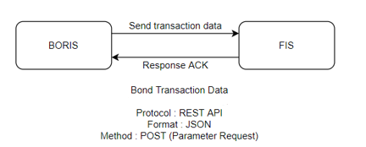

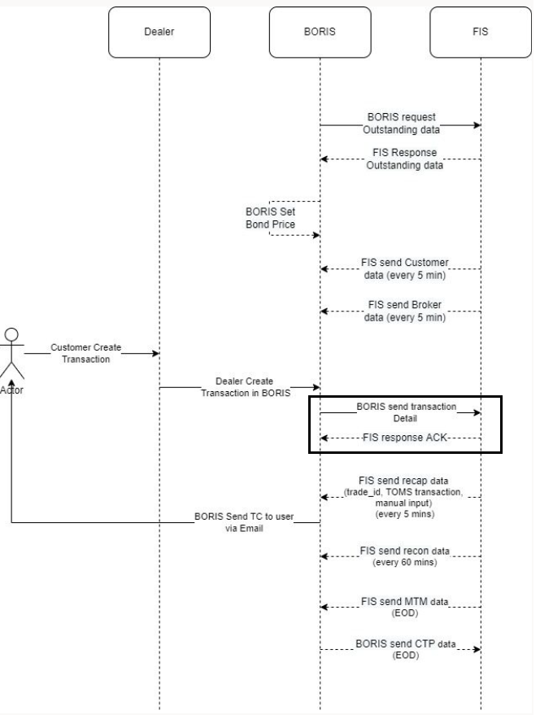

Following is technical flow for this service.

1. ATS service is running to host the WebService required for this interface.
2. BORIS system calls the Web API to send Transaction details.
3. WebAPI call the interface program to read the incoming transaction details in JSON format.
4. FA trades are created based on details received from BORIS system.
5. WebAPI function returns the status based on the transactions created in FA.

### BOND TRANACTIONS – OUT

|  |  |  |  |
| --- | --- | --- | --- |
| Interface - Treasury Bond System – BORIS OUT | | | |
| Interface name | BORISOUT | | |
| Type of data | Trades- Bond | Frequency | Realtime |
| Source | FA | Direction | OUT |
| Format | JSON | Transfer mechanism | Web API |
| Response Required | NA | Dependencies on other processes | NA |
| Purpose | Bond outstanding transaction need to send to Treasury Bond system (BORIS). | | |

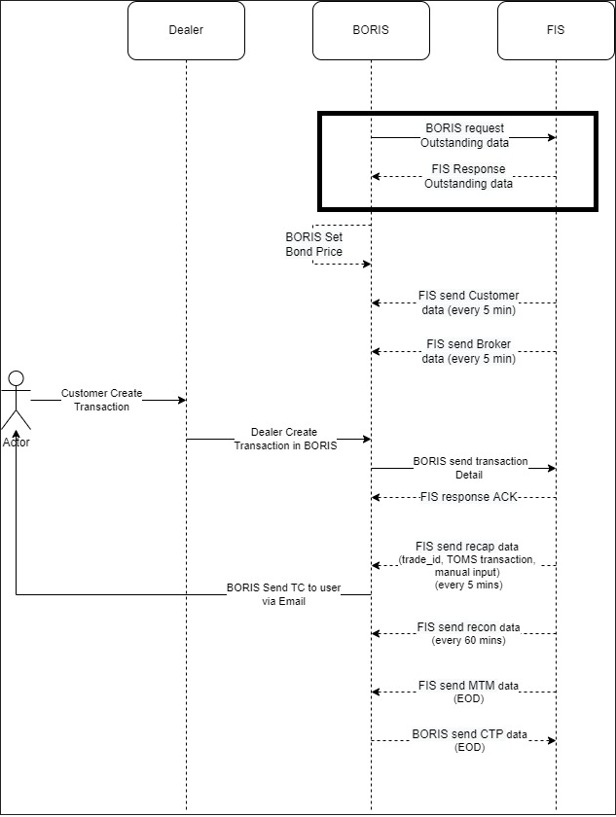

Following is the technical flow for this service-

This service ger triggered by BORIS system. It sends inquiry request to Front Arena web service.

1. In this service, ATS service is running to host web service to receive the request from BORIS.
2. BORIS system calls this service’s Web API to request for Bond transactions.
3. Upon calling the API function, it collects outstanding Bond trades in Front Arena
4. Transforms trades details in required JSON format and reply to the API call.

### MTM PRICE

|  |  |  |  |
| --- | --- | --- | --- |
| Interface - Treasury Bond System – BORIS OUT Mark to Market Prices | | | |
| Interface name | BORISOUT MtM | | |
| Type of data | Mark to Market Prices | Frequency | Batch |
| Source | FA | Direction | OUT |
| Format | File | Transfer mechanism | Shared location |
| Response Required | NA | Dependencies on other processes | NA |
| Purpose | Mark to Market Prices of Bond instrument need to send to Treasury Bond system (BORIS). | | |

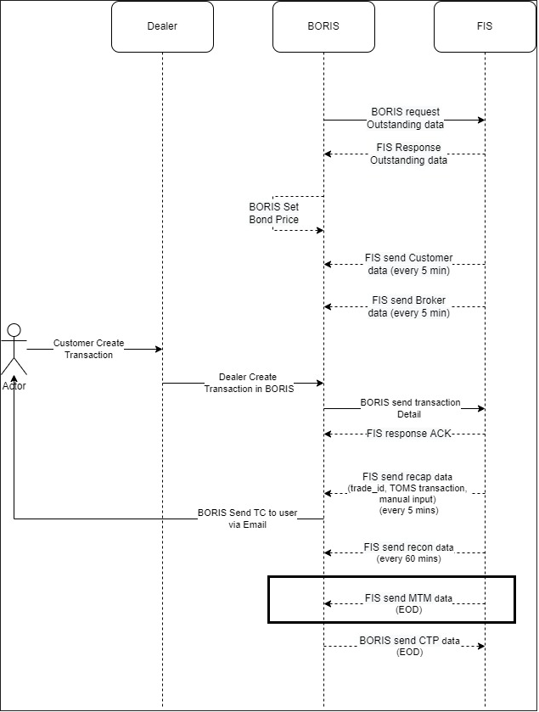

Following is the technical workflow –

This service runs as part of End Of Day process.

1. Front Arena Task is created to execute this service.
2. This Task takes following parameters -
   1. Query Folder – this is Bond selection criteria to consider Bond Instruments
   2. MtM Market – This is FA market from which prices are fetched for selected instruments.
   3. Output Folder Path – Path where output file is generated.
   4. Logging - details for logging mechanism
3. This task directly writes the output file to the shared location.
4. This task can be scheduled or arranged in task dependency structure.
5. Also, this task can be grouped in EOD group so that EOD ATS can trigger this task as per schedule or Dependency level.
6. Separate log file is used to workflow logging and can be used for monitoring purpose.

NOTE:

Shared location must be accessible from the server where ATS service is running.

### CIF

|  |  |  |  |
| --- | --- | --- | --- |
| **Interface - Treasury Bond System – BORIS OUT CIF** | | | |
| **Interface name** | BORISOUT CIF | | |
| **Type of data** | CIF – party information | **Frequency** | Batch |
| **Source** | FA | **Direction** | OUT |
| **Format** | File | **Transfer mechanism** | Shared location |
| **Response Required** | NA | **Dependencies on other processes** | NA |
| **Purpose** | CIF information need to send to Treasury Bond system (BORIS). | | |

Following is the technical workflow –

This service runs as part of End Of Day process.

1. Front Arena Task is created to execute this service.
2. This Task takes following parameters -
   1. Query Folder – this is Counterparty selection criteria to consider parties.
   2. Output Folder Path – Path where output file is generated.
   3. Logging - details for logging mechanism
3. This task directly writes the output file to the shared location.
4. This task can be scheduled or arranged in task dependency structure.
5. Also, this task can be grouped in EOD group so that EOD ATS can trigger this task as per schedule or Dependency level.
6. Separate log file is used to workflow logging and can be used for monitoring purpose.

NOTE:

Shared location must be accessible from the server where ATS service is running.

### BROKER

|  |  |  |  |
| --- | --- | --- | --- |
| Interface - Treasury Bond System – BORIS OUT BROKER | | | |
| Interface name | BORISOUT BROKER | | |
| Type of data | Broker – party information | Frequency | Batch |
| Source | FA | Direction | OUT |
| Format | File | Transfer mechanism | Shared location |
| Response Required | NA | Dependencies on other processes | NA |
| Purpose | Broker information need to send to Treasury Bond system (BORIS). | | |

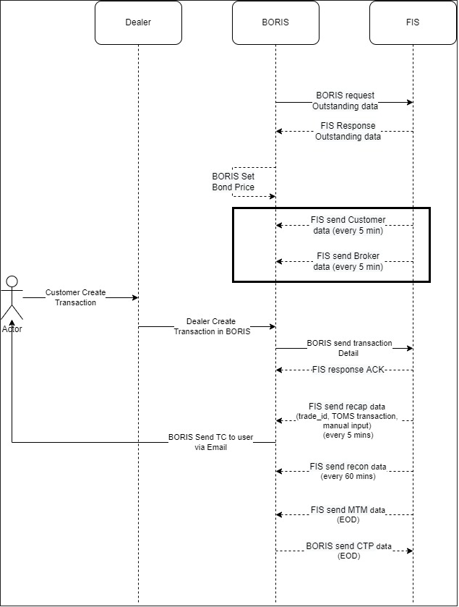

Following is the technical workflow –

This service runs as part of End Of Day process.

1. Front Arena Task is created to execute this service.
2. This Task takes following parameters -
   1. Query Folder – this is Broker party selection criteria to consider parties.
   2. Output Folder Path – Path where output file is generated.
   3. Logging - details for logging mechanism
3. This task directly writes the output file to the shared location.
4. This task can be scheduled or arranged in task dependency structure.
5. Also, this task can be grouped in EOD group so that EOD ATS can trigger this task as per schedule or Dependency level.
6. Separate log file is used to workflow logging and can be used for monitoring purpose.

NOTE:

Shared location must be accessible from the server where ATS service is running.

### RECAP DATA

|  |  |  |  |
| --- | --- | --- | --- |
| Interface - Treasury Bond System – BORIS OUT Recap Data | | | |
| Interface name | BORISOUT RECAP | | |
| Type of data | Recap Data | Frequency | Batch |
| Source | FA | Direction | OUT |
| Format | File | Transfer mechanism | Shared location |
| Response Required | NA | Dependencies on other processes | NA |
| Purpose | Bond Trade information need to send to Treasury Bond system (BORIS). | | |

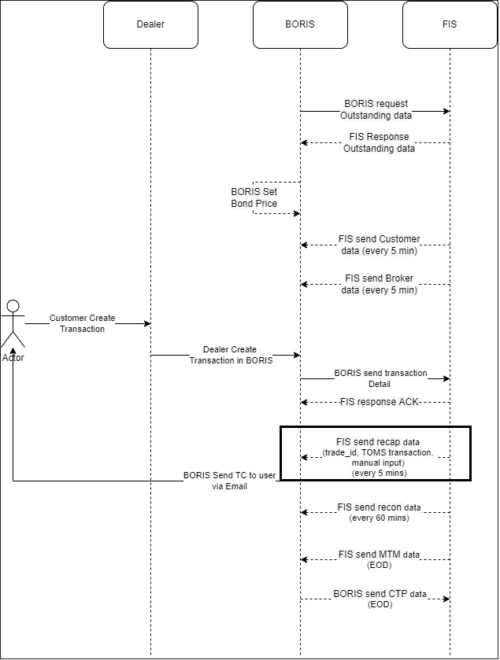

Following is the technical workflow –

This service runs as part of End Of Day process.

1. Front Arena Task is created to execute this service.
2. This Task takes following parameters -
   1. Query Folder – this is Bond trade selection criteria to consider required set of trades.
   2. Output Folder Path – Path where output file is generated.
   3. Logging - details for logging mechanism
3. This task directly writes the output file to the shared location.
4. This task can be scheduled or arranged in task dependency structure.
5. Also, this task can be grouped in EOD group so that EOD ATS can trigger this task as per schedule or Dependency level.
6. Separate log file is used to workflow logging and can be used for monitoring purpose.

NOTE:

Shared location must be accessible from the server where ATS service is running.

### RECON DATA

|  |  |  |  |
| --- | --- | --- | --- |
| Interface - Treasury Bond System – BORIS OUT Recon Data | | | |
| Interface name | BORISOUT RECON | | |
| Type of data | Recon Data | Frequency | Batch |
| Source | FA | Direction | OUT |
| Format | File | Transfer mechanism | Shared location |
| Response Required | NA | Dependencies on other processes | NA |
| Purpose | Bond trade information need to send to Treasury Bond system (BORIS). | | |

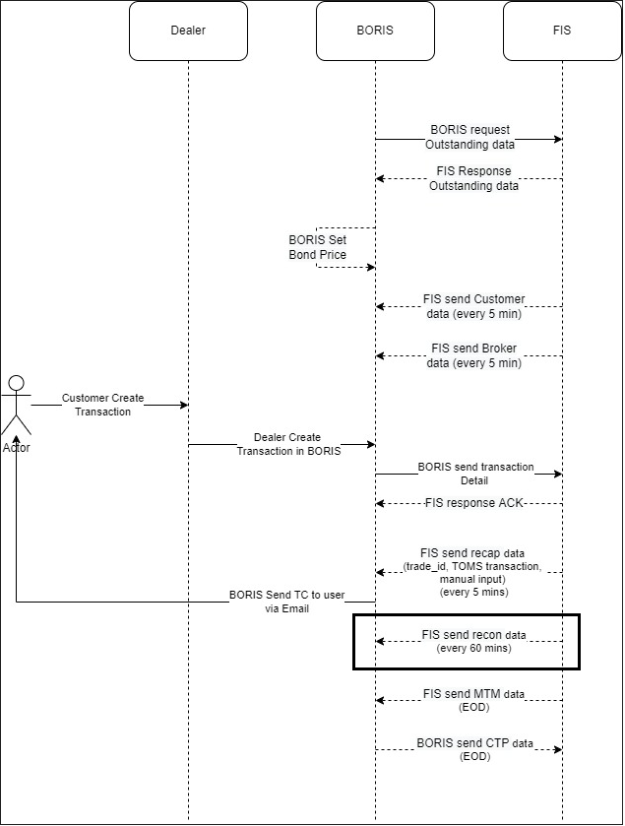

Following is the technical workflow –

This service runs as part of End Of Day process.

1. Front Arena Task is created to execute this service.
2. This Task takes following parameters -
   1. Query Folder – this is Bond trade selection criteria to consider required set of trades.
   2. Output Folder Path – Path where output file is generated.
   3. Logging - details for logging mechanism
3. This task directly writes the output file to the shared location.
4. This task can be scheduled or arranged in task dependency structure.
5. Also, this task can be grouped in EOD group so that EOD ATS can trigger this task as per schedule or Dependency level.
6. Separate log file is used to workflow logging and can be used for monitoring purpose.

NOTE:

Shared location must be accessible from the server where ATS service is running.

### CTP

|  |  |  |  |
| --- | --- | --- | --- |
| Interface - BORIS IN CTP | | | |
| Interface name | BORIS IN CTP | | |
| Type of data | CTP information | Frequency | Batch |
| Source | BORIS | Direction | IN |
| Format | File | Transfer mechanism | Shared location |
| Response Required |  | Dependencies on other processes |  |

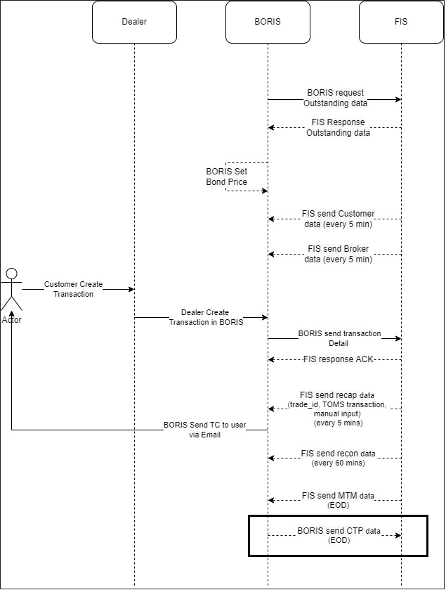

Following is the technical workflow –

This service runs as part of End Of Day process.

1. Front Arena Task is created to execute this service.
2. This Task takes following parameters -
   1. Input Folder Path – Path where input file is available.
   2. Logging - details for logging mechanism
3. This task reads input file from given location.
4. It reads records from file to get trade as per identifier mentioned in that file.
5. Once the trade is identified then it stores CTP number on that trade in Additional information field.
6. This task can be scheduled or arranged in task dependency structure.
7. Also, this task can be grouped in EOD group so that EOD ATS can trigger this task as per schedule or Dependency level.
8. Separate log file is used to workflow logging and can be used for monitoring purpose.

NOTE:

Shared location must be accessible from the server where ATS service is running.

## LOGIC AND CONFIGURATION

## BOND TRANSACTION – IN

### Flow Logic

1. Webservice for this service is hosted through the dedicated ATS service.
2. Once the ATS service is started in running, webserver is running to receive any request message from source.
3. There is Extension module mapped in ATS configuration to run that ATS in module mode.
4. The extension module contains the code to route the request from Web URL to python function.
5. Function program receives request and parse it to extract information to create trade in Front Arena.
6. Some details which cannot map to FA trades, are stored in the form of additional information. Details are available in configuration section.
7. In case of any trade creation failure, response with error status is send through web API response.

### Configuration

|  |  |
| --- | --- |
| Delivery Items | |
| Extension Context | +Integration |
| Extension Module | PS_BorisIn |
| ATS service | ATS_BORIS_IN |
|  |  |
|  |  |
| FA Component | |
| ATS | ATS service - ATS_BORIS_IN is used to host the web service required for this interface. |
| Web URL | <https://<serverName>:8082/borisin> |
| Service URL | /borisin |
| Deployment and Manual Configuration | |
| This service is deployed through FA standard deployment process.  Manual configuration may require to check the Certificate and Key files specified in FParameter in extension module. | |
|  |  |
| Additional Information |  |
| CostCenter | To store cost center information on trade |
| DealNotes | Notes text |
| BR | Branch code |
| StandingInstruction | Standing Instruction |
| InvestmentType | Investment type |
| AcquisitionPrice | Acquisition Price |
|  |  |
| FParameters |  |
| CertificateFile | Provided by Bank Mandiri |
| KeyFile | Provided by Bank Mandiri |
| ServerPort | 8082 |
| DummyBondName | DummyBorisBond |
|  |  |
| Pre-requisites |  |
| Dummy Bond Instrument | In case the Bond Instrument for incoming trades is not available then Dummy bond is used to assign the Instrument to that trade.  All such trades can be monitored using Query folders in Trading Manager. |
| Additional information fields | Above mentioned additional information field must be available to update details on Trade level |
| ATS service | ATS service for this interface must be running to work this interface. |
| Flask module | This module is used to host the RESTful webservice. This module is third party module. It is deployed through standard deployment package. No need to install it manually. |
| Choice List | Interface name must be present in choice list- Interface.  This choice is mapped to Trades OptKey2. To store Inteface name at trade level. |

**Additional Information Fields**

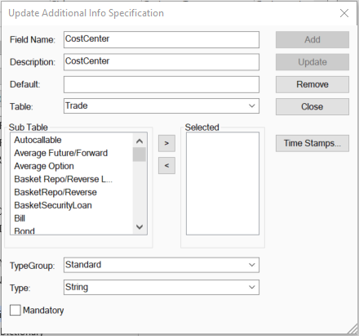

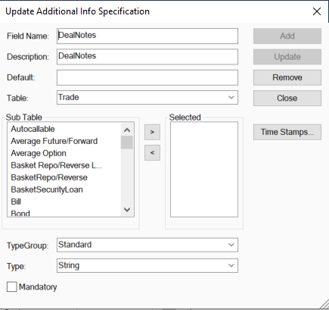

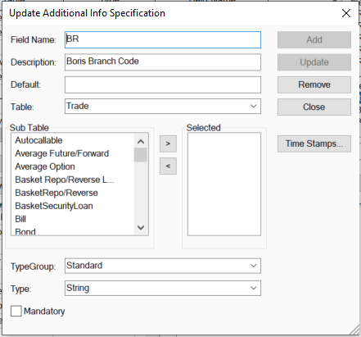

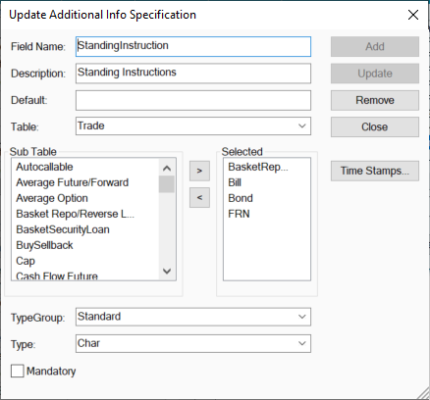

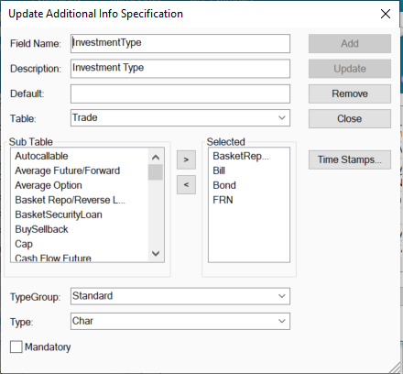

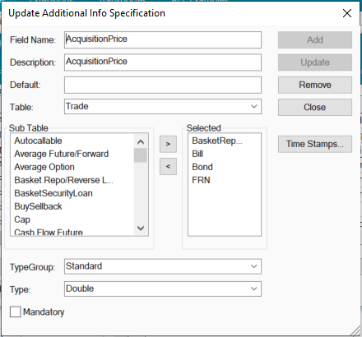

**Choice List**

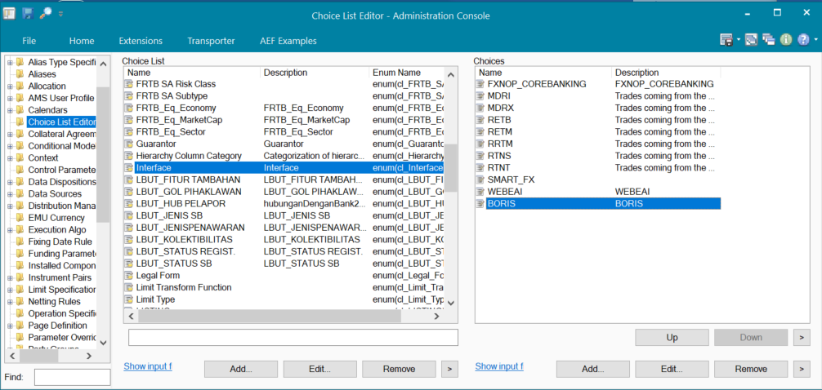

### Data Dictionary

Please refer Appendix 3 - Interface Data Format in the Phase 1B PDR, for more details about fields description

Document - BORIS x FIS.xlsx

### A Data Model

Following Front Arena table are used to store trade details.

Trade

Instrument

Party

User

Portfolio

AdditonalInformation

Following are field mapping done for this interface.

|  |  |
| --- | --- |
| Parameter Name | Description |
| BR | Branch Code |
| FEDEALNO | Front End Deal Number |
| SEQ | Sequence Number |
| CNO | CIF |
| SECSACCT | Safekeeping Account |
| PS | Purchase/Sale Indicator |
| INVTYPE | Investment Type |
| PORT | Portfolio |
| TRAD | Trader |
| SECID | Security Identifier |
| ISINCODE | ISIN Code |
| ORIGQTY | Original Quantity |
| PRICE_8 | Price |
| SETTDATE | Settlement Date |
| COST | Cost Center |
| DEALDATE | Deal Date |
| DEALTIME | Deal Time |
| DEALTEXT | Deal Text |
| VERIND | Verify Indicator |
| STANDINSTR | Standing Instructions |
| SETTCCY | Settlement Currency |
| BROKER | Broker |
| DEALNOTES | Deal Notes |
| TAX | Tax (Nominal) |
| TOTALTAX | Total Tax |
| NETPROCEED | Net Proceed |
| ACQPRICE | Harga saat beli/Acq Price |
| TAXPERCENTAGE | Tax (percentage) |
| ACQDATE | Tanggal beli/Acq Date |
| CUSTODIAN | Custodian |

|  |  |
| --- | --- |
| Additional Mapping | |
| Product Type | It is mapped to Trades OptKey3. This value is taken from Instrument product type field. |
| Category | It is mapped to Trades OptKey4. This value is taken from Instrument Category field. |
| Interface Name | Interface is mapped to trades’ optkey2 field to identify the source of that trade. |

### B Data Entity and Key Elements Definition

All required details are available in AEF Browser document. For Data field mapping please refer Data Model

### C Reference Code Table Definition

Table code references for the tables are available in AEF Browser and ADM data model document.

FCA - 4033

## BOND TRANACTIONS – OUT

### Flow Logic

Following is the logic workflow for this interface service.

1. BORIS system send inquiry request to Front Arena using Web API hosted through ATS service.
2. Upon web API call, program extract Bond trades information based on already defined Query folder and trades updated on that day before the time specified.
3. Extracted trades data is transformed into BORIS specific JSON format and responds through the WebAPI call return.
4. In case of an error in this process, Web API returns Internal Server Error status and description.

### Configuration

|  |  |
| --- | --- |
| Delivery Items | |
| Extension Context | +Integration |
| Extension Module | PS_BorisOut |
| ATS service | ATS_BORIS_OUT |
|  |  |
|  |  |
| FA Component | |
| ATS | ATS service - ATS_BORIS_OUT is used to host the web service required for this interface. |
| Web URL | <https://<serverName>:8083/borisout> |
| Service URL | /borisout |
| Deployment and Manual Configuration | |
| This service is deployed through FA standard deployment process.  Manual configuration may require to check the Certificate and Key files specified in FParameter in extension module. | |
|  |  |
| Additional Information | |
| No Additional information field is used in this service. | |
|  |  |
| FParameters |  |
| CertificateFile | Provided by Bank Mandiri |
| KeyFile | Provided by Bank Mandiri |
| ServerPort | 8083 |
| TransactionFilter | BorisBondTransactionFilter  This is query folder used to extract trades. |
| CaptureTradesUntil | 16:00:00  This parameter is used to extract trades which are updated before CaptureTradesUntil mentioned. |
| Pre-requisites |  |
| Query Folder | Query folder with name specified in Parameters, must be available, so that program can extract trades through that query folder. |
| ATS service | ATS service for this interface must be running to work this interface. |
| Flask module | This module is used to host the RESTful webservice. This module is third party module. It is deployed through standard deployment package. No need to install it manually. |

### Data Dictionary

Please refer Appendix 3 - Interface Data Format in the Phase 1B PDR, for more details about fields description

Document - BORIS x FIS.xlsx

### A Data Model

Following field are extracted from FA trade as per mapping specified in below table.

|  |  |
| --- | --- |
| Parameter Name | Description |
| SECID | Seri surat berharga |
| NOMINALSB | Nominal surat berharga |
| AVARAGECOST | Avarage cost |
| PORT | Portofolio |
| LAST_UPDATED | Last Updated |

### B Data Entity and Key Elements Definition

|  |  |
| --- | --- |
| Parameter Name | Description |
| SECID | Instrument Name from Trade |
| NOMINALSB | Trade Nominal Amount |
| AVARAGECOST | Trade Price |
| PORT | Portfolio |
| LAST_UPDATED | Last Updated time of that trade |

### C Reference Code Table Definition

Please refer AEF Browser document for details about Front Arena Data Model.

Document - FCA4033

## MTM PRICE

### Flow Logic

1. Front Arena Task created for this service.
2. Query folder mentioned in task parameter is used to extract all required Bond Instruments
3. For each instrument selected the price fetched from the MtM market specified in Task parameter.
4. MtM Prices are extracted for that Instrument for given Front Arena market and for the date as report date (i.e. Task execution date).
5. Settle price from Price table is considered for this functionality.
6. Extracted data then transformed into BORIS specific format.
7. Formatted data written in output file at specified location in Task parameter.

### Configuration

|  |  |
| --- | --- |
| Delivery Items | |
| Extension Context | +Integration |
| Extension Module | PS_BorisOutMTMData |
| Query Folder | MTMDataCreateUpdate |
|  |  |
| FA Component | |
| ATS | This task will be executed as per of EOD process, so no separate ATS service required for this task.  This task can be grouped with EOD tasks and common EOD ATS service handles execution of this task. |
|  |  |
|  |  |
| Deployment and Manual Configuration | |
| This service is deployed through FA standard deployment process. | |
|  |  |
| FParameters |  |
| mtmLogFilename | Log file name. Date timestamp will be added to this file name while generating log file. |
| mtmOutputFilename | Output file name. Date timestamp will be added to this file name while generating output file. |
| Pre-requisites |  |
| Query Folder | MTMDataCreateUpdate  Query folder mentioned in task parameter must be available to run this task. |
| MtM Market | internal  MtM Market must be provided to extract prices from. |

Task:

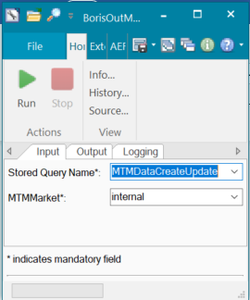

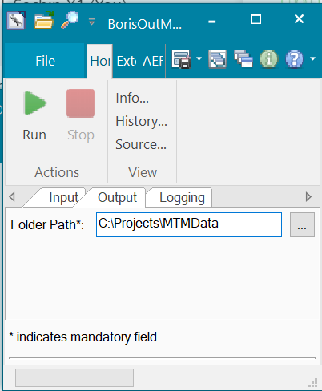

Query Folder:

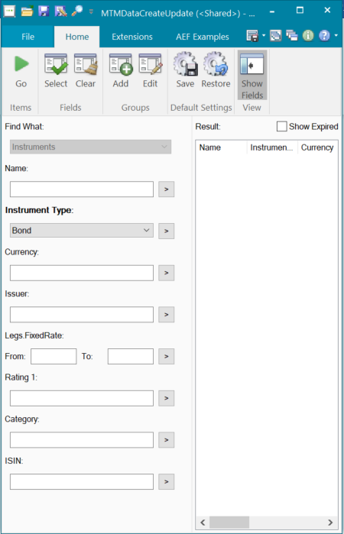

### Data Dictionary

Please refer Appendix 3 - Interface Data Format in the Phase 1B PDR, for more details about fields description

Document - BORIS x FIS.xlsx

### A Data Model

|  |  |
| --- | --- |
| Parameter Name | Description |
| ISINCODE | ISIN Code |
| SECID | Security Identifier |
| PRICE | Price |
| LAST_UPDATED | Last Updated |

### B Data Entity and Key Elements Definition

|  |  |
| --- | --- |
| Parameter Name | Description |
| ISINCODE | ISIN code is available on Instrument level |
| SECID | Selected Instrument name |
| PRICE | Price from column – Settle, |
| LAST_UPDATED | Last Updated time for that price record |

### C Reference Code Table Definition

Please refer AEF Browser document for details about Front Arena Data Model.

Document - FCA4033

## CIF

### Flow Logic

1. Front Arena Task is created to extract Customer information.
2. Here, this tasks extract information of Front Arena counterparties.
3. Query folder specified in task parameter is executed to collect all required Counterparty as per criteria specified in Query folder. Please refer configuration section for more details about party selection criteria.
4. For each Counterparty, information extracted as per specification. Please refer Data Model section for more details about party information.
5. Extracted information then written in output file.
6. Output is generated at Output folder path specified in Task parameter.
7. Log details are written in Log file specified in task parameter.

### Configuration

|  |  |
| --- | --- |
| Delivery Items | |
| Extension Context | +Integration |
| Extension Module | BM_BrokerAndCustomerData |
| Query Folder | CustomerDataToday |
|  |  |
| FA Component | |
| ATS | This task will be executed as per of EOD process, so no separate ATS service required for this task.  This task can be grouped with EOD tasks and common EOD ATS service handles execution of this task. |
|  |  |
|  |  |
| Deployment and Manual Configuration | |
| This service is deployed through FA standard deployment process. | |
|  |  |
| FParameters |  |
| customerLogFilename | BORIS_CUST_LOG_{}.txt  Log file name. Date timestamp will be added to this file name while generating log file. |
| customerOutputFilename | BORIS_CUST_DATA_{}.csv  Output file name. Date timestamp will be added to this file name while generating output file. |
| Pre-requisites | |
| Query Folder | CustomerDataToday  Query folder mentioned in task parameter must be available to run this task. |

**Task:**

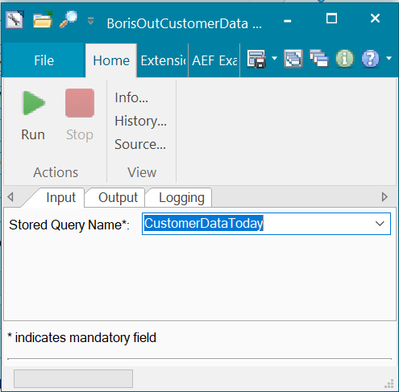

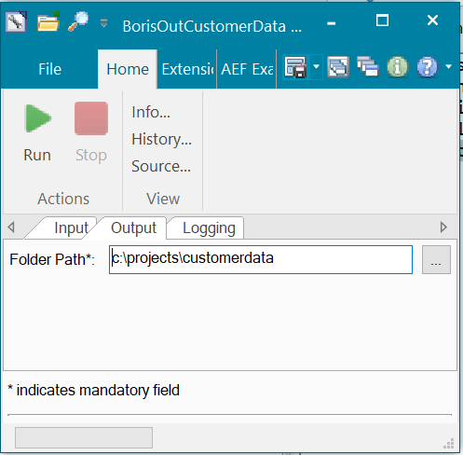

**Query Folder:**

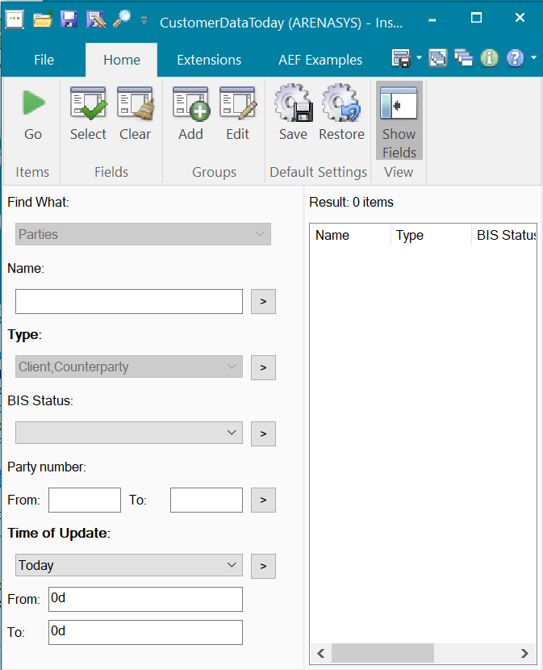

### Data Dictionary

Please refer Appendix 3 - Interface Data Format in the Phase 1B PDR, for more details about fields description

Document - BORIS x FIS.xlsx

### A Data Model

|  |  |
| --- | --- |
| Parameter Name | Description |
| CNO* | Customer Number |
| CMNE | Customer Mnemonic |
| BIC | Bank Identification Code |
| CCODE | Country Code |
| SIC | Standard Industry Code Identifier |
| SN | Short Name |
| CFN1 | Customer Full Name 1 |
| CFN2 | Customer Full Name 2 |
| CA1 | Customer Address 1 |
| CA2 | Customer Address 2 |
| CA3 | Customer Address 3 |
| CA4 | Customer Address 4 |
| CA5 | Customer Address 5 |
| CTYPE | Customer Type |
| CPOST | Customer Postal Code |
| LSTMNTDTE | Last Maintenance Date |
| UCCODE | Ultimate Risk Country Code |
| BIRTHDATE | Birth Date |
| TAXID | Taxpayer Identifier |
| ACCTNGTYPE | Accounting Type |
| TAXAPPLY | Tax Apply |
| LAST_UPDATED | Last Updated |

### B Data Entity and Key Elements Definition

|  |  |
| --- | --- |
| Parameter Name | Description |
| CNO* | This is Host ID field on counterparty |
| CMNE | Alias field on Party |
| BIC | SWIFT code on Party |
| CCODE | Country Code on Party |
| SIC | Ignore. Option field. |
| SN | Party Name |
| CFN1 | Party Full Name 1 |
| CFN2 | Party Full Name 2 |
| CA1 | Party Address 1 |
| CA2 | BLANK |
| CA3 | Party Address 2 |
| CA4 | BLANK |
| CA5 | BLANK |
| CTYPE | BLANK |
| CPOST | Party ZipCode |
| LSTMNTDTE | Ignored |
| UCCODE | Additional Info - UCCODE |
| BIRTHDATE | Additional Info - DOB |
| TAXID | Additional Info - NPWP |
| ACCTNGTYPE | BLANK |
| TAXAPPLY | BLANK |
| LAST_UPDATED | Party Update time |

### C Reference Code Table Definition

Please refer AEF Browser document for details about Front Arena Data Model.

Document - FCA4033

## BROKER

### Flow Logic

1. Front Arena Task is created to extract Broker Party information.
2. Here, this tasks extract information of Front Arena Broker Party.
3. Query folder specified in task parameter is executed to collect all required Broker party as per criteria specified in Query folder. Please refer configuration section for more details about party selection criteria.
4. For each Broker party, information extracted as per specification. Please refer Data Model section for more details about party information.
5. Extracted information then written in output file.
6. Output is generated at Output folder path specified in Task parameter.
7. Log details are written in Log file specified in task parameter.

### Configuration

|  |  |
| --- | --- |
| Delivery Items | |
| Extension Context | +Integration |
| Extension Module | BM_BrokerAndCustomerData |
| Query Folder | BrokerCreateUpdateToday |
|  |  |
| FA Component | |
| ATS | This task will be executed as per of EOD process, so no separate ATS service required for this task.  This task can be grouped with EOD tasks and common EOD ATS service handles execution of this task. |
|  |  |
|  |  |
| Deployment and Manual Configuration | |
| This service is deployed through FA standard deployment process. | |
|  |  |
| FParameters |  |
| brokerLogFilename | BORIS_BROKER_LOG_{}.txt  Log file name. Date timestamp will be added to this file name while generating log file. |
| brokerOutputFilename | BORIS_BROKER_DATA_{}.csv  Output file name. Date timestamp will be added to this file name while generating output file. |
| Pre-requisites | |
| Query Folder | BrokerCreateUpdateToday  Query folder mentioned in task parameter must be available to run this task. |

**Task:**

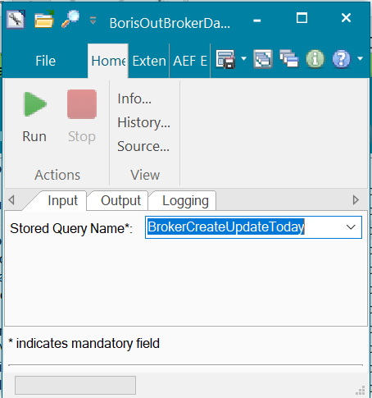

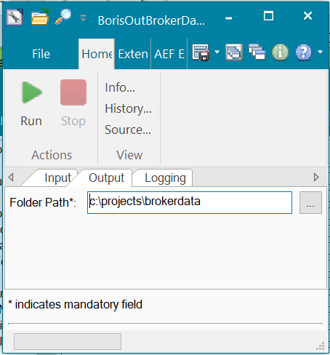

**Query Folder:**

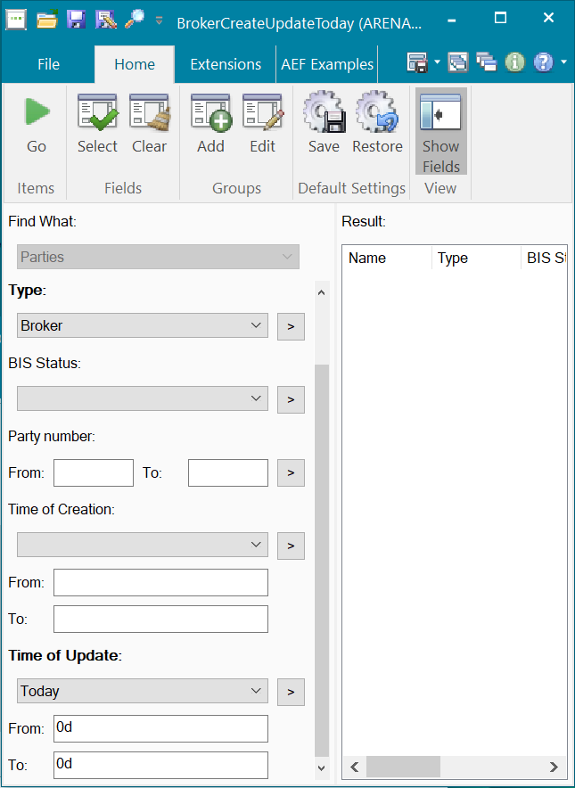

### Data Dictionary

Please refer Appendix 3 - Interface Data Format in the Phase 1B PDR, for more details about fields description

Document - BORIS x FIS.xlsx

### A Data Model

|  |  |
| --- | --- |
| Parameter Name | Description |
| BROKNO | Broker Number |
| BROKID | Broker Mnemonic |
| LAST_UPDATED | Last Updated |

### B Data Entity and Key Elements Definition

|  |  |
| --- | --- |
| Parameter Name | Description |
| BROKNO | Party ID filed |
| BROKID | Party ID2 filed |
| LAST_UPDATED | Update time on Party. |

### C Reference Code Table Definition

Please refer AEF Browser document for details about Front Arena Data Model.

Document - FCA4033

## RECAP DATA

### Flow Logic

1. Front Arena Task is created to extract Bond trades information.
2. Query folder specified in task parameter is executed to collect all required trades as per criteria specified in Query folder. Please refer configuration section for more details about trade selection criteria.
3. For each trade selected, information extracted as per specification. Please refer Data Model section for more details about party information.
4. Extracted information then written in output file.
5. Output is generated at Output folder path specified in Task parameter.
6. Log details are written in Log file specified in task parameter.

### Configuration

|  |  |
| --- | --- |
| Delivery Items | |
| Extension Context | +Integration |
| Extension Module | PS_BorisOutRecap |
| Query Folder | BorisOutRecapDataFilter |
|  |  |
| FA Component | |
| ATS | This task will be executed as per of EOD process, so no separate ATS service required for this task.  This task can be grouped with EOD tasks and common EOD ATS service handles execution of this task.  If required, the task can be added to the task group INTEGRATIONS and scheduled as per requirement. In such a case ATS_INTEGRATIONS will execute the task as per the schedule. |
|  |  |
|  |  |
| Deployment and Manual Configuration | |
| This service is deployed through FA standard deployment process. | |
|  |  |
| FParameters |  |
| recapLogFilename | BORIS_OUT_RECAP_LOG_{}.txt  Log file name. Date timestamp will be added to this file name while generating log file. |
| recapOutputFilename | BORIS_OUT_RECAP_DATA_{}.csv  Output file name. Date timestamp will be added to this file name while generating output file. |
| Pre-requisites | |
| Query Folder | BorisOutRecapDataFilter  Query folder mentioned in task parameter must be available to run this task. |

**Task:**

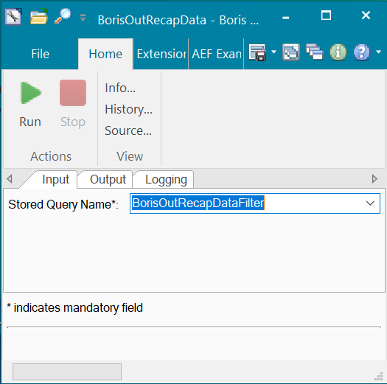

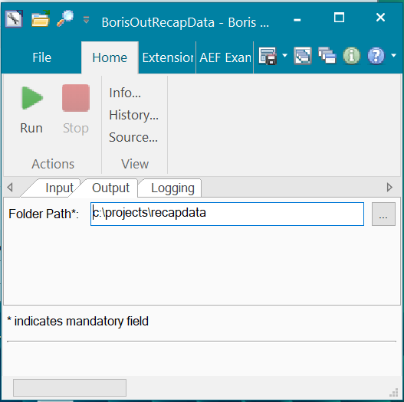

**Query Folder:**

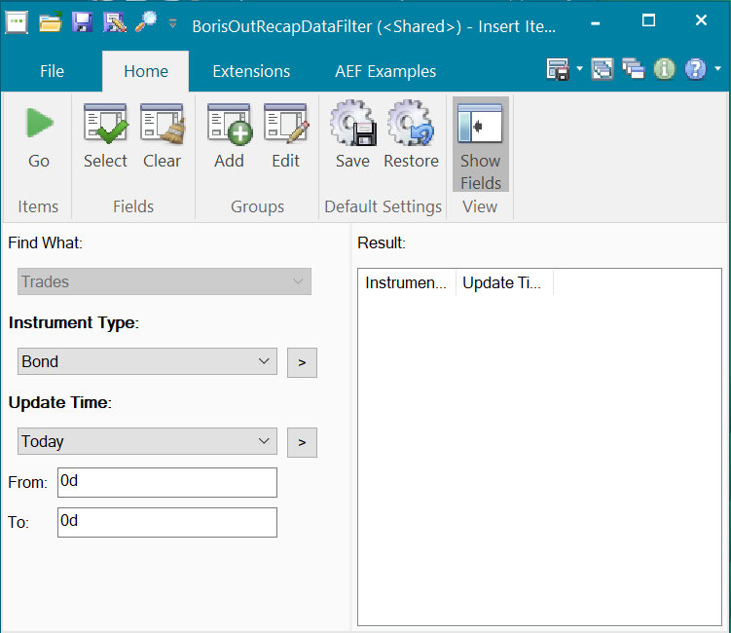

### Data Dictionary

Please refer Appendix 3 - Interface Data Format in the Phase 1B PDR, for more details about fields description

Document - BORIS x FIS.xlsx

### A Data Model

|  |  |
| --- | --- |
| Parameter Name | Description |
| FEDEALNO | Front End Deal Number/REF No |
| DEALNO | Deal No |
| BR | Branch Code |
| SEQ | Sequence Number |
| CNO | CIF |
| SECSACCT | Safekeeping Account |
| PS | Purchase/Sale Indicator |
| INVTYPE | Investment Type |
| PORT | Portfolio |
| TRAD | Trader |
| SECID | Security Identifier |
| ISINCODE | ISIN Code |
| ORIGQTY | Original Quantity |
| PRICE_8 | Price |
| SETTDATE | Settlement Date |
| COST | Cost Center |
| DEALDATE | Deal Date |
| DEALTIME | Deal Time |
| DEALTEXT | Deal Text |
| VERIND | Verify Indicator |
| STANDINSTR | Standing Instructions |
| SETTCCY | Settlement Currency |
| CMNE | Customer Mnemonic |
| LAST_UPDATED | Last Updated |

### B Data Entity and Key Elements Definition

|  |  |
| --- | --- |
| Parameter Name | Description |
| FEDEALNO | Trade Optional key. Its BORIS Unique ID for the trade received from BORIS. If trade is not from BORIS then this field is BLANK. |
| DEALNO | Front Arena trade number |
| BR | Branch Code from Trade’s additional information field. |
| SEQ | FA Trade’s version id. |
| CNO | Trade’s counterparty Alias. |
| SECSACCT | BLANK. Open for discussion |
| PS | Purchase – If trade quantity is greater than 0  Sale – if trade quantity is less than 0 |
| INVTYPE | Trade’s Additional information field - Investment Type |
| PORT | Trade’s Portfolio |
| TRAD | Trader full name |
| SECID | Trade’s Instrument name |
| ISINCODE | Trade’s Instrument ISIN code |
| ORIGQTY | Trade Quantity |
| PRICE_8 | Trade Price |
| SETTDATE | Trade Value date in YYYY-MM-DD HH:MM:SS format |
| COST | Trade’s Additional information field - Cost Center |
| DEALDATE | Trade date time in YYYY-MM-DD 12:00:00 format |
| DEALTIME | Trade date time in YYYY-MM-DD 12:00:00 format |
| DEALTEXT | Trade Text1 field value |
| VERIND | Trade Status Enumeration number |
| STANDINSTR | Trade Additional information - Standing Instructions |
| SETTCCY | Trade Currency |
| CMNE | Trade counterparty Alias |
| LAST_UPDATED | Trade update time in YYYY-MM-DD HH:MM:SS format |

### C Reference Code Table Definition

Please refer AEF Browser document for details about Front Arena Data Model.

Document - FCA4033

## RECON DATA

### Flow Logic

1. Front Arena Task is created to extract Bond trades information.
2. Query folder specified in task parameter is executed to collect all required trades as per criteria specified in Query folder. Please refer configuration section for more details about trade selection criteria.
3. In this process all trades which are received through BORIS are collected to reconciliation purpose.
4. For each trade selected, information extracted as per specification. Please refer Data Model section for more details about party information.
5. Extracted information then written in output file.
6. Output is generated at Output folder path specified in Task parameter.
7. Log details are written in Log file specified in task parameter.

### Configuration

|  |  |
| --- | --- |
| Delivery Items | |
| Extension Context | +Integration |
| Extension Module | PS_BorisOutReconData |
| Query Folder | BorisOutReconDataFilter |
|  |  |
| FA Component | |
| ATS | This task will be executed as per of EOD process, so no separate ATS service required for this task.  This task can be grouped with EOD tasks and common EOD ATS service handles execution of this task. |
|  |  |
|  |  |
| Deployment and Manual Configuration | |
| This service is deployed through FA standard deployment process. | |
|  |  |
| FParameters |  |
| reconLogFilename | BORIS_OUT_RECON_LOG_{}.txt  Log file name. Date timestamp will be added to this file name while generating log file. |
| reconOutputFilename | BORIS_OUT_RECON_DATA_{}.csv  Output file name. Date timestamp will be added to this file name while generating output file. |
| Pre-requisites | |
| Query Folder | BorisOutReconDataFilter  Query folder mentioned in task parameter must be available to run this task. |

**Task:**

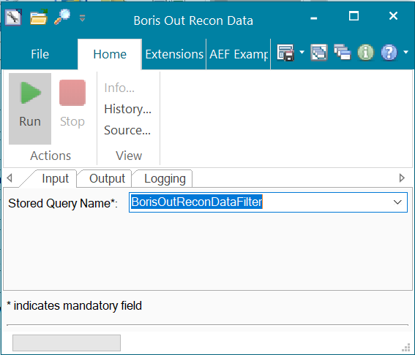

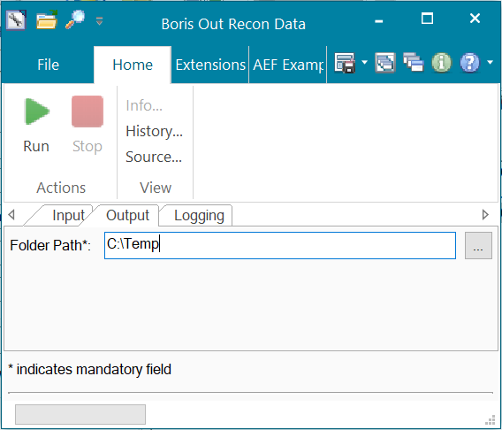

**Query Folder:**

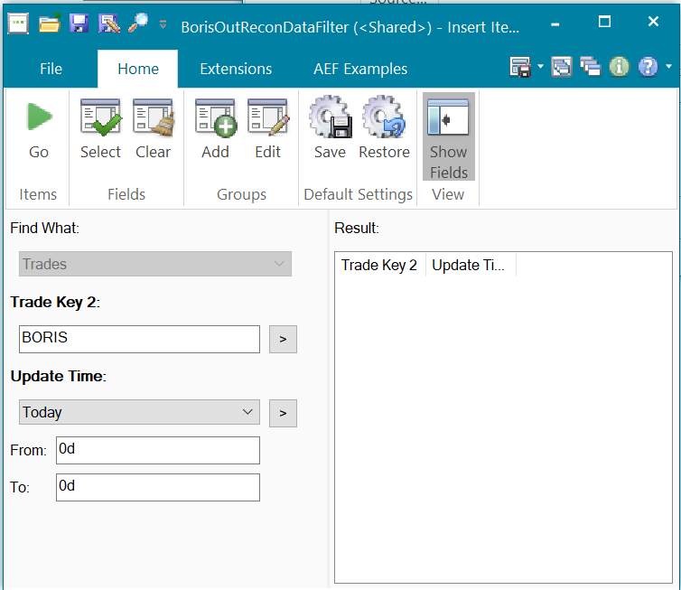

### Data Dictionary

Please refer Appendix 3 - Interface Data Format in the Phase 1B PDR, for more details about fields description

Document - BORIS x FIS.xlsx

### A Data Model

|  |  |
| --- | --- |
| Parameter Name | Description |
| DEALNO | Deal No |
| FEDEALNO | Front End Deal Number |
| BR | Branch Code |
| SEQ | Sequence Number |
| CNO | CIF |
| SECSACCT | Safekeeping Account |
| PS | Purchase/Sale Indicator |
| INVTYPE | Investment Type |
| PORT | Portfolio |
| TRAD | Trader |
| SECID | Security Identifier |
| ISINCODE | ISIN Code |
| ORIGQTY | Original Quantity |
| PRICE_8 | Price |
| SETTDATE | Settlement Date |
| COST | Cost Center |
| DEALDATE | Deal Date |
| DEALTIME | Deal Time |
| DEALTEXT | Deal Text |
| VERIND | Verify Indicator |
| STANDINSTR | Standing Instructions |
| SETTCCY | Settlement Currency |
| CTPNO | CTP No |
| SOURCE | Source |
| TAX | Tax (Nominal) |
| TOTALTAX | Total Tax |
| NETPROCEED | Net Proceed |
| CUSTODIAN | Custodian |
| ACQPRICE | Harga saat beli/Acq Price |
| TAXPERCENTAGE | Tax (percentage) |
| ACQDATE | Tanggal beli/Acq Date |
| FOINPUT | User Input FO |
| BOVERIFIED | User Verified BO |
| BOAUTHORIZED | User Authorized BO |
| BOREVERSED | User Reversed BO |
| FOREVERSED | User Reversed FO |
| VERIFIEDSTATUS | Status Verified |
| AUTHORIZEDSTATUS | Status Authorized |
| REVERSEDUNREVERSEDSTATUS | Status Reversed & Unreversed |
| LAST_UPDATED | Last Updated |

### B Data Entity and Key Elements Definition

|  |  |
| --- | --- |
| Parameter Name | Description |
| DEALNO | Front Arena Trade number |
| FEDEALNO | Trade Optional key, Unique id received from BORIS |
| BR | Trade Additional Information – Branch Code |
| SEQ | Trade version Id |
| CNO | Counterparty Host Id |
| SECSACCT | BLANK |
| PS | Purchase – If trade quantity is greater than 0  Sale – if trade quantity is less than 0 |
| INVTYPE | Trade’s Additional information field - Investment Type |
| PORT | Portfolio |
| TRAD | Trader full name |
| SECID | Trade’s Instrument name |
| ISINCODE | Trade’s Instrument ISIN code |
| ORIGQTY | Trade Quantity |
| PRICE_8 | Trade Price |
| SETTDATE | Trade Value date in YYYY-MM-DD HH:MM:SS format |
| COST | Trade’s Additional information field - Cost Center |
| DEALDATE | Trade date time in YYYY-MM-DD 12:00:00 format |
| DEALTIME | Trade date time in YYYY-MM-DD 12:00:00 format |
| DEALTEXT | Trade Text1 field value |
| VERIND | Trade Status Enumeration number |
| STANDINSTR | Trade Additional information - Standing Instructions |
| SETTCCY | Trade Currency |
| CTPNO | Trade Additional Info - CTPNumber |
| SOURCE | Trade OptKey2 |
| TAX | Additonal Payments of type TAX |
| TOTALTAX | BLANK |
| NETPROCEED | Trade Premium |
| CUSTODIAN | BLANK |
| ACQPRICE | Trade Additional Info- AcquisitionPrice |
| TAXPERCENTAGE | Text field on Trade’s Additonal Payments of type TAX |
| ACQDATE | Trade Acquirer date |
| FOINPUT | User who FO Confirmed the trade |
| BOVERIFIED | User who BO Confirmed the trade |
| BOAUTHORIZED | User who BO Confirmed the trade |
| BOREVERSED | User who Reserved the trade |
| FOREVERSED | User who Reserved the trade |
| VERIFIEDSTATUS | Trade Status |
| AUTHORIZEDSTATUS | BLANK |
| REVERSEDUNREVERSEDSTATUS | BLANK |
| LAST_UPDATED | Trade update time |

### C Reference Code Table Definition

Please refer AEF Browser document for details about Front Arena Data Model.

Document - FCA4033

## CTP

### Flow Logic

1. Front Arena Task is created to read the incoming file from BORIS.
2. Incoming file contains the Front Arena trade number and BORIS deal number.
3. Based on the Front Arena trade number, actual trade is identified.
4. If FA trade not found, then it searches based on BORIS deal number which is stored on FA trade’s OptionalKey
5. Once the trade found, the CTP number from incoming file is set on Trade’s additional information field – CTPNumber
6. Once the file processing is completed, then that file moved to Archive folder. Archive folder path provided as Task’s parameter.
7. Log details are written in Log file specified in task parameter.

### Configuration

|  |  |
| --- | --- |
| Delivery Items | |
| Extension Context | +Integration |
| Extension Module | PS_BorisInCTP |
| Task | BorisInCTP |
| FA Component | |
| ATS | This task will be executed as per of EOD process, so no separate ATS service required for this task.  This task can be grouped with EOD tasks and common EOD ATS service handles execution of this task. |
|  |  |
|  |  |
| Deployment and Manual Configuration | |
| This service is deployed through FA standard deployment process. | |
|  |  |
| FParameters |  |
| ctpLogFilename | BORIS_IN_CTP_DATA_LOG_{}.txt  Log file name. Date timestamp will be added to this file name while generating log file. |
| Pre-requisites | |
| ATS Task | Task must be scheduled or Grouped under EOD task. So that common EOD ATS can handle execution of this task |

**Task:**

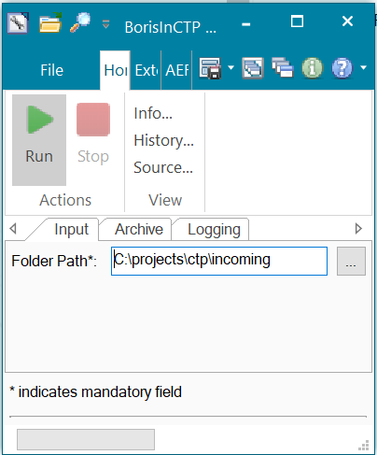

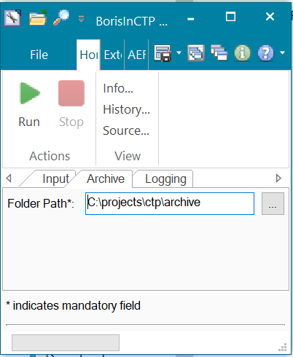

### Data Dictionary

Please refer Appendix 3 - Interface Data Format in the Phase 1B PDR, for more details about fields description

Document - BORIS x FIS.xlsx

### A Data Model

|  |  |
| --- | --- |
| Parameter Name | Description |
| CTPNO | CTP No |
| DEALNO | Deal No |
| FEDEALNO | Reference No |
| LAST_UPDATED | Last Updated |

### B Data Entity and Key Elements Definition

|  |  |
| --- | --- |
| Parameter Name | Description |
| CTPNO | CTP number from BORIS |
| DEALNO | Front Arena trade number |
| FEDEALNO | BORIS Unique number – stored in Additional information field. |
| LAST_UPDATED | Update time. It is not used in this process. |

### C Reference Code Table Definition

Please refer AEF Browser document for details about Front Arena Data Model.

Document - FCA4033

### 6. SECURITY AND CONTROL DESIGN

#### 6.1 Security Requirement Response

|  |  |  |
| --- | --- | --- |
| **Security Domain** | **Security Requirement** | **Response** |
| User Management | The system must identify users using a unique user identification code before allowing a log-on. | It will be controlled through CDCA application |
| The system must suspend access to a user session after a specified interval of inactivity. | Inactivity of user session will not be applicable  as the integration is in Realtime |
| The system must require user authentication before re-enabling the session. | It will be controlled through CDCA application |
| The system must display a warning message indicating that only authorised use is permitted before allowing users to perform a log-on. | It will be controlled through CDCA application |
| The system must display system information to a user, only after a successful log-on. |  |
| After a successful log-on, the system must display information concerning the previous successful attempt to perform a log-on. | It will not be possible in real-time connections. |
| The system must allow a user account to be manually disabled. | NA |
| The system must disable the user account following 3 (three) consecutive failures to perform a successful log-on. | It will be controlled through CDCA application |
| The system must automatically disable the user account following a configurable period (90 days) without use. |  |
| Password Management | The system must authenticate users using a password before allowing access to any system functions. | Not applicable at Front Arena Database side. |
| The system must ensure that passwords used by system users for log-on consist of at least 8 (eight) characters. | Not applicable at Front Arena Database side. |
| The system must enforce the use of complex passwords for all users. (Aplhanumieric & Special Characters) | Not applicable at Front Arena Database side. |
| The system must use cryptographic techniques to protect the confidentiality of user authentication data during transmission. | Not applicable at Front Arena Database side. |
| The system must enforce a password change when a password is first issued or re-issued. |  |
| The system must allow system users to change the password used for log-on. | Not applicable at Front Arena Database side. |
| The system must ensure that passwords do not remain valid for more than 90 (ninety) days. | Not applicable at Front Arena Database side. |
| The system must ensure that passwords may not be changed to any of the last 5 (five) passwords used. | Not applicable at Front Arena Database side. |
| The system must ensure that passwords are not displayed in clear text during entry. | Not applicable at Front Arena Database side. |
| Multi Factor Authentication | The system must enforce dual factor authentication of all users (system that related to financial, faced to customer directly & only use for external purposes) | Not applicable at Front Arena Database side. |
| Data Storage | The system must use cryptographic techniques to protect the storage of authentication data. | NA |
| The system must use cryptographic techniques to protect the integrity of stored critical data. | NA |
| The system must use cryptographic techniques to protect the confidentiality of stored sensitive data. | NA |
| Logging | The system must support the recording of security events in one or multiple specific security event logs. 2 weeks in minimum must be available at the Production Environment | It will be controlled through CDCA application |
| The system must include the Logical Account identity, event type and timestamp in each entry in the security event logs. | It will be controlled through CDCA application |
| The system must record when each security event lo fills to a configurable limit. | It will be controlled through CDCA application |
| The system must protect the integrity of the information in the security event logs | It will be controlled through CDCA application |
| The system must allow access to the security event logs to be limited to the authorised security staff. | It will be controlled through CDCA application |
| The system must record if the integrity of the security event logs is compromised | NA |
| The system must record all instances that system event logs are cleared. | It will be controlled through CDCA application |
| The system must record when a change is made to the system log settings (e.g. logs for certain events are turned off). | It will be controlled through CDCA application |
| The system must record when any system security policy is modified. | NA |
| The system must record all creations of Logical Accounts. | It will be controlled through CDCA application |
| The system must record all deletions of Logical Accounts. |  |
| The system must record all de-activation of Logical Accounts. |  |
| The system must record all unsuccessful attempts to log-on to the system using invalid credentials. |  |
| The system must record all successful attempts to log-on to the system. |  |
| The system must record all successful and unsuccessful attempts to change passwords. |  |
| The system must automatically build and maintain a normal usage pattern for each Logical Account. |  |
| The system must record all activation of disabled Logical Accounts. |  |
| The system must record all attempts to change any account attribute affecting authentication of the Logical Account |  |
| The system must record all allocations of system access rights. |  |
| The system must record all removals of system access rights. |  |
| The system must record all unauthorised attempts to access a system function. |  |
| The system must record when a configurable deviation from a Logical Account's normal pattern is detected. |  |
| The system must record all failures of the check on the timestamp of payment and settlement orders. |  |
| The system must record all attempts to mutually authenticate interface connections that handle critical data |  |
| The system must record all events that may indicate an attempt to cause denial of service. |  |
| The system must record all access to functions processing critical information within the system. |  |
| The system must record all access to sensitive information within the system. |  |
| The system must record all start-up and shut down events. |  |
| The system must have been integrated in the SIEM, Identity Management System & Privilege Identity Management System |  |
| Remote Access | The system logical access control mechanism must be able to discretely grant remote access capability to specific users and user groups. |  |
| The system must strictly limit user access rights to their minimum requirements when they access the system remotely. |  |
| All relevant approvals must be obtained if this application is to be made available for remote use (E.g. on the RCA-portal) by Users |  |
| System Interfaces | The system must use a logical access control mechanism to control system to system data communications, in order to avoid anonymous data transfers (for all interfaces) |  |
| The system must ensure that system to system mutual authentication takes place before data communications are allowed (for all interfaces) |  |
| System to system mutual authentication must be based on cryptographic techniques (for all interfaces) |  |
| The system must use cryptographic techniques to protect the integrity of critical data during transmission (for all interfaces) |  |
| The system must use cryptographic techniques to protect the confidentiality of sensitive data during transmission (for all interfaces) |  |
| All 'critical data' must have been identified, documented and approved by the Business |  |
| All 'confidential data' must have been identified, documented and approved by the Business |  |
| Availability | The system must have a documented and successfully tested disaster recovery plan in place | It will be managed through Front Arena Database DR setup. |
| The system must enforce quotas limiting the maximum resources that an individual user can use simultaneously. |  |
| The system must provide adequate resources to support the required number of users or concurrent users. |  |
| The system should have a documented capacity monitoring process in-place with regular reporting on its use |  |
| Security Testing | The system must be tested for specific technical security flaws where it faces the public internet, prior to release into production. |  |
| The system must only be released into production, where it faces the public internet, once all identified key findings from the security test have been rectified, or if this is not possible, the risks must be formally reviewed and signed off |  |
| The system must be tested for specific technical security flaws prior to release into production. |  |
| The system must only be released into production once all the identified key findings from the security tests have been rectified or if this is not possible, the risks must be formally reviewed and signed off |  |

#### 6.2 Preventive controls

*<This sub-section describe the technical specification for preventive controls that are specific to this module. This includes logical access control, physical security control, encryption, PIN generation and validation, etc>*

*<Sample of list of Role Table and Authorization Matrix>*

|  |  |  |  |
| --- | --- | --- | --- |
| **No** | **Role** | **Authorization** | **Object** |
| 1 | Role1 | ZXXXX | Maintain |
| 2 | Role2 | ZYYYY | Display |
| 3 |  |  |  |

|  |  |  |  |  |  |  |
| --- | --- | --- | --- | --- | --- | --- |
| **No** | **User Group** | **Role1** | **Role2** | **Role3** | **Role4** | **Role5** |
| 1 | User Group1 | X | X |  | X |  |
| 2 | User Group2 |  | X | X |  | X |
|  |  |  |  |  |  |  |

#### 6.3 Detective controls

*<This sub-section describe the technical specification for detective controls that are specific to this module. This includes audit trail, exception reports, reconciliation, balancing & control totals, validations, etc>.*

#### 6.4 Corrective controls

*<This sub-section describe the technical specification for corrective controls that are specific to this module. This includes automated error corrections, backup, recovery & restart, etc>.*

## 7. USER INTERFACE

*NA*

## 8. OPERATING SPECIFICATION

The connection between WebEAI and FA is database to database integration using CDC Agent, the interface is for extract data from FA to WebEAI.

Front Arena Base and CDCA will have real-time live connection.

## REPORTING

### 9.1 Inventory of Reports

*<This sub-section provides a list of operational reports relevant to this module. It is assumed that MIS/EIS module will produce the executive management and regulatory related reports>.*

*<Sample of report definition>*

|  |  |  |
| --- | --- | --- |
| **No** | **Report Name** | **Description** |
|  |  | <Description> |
|  |  |  |

*<if there is data integrity checking requirement, please provide any additional supporting information>.*

### 9.2 Report layout and definition

*<This sub-section describes each of the reports in the inventory list. Report Layout and It’s selection screen must be drawn clearly in this subsection>*

*<Sample of Selection Screen:>*

Selection Field 1

Selection Field 2

to

*<Sample of Report Layout>*

**Report Title**

Report Header

LOGO

Report Footer

Page No.

**Column1**

**Column2**

**Column3**

**Column4**

**Column5**

**Column6**

**Total1**

## Communication

*<This section provides the communication line that will be used in this system>*

### New / Existing*) system *) choose one

|  |  |  |  |  |  |  |  |  |  |
| --- | --- | --- | --- | --- | --- | --- | --- | --- | --- |
| **NO** | **NEW / SURROUNDING SYSTEM** | **HOSTNAME SOURCE** | **IP SOURCE** | **PORT SOURCE** | **HOSTNAME DESTINATION** | **IP DESTINATION** | **PORT DESTINATION** | **PROTOCOL (TCP /UDP /ICMP)** | **ALLOW / DENY** |
| 1 | *<new / surrounding status>* | *<isi nama host source>* | *<isi IP source>* | *<isi port source>* | *<isi nama host destination>* | *<isi IP destination>* | *<isi port destination>* | *<isi protocol>* | *<allow / deny status>* |
| 2 |  |  |  |  |  |  |  |  |  |
| 3 |  |  |  |  |  |  |  |  |  |
| 4 |  |  |  |  |  |  |  |  |  |
| 5 |  |  |  |  |  |  |  |  |  |
| 6 |  |  |  |  |  |  |  |  |  |
| 7 |  |  |  |  |  |  |  |  |  |
| 8 |  |  |  |  |  |  |  |  |  |
| … |  | … | … | … | … | … |  | … | … |

*< For a new developed system, if there are some undefined hostnames/ ip addresses/ ports yet, then should be written with* ***TBC*** *notes and will be completely defined in SDN contract review form >*

*< For an existing system and surrounding, please define and write its hostnames/ ip addresses/ ports >*

## OTHERS

*<This section provides other technical specifications that have not been address in previous section>.*

## Appendix

# BPS NOSTRO GL

## 1. DESCRIPTION

TPS – Nostro GL Records

BPS will send nostro transaction records to Front Arena. FA will create standalone payment, so that it can be sent to IRS Citynet system via MT950.

## 2. TECHNICAL ATTRIBUTE

|  |  |  |  |
| --- | --- | --- | --- |
| **Interface name** | BPS - Nostro GL Records | | |
| **Type of data** | Nostro transaction Records | **Frequency** | Batch |
| **Source** | BPS | **Direction** | IN |
| **Format** | File | **Transfer mechanism** | Shared Location |
| **Response Required** | N/A | **Dependencies on other processes** |  |
| **Purpose** | Posting GL record to FA and MT950 Reconciliation | | |

**Workflow**

1. Files from BPS system will be available at specified shared location.

2. Script will be developed to read the detailed file to get Nostro transaction records.

3. That script will create standalone payments in FA from each valid record available in file.

4. Keep the source name in Counterparty field. Party will be created with name of surrounding system (e.g. BPS, TPS, EXIMBILL)

## 3. TECHNICAL ARCHITECTURE

**Architectural overview**

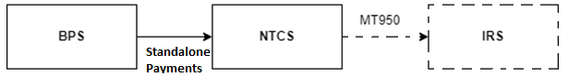

GL account matching with Acquirer Account

Standalone

Payments

Front Arena

BPS

## TECHNICAL FLOW DIAGRAM

Please refer section - tECHNICAL aRCHITECTURE

## 5. LOGIC AND CONFIGURATION

### 5.1 Flow Logic

1. Script reads the BPS file having Nostro GL records
2. Identifies the record having Non-Suspense GL Account.
3. For this record, if the GL account matches with the Account of the Acquirer, settlement is created
4. Type of settlement will be ‘Stand Alone Payment’
5. The settlement status is set to ‘Pending Closure’
6. The Account for this settlement is the one which has matching GL Account in the file record
7. This payment will have counterparty as BPS, which is assigned in the FParameters
8. The Acquirer is assigned in the FParameters

### 5.2 Configuration

Configurations parameter are available as FParameters in the PS_BPSNostroGL extension module.

### 5.3 Data Dictionary

Please refer attached Data Mapping file and sample input file



### 5.3.A Data Model

Please refer AEF Browser document for details about Front Arena Data Model.

Document - FCA4033

### 5.3.B Data Entity and Key Elements Definition

All required details are available in AEF Browser document.

### 5.3.C Reference Code Table Definition

*<This sub-section describes the reference code tables and the codes within each table. Only describes those reference code tables that affect the users>.*

*Template is the same as 5.3.B*

## 6. SECURITY AND CONTROL DESIGN

### 6.1 Security Requirement Response

|  |  |  |
| --- | --- | --- |
| **Security Domain** | **Security Requirement** | **Response** |
| User Management | The system must identify users using a unique user identification code before allowing a log-on. | NA |
| The system must suspend access to a user session after a specified interval of inactivity. | NA |
| The system must require user authentication before re-enabling the session. | NA |
| The system must display a warning message indicating that only authorised use is permitted before allowing users to perform a log-on. | NA |
| The system must display system information to a user, only after a successful log-on. | NA |
| After a successful log-on, the system must display information concerning the previous successful attempt to perform a log-on. | NA |
| The system must allow a user account to be manually disabled. | NA |
| The system must disable the user account following 3 (three) consecutive failures to perform a successful log-on. | NA |
| The system must automatically disable the user account following a configurable period (90 days) without use. | NA |
| Password Management | The system must authenticate users using a password before allowing access to any system functions. | NA |
| The system must ensure that passwords used by system users for log-on consist of at least 8 (eight) characters. | NA |
| The system must enforce the use of complex passwords for all users. (Aplhanumieric & Special Characters) | NA |
| The system must use cryptographic techniques to protect the confidentiality of user authentication data during transmission. | NA |
| The system must enforce a password change when a password is first issued or re-issued. | NA |
| The system must allow system users to change the password used for log-on. | NA |
| The system must ensure that passwords do not remain valid for more than 90 (ninety) days. | NA |
| The system must ensure that passwords may not be changed to any of the last 5 (five) passwords used. | NA |
| The system must ensure that passwords are not displayed in clear text during entry. | NA |
| Multi Factor Authentication | The system must enforce dual factor authentication of all users (system that related to financial, faced to customer directly & only use for external purposes) | NA |
| Data Storage | The system must use cryptographic techniques to protect the storage of authentication data. | NA |
| The system must use cryptographic techniques to protect the integrity of stored critical data. | NA |
| The system must use cryptographic techniques to protect the confidentiality of stored sensitive data. | NA |
| Logging | The system must support the recording of security events in one or multiple specific security event logs. 2 weeks in minimum must be available at the Production Environment | NA |
| The system must include the Logical Account identity, event type and timestamp in each entry in the security event logs. | NA |
| The system must record when each security event lo fills to a configurable limit. | NA |
| The system must protect the integrity of the information in the security event logs | NA |
| The system must allow access to the security event logs to be limited to the authorised security staff. | NA |
| The system must record if the integrity of the security event logs is compromised | NA |
| The system must record all instances that system event logs are cleared. | NA |
| The system must record when a change is made to the system log settings (e.g. logs for certain events are turned off). | NA |
| The system must record when any system security policy is modified. | NA |
| The system must record all creations of Logical Accounts. | NA |
| The system must record all deletions of Logical Accounts. |  |
| The system must record all de-activation of Logical Accounts. |  |
| The system must record all unsuccessful attempts to log-on to the system using invalid credentials. |  |
| The system must record all successful attempts to log-on to the system. |  |
| The system must record all successful and unsuccessful attempts to change passwords. |  |
| The system must automatically build and maintain a normal usage pattern for each Logical Account. |  |
| The system must record all activation of disabled Logical Accounts. |  |
| The system must record all attempts to change any account attribute affecting authentication of the Logical Account |  |
| The system must record all allocations of system access rights. |  |
| The system must record all removals of system access rights. |  |
| The system must record all unauthorised attempts to access a system function. |  |
| The system must record when a configurable deviation from a Logical Account's normal pattern is detected. |  |
| The system must record all failures of the check on the timestamp of payment and settlement orders. |  |
| The system must record all attempts to mutually authenticate interface connections that handle critical data |  |
| The system must record all events that may indicate an attempt to cause denial of service. |  |
| The system must record all access to functions processing critical information within the system. |  |
| The system must record all access to sensitive information within the system. |  |
| The system must record all start-up and shut down events. |  |
| The system must have been integrated in the SIEM, Identity Management System & Privilege Identity Management System |  |
| Remote Access | The system logical access control mechanism must be able to discretely grant remote access capability to specific users and user groups. |  |
| The system must strictly limit user access rights to their minimum requirements when they access the system remotely. |  |
| All relevant approvals must be obtained if this application is to be made available for remote use (E.g. on the RCA-portal) by Users |  |
| System Interfaces | The system must use a logical access control mechanism to control system to system data communications, in order to avoid anonymous data transfers (for all interfaces) |  |
| The system must ensure that system to system mutual authentication takes place before data communications are allowed (for all interfaces) |  |
| System to system mutual authentication must be based on cryptographic techniques (for all interfaces) |  |
| The system must use cryptographic techniques to protect the integrity of critical data during transmission (for all interfaces) |  |
| The system must use cryptographic techniques to protect the confidentiality of sensitive data during transmission (for all interfaces) |  |
| All 'critical data' must have been identified, documented and approved by the Business |  |
| All 'confidential data' must have been identified, documented and approved by the Business |  |
| Availability | The system must have a documented and successfully tested disaster recovery plan in place | It will be managed through Front Arena Database DR setup. |
| The system must enforce quotas limiting the maximum resources that an individual user can use simultaneously. |  |
| The system must provide adequate resources to support the required number of users or concurrent users. |  |
| The system should have a documented capacity monitoring process in-place with regular reporting on its use |  |
| Security Testing | The system must be tested for specific technical security flaws where it faces the public internet, prior to release into production. |  |
| The system must only be released into production, where it faces the public internet, once all identified key findings from the security test have been rectified, or if this is not possible, the risks must be formally reviewed and signed off |  |
| The system must be tested for specific technical security flaws prior to release into production. |  |
| The system must only be released into production once all the identified key findings from the security tests have been rectified or if this is not possible, the risks must be formally reviewed and signed off |  |

### 6.2 Preventive controls

*<This sub-section describe the technical specification for preventive controls that are specific to this module. This includes logical access control, physical security control, encryption, PIN generation and validation, etc>*

*<Sample of list of Role Table and Authorization Matrix>*

|  |  |  |  |
| --- | --- | --- | --- |
| **No** | **Role** | **Authorization** | **Object** |
| 1 | Role1 | ZXXXX | Maintain |
| 2 | Role2 | ZYYYY | Display |
| 3 |  |  |  |

|  |  |  |  |  |  |  |
| --- | --- | --- | --- | --- | --- | --- |
| **No** | **User Group** | **Role1** | **Role2** | **Role3** | **Role4** | **Role5** |
| 1 | User Group1 | X | X |  | X |  |
| 2 | User Group2 |  | X | X |  | X |
|  |  |  |  |  |  |  |

### 6.3 Detective controls

*<This sub-section describe the technical specification for detective controls that are specific to this module. This includes audit trail, exception reports, reconciliation, balancing & control totals, validations, etc>.*

### 6.4 Corrective controls

*<This sub-section describe the technical specification for corrective controls that are specific to this module. This includes automated error corrections, backup, recovery & restart, etc>.*

**7**. **USER INTERFACE**

The task invokes run script GUI which takes below parameters -

* Folder selection criteria for input file from BPS
* Folder selection criteria for archiving the file
* Log file details for the task

## 8. OPERATING SPECIFICATION

1. Files from BPS system will be available at specified shared location.
2. Script will be developed to read the detailed file to get Nostro transactions.
3. That script will create standalone payments in FA from each valid record available in file where the GL record matches with the Acquirer account
4. Keep the source name in Counterparty field. Party will be created with name of surrounding system (e.g. BPS, TPS, TPS)

### TECHNICAL ATTRIBUTE

|  |  |
| --- | --- |
| **Attribute** | **Description** |
| Extension Module | PS_BPSNostroGL  *It contains code required to perform Deal posting activity.* |

FParameters

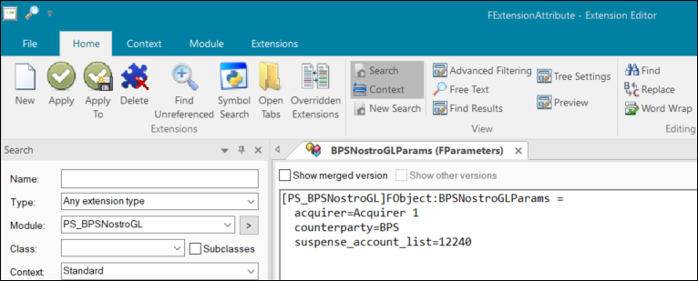

Sample input shared folder for BPS Nostro GL file processing

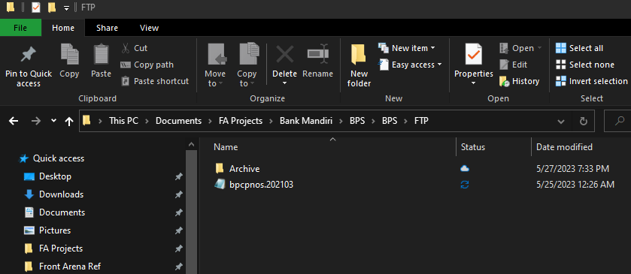

Run task GUI

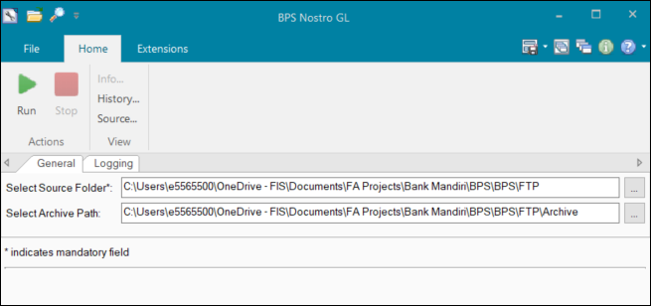

Settlement records samples after task run

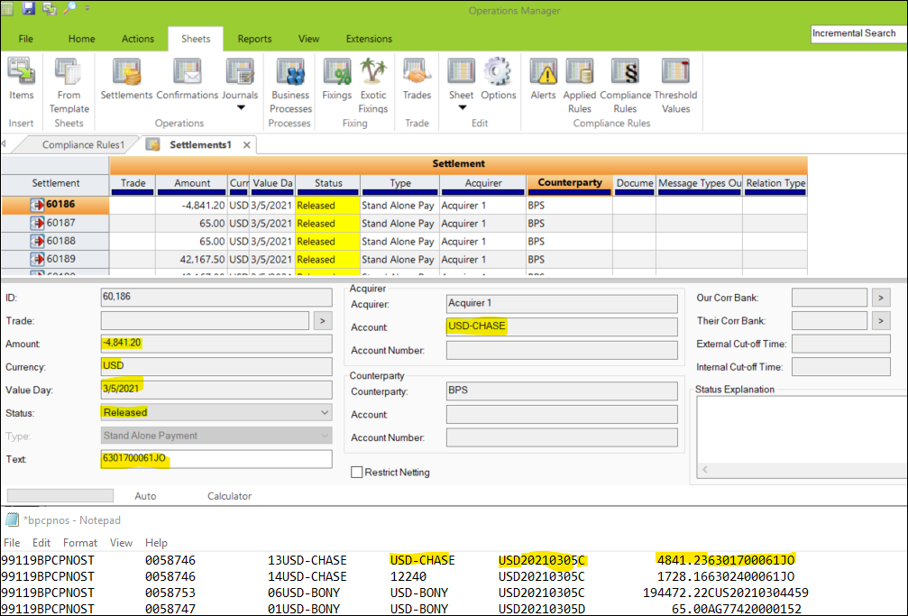

File Archived at mentioned location

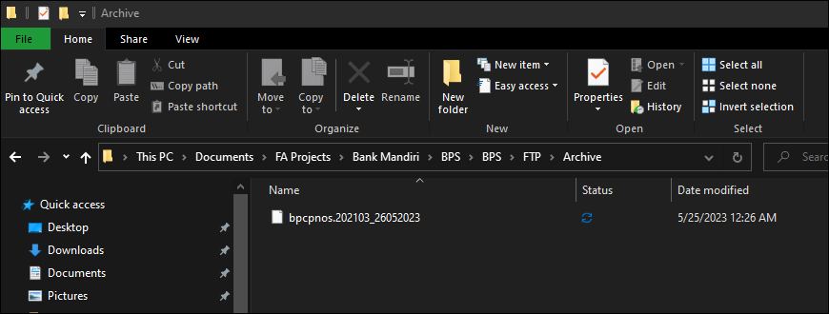

## REPORTING

### 9.1 Inventory of Reports

*<This sub-section provides a list of operational reports relevant to this module. It is assumed that MIS/EIS module will produce the executive management and regulatory related reports>.*

*<Sample of report definition>*

|  |  |  |
| --- | --- | --- |
| **No** | **Report Name** | **Description** |
|  |  | <Description> |
|  |  |  |

*<if there is data integrity checking requirement, please provide any additional supporting information>.*

### 9.2 Report layout and definition

*<This sub-section describes each of the reports in the inventory list. Report Layout and It’s selection screen must be drawn clearly in this subsection>*

*<Sample of Selection Screen:>*

Selection Field 1

Selection Field 2

to

*<Sample of Report Layout>*

**Report Title**

Report Header

LOGO

Report Footer

Page No.

**Column1**

**Column2**

**Column3**

**Column4**

**Column5**

**Column6**

**Total1**

## Communication

*<This section provides the communication line that will be used in this system>*

### New / Existing*) system *) choose one

|  |  |  |  |  |  |  |  |  |  |
| --- | --- | --- | --- | --- | --- | --- | --- | --- | --- |
| **NO** | **NEW / SURROUNDING SYSTEM** | **HOSTNAME SOURCE** | **IP SOURCE** | **PORT SOURCE** | **HOSTNAME DESTINATION** | **IP DESTINATION** | **PORT DESTINATION** | **PROTOCOL (TCP /UDP /ICMP)** | **ALLOW / DENY** |
| 1 | *<new / surrounding status>* | *<isi nama host source>* | *<isi IP source>* | *<isi port source>* | *<isi nama host destination>* | *<isi IP destination>* | *<isi port destination>* | *<isi protocol>* | *<allow / deny status>* |
| 2 |  |  |  |  |  |  |  |  |  |
| 3 |  |  |  |  |  |  |  |  |  |
| 4 |  |  |  |  |  |  |  |  |  |
| 5 |  |  |  |  |  |  |  |  |  |
| 6 |  |  |  |  |  |  |  |  |  |
| 7 |  |  |  |  |  |  |  |  |  |
| 8 |  |  |  |  |  |  |  |  |  |
| … |  | … | … | … | … | … |  | … | … |

*< For a new developed system, if there are some undefined hostnames/ ip addresses/ ports yet, then should be written with* ***TBC*** *notes and will be completely defined in SDN contract review form >*

*< For an existing system and surrounding, please define and write its hostnames/ ip addresses/ ports >*

## OTHERS

*<This section provides other technical specifications that have not been address in previous section>.*

## Appendix

# CTP IMPORT EXPORT



FIS Cross Asset Trading and Risk Platform (formerly Front Arena) Treasury Implementation Project

Technical Specifications Document

CTP 1.0

## CTP – import / export

DESCRIPTION

|  |  |  |  |
| --- | --- | --- | --- |
| Interface name | CTP – IMPORT / EXPORT | | |
| Type of data | Bond Trade: Bond, Bill, FRN Repo/Reverse | Frequency | Realtime/Batch |
| Source | CTP / FA | Direction | IN / OUT |
| Format | File | Transfer mechanism | Shared Location |
| Response Required | N/A | Dependencies on other processes | N / A |
| Purpose | CTP is a reporting platform at exchange. CTP Import interface will send CTP number for a transaction in a file format from CTP to FA. CTP Export interface will send transaction details in CTP file format from FA to CTP. | | |

CTP Import interface will send CTP number for a transaction in a file format from CTP platform to Front Arena. CTP Export interface will send transaction details in CTP file format from Front Arena to CTP platform.

### TECHNICAL ATTRIBUTE

|  |  |
| --- | --- |
| **Attribute** | **Description** |
| Extension Module | ICT_CTP *It contains scripts for CTP Export and CTP Import interfaces* |
| ATS | ATS_INTEGRATIONS  *ATS is configured in task mode to automate the process of CTP Import and CTP Export interfaces* |

### TECHNICAL ARCHITECTURE

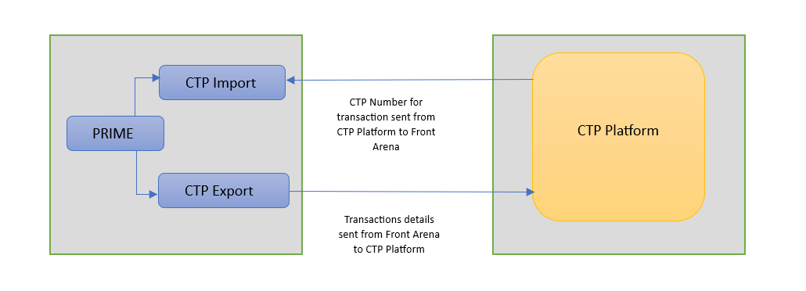

### TECHNICAL FLOW DIAGRAM

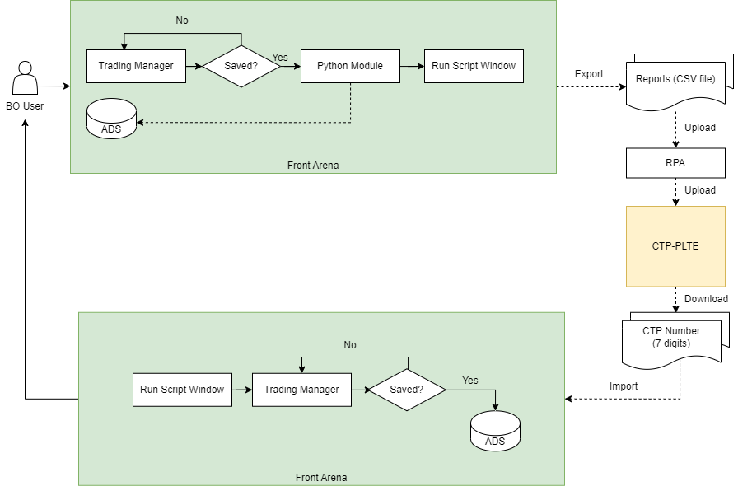

### LOGIC AND CONFIGURATION

#### Flow Logic

1. CTP Import

* CTP platform will send CTP numbers for transaction in file format.
* Script will be developed to get the input file from specified location, read the file and store the CTP number on respective transaction in Front Arena. The input file should contain transaction reference to identify the transaction in Front Arena.

1. CTP Export

* The interface will be triggered based on the conditions specified in the below trade actions:
  + - * 1. Save New

Trade Status: FO CONFIRMED

Trigger: When a new trade moved to FO CONFIRMED status

Action: Generate file with Excel format with the following naming:

CTP_[Trade_ID]_yymmddhhmmss_NEW

* + - * 1. Amend

Trade Status: FO CONFIRMED

Trigger: When there is an update on FO CONFIRMED status

Action: Generate file with Excel format with the following naming:

CTP_[Trade_ID]_yymmddhhmmss_AMD

* + - * 1. Void

Trade Status: VOID

Trigger: When a new trade moved to VOID status

Action: Generate file with Excel format with the following naming:

CTP_[Trade_ID]_yymmddhhmmss_VOID

* Transaction details will be transformed in CTP format and send transaction details to CTP platform.
* Additionalinfo CTPStateStatus is used to maintain the file generation status.
  + SUCCESS: means file successfully generated.
  + FAILED_NEW: this means FA failed to generate the CTP NEW file.
  + FAILED_AMD: this means FA failed to generate the CTP AMD file.
  + FAILED_VOID: this means FA failed to generate the CTP VOID file.
* The following trade selection criteria will be applied.

• Repo/Rev Repo, Sell/Buy Outright Bonds, and Asset transfer

• The transaction is not from BORIS.

• Government & Corporate Bonds.

• Not buy from the primary market.

(Usually for government bonds buy in primary market, bonds issuer

and seller counterparty is same. for corporate bonds there will be

additional info in trade to mark whether the trade is on primary

market/not.)

• In IDR currency

#### Configuration

|  |  |
| --- | --- |
| Delivery Items | |
| Extension Context | +Integration |
| Extension Module | ICT_CTP |
| ATS | ATS_INTEGRATIONS |
|  |  |
| FA Component | |
| ATS | ATS_INTERGRATIONS is configured in task mode to execute CTP Import and CTP Export tasks |
|  | |
| Deployment and Manual Configuration | |
| This service is deployed through FA standard deployment process.  Manual configuration may be required to update the configuration in FParameter in extension module. | |
|  | |
| Additional Information | |
| CTPAlias | AdditionalInfo on Party |
| CTPCustody | AdditionalInfo on Party |
| CTPMatchingStatus | AdditionalInfo on Trade |
| CTPNumber | AdditionalInfo on Trade |
| CTPParticipants | AdditionalInfo on Party |
| CTPReference | AdditionalInfo on Trade |
| CTPStateStatus | AdditionalInfo on Trade |
| FParameters | Default values |
| No FParamaters specified for this interface | |
|  | |
| Pre-requisites |  |
| Query Folder | Query folder with name specified in Parameters, must be available, so that program can extract trades through that query folder. |
| ATS service | ATS is optional. Totally depends on the mode of task execution |
| FStoredASQLQuery | Purpose |
| CTP_Mandiri | Filter specifying the eligible trades/transactions |

#### Data Dictionary

No Mapping File required for this interface.

#### A Data Model

Please refer AEF Browser document for details about Front Arena Data Model.

Document - FCA4033

#### B Data Entity and Key Elements Definition

All required details are available in AEF Browser document.

#### C Reference Code Table Definition

Please refer AEF Browser document for details about Front Arena Data Model.

Document - FCA4033

### SECURITY AND CONTROL DESIGN

#### Security Requirement Response

|  |  |  |
| --- | --- | --- |
| **Security Domain** | **Security Requirement** | **Response** |
| User Management | The system must identify users using a unique user identification code before allowing a log-on. | It will be controlled through CDCA application |
| The system must suspend access to a user session after a specified interval of inactivity. | Inactivity of user session will not be applicable  as the integration is in Realtime |
| The system must require user authentication before re-enabling the session. | It will be controlled through CDCA application |
| The system must display a warning message indicating that only authorized use is permitted before allowing users to perform a log-on. | It will be controlled through CDCA application |
| The system must display system information to a user, only after a successful log-on. |  |
| After a successful log-on, the system must display information concerning the previous successful attempt to perform a log-on. | It will not be possible in real-time connections. |
| The system must allow a user account to be manually disabled. | NA |
| The system must disable the user account following 3 (three) consecutive failures to perform a successful log-on. | It will be controlled through CDCA application |
| The system must automatically disable the user account following a configurable period (90 days) without use. |  |
| Password Management | The system must authenticate users using a password before allowing access to any system functions. | Not applicable at Front Arena Database side. |
| The system must ensure that passwords used by system users for log-on consist of at least 8 (eight) characters. | Not applicable at Front Arena Database side. |
| The system must enforce the use of complex passwords for all users. (Aplhanumieric & Special Characters) | Not applicable at Front Arena Database side. |
| The system must use cryptographic techniques to protect the confidentiality of user authentication data during transmission. | Not applicable at Front Arena Database side. |
| The system must enforce a password change when a password is first issued or re-issued. |  |
| The system must allow system users to change the password used for log-on. | Not applicable at Front Arena Database side. |
| The system must ensure that passwords do not remain valid for more than 90 (ninety) days. | Not applicable at Front Arena Database side. |
| The system must ensure that passwords may not be changed to any of the last 5 (five) passwords used. | Not applicable at Front Arena Database side. |
| The system must ensure that passwords are not displayed in clear text during entry. | Not applicable at Front Arena Database side. |
| Multi Factor Authentication | The system must enforce dual factor authentication of all users (system that related to financial, faced to customer directly & only use for external purposes) | Not applicable at Front Arena Database side. |
| Data Storage | The system must use cryptographic techniques to protect the storage of authentication data. | NA |
| The system must use cryptographic techniques to protect the integrity of stored critical data. | NA |
| The system must use cryptographic techniques to protect the confidentiality of stored sensitive data. | NA |
| Logging | The system must support the recording of security events in one or multiple specific security event logs. 2 weeks in minimum must be available at the Production Environment | It will be controlled through CDCA application |
| The system must include the Logical Account identity, event type and timestamp in each entry in the security event logs. | It will be controlled through CDCA application |
| The system must record when each security event lo fills to a configurable limit. | It will be controlled through CDCA application |
| The system must protect the integrity of the information in the security event logs | It will be controlled through CDCA application |
| The system must allow access to the security event logs to be limited to the authorised security staff. | It will be controlled through CDCA application |
| The system must record if the integrity of the security event logs is compromised | NA |
| The system must record all instances that system event logs are cleared. | It will be controlled through CDCA application |
| The system must record when a change is made to the system log settings (e.g. logs for certain events are turned off). | It will be controlled through CDCA application |
| The system must record when any system security policy is modified. | NA |
| The system must record all creations of Logical Accounts. | It will be controlled through CDCA application |
| The system must record all deletions of Logical Accounts. |  |
| The system must record all de-activation of Logical Accounts. |  |
| The system must record all unsuccessful attempts to log-on to the system using invalid credentials. |  |
| The system must record all successful attempts to log-on to the system. |  |
| The system must record all successful and unsuccessful attempts to change passwords. |  |
| The system must automatically build and maintain a normal usage pattern for each Logical Account. |  |
| The system must record all activation of disabled Logical Accounts. |  |
| The system must record all attempts to change any account attribute affecting authentication of the Logical Account |  |
| The system must record all allocations of system access rights. |  |
| The system must record all removals of system access rights. |  |
| The system must record all unauthorised attempts to access a system function. |  |
| The system must record when a configurable deviation from a Logical Account's normal pattern is detected. |  |
| The system must record all failures of the check on the timestamp of payment and settlement orders. |  |
| The system must record all attempts to mutually authenticate interface connections that handle critical data |  |
| The system must record all events that may indicate an attempt to cause denial of service. |  |
| The system must record all access to functions processing critical information within the system. |  |
| The system must record all access to sensitive information within the system. |  |
| The system must record all start-up and shut down events. |  |
| The system must have been integrated in the SIEM, Identity Management System & Privilege Identity Management System |  |
| Remote Access | The system logical access control mechanism must be able to discretely grant remote access capability to specific users and user groups. |  |
| The system must strictly limit user access rights to their minimum requirements when they access the system remotely. |  |
| All relevant approvals must be obtained if this application is to be made available for remote use (E.g. on the RCA-portal) by Users |  |
| System Interfaces | The system must use a logical access control mechanism to control system to system data communications, in order to avoid anonymous data transfers (for all interfaces) |  |
| The system must ensure that system to system mutual authentication takes place before data communications are allowed (for all interfaces) |  |
| System to system mutual authentication must be based on cryptographic techniques (for all interfaces) |  |
| The system must use cryptographic techniques to protect the integrity of critical data during transmission (for all interfaces) |  |
| The system must use cryptographic techniques to protect the confidentiality of sensitive data during transmission (for all interfaces) |  |
| All 'critical data' must have been identified, documented and approved by the Business |  |
| All 'confidential data' must have been identified, documented and approved by the Business |  |
| Availability | The system must have a documented and successfully tested disaster recovery plan in place | It will be managed through Front Arena Database DR setup. |
| The system must enforce quotas limiting the maximum resources that an individual user can use simultaneously. |  |
| The system must provide adequate resources to support the required number of users or concurrent users. |  |
| The system should have a documented capacity monitoring process in-place with regular reporting on its use |  |
| Security Testing | The system must be tested for specific technical security flaws where it faces the public internet, prior to release into production. |  |
| The system must only be released into production, where it faces the public internet, once all identified key findings from the security test have been rectified, or if this is not possible, the risks must be formally reviewed and signed off |  |
| The system must be tested for specific technical security flaws prior to release into production. |  |
| The system must only be released into production once all the identified key findings from the security tests have been rectified or if this is not possible, the risks must be formally reviewed and signed off |  |

#### Preventive controls

*<This sub-section describe the technical specification for preventive controls that are specific to this module. This includes logical access control, physical security control, encryption, PIN generation and validation, etc>*

*<Sample of list of Role Table and Authorization Matrix>*

|  |  |  |  |
| --- | --- | --- | --- |
| **No** | **Role** | **Authorization** | **Object** |
| 1 | Role1 | ZXXXX | Maintain |
| 2 | Role2 | ZYYYY | Display |
| 3 |  |  |  |

|  |  |  |  |  |  |  |
| --- | --- | --- | --- | --- | --- | --- |
| **No** | **User Group** | **Role1** | **Role2** | **Role3** | **Role4** | **Role5** |
| 1 | User Group1 | X | X |  | X |  |
| 2 | User Group2 |  | X | X |  | X |
|  |  |  |  |  |  |  |

#### Detective controls

*<This sub-section describe the technical specification for detective controls that are specific to this module. This includes audit trail, exception reports, reconciliation, balancing & control totals, validations, etc>.*

#### Corrective controls

*<This sub-section describes the technical specification for corrective controls that are specific to this module. This includes automated error corrections, backup, recovery & restart, etc>.*

### USER INTERFACE

If required, the user can trigger the interfaces, by using the task GUIs

*CTP_Mandiri_Import_CTP_File and CTP_Mandiri_Export_CSV.*

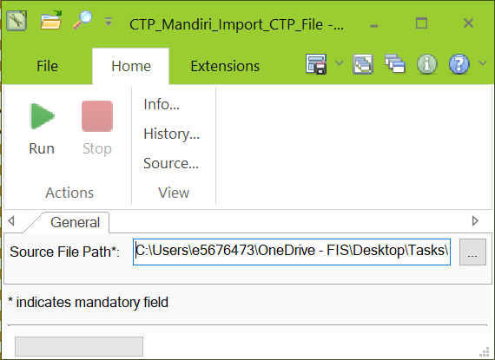

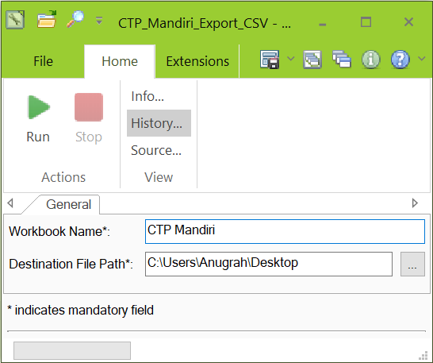

Below task is used by *CTP_Mandiri_Export_CSV script to execute the workflow*

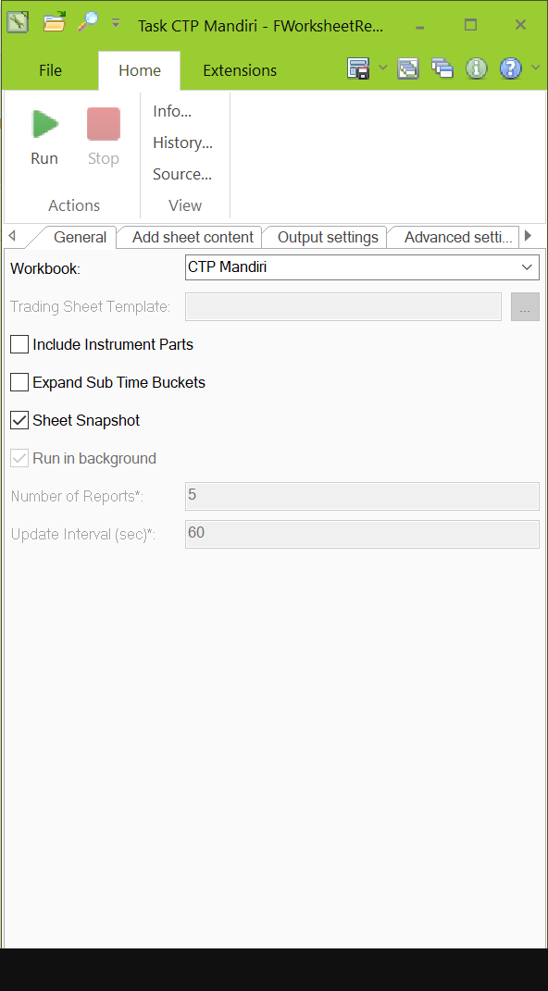

### OPERATING SPECIFICATION

1. CTP Import interface will send CTP number for a transaction in a file format from CTP platform to Front Arena
2. CTP Export interface will send transaction details in CTP file format from Front Arena to CTP platform
3. By starting ATS_INTEGRATIONS the tasks can be run in a scheduled mode

The following filter query will be used:-

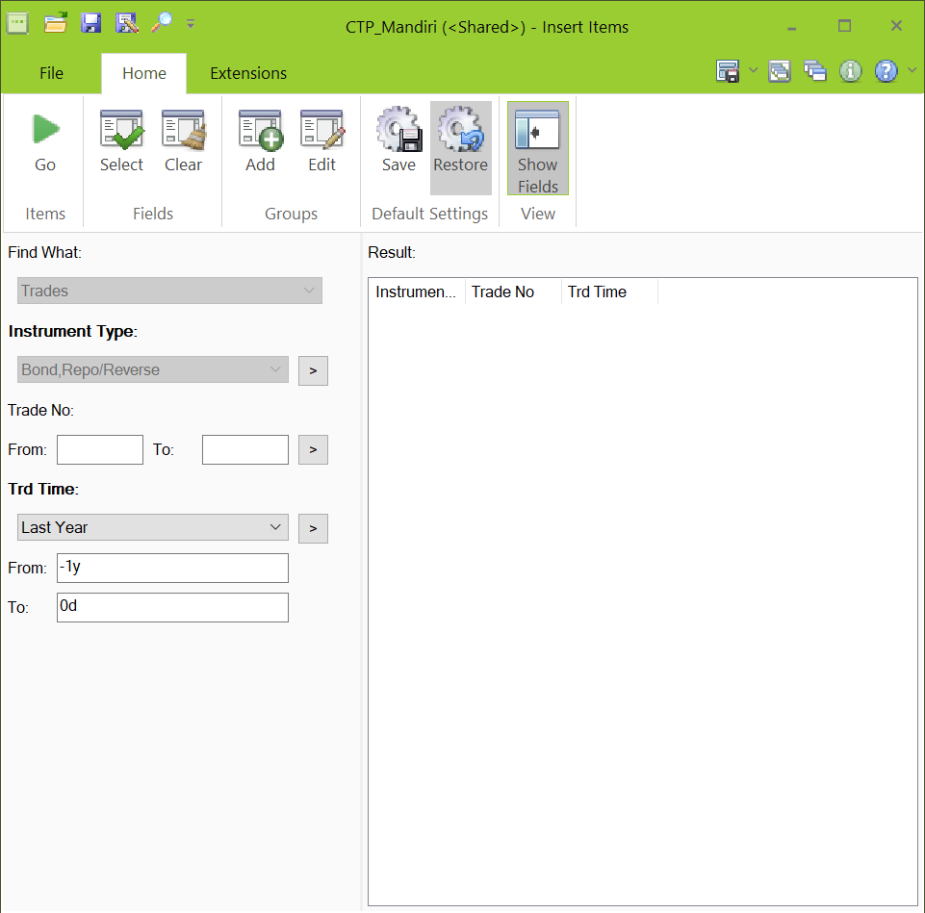

Following additional informations will be used.

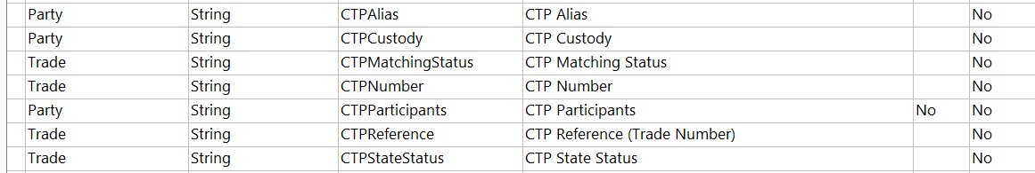

## Communication

*<This section provides the communication line that will be used in this system>*

### New / Existing*) system *) choose one

|  |  |  |  |  |  |  |  |  |  |
| --- | --- | --- | --- | --- | --- | --- | --- | --- | --- |
| **NO** | **NEW / SURROUNDING SYSTEM** | **HOSTNAME SOURCE** | **IP SOURCE** | **PORT SOURCE** | **HOSTNAME DESTINATION** | **IP DESTINATION** | **PORT DESTINATION** | **PROTOCOL (TCP /UDP /ICMP)** | **ALLOW / DENY** |
| 1 | *<new / surrounding status>* | *<isi nama host source>* | *<isi IP source>* | *<isi port source>* | *<isi nama host destination>* | *<isi IP destination>* | *<isi port destination>* | *<isi protocol>* | *<allow / deny status>* |
| 2 |  |  |  |  |  |  |  |  |  |
| 3 |  |  |  |  |  |  |  |  |  |
| 4 |  |  |  |  |  |  |  |  |  |
| 5 |  |  |  |  |  |  |  |  |  |
| 6 |  |  |  |  |  |  |  |  |  |
| 7 |  |  |  |  |  |  |  |  |  |
| 8 |  |  |  |  |  |  |  |  |  |
| … |  | … | … | … | … | … |  | … | … |

*< For a new developed system, if there are some undefined hostnames/ ip addresses/ ports yet, then should be written with* ***TBC*** *notes and will be completely defined in SDN contract review form >*

*< For an existing system and surrounding, please define and write its hostnames/ ip addresses/ ports >*

## OTHERS

*<This section provides other technical specifications that have not been address in previous section>.*

# CUSTODY SYSTEM

## Custody System-OUT-BOND

DESCRIPTION

|  |  |  |  |
| --- | --- | --- | --- |
| **Interface name** | Custody System – OUT - Bond | | |
| **Type of data** | Bond Trades | **Frequency** | Batch |
| **Source** | FA | **Direction** | OUT |
| **Format** | File | **Transfer mechanism** | Shared Location |
| **Response Required** | N/A | **Dependencies on other processes** |  |
| **Purpose** | Sending Bond transactions to Custodian Systems. | | |

Bond transactions from Front Arena need to send to Custodian periodically. Interface should be developed to capture applicable Bond transaction and send to Custodian system in specific format.

### TECHNICAL ATTRIBUTE

|  |  |
| --- | --- |
| **Attribute** | **Description** |
| Extension Module | *PS_CustodySystemOutBond* |
| ATS | *ATS_INTEGRATIONS* |

### TECHNICAL ARCHITECTURE

Prime

ATS Integrations

Custody Online

**Front Arena**

Shared file location

ADS

CustodySystemHoldingPosition

Task

**Custody System**

### TECHNICAL FLOW DIAGRAM

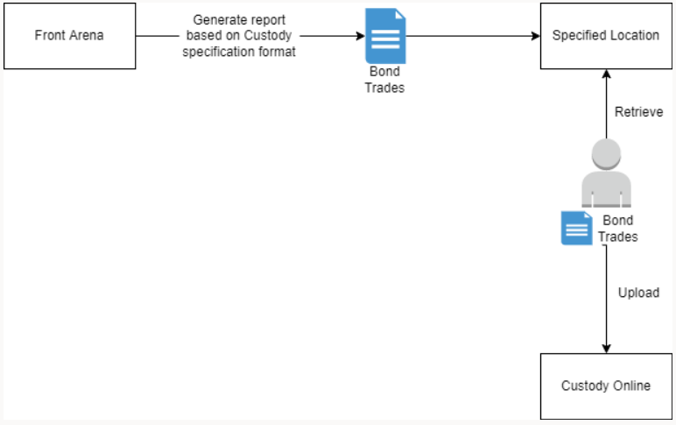

### LOGIC AND CONFIGURATION

#### Flow Logic

1. Bond selection filtering criteria will be designed to selection applicable transactions in FA.

2. Script has been developed to get Bond transactions and convert it in Custodian format write in output file.

3. Output file will be stored at a location specified in the configuration.

4. Bank Mandiri needs to pick up the generated file and feed it to custodian system.

5. This is scheduled to generate output file at every 20 minutes.

#### Configuration

|  |  |
| --- | --- |
| Delivery Items | |
| Extension Context | +CUSTODY_SYSTEM |
| Extension Module | PS_CustodySystemOutBond |
| ATS Service | ATS Integrations |
|  |  |
| FA Component | |
| ATS | ATS Integrations |
|  |  |
| Deployment and Manual Configuration | |
| This service is deployed through FA standard deployment process.  Manual configuration may be required to update the configuration in FParameter in extension module. | |
|  |  |
| Additional Information | |
| Add info | CTPNumber |
| FParameters | Default values |
| logFilename | CUSTODY_OUT_BOND_LOG_{}.txt |
| outputFilename | CUSTODY_OUT_BOND_{}.csv |
| securitiesAccountNo | 033369100001 |
| Pre-requisites |  |
| Pre-requisite | A valid folder should be present as pre requisite |
|  |  |
| FStoredASQLQuery | Purpose |
| Query | CustodyBondTransactionFilter |

#### Data Dictionary

Following are field mapping done for this interface.

Document – Custody_Mapping



#### A Data Model

Please refer AEF Browser document for details about Front Arena Data Model.

Document - FCA4033

#### B Data Entity and Key Elements Definition

All required details are available in AEF Browser document.

#### C Reference Code Table Definition

Please refer AEF Browser document for details about Front Arena Data Model.

Document - FCA4033

### SECURITY AND CONTROL DESIGN

#### Security Requirement Response

|  |  |  |
| --- | --- | --- |
| **Security Domain** | **Security Requirement** | **Response** |
| User Management | The system must identify users using a unique user identification code before allowing a log-on. | It will be controlled through CDCA application |
| The system must suspend access to a user session after a specified interval of inactivity. | Inactivity of user session will not be applicable  as the integration is in Realtime |
| The system must require user authentication before re-enabling the session. | It will be controlled through CDCA application |
| The system must display a warning message indicating that only authorized use is permitted before allowing users to perform a log-on. | It will be controlled through CDCA application |
| The system must display system information to a user, only after a successful log-on. |  |
| After a successful log-on, the system must display information concerning the previous successful attempt to perform a log-on. | It will not be possible in real-time connections. |
| The system must allow a user account to be manually disabled. | NA |
| The system must disable the user account following 3 (three) consecutive failures to perform a successful log-on. | It will be controlled through CDCA application |
| The system must automatically disable the user account following a configurable period (90 days) without use. |  |
| Password Management | The system must authenticate users using a password before allowing access to any system functions. | Not applicable at Front Arena Database side. |
| The system must ensure that passwords used by system users for log-on consist of at least 8 (eight) characters. | Not applicable at Front Arena Database side. |
| The system must enforce the use of complex passwords for all users. (Aplhanumieric & Special Characters) | Not applicable at Front Arena Database side. |
| The system must use cryptographic techniques to protect the confidentiality of user authentication data during transmission. | Not applicable at Front Arena Database side. |
| The system must enforce a password change when a password is first issued or re-issued. |  |
| The system must allow system users to change the password used for log-on. | Not applicable at Front Arena Database side. |
| The system must ensure that passwords do not remain valid for more than 90 (ninety) days. | Not applicable at Front Arena Database side. |
| The system must ensure that passwords may not be changed to any of the last 5 (five) passwords used. | Not applicable at Front Arena Database side. |
| The system must ensure that passwords are not displayed in clear text during entry. | Not applicable at Front Arena Database side. |
| Multi Factor Authentication | The system must enforce dual factor authentication of all users (system that related to financial, faced to customer directly & only use for external purposes) | Not applicable at Front Arena Database side. |
| Data Storage | The system must use cryptographic techniques to protect the storage of authentication data. | NA |
| The system must use cryptographic techniques to protect the integrity of stored critical data. | NA |
| The system must use cryptographic techniques to protect the confidentiality of stored sensitive data. | NA |
| Logging | The system must support the recording of security events in one or multiple specific security event logs. 2 weeks in minimum must be available at the Production Environment | It will be controlled through CDCA application |
| The system must include the Logical Account identity, event type and timestamp in each entry in the security event logs. | It will be controlled through CDCA application |
| The system must record when each security event lo fills to a configurable limit. | It will be controlled through CDCA application |
| The system must protect the integrity of the information in the security event logs | It will be controlled through CDCA application |
| The system must allow access to the security event logs to be limited to the authorised security staff. | It will be controlled through CDCA application |
| The system must record if the integrity of the security event logs is compromised | NA |
| The system must record all instances that system event logs are cleared. | It will be controlled through CDCA application |
| The system must record when a change is made to the system log settings (e.g. logs for certain events are turned off). | It will be controlled through CDCA application |
| The system must record when any system security policy is modified. | NA |
| The system must record all creations of Logical Accounts. | It will be controlled through CDCA application |
| The system must record all deletions of Logical Accounts. |  |
| The system must record all de-activation of Logical Accounts. |  |
| The system must record all unsuccessful attempts to log-on to the system using invalid credentials. |  |
| The system must record all successful attempts to log-on to the system. |  |
| The system must record all successful and unsuccessful attempts to change passwords. |  |
| The system must automatically build and maintain a normal usage pattern for each Logical Account. |  |
| The system must record all activation of disabled Logical Accounts. |  |
| The system must record all attempts to change any account attribute affecting authentication of the Logical Account |  |
| The system must record all allocations of system access rights. |  |
| The system must record all removals of system access rights. |  |
| The system must record all unauthorised attempts to access a system function. |  |
| The system must record when a configurable deviation from a Logical Account's normal pattern is detected. |  |
| The system must record all failures of the check on the timestamp of payment and settlement orders. |  |
| The system must record all attempts to mutually authenticate interface connections that handle critical data |  |
| The system must record all events that may indicate an attempt to cause denial of service. |  |
| The system must record all access to functions processing critical information within the system. |  |
| The system must record all access to sensitive information within the system. |  |
| The system must record all start-up and shut down events. |  |
| The system must have been integrated in the SIEM, Identity Management System & Privilege Identity Management System |  |
| Remote Access | The system logical access control mechanism must be able to discretely grant remote access capability to specific users and user groups. |  |
| The system must strictly limit user access rights to their minimum requirements when they access the system remotely. |  |
| All relevant approvals must be obtained if this application is to be made available for remote use (E.g. on the RCA-portal) by Users |  |
| System Interfaces | The system must use a logical access control mechanism to control system to system data communications, in order to avoid anonymous data transfers (for all interfaces) |  |
| The system must ensure that system to system mutual authentication takes place before data communications are allowed (for all interfaces) |  |
| System to system mutual authentication must be based on cryptographic techniques (for all interfaces) |  |
| The system must use cryptographic techniques to protect the integrity of critical data during transmission (for all interfaces) |  |
| The system must use cryptographic techniques to protect the confidentiality of sensitive data during transmission (for all interfaces) |  |
| All 'critical data' must have been identified, documented and approved by the Business |  |
| All 'confidential data' must have been identified, documented and approved by the Business |  |
| Availability | The system must have a documented and successfully tested disaster recovery plan in place | It will be managed through Front Arena Database DR setup. |
| The system must enforce quotas limiting the maximum resources that an individual user can use simultaneously. |  |
| The system must provide adequate resources to support the required number of users or concurrent users. |  |
| The system should have a documented capacity monitoring process in-place with regular reporting on its use |  |
| Security Testing | The system must be tested for specific technical security flaws where it faces the public internet, prior to release into production. |  |
| The system must only be released into production, where it faces the public internet, once all identified key findings from the security test have been rectified, or if this is not possible, the risks must be formally reviewed and signed off |  |
| The system must be tested for specific technical security flaws prior to release into production. |  |
| The system must only be released into production once all the identified key findings from the security tests have been rectified or if this is not possible, the risks must be formally reviewed and signed off |  |

#### Preventive controls

*<This sub-section describe the technical specification for preventive controls that are specific to this module. This includes logical access control, physical security control, encryption, PIN generation and validation, etc>*

*<Sample of list of Role Table and Authorization Matrix>*

|  |  |  |  |
| --- | --- | --- | --- |
| **No** | **Role** | **Authorization** | **Object** |
| 1 | Role1 | ZXXXX | Maintain |
| 2 | Role2 | ZYYYY | Display |
| 3 |  |  |  |

|  |  |  |  |  |  |  |
| --- | --- | --- | --- | --- | --- | --- |
| **No** | **User Group** | **Role1** | **Role2** | **Role3** | **Role4** | **Role5** |
| 1 | User Group1 | X | X |  | X |  |
| 2 | User Group2 |  | X | X |  | X |
|  |  |  |  |  |  |  |

#### Detective controls

*<This sub-section describe the technical specification for detective controls that are specific to this module. This includes audit trail, exception reports, reconciliation, balancing & control totals, validations, etc>.*

#### Corrective controls

*<This sub-section describes the technical specification for corrective controls that are specific to this module. This includes automated error corrections, backup, recovery & restart, etc>.*

### USER INTERFACE

If required, the user can trigger the process, by using the task GUI *CustodySystemOutBond.*

***Input***

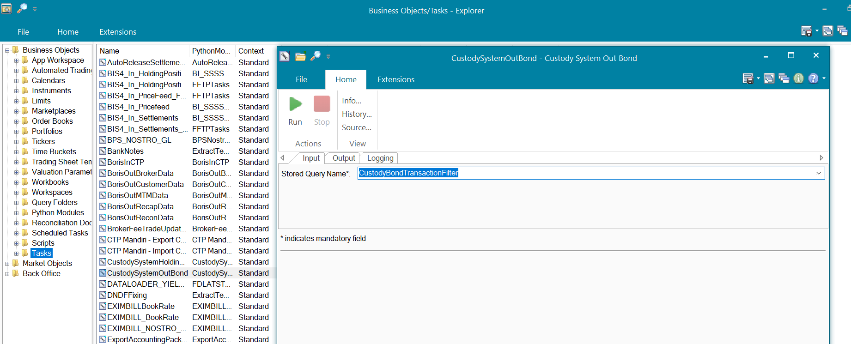

***Output***

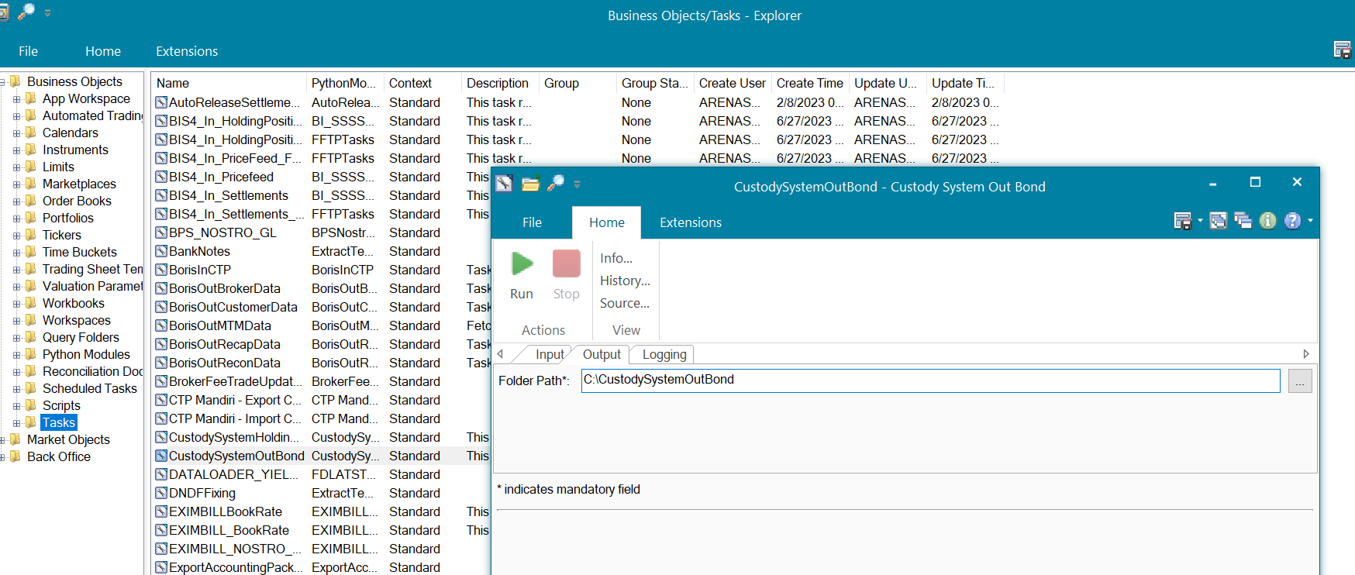

**ATS**



### OPERATING SPECIFICATION

Bond transactions from Front Arena will be sent to Custodian periodically. Interface is developed to capture applicable Bond transaction and sent to Custodian system in specific format.

1. The user will select filtering criteria designed to select applicable trades.
2. Script has been developed to get Bond transactions and convert it in Custodian format. And write in output file.
3. Script will store the output file at specified location.
4. Task has been scheduled to generate output file in every 20 minutes.

The following filter query will be used

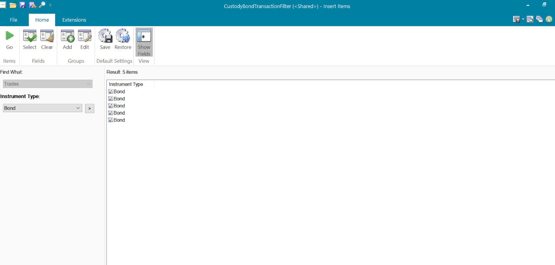

## Eurocleare In holding position

DESCRIPTION

|  |  |  |  |
| --- | --- | --- | --- |
| Interface name | EuroClear – IN - Holding Position | | |
| Type of data | Incoming Swift Message | Frequency | Realtime |
| Source | Swift Gateway | Direction | IN |
| Format | Swift Message | Transfer mechanism | N/A |
| Response Required | N/A | Dependencies on other processes | N/A |
| Purpose | To ignore the incoming swift message with message type as MT535 | | |

Once FA received the incoming swift message from outside FA then this interface will make sure that the incoming message type MT535 will get ignored.

### TECHNICAL ATTRIBUTE

|  |  |
| --- | --- |
| **Attribute** | **Description** |
| Extension Module | PS_CustodySystemEuroClearInHoldingPosition  *It contains code required to ignore the incoming swift message type MT535* |
| Hook | Module- PS_CustomSwift  File – FMTHooks  This is the extension point where user can do customization for incoming message. |

### TECHNICAL ARCHITECTURE

**Front Arena**

Front Arena

ATS Swift Reader

Swift Incoming Message

Swift Hook

Ignore Incoming MT535

Update Addinfo- HoldPosEuroClear

### TECHNICAL FLOW DIAGRAM

ATS Swift Reader

Swift Incoming Message

Swift Hook

Ignore Incoming MT535

Update Addinfo- HoldPosEuroClear

If 19A tag has HOLD

Yes

### LOGIC AND CONFIGURATION

#### Flow Logic

1. FA will received the Swift Incoming message.
2. If Incoming message is for MT535 then it will get ignored by FA.
3. If the message has tag 19A starts with HOLD then update the AdditionalInfo HoldPosEuroClear on instrument.
4. AdditionalInfo will have value as - “UpdateDate_HoldAmount”
5. UpdateDate –value from tag 98A/98C if it starts with STAT
6. HoldAmount – Value from tag 19A if it starts with HOLD

#### Configuration

|  |  |
| --- | --- |
| Delivery Items | |
| Extension Context | +Integration |
| Extension Module | PS_CustodySystemEuroClearInHoldingPosition |
|  |  |
| FA Component | |
| ATS Swift Reader | Swift Reader will read the incoming message and call the FSwiftHook. Where message will get ignored if that is of MT type 535 |
|  |  |
|  |  |
| Deployment and Manual Configuration | |
| This service is deployed through FA standard deployment process.  Manual configuration may be required to update the configuration in FParameter in extension module. | |
|  |  |
| Additional Information | |
| HoldPosEuroClear | AdditionalInfo on Instrument. |
| FParameters | Default values |
| archiveFilePath | C:\temp\mt535\archive |
| inputFilePath | c:\temp\mt535 |
| logFilename | EuroClearInHoldingPosition_LOG_{}.txt |
| logFilePath | c:\temp\log |
| Pre-requisites |  |
| ATS Swift Reader | ATS service for this interface must be running to work this interface. |
| FStoredASQLQuery | Purpose |
|  |  |

#### Data Dictionary

NA

#### A Data Model

Please refer AEF Browser document for details about Front Arena Data Model.

Document - FCA4033

#### B Data Entity and Key Elements Definition

All required details are available in AEF Browser document.

#### C Reference Code Table Definition

Please refer AEF Browser document for details about Front Arena Data Model.

Document - FCA4033

### SECURITY AND CONTROL DESIGN

#### Security Requirement Response

|  |  |  |
| --- | --- | --- |
| **Security Domain** | **Security Requirement** | **Response** |
| User Management | The system must identify users using a unique user identification code before allowing a log-on. | It will be controlled through CDCA application |
| The system must suspend access to a user session after a specified interval of inactivity. | Inactivity of user session will not be applicable  as the integration is in Realtime |
| The system must require user authentication before re-enabling the session. | It will be controlled through CDCA application |
| The system must display a warning message indicating that only authorized use is permitted before allowing users to perform a log-on. | It will be controlled through CDCA application |
| The system must display system information to a user, only after a successful log-on. |  |
| After a successful log-on, the system must display information concerning the previous successful attempt to perform a log-on. | It will not be possible in real-time connections. |
| The system must allow a user account to be manually disabled. | NA |
| The system must disable the user account following 3 (three) consecutive failures to perform a successful log-on. | It will be controlled through CDCA application |
| The system must automatically disable the user account following a configurable period (90 days) without use. |  |
| Password Management | The system must authenticate users using a password before allowing access to any system functions. | Not applicable at Front Arena Database side. |
| The system must ensure that passwords used by system users for log-on consist of at least 8 (eight) characters. | Not applicable at Front Arena Database side. |
| The system must enforce the use of complex passwords for all users. (Aplhanumieric & Special Characters) | Not applicable at Front Arena Database side. |
| The system must use cryptographic techniques to protect the confidentiality of user authentication data during transmission. | Not applicable at Front Arena Database side. |
| The system must enforce a password change when a password is first issued or re-issued. |  |
| The system must allow system users to change the password used for log-on. | Not applicable at Front Arena Database side. |
| The system must ensure that passwords do not remain valid for more than 90 (ninety) days. | Not applicable at Front Arena Database side. |
| The system must ensure that passwords may not be changed to any of the last 5 (five) passwords used. | Not applicable at Front Arena Database side. |
| The system must ensure that passwords are not displayed in clear text during entry. | Not applicable at Front Arena Database side. |
| Multi Factor Authentication | The system must enforce dual factor authentication of all users (system that related to financial, faced to customer directly & only use for external purposes) | Not applicable at Front Arena Database side. |
| Data Storage | The system must use cryptographic techniques to protect the storage of authentication data. | NA |
| The system must use cryptographic techniques to protect the integrity of stored critical data. | NA |
| The system must use cryptographic techniques to protect the confidentiality of stored sensitive data. | NA |
| Logging | The system must support the recording of security events in one or multiple specific security event logs. 2 weeks in minimum must be available at the Production Environment | It will be controlled through CDCA application |
| The system must include the Logical Account identity, event type and timestamp in each entry in the security event logs. | It will be controlled through CDCA application |
| The system must record when each security event lo fills to a configurable limit. | It will be controlled through CDCA application |
| The system must protect the integrity of the information in the security event logs | It will be controlled through CDCA application |
| The system must allow access to the security event logs to be limited to the authorised security staff. | It will be controlled through CDCA application |
| The system must record if the integrity of the security event logs is compromised | NA |
| The system must record all instances that system event logs are cleared. | It will be controlled through CDCA application |
| The system must record when a change is made to the system log settings (e.g. logs for certain events are turned off). | It will be controlled through CDCA application |
| The system must record when any system security policy is modified. | NA |
| The system must record all creations of Logical Accounts. | It will be controlled through CDCA application |
| The system must record all deletions of Logical Accounts. |  |
| The system must record all de-activation of Logical Accounts. |  |
| The system must record all unsuccessful attempts to log-on to the system using invalid credentials. |  |
| The system must record all successful attempts to log-on to the system. |  |
| The system must record all successful and unsuccessful attempts to change passwords. |  |
| The system must automatically build and maintain a normal usage pattern for each Logical Account. |  |
| The system must record all activation of disabled Logical Accounts. |  |
| The system must record all attempts to change any account attribute affecting authentication of the Logical Account |  |
| The system must record all allocations of system access rights. |  |
| The system must record all removals of system access rights. |  |
| The system must record all unauthorised attempts to access a system function. |  |
| The system must record when a configurable deviation from a Logical Account's normal pattern is detected. |  |
| The system must record all failures of the check on the timestamp of payment and settlement orders. |  |
| The system must record all attempts to mutually authenticate interface connections that handle critical data |  |
| The system must record all events that may indicate an attempt to cause denial of service. |  |
| The system must record all access to functions processing critical information within the system. |  |
| The system must record all access to sensitive information within the system. |  |
| The system must record all start-up and shut down events. |  |
| The system must have been integrated in the SIEM, Identity Management System & Privilege Identity Management System |  |
| Remote Access | The system logical access control mechanism must be able to discretely grant remote access capability to specific users and user groups. |  |
| The system must strictly limit user access rights to their minimum requirements when they access the system remotely. |  |
| All relevant approvals must be obtained if this application is to be made available for remote use (E.g. on the RCA-portal) by Users |  |
| System Interfaces | The system must use a logical access control mechanism to control system to system data communications, in order to avoid anonymous data transfers (for all interfaces) |  |
| The system must ensure that system to system mutual authentication takes place before data communications are allowed (for all interfaces) |  |
| System to system mutual authentication must be based on cryptographic techniques (for all interfaces) |  |
| The system must use cryptographic techniques to protect the integrity of critical data during transmission (for all interfaces) |  |
| The system must use cryptographic techniques to protect the confidentiality of sensitive data during transmission (for all interfaces) |  |
| All 'critical data' must have been identified, documented and approved by the Business |  |
| All 'confidential data' must have been identified, documented and approved by the Business |  |
| Availability | The system must have a documented and successfully tested disaster recovery plan in place | It will be managed through Front Arena Database DR setup. |
| The system must enforce quotas limiting the maximum resources that an individual user can use simultaneously. |  |
| The system must provide adequate resources to support the required number of users or concurrent users. |  |
| The system should have a documented capacity monitoring process in-place with regular reporting on its use |  |
| Security Testing | The system must be tested for specific technical security flaws where it faces the public internet, prior to release into production. |  |
| The system must only be released into production, where it faces the public internet, once all identified key findings from the security test have been rectified, or if this is not possible, the risks must be formally reviewed and signed off |  |
| The system must be tested for specific technical security flaws prior to release into production. |  |
| The system must only be released into production once all the identified key findings from the security tests have been rectified or if this is not possible, the risks must be formally reviewed and signed off |  |

#### Preventive controls

*<This sub-section describe the technical specification for preventive controls that are specific to this module. This includes logical access control, physical security control, encryption, PIN generation and validation, etc>*

*<Sample of list of Role Table and Authorization Matrix>*

|  |  |  |  |
| --- | --- | --- | --- |
| **No** | **Role** | **Authorization** | **Object** |
| 1 | Role1 | ZXXXX | Maintain |
| 2 | Role2 | ZYYYY | Display |
| 3 |  |  |  |

|  |  |  |  |  |  |  |
| --- | --- | --- | --- | --- | --- | --- |
| **No** | **User Group** | **Role1** | **Role2** | **Role3** | **Role4** | **Role5** |
| 1 | User Group1 | X | X |  | X |  |
| 2 | User Group2 |  | X | X |  | X |
|  |  |  |  |  |  |  |

#### Detective controls

*<This sub-section describe the technical specification for detective controls that are specific to this module. This includes audit trail, exception reports, reconciliation, balancing & control totals, validations, etc>.*

#### Corrective controls

*<This sub-section describes the technical specification for corrective controls that are specific to this module. This includes automated error corrections, backup, recovery & restart, etc>.*

### USER INTERFACE

If required, the user can use this script to process any pending or failed incoming message if any.

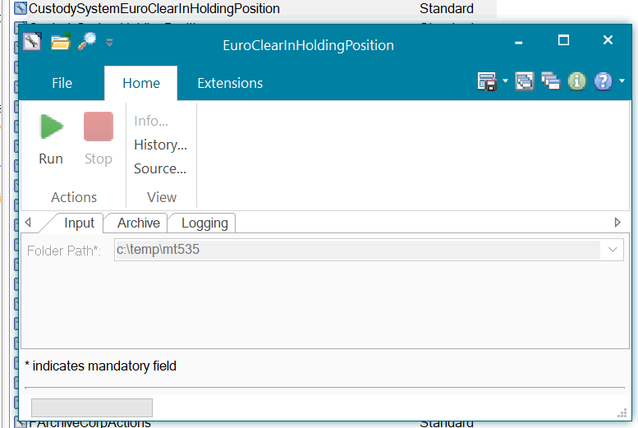

### OPERATING SPECIFICATION

NA

## Custody System-IN-holding Position

DESCRIPTION

|  |  |  |  |
| --- | --- | --- | --- |
| **Interface name** | Custody System – Holding Position | | |
| **Type of data** | Holding Position | **Frequency** | Batch |
| **Source** | Custody Mandiri System | **Direction** | IN |
| **Format** | ETL | **Transfer mechanism** | Database Connection |
| **Response Required** | N/A | **Dependencies on other processes** |  |
| **Purpose** | Store Holding position from Custody system for reporting purpose | | |

For reconciliation purpose, holding positions for Bond securities will be uploaded in FA. Holding position details will be received from custody systems – Mandiri

Bank Mandiri will have external database from where, FA need to take holding position.

### TECHNICAL ATTRIBUTE

|  |  |
| --- | --- |
| **Attribute** | **Description** |
| Extension Module | *BM_CustodySystemHoldingPosition* |
| ATS | *ATS_INTEGRATIONS* |

### TECHNICAL ARCHITECTURE

Prime

ATS Integrations

Custody Online

**Front Arena**

Database Connection

ADS

CustodySystemHoldingPosition

Task

**Custody System**

### TECHNICAL FLOW DIAGRAM

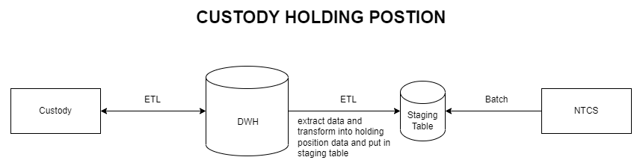

### LOGIC AND CONFIGURATION

#### Flow Logic

1. Script will be created to connect to a staging database located outside FrontArena..

2. The script will query the staging database for Instruments where Instrument alias is for Mandiri Custody.

3. If the instrument is found in FA the holding position will be stored on FA Instrument (ISIN) Additional information. The format of the holding position stored is YYMMDD_<HoldingPositonAmount>

4. Custom report will be created in FA (Trading Manager application) to display FA position,

Holding position from Custodian and reconciliation result. Custom column needs to be

created wherever applicable.

### Configuration

|  |  |
| --- | --- |
| Delivery Items | |
| Extension Context | +CUSTODY_SYSTEM |
| Extension Module | *BM_CustodySystemHoldingPosition* |
| ATS Service | ATS Integrations |
|  |  |
| FA Component | |
| ATS | ATS Integrations |
|  |  |
| Deployment and Manual Configuration | |
| This service is deployed through FA standard deployment process.  Manual configuration may be required to update the configuration in FParameter in extension module. | |
|  |  |
| Additional Information | |
| Add info | HoldPosCustody |
| FParameters | Default values |
| DRIVER | ODBC Driver 17 for SQL Server |
| REC_FETCH_PAGE_SIZE | 50 |
| Pre-requisites |  |
| Pre-requisite | A valid folder should be present as pre requisite |
|  |  |
| FStoredASQLQuery | Purpose |
| No stored query has been used. | |

#### Data Dictionary

NA

#### A Data Model

Please refer AEF Browser document for details about Front Arena Data Model.

Document - FCA4033

#### B Data Entity and Key Elements Definition

All required details are available in AEF Browser document.

#### C Reference Code Table Definition

Please refer AEF Browser document for details about Front Arena Data Model.

Document - FCA4033

### SECURITY AND CONTROL DESIGN

#### Security Requirement Response

|  |  |  |
| --- | --- | --- |
| **Security Domain** | **Security Requirement** | **Response** |
| User Management | The system must identify users using a unique user identification code before allowing a log-on. | It will be controlled through CDCA application |
| The system must suspend access to a user session after a specified interval of inactivity. | Inactivity of user session will not be applicable  as the integration is in Realtime |
| The system must require user authentication before re-enabling the session. | It will be controlled through CDCA application |
| The system must display a warning message indicating that only authorized use is permitted before allowing users to perform a log-on. | It will be controlled through CDCA application |
| The system must display system information to a user, only after a successful log-on. |  |
| After a successful log-on, the system must display information concerning the previous successful attempt to perform a log-on. | It will not be possible in real-time connections. |
| The system must allow a user account to be manually disabled. | NA |
| The system must disable the user account following 3 (three) consecutive failures to perform a successful log-on. | It will be controlled through CDCA application |
| The system must automatically disable the user account following a configurable period (90 days) without use. |  |
| Password Management | The system must authenticate users using a password before allowing access to any system functions. | Not applicable at Front Arena Database side. |
| The system must ensure that passwords used by system users for log-on consist of at least 8 (eight) characters. | Not applicable at Front Arena Database side. |
| The system must enforce the use of complex passwords for all users. (Aplhanumieric & Special Characters) | Not applicable at Front Arena Database side. |
| The system must use cryptographic techniques to protect the confidentiality of user authentication data during transmission. | Not applicable at Front Arena Database side. |
| The system must enforce a password change when a password is first issued or re-issued. |  |
| The system must allow system users to change the password used for log-on. | Not applicable at Front Arena Database side. |
| The system must ensure that passwords do not remain valid for more than 90 (ninety) days. | Not applicable at Front Arena Database side. |
| The system must ensure that passwords may not be changed to any of the last 5 (five) passwords used. | Not applicable at Front Arena Database side. |
| The system must ensure that passwords are not displayed in clear text during entry. | Not applicable at Front Arena Database side. |
| Multi Factor Authentication | The system must enforce dual factor authentication of all users (system that related to financial, faced to customer directly & only use for external purposes) | Not applicable at Front Arena Database side. |
| Data Storage | The system must use cryptographic techniques to protect the storage of authentication data. | NA |
| The system must use cryptographic techniques to protect the integrity of stored critical data. | NA |
| The system must use cryptographic techniques to protect the confidentiality of stored sensitive data. | NA |
| Logging | The system must support the recording of security events in one or multiple specific security event logs. 2 weeks in minimum must be available at the Production Environment | It will be controlled through CDCA application |
| The system must include the Logical Account identity, event type and timestamp in each entry in the security event logs. | It will be controlled through CDCA application |
| The system must record when each security event lo fills to a configurable limit. | It will be controlled through CDCA application |
| The system must protect the integrity of the information in the security event logs | It will be controlled through CDCA application |
| The system must allow access to the security event logs to be limited to the authorised security staff. | It will be controlled through CDCA application |
| The system must record if the integrity of the security event logs is compromised | NA |
| The system must record all instances that system event logs are cleared. | It will be controlled through CDCA application |
| The system must record when a change is made to the system log settings (e.g. logs for certain events are turned off). | It will be controlled through CDCA application |
| The system must record when any system security policy is modified. | NA |
| The system must record all creations of Logical Accounts. | It will be controlled through CDCA application |
| The system must record all deletions of Logical Accounts. |  |
| The system must record all de-activation of Logical Accounts. |  |
| The system must record all unsuccessful attempts to log-on to the system using invalid credentials. |  |
| The system must record all successful attempts to log-on to the system. |  |
| The system must record all successful and unsuccessful attempts to change passwords. |  |
| The system must automatically build and maintain a normal usage pattern for each Logical Account. |  |
| The system must record all activation of disabled Logical Accounts. |  |
| The system must record all attempts to change any account attribute affecting authentication of the Logical Account |  |
| The system must record all allocations of system access rights. |  |
| The system must record all removals of system access rights. |  |
| The system must record all unauthorised attempts to access a system function. |  |
| The system must record when a configurable deviation from a Logical Account's normal pattern is detected. |  |
| The system must record all failures of the check on the timestamp of payment and settlement orders. |  |
| The system must record all attempts to mutually authenticate interface connections that handle critical data |  |
| The system must record all events that may indicate an attempt to cause denial of service. |  |
| The system must record all access to functions processing critical information within the system. |  |
| The system must record all access to sensitive information within the system. |  |
| The system must record all start-up and shut down events. |  |
| The system must have been integrated in the SIEM, Identity Management System & Privilege Identity Management System |  |
| Remote Access | The system logical access control mechanism must be able to discretely grant remote access capability to specific users and user groups. |  |
| The system must strictly limit user access rights to their minimum requirements when they access the system remotely. |  |
| All relevant approvals must be obtained if this application is to be made available for remote use (E.g. on the RCA-portal) by Users |  |
| System Interfaces | The system must use a logical access control mechanism to control system to system data communications, in order to avoid anonymous data transfers (for all interfaces) |  |
| The system must ensure that system to system mutual authentication takes place before data communications are allowed (for all interfaces) |  |
| System to system mutual authentication must be based on cryptographic techniques (for all interfaces) |  |
| The system must use cryptographic techniques to protect the integrity of critical data during transmission (for all interfaces) |  |
| The system must use cryptographic techniques to protect the confidentiality of sensitive data during transmission (for all interfaces) |  |
| All 'critical data' must have been identified, documented and approved by the Business |  |
| All 'confidential data' must have been identified, documented and approved by the Business |  |
| Availability | The system must have a documented and successfully tested disaster recovery plan in place | It will be managed through Front Arena Database DR setup. |
| The system must enforce quotas limiting the maximum resources that an individual user can use simultaneously. |  |
| The system must provide adequate resources to support the required number of users or concurrent users. |  |
| The system should have a documented capacity monitoring process in-place with regular reporting on its use |  |
| Security Testing | The system must be tested for specific technical security flaws where it faces the public internet, prior to release into production. |  |
| The system must only be released into production, where it faces the public internet, once all identified key findings from the security test have been rectified, or if this is not possible, the risks must be formally reviewed and signed off |  |
| The system must be tested for specific technical security flaws prior to release into production. |  |
| The system must only be released into production once all the identified key findings from the security tests have been rectified or if this is not possible, the risks must be formally reviewed and signed off |  |

#### Preventive controls

*<This sub-section describe the technical specification for preventive controls that are specific to this module. This includes logical access control, physical security control, encryption, PIN generation and validation, etc>*

*<Sample of list of Role Table and Authorization Matrix>*

|  |  |  |  |
| --- | --- | --- | --- |
| **No** | **Role** | **Authorization** | **Object** |
| 1 | Role1 | ZXXXX | Maintain |
| 2 | Role2 | ZYYYY | Display |
| 3 |  |  |  |

|  |  |  |  |  |  |  |
| --- | --- | --- | --- | --- | --- | --- |
| **No** | **User Group** | **Role1** | **Role2** | **Role3** | **Role4** | **Role5** |
| 1 | User Group1 | X | X |  | X |  |
| 2 | User Group2 |  | X | X |  | X |
|  |  |  |  |  |  |  |

#### Detective controls

*<This sub-section describe the technical specification for detective controls that are specific to this module. This includes audit trail, exception reports, reconciliation, balancing & control totals, validations, etc>.*

#### Corrective controls

*<This sub-section describes the technical specification for corrective controls that are specific to this module. This includes automated error corrections, backup, recovery & restart, etc>.*

### USER INTERFACE

If required, the user can trigger the process, by using the task GUI *CustodySystemOutBond.*

***Task***

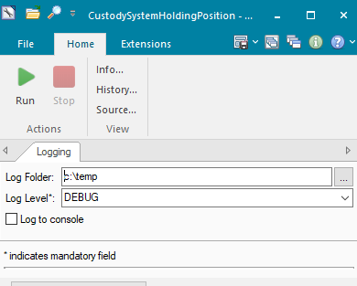

**ATS**



### OPERATING SPECIFICATION

For reconciliation purpose, holding positions for Bond securities will uploaded in FA. Holding position details will be received from custody systems - Mandiri

Bank Mandiri will have external database from where, FA need to take holding position.

1. Script has been created to connect to external database.
2. Script will query to database for holding position for Instruments where Instrument alias is for Mandiri custody. Script will store the output file at specified location.
3. Holding position will be stored on FA Instrument (ISIN) Additional information.
4. Custom report will be created in FA (Trading Manager application) to display FA position, Holding position from Custodian and reconciliation result. Custom column needs to be created wherever applicable.

The following filter Addinfo will be used.

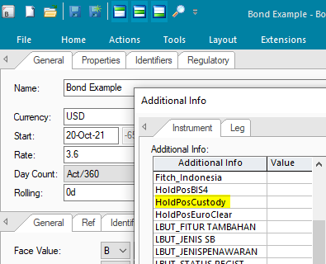

# **EMAS**

## Account Inquiry

DESCRIPTION

There will be separate communication to get details of each account belongs to the party in FA. Request should send the Account number, so eMAS system can reply to details for that account number. Account details like Account type, status, Branch code will be stored on respective account. The main purpose of this interface to check the Balance before sending settlement records to eMAS. This interface only applies when FrontArena will debit account customer. FrontArena will check sufficient balance for amount debit.

### TECHNICAL ATTRIBUTE

|  |  |
| --- | --- |
| **Attribute** | **Description** |
| Extension Module | PS_eMASAccountingSettlementExport  *It contains the code required to send the account inquiry request and handle the response both in JSON format.* |
| AMBA | AMBA_EMAS  *AMBA sender hook is configured to capture settlement update events and send the account details to EMAS.* |

### TECHNICAL ARCHITECTURE

FrontArena eMAS System

Capture Settlement update and send request to eMAS

Response to FA in

JSON format.

Request from FA in

JSON format.

Handles response from eMAS

AMBA

Generate Settlement

Generate Trade

Prime

ATS Settlement

EMAS Webserver

### TECHNICAL FLOW DIAGRAM

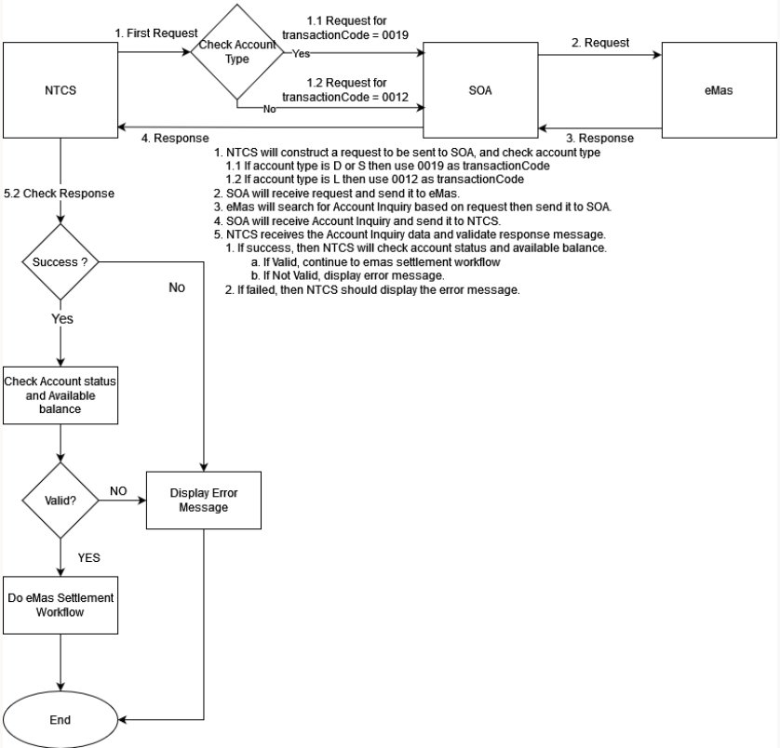

### LOGIC AND CONFIGURATION

#### Flow Logic

1. Script will be developed to capture settlement information created in real-time.
2. Settlement information will be transformed into eMAS Web API format.
3. Perform Account inquiry, to validate Account status and balance.
4. If the account status is active (1) and account has adequate amount, proceed with flow further (send settlement account records to eMAS, covered under Accounting Settlement Export).

#### Configuration

|  |  |
| --- | --- |
| Delivery Items | |
| Extension Context | +Integration |
| Extension Module | PS_eMASAccountingSettlementExport |
| AMBA service | AMBA_EMAS |
|  |  |
| FA Component | |
| AMBA | AMBA service – AMBA_EMAS is used to capture settlements with released status and send the request to eMAS web service. |
|  |  |
| Deployment and Manual Configuration | |
| This service is deployed through FA standard deployment process.  Manual configuration may be required to update the configuration in FParameter in extension module. | |
|  |  |
| Additional Information | |
| No additional information field is used. | |
| FParameters | Default values |
| eMASAccountInquiryParams | |
| ApiKey | 638f2361-cd12-4fad-bfc9-d0c14aabf2f9 |
| BranchNumber | 10 |
| ChannelId | 11 |
| Timeout | 30 |
| Url | /gateway/CoreBankAccountInquiry/1.0/accountInquiry |
| Pre-requisites |  |
| AMBA service | AMBA service for this interface must be running to work this interface. |
| FStoredASQLQuery | Purpose |
| No FStoredASQLQuery is used. | |

#### Data Dictionary

Following are field mapping done for this interface. The API mappings are specified unders corresponding interface name.



#### A Data Model

Please refer AEF Browser document for details about Front Arena Data Model.

Document - FCA4033

#### B Data Entity and Key Elements Definition

All required details are available in AEF Browser document.

#### C Reference Code Table Definition

Please refer AEF Browser document for details about Front Arena Data Model.

Document - FCA4033

### SECURITY AND CONTROL DESIGN

#### Security Requirement Response

|  |  |  |
| --- | --- | --- |
| **Security Domain** | **Security Requirement** | **Response** |
| User Management | The system must identify users using a unique user identification code before allowing a log-on. | It will be controlled through CDCA application |
| The system must suspend access to a user session after a specified interval of inactivity. | Inactivity of user session will not be applicable  as the integration is in Realtime |
| The system must require user authentication before re-enabling the session. | It will be controlled through CDCA application |
| The system must display a warning message indicating that only authorized use is permitted before allowing users to perform a log-on. | It will be controlled through CDCA application |
| The system must display system information to a user, only after a successful log-on. |  |
| After a successful log-on, the system must display information concerning the previous successful attempt to perform a log-on. | It will not be possible in real-time connections. |
| The system must allow a user account to be manually disabled. | NA |
| The system must disable the user account following 3 (three) consecutive failures to perform a successful log-on. | It will be controlled through CDCA application |
| The system must automatically disable the user account following a configurable period (90 days) without use. |  |
| Password Management | The system must authenticate users using a password before allowing access to any system functions. | Not applicable at Front Arena Database side. |
| The system must ensure that passwords used by system users for log-on consist of at least 8 (eight) characters. | Not applicable at Front Arena Database side. |
| The system must enforce the use of complex passwords for all users. (Aplhanumieric & Special Characters) | Not applicable at Front Arena Database side. |
| The system must use cryptographic techniques to protect the confidentiality of user authentication data during transmission. | Not applicable at Front Arena Database side. |
| The system must enforce a password change when a password is first issued or re-issued. |  |
| The system must allow system users to change the password used for log-on. | Not applicable at Front Arena Database side. |
| The system must ensure that passwords do not remain valid for more than 90 (ninety) days. | Not applicable at Front Arena Database side. |
| The system must ensure that passwords may not be changed to any of the last 5 (five) passwords used. | Not applicable at Front Arena Database side. |
| The system must ensure that passwords are not displayed in clear text during entry. | Not applicable at Front Arena Database side. |
| Multi Factor Authentication | The system must enforce dual factor authentication of all users (system that related to financial, faced to customer directly & only use for external purposes) | Not applicable at Front Arena Database side. |
| Data Storage | The system must use cryptographic techniques to protect the storage of authentication data. | NA |
| The system must use cryptographic techniques to protect the integrity of stored critical data. | NA |
| The system must use cryptographic techniques to protect the confidentiality of stored sensitive data. | NA |
| Logging | The system must support the recording of security events in one or multiple specific security event logs. 2 weeks in minimum must be available at the Production Environment | It will be controlled through CDCA application |
| The system must include the Logical Account identity, event type and timestamp in each entry in the security event logs. | It will be controlled through CDCA application |
| The system must record when each security event lo fills to a configurable limit. | It will be controlled through CDCA application |
| The system must protect the integrity of the information in the security event logs | It will be controlled through CDCA application |
| The system must allow access to the security event logs to be limited to the authorised security staff. | It will be controlled through CDCA application |
| The system must record if the integrity of the security event logs is compromised | NA |
| The system must record all instances that system event logs are cleared. | It will be controlled through CDCA application |
| The system must record when a change is made to the system log settings (e.g. logs for certain events are turned off). | It will be controlled through CDCA application |
| The system must record when any system security policy is modified. | NA |
| The system must record all creations of Logical Accounts. | It will be controlled through CDCA application |
| The system must record all deletions of Logical Accounts. |  |
| The system must record all de-activation of Logical Accounts. |  |
| The system must record all unsuccessful attempts to log-on to the system using invalid credentials. |  |
| The system must record all successful attempts to log-on to the system. |  |
| The system must record all successful and unsuccessful attempts to change passwords. |  |
| The system must automatically build and maintain a normal usage pattern for each Logical Account. |  |
| The system must record all activation of disabled Logical Accounts. |  |
| The system must record all attempts to change any account attribute affecting authentication of the Logical Account |  |
| The system must record all allocations of system access rights. |  |
| The system must record all removals of system access rights. |  |
| The system must record all unauthorised attempts to access a system function. |  |
| The system must record when a configurable deviation from a Logical Account's normal pattern is detected. |  |
| The system must record all failures of the check on the timestamp of payment and settlement orders. |  |
| The system must record all attempts to mutually authenticate interface connections that handle critical data |  |
| The system must record all events that may indicate an attempt to cause denial of service. |  |
| The system must record all access to functions processing critical information within the system. |  |
| The system must record all access to sensitive information within the system. |  |
| The system must record all start-up and shut down events. |  |
| The system must have been integrated in the SIEM, Identity Management System & Privilege Identity Management System |  |
| Remote Access | The system logical access control mechanism must be able to discretely grant remote access capability to specific users and user groups. |  |
| The system must strictly limit user access rights to their minimum requirements when they access the system remotely. |  |
| All relevant approvals must be obtained if this application is to be made available for remote use (E.g. on the RCA-portal) by Users |  |
| System Interfaces | The system must use a logical access control mechanism to control system to system data communications, in order to avoid anonymous data transfers (for all interfaces) |  |
| The system must ensure that system to system mutual authentication takes place before data communications are allowed (for all interfaces) |  |
| System to system mutual authentication must be based on cryptographic techniques (for all interfaces) |  |
| The system must use cryptographic techniques to protect the integrity of critical data during transmission (for all interfaces) |  |
| The system must use cryptographic techniques to protect the confidentiality of sensitive data during transmission (for all interfaces) |  |
| All 'critical data' must have been identified, documented and approved by the Business |  |
| All 'confidential data' must have been identified, documented and approved by the Business |  |
| Availability | The system must have a documented and successfully tested disaster recovery plan in place | It will be managed through Front Arena Database DR setup. |
| The system must enforce quotas limiting the maximum resources that an individual user can use simultaneously. |  |
| The system must provide adequate resources to support the required number of users or concurrent users. |  |
| The system should have a documented capacity monitoring process in-place with regular reporting on its use |  |
| Security Testing | The system must be tested for specific technical security flaws where it faces the public internet, prior to release into production. |  |
| The system must only be released into production, where it faces the public internet, once all identified key findings from the security test have been rectified, or if this is not possible, the risks must be formally reviewed and signed off |  |
| The system must be tested for specific technical security flaws prior to release into production. |  |
| The system must only be released into production once all the identified key findings from the security tests have been rectified or if this is not possible, the risks must be formally reviewed and signed off |  |

#### Preventive controls

*<This sub-section describe the technical specification for preventive controls that are specific to this module. This includes logical access control, physical security control, encryption, PIN generation and validation, etc>*

*<Sample of list of Role Table and Authorization Matrix>*

|  |  |  |  |
| --- | --- | --- | --- |
| **No** | **Role** | **Authorization** | **Object** |
| 1 | Role1 | ZXXXX | Maintain |
| 2 | Role2 | ZYYYY | Display |
| 3 |  |  |  |

|  |  |  |  |  |  |  |
| --- | --- | --- | --- | --- | --- | --- |
| **No** | **User Group** | **Role1** | **Role2** | **Role3** | **Role4** | **Role5** |
| 1 | User Group1 | X | X |  | X |  |
| 2 | User Group2 |  | X | X |  | X |
|  |  |  |  |  |  |  |

#### Detective controls

*<This sub-section describe the technical specification for detective controls that are specific to this module. This includes audit trail, exception reports, reconciliation, balancing & control totals, validations, etc>.*

#### Corrective controls

*<This sub-section describes the technical specification for corrective controls that are specific to this module. This includes automated error corrections, backup, recovery & restart, etc>.*

### USER INTERFACE

This interface is consumed from the interface eMAS – Accounting Settlement Export and hence it does not have any user interface.

### OPERATING SPECIFICATION

The connection from FrontArena to eMAS is web-based URL. This connection is real time connection, and the request and response are interchanged in a synchronous manner.

1. The user will generate the settlements and release it.
2. The script will process all the eligible settlements based on the predefined query.
3. The settlement request in the JSON format will be sent to the Webserver.
4. Webserver send the response the script in FrontArena. Depending on the response further action is taken care by the parent interface.

Following is the request that is sent to the eMAS server.

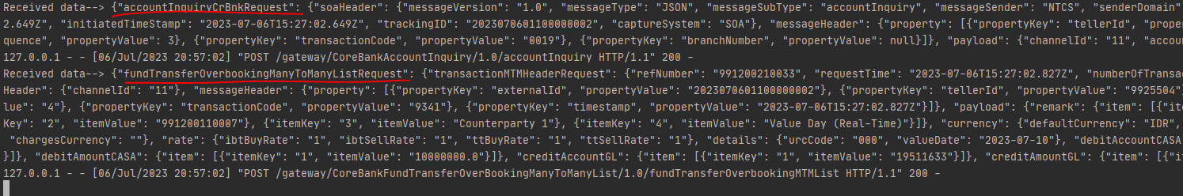

## eMAS – Accounting Settlement Export

### DESCRIPTION

|  |  |  |  |
| --- | --- | --- | --- |
| **Interface name** | Accounting settlement Export | | |
| **Type of data** | Custom – FA Settlement information | **Frequency** | Realtime |
| **Source** | FA | **Direction** |  |
| **Format** | JSON | **Transfer mechanism** | Web API |
| **Response Required** | N/A | **Dependencies on other processes** | FA Settlement |
| **Purpose** | Accounting information from FA generated settlements, needs to be transferred to Core Banking system- eMAS | | |

Functionality will be developed to fetch all required accounting information from FA settlements and send it in Real-time to eMAS system using Web API.

Following conditions will be checked to select settlement information:

• Settlement status - Released

• Settlement value date - Today

Front Arena settlements for eMAS system only will be considered for this interface. These settlements are not considered for SWIFT or any other systems for same purpose.

Account inquiry interface should be triggered to validate Account status and Balance, before sending settlement information to core banking. This accounting settlement interface will be triggered based on Account status and balance validation.

### TECHNICAL ATTRIBUTE

|  |  |
| --- | --- |
| **Attribute** | **Description** |
| Extension Module | PS_eMASAccountingSettlementExport  *It contains the code required to send the settlement account information request and handle the response both in JSON format.* |
| AMBA | AMBA_EMAS  *AMBA sender hook is configured to capture settlement update events and send the account details to EMAS.* |

### TECHNICAL ARCHITECTURE

FrontArena eMAS System

Capture Settlement update and send request to eMAS

Response to FA in

JSON format.

Request from FA in

JSON format.

Handles response from eMAS

AMBA

Generate Settlement

Generate Trade

Prime

ATS Settlement

EMAS Webserver

### TECHNICAL FLOW DIAGRAM



### LOGIC AND CONFIGURATION

#### Flow Logic

1. AMBA sender modify script is used to capture settlement information in real-time. AMBA script checks the eligible settlements using the settlement filter query *eMASAccountingSettlementExport* and processes them further.
2. AMBA captures the settlement update in real time and the information is transformed into eMAS Web API JSON format.
3. If the counterparty account is to be debited account inquiry request is sent to eMAS, otherwise the account inquiry is not required. This is done to validate Account status and Balance.
4. If the account inquiry is successful or not needed settlement records (transformed) for each trade in FrontArena, will be sent in separate request message. If the account inquiry is not successful, the settlement status is set to NACK and settlement record is not sent to eMAS.
5. Based on response from eMAS, status on Settlement in FrontArena (standard field) will be updated to NACK (for error) or ACK (for successful). A failed settlement can be moved from NACK to Authorized as per standard settlement workflow.
6. In case of manual release of settlement, user can select multiple settlements and perform settlement Release manually.
7. This module runs continually to send settlement information to eMAS in real time.
8. Request for transaction status inquiry will be sent to eMAS based on response for fund transfer request. If the response for the fund transfer times out, request for transaction status inquiry will get triggered. Settlement in FrontArena will be set to Acknowledged or NotAcknowledged based on the response of status inquiry.
9. Request for transaction status inquiry can also be invoked manually using the context menu on the settlement on the Settlement sheet.

#### Configuration

|  |  |
| --- | --- |
| Delivery Items | |
| Extension Context | +Integration |
| Extension Module | PS_eMASAccountingSettlementExport |
|  |  |
| FA Component | |
| AMBA | AMBA service – AMBA_EMAS is used to capture settlements with released status and send the request to eMAS web service |
|  |  |
| Deployment and Manual Configuration | |
| The script and AMBA is deployed through FA standard deployment process.  Manual configuration may be required to update the configuration in FParameter in extension module. | |
|  |  |
| Additional Information | |
| EMASInquirSetlment | This add info is used internally for invoking the transaction inquiry request manually using the menu. It does not carry any functional mapping. |
| EMASSetlTellerId | This add info is used to map the teller id to be used for the transaction inquiry request. This is basically the teller id of the original fund transfer request. |
| EMASSetlSeqNum | This add info is used to map the sequence number to be used for the transaction inquiry request. This is basically the sequence number of the original fund transfer request. |
| AEL GUI Task | |
| No task GUI has been used in this interface. | |
| FParameters | Default values |
| eMASAccountingSettlementExportParams | |
| AccountingInstruction | Value Day (Real-Time). This is the name of the accounting instruction. |
| ApiKey | 638f2361-cd12-4fad-bfc9-d0c14aabf2f9 |
| BranchNumber | 10 |
| ChannelId | 11 |
| ClientIP | 1.1.1.1 |
| DefaultTellerId | 9925504 |
| SettlementFilter | eMASAccountingSettlementExport |
| SuspenseAccount | ALL AKUN SUSPEND TRANSAKSI TREASURY |
| Timeout | 30 |
| Url | /gateway/  CoreBankFundTransferOverBookingManyToManyList  /1.0/fundTransferOverbookingMTMList |
| FStoredASQLQuery | |
| eMASAccountingSettlementExport | This query checks the eligible settlement. |
| Pre-requisites |  |
| AMBA service | AMBA service for this interface must be running to work this interface. |
| Query Folder | Query folder with name specified in Parameters, must be available, so that program can extract settlements through that query folder. |
| eMAS connection | Connection to eMAS server must be live. |

#### Data Dictionary

Please refer attached Data Mapping file and sample input file

Following are field mapping done for this interface.



#### A Data Model

Please refer AEF Browser document for details about Front Arena Data Model.

Document - FCA4033

#### B Data Entity and Key Elements Definition

All required details are available in AEF Browser document.

#### C Reference Code Table Definition

Please refer AEF Browser document for details about Front Arena Data Model.

Document - FCA4033

### SECURITY AND CONTROL DESIGN

#### Security Requirement Response

|  |  |  |
| --- | --- | --- |
| **Security Domain** | **Security Requirement** | **Response** |
| User Management | The system must identify users using a unique user identification code before allowing a log-on. | It will be controlled through CDCA application |
| The system must suspend access to a user session after a specified interval of inactivity. | Inactivity of user session will not be applicable  as the integration is in Realtime |
| The system must require user authentication before re-enabling the session. | It will be controlled through CDCA application |
| The system must display a warning message indicating that only authorized use is permitted before allowing users to perform a log-on. | It will be controlled through CDCA application |
| The system must display system information to a user, only after a successful log-on. |  |
| After a successful log-on, the system must display information concerning the previous successful attempt to perform a log-on. | It will not be possible in real-time connections. |
| The system must allow a user account to be manually disabled. | NA |
| The system must disable the user account following 3 (three) consecutive failures to perform a successful log-on. | It will be controlled through CDCA application |
| The system must automatically disable the user account following a configurable period (90 days) without use. |  |
| Password Management | The system must authenticate users using a password before allowing access to any system functions. | Not applicable at Front Arena Database side. |
| The system must ensure that passwords used by system users for log-on consist of at least 8 (eight) characters. | Not applicable at Front Arena Database side. |
| The system must enforce the use of complex passwords for all users. (Aplhanumieric & Special Characters) | Not applicable at Front Arena Database side. |
| The system must use cryptographic techniques to protect the confidentiality of user authentication data during transmission. | Not applicable at Front Arena Database side. |
| The system must enforce a password change when a password is first issued or re-issued. |  |
| The system must allow system users to change the password used for log-on. | Not applicable at Front Arena Database side. |
| The system must ensure that passwords do not remain valid for more than 90 (ninety) days. | Not applicable at Front Arena Database side. |
| The system must ensure that passwords may not be changed to any of the last 5 (five) passwords used. | Not applicable at Front Arena Database side. |
| The system must ensure that passwords are not displayed in clear text during entry. | Not applicable at Front Arena Database side. |
| Multi Factor Authentication | The system must enforce dual factor authentication of all users (system that related to financial, faced to customer directly & only use for external purposes) | Not applicable at Front Arena Database side. |
| Data Storage | The system must use cryptographic techniques to protect the storage of authentication data. | NA |
| The system must use cryptographic techniques to protect the integrity of stored critical data. | NA |
| The system must use cryptographic techniques to protect the confidentiality of stored sensitive data. | NA |
| Logging | The system must support the recording of security events in one or multiple specific security event logs. 2 weeks in minimum must be available at the Production Environment | It will be controlled through CDCA application |
| The system must include the Logical Account identity, event type and timestamp in each entry in the security event logs. | It will be controlled through CDCA application |
| The system must record when each security event lo fills to a configurable limit. | It will be controlled through CDCA application |
| The system must protect the integrity of the information in the security event logs | It will be controlled through CDCA application |
| The system must allow access to the security event logs to be limited to the authorised security staff. | It will be controlled through CDCA application |
| The system must record if the integrity of the security event logs is compromised | NA |
| The system must record all instances that system event logs are cleared. | It will be controlled through CDCA application |
| The system must record when a change is made to the system log settings (e.g. logs for certain events are turned off). | It will be controlled through CDCA application |
| The system must record when any system security policy is modified. | NA |
| The system must record all creations of Logical Accounts. | It will be controlled through CDCA application |
| The system must record all deletions of Logical Accounts. |  |
| The system must record all de-activation of Logical Accounts. |  |
| The system must record all unsuccessful attempts to log-on to the system using invalid credentials. |  |
| The system must record all successful attempts to log-on to the system. |  |
| The system must record all successful and unsuccessful attempts to change passwords. |  |
| The system must automatically build and maintain a normal usage pattern for each Logical Account. |  |
| The system must record all activation of disabled Logical Accounts. |  |
| The system must record all attempts to change any account attribute affecting authentication of the Logical Account |  |
| The system must record all allocations of system access rights. |  |
| The system must record all removals of system access rights. |  |
| The system must record all unauthorised attempts to access a system function. |  |
| The system must record when a configurable deviation from a Logical Account's normal pattern is detected. |  |
| The system must record all failures of the check on the timestamp of payment and settlement orders. |  |
| The system must record all attempts to mutually authenticate interface connections that handle critical data |  |
| The system must record all events that may indicate an attempt to cause denial of service. |  |
| The system must record all access to functions processing critical information within the system. |  |
| The system must record all access to sensitive information within the system. |  |
| The system must record all start-up and shut down events. |  |
| The system must have been integrated in the SIEM, Identity Management System & Privilege Identity Management System |  |
| Remote Access | The system logical access control mechanism must be able to discretely grant remote access capability to specific users and user groups. |  |
| The system must strictly limit user access rights to their minimum requirements when they access the system remotely. |  |
| All relevant approvals must be obtained if this application is to be made available for remote use (E.g. on the RCA-portal) by Users |  |
| System Interfaces | The system must use a logical access control mechanism to control system to system data communications, in order to avoid anonymous data transfers (for all interfaces) |  |
| The system must ensure that system to system mutual authentication takes place before data communications are allowed (for all interfaces) |  |
| System to system mutual authentication must be based on cryptographic techniques (for all interfaces) |  |
| The system must use cryptographic techniques to protect the integrity of critical data during transmission (for all interfaces) |  |
| The system must use cryptographic techniques to protect the confidentiality of sensitive data during transmission (for all interfaces) |  |
| All 'critical data' must have been identified, documented and approved by the Business |  |
| All 'confidential data' must have been identified, documented and approved by the Business |  |
| Availability | The system must have a documented and successfully tested disaster recovery plan in place | It will be managed through Front Arena Database DR setup. |
| The system must enforce quotas limiting the maximum resources that an individual user can use simultaneously. |  |
| The system must provide adequate resources to support the required number of users or concurrent users. |  |
| The system should have a documented capacity monitoring process in-place with regular reporting on its use |  |
| Security Testing | The system must be tested for specific technical security flaws where it faces the public internet, prior to release into production. |  |
| The system must only be released into production, where it faces the public internet, once all identified key findings from the security test have been rectified, or if this is not possible, the risks must be formally reviewed and signed off |  |
| The system must be tested for specific technical security flaws prior to release into production. |  |
| The system must only be released into production once all the identified key findings from the security tests have been rectified or if this is not possible, the risks must be formally reviewed and signed off |  |

#### Preventive controls

*<This sub-section describe the technical specification for preventive controls that are specific to this module. This includes logical access control, physical security control, encryption, PIN generation and validation, etc>*

*<Sample of list of Role Table and Authorization Matrix>*

|  |  |  |  |
| --- | --- | --- | --- |
| **No** | **Role** | **Authorization** | **Object** |
| 1 | Role1 | ZXXXX | Maintain |
| 2 | Role2 | ZYYYY | Display |
| 3 |  |  |  |

|  |  |  |  |  |  |  |
| --- | --- | --- | --- | --- | --- | --- |
| **No** | **User Group** | **Role1** | **Role2** | **Role3** | **Role4** | **Role5** |
| 1 | User Group1 | X | X |  | X |  |
| 2 | User Group2 |  | X | X |  | X |
|  |  |  |  |  |  |  |

#### Detective controls

*<This sub-section describe the technical specification for detective controls that are specific to this module. This includes audit trail, exception reports, reconciliation, balancing & control totals, validations, etc>.*

#### Corrective controls

*<This sub-section describe the technical specification for corrective controls that are specific to this module. This includes automated error corrections, backup, recovery & restart, etc>.*

### USER INTERFACE

If required, the user can trigger the settlement status inquiry request manually by clicking on the menu on settlement on the settlement sheet.

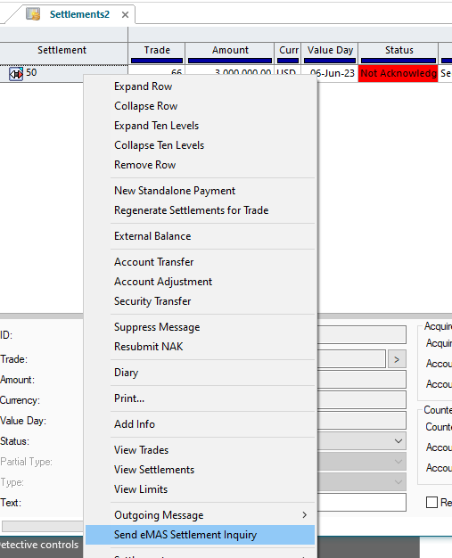

### OPERATING SPECIFICATION

The connection from FrontArena to eMAS server is based on web-based URL. This connection is real time, and the request and response are interchanged in a synchronous manner.

1. The user will generate the settlements and release it.
2. The AMBA sender modify script will process all the eligible settlements based on the predefined query.
3. The settlement request in the JSON format will be sent to the Webserver.
4. If required account status inquiry request is sent to eMAS prior to sending the settlement records. If the status inquiry response is not ok, then settlement record is not sent to eMAS.
5. If the status inquiry is successful, then FrontArena sends the fund transfer request to the eMAS server.
6. Depending upon the response from the eMAS the settlement status in FrontArena will be set to Acknowledged or NotAcknowledged.

The following settlement filter query will be used.

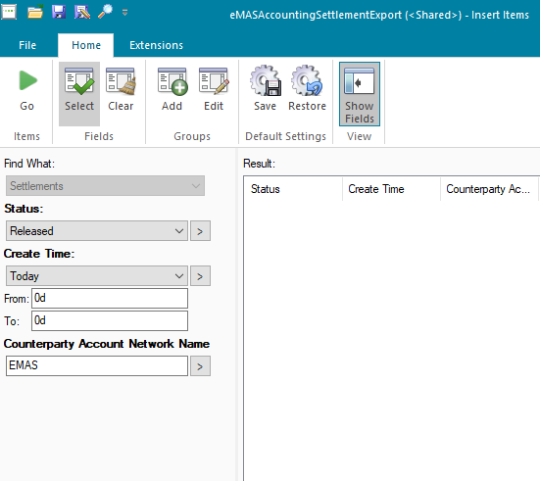

The following AMBA service will be used.



Once the settlement for EMAS is generated it should be released to eMAS.



If the request and corresponding response is successful then settlement goes to acknowledged status.



Log similar to following should appear in the AMBA EMAS log.



At the eMAS webserver request like following should be received. Note that this contains the account inquiry request also.

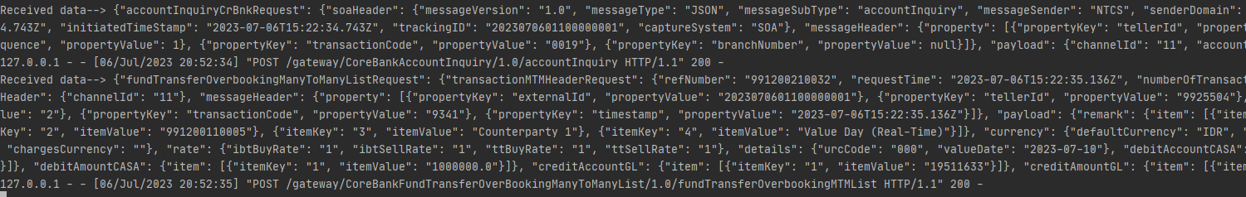

Following additional infos are populated on the settlement. These values are used internally when invoking status inquiry request manually.

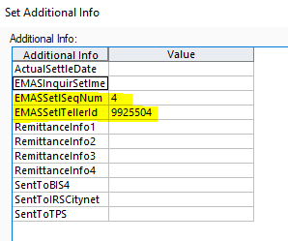

## eMAS – HoldAmount

### DESCRIPTION

|  |  |  |  |
| --- | --- | --- | --- |
| Interface name | Hold Amount | | |
| Type of data | Custom | Frequency | Realtime |
| Source | FA | Direction | IN/OUT |
| Format | JSON | Transfer mechanism | Web API |
| Response Required | Yes | Dependencies on other processes | NA |
| Purpose | Please refer Collateral Management Section | | |

AMBA sender modify script is developed to get the collateral hold amount from FA trades and send it to eMAS system in Real-time using Web API.

On the broad level following conditions will be checked to select trade information:

• Trade status – BO Confirmed

• Trade category - Collateral

Front Arena trades for eMAS system only will be considered for this interface. These trades are not considered for SWIFT or any other systems for same purpose.

### TECHNICAL ATTRIBUTE

|  |  |
| --- | --- |
| **Attribute** | **Description** |
| Extension Module | PS_eMASHoldAmount  *It contains the code required to send the collateral amount request and handle the response both in JSON format.* |
| AMBA | AMBA_EMAS  *AMBA sender hook is configured to capture trade update events and send the collateral details to EMAS.* |

### TECHNICAL ARCHITECTURE

FrontArena eMAS System

Capture trade update and send request to eMAS

Response to FA in

JSON format.

Request from FA in

JSON format.

Handles response from eMAS

AMBA

Generate Trade

Prime

EMAS Webserver

### TECHNICAL FLOW DIAGRAM

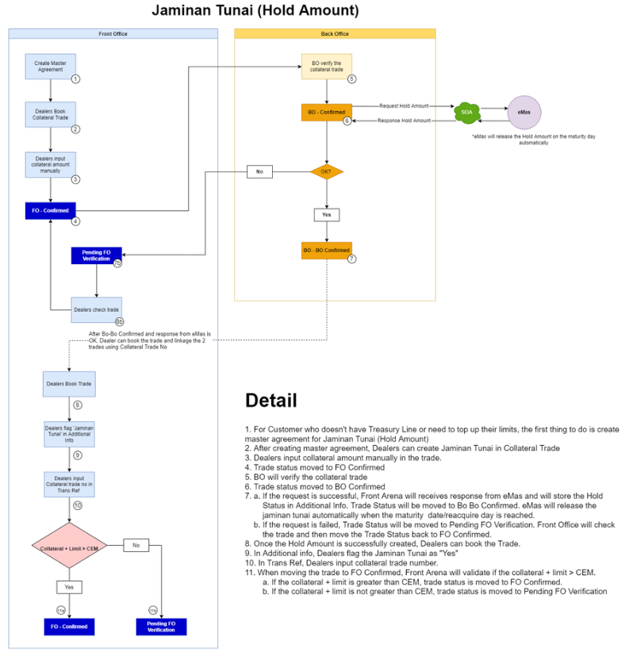

### LOGIC AND CONFIGURATION

#### Flow Logic

1. AMBA sender modify script is used to capture trade information in real-time. AMBA script checks the eligible trades using the trade filter query *eMASHoldAmount* and processes them further.
2. AMBA captures the trades update in real time and the information is transformed into eMAS Web API JSON format.
3. Based on response from eMAS, status on Trade in FrontArena (standard field) will be updated to *BO-BO Confirmed* (for success) or *Pending FO Verification* (for failed). Along with the trade status, the additional info *EMASHoldAmountSeqNo* is updated with a sequence number received in the response. This sequence number is referred to while releasing the collateral, in other eMAS interfaces.
4. This module runs continually to send trade information to eMAS in real time.

#### Configuration

|  |  |
| --- | --- |
| Delivery Items | |
| Extension Context | +Integration |
| Extension Module | PS_eMASHoldAmount |
|  |  |
| FA Component | |
| AMBA | AMBA service – AMBA_EMAS is used to capture collateral trades in *BO-Confirmed* status and send the request to eMAS web service about the hold amount. |
|  |  |
| Deployment and Manual Configuration | |
| The script and AMBA is deployed through FA standard deployment process.  Manual configuration may be required to update the configuration in FParameter in extension module. | |
|  |  |
| Additional Information | |
| EMASHoldAmountSeqNo | This add info is used to store the sequence number received in the response from eMAS server. |
| AEL GUI Task | |
| eMAS_HoldAmount | |
| FParameters | Default values |
| eMASHoldAmountParams | |
| ApiKey | 638f2361-cd12-4fad-bfc9-d0c14aabf2f9 |
| BranchNumber | 10 |
| ChannelId | 11 |
| DefaultTellerId | 9925501 |
| FailedTradeStatus | Pending FO Verification |
| LogFilename | eMAS_HoldAmount_LOG_{}.txt |
| MessageSender | NTCS |
| SuccessTradeStatus | BO-BO Confirmed |
| Timeout | 30 |
| TradeFilter | eMASHoldAmount |
| TypeOfEntry | SC |
| Url | /gateway/CoreBankHoldRelease/1.0/holdRelease |
|  |  |
| FStoredASQLQuery |  |
| eMASHoldAmount | This query checks the eligible trades. |
| Pre-requisites |  |
| AMBA service | AMBA service for this interface must be running to work this interface. |
| Query Folder | Query folder with name specified in Parameters, must be available, so that program can extract trades through that query folder. |
| eMAS connection | Connection to eMAS server must be live. |

#### Data Dictionary

Please refer to the section 2.4.3.

#### A Data Model

Please refer AEF Browser document for details about Front Arena Data Model.

Document - FCA4033

#### B Data Entity and Key Elements Definition

All required details are available in AEF Browser document.

#### C Reference Code Table Definition

Please refer AEF Browser document for details about Front Arena Data Model.

Document - FCA4033

### SECURITY AND CONTROL DESIGN

#### Security Requirement Response

|  |  |  |
| --- | --- | --- |
| **Security Domain** | **Security Requirement** | **Response** |
| User Management | The system must identify users using a unique user identification code before allowing a log-on. | It will be controlled through CDCA application |
| The system must suspend access to a user session after a specified interval of inactivity. | Inactivity of user session will not be applicable  as the integration is in Realtime |
| The system must require user authentication before re-enabling the session. | It will be controlled through CDCA application |
| The system must display a warning message indicating that only authorized use is permitted before allowing users to perform a log-on. | It will be controlled through CDCA application |
| The system must display system information to a user, only after a successful log-on. |  |
| After a successful log-on, the system must display information concerning the previous successful attempt to perform a log-on. | It will not be possible in real-time connections. |
| The system must allow a user account to be manually disabled. | NA |
| The system must disable the user account following 3 (three) consecutive failures to perform a successful log-on. | It will be controlled through CDCA application |
| The system must automatically disable the user account following a configurable period (90 days) without use. |  |
| Password Management | The system must authenticate users using a password before allowing access to any system functions. | Not applicable at Front Arena Database side. |
| The system must ensure that passwords used by system users for log-on consist of at least 8 (eight) characters. | Not applicable at Front Arena Database side. |
| The system must enforce the use of complex passwords for all users. (Aplhanumieric & Special Characters) | Not applicable at Front Arena Database side. |
| The system must use cryptographic techniques to protect the confidentiality of user authentication data during transmission. | Not applicable at Front Arena Database side. |
| The system must enforce a password change when a password is first issued or re-issued. |  |
| The system must allow system users to change the password used for log-on. | Not applicable at Front Arena Database side. |
| The system must ensure that passwords do not remain valid for more than 90 (ninety) days. | Not applicable at Front Arena Database side. |
| The system must ensure that passwords may not be changed to any of the last 5 (five) passwords used. | Not applicable at Front Arena Database side. |
| The system must ensure that passwords are not displayed in clear text during entry. | Not applicable at Front Arena Database side. |
| Multi Factor Authentication | The system must enforce dual factor authentication of all users (system that related to financial, faced to customer directly & only use for external purposes) | Not applicable at Front Arena Database side. |
| Data Storage | The system must use cryptographic techniques to protect the storage of authentication data. | NA |
| The system must use cryptographic techniques to protect the integrity of stored critical data. | NA |
| The system must use cryptographic techniques to protect the confidentiality of stored sensitive data. | NA |
| Logging | The system must support the recording of security events in one or multiple specific security event logs. 2 weeks in minimum must be available at the Production Environment | It will be controlled through CDCA application |
| The system must include the Logical Account identity, event type and timestamp in each entry in the security event logs. | It will be controlled through CDCA application |
| The system must record when each security event lo fills to a configurable limit. | It will be controlled through CDCA application |
| The system must protect the integrity of the information in the security event logs | It will be controlled through CDCA application |
| The system must allow access to the security event logs to be limited to the authorised security staff. | It will be controlled through CDCA application |
| The system must record if the integrity of the security event logs is compromised | NA |
| The system must record all instances that system event logs are cleared. | It will be controlled through CDCA application |
| The system must record when a change is made to the system log settings (e.g. logs for certain events are turned off). | It will be controlled through CDCA application |
| The system must record when any system security policy is modified. | NA |
| The system must record all creations of Logical Accounts. | It will be controlled through CDCA application |
| The system must record all deletions of Logical Accounts. |  |
| The system must record all de-activation of Logical Accounts. |  |
| The system must record all unsuccessful attempts to log-on to the system using invalid credentials. |  |
| The system must record all successful attempts to log-on to the system. |  |
| The system must record all successful and unsuccessful attempts to change passwords. |  |
| The system must automatically build and maintain a normal usage pattern for each Logical Account. |  |
| The system must record all activation of disabled Logical Accounts. |  |
| The system must record all attempts to change any account attribute affecting authentication of the Logical Account |  |
| The system must record all allocations of system access rights. |  |
| The system must record all removals of system access rights. |  |
| The system must record all unauthorised attempts to access a system function. |  |
| The system must record when a configurable deviation from a Logical Account's normal pattern is detected. |  |
| The system must record all failures of the check on the timestamp of payment and settlement orders. |  |
| The system must record all attempts to mutually authenticate interface connections that handle critical data |  |
| The system must record all events that may indicate an attempt to cause denial of service. |  |
| The system must record all access to functions processing critical information within the system. |  |
| The system must record all access to sensitive information within the system. |  |
| The system must record all start-up and shut down events. |  |
| The system must have been integrated in the SIEM, Identity Management System & Privilege Identity Management System |  |
| Remote Access | The system logical access control mechanism must be able to discretely grant remote access capability to specific users and user groups. |  |
| The system must strictly limit user access rights to their minimum requirements when they access the system remotely. |  |
| All relevant approvals must be obtained if this application is to be made available for remote use (E.g. on the RCA-portal) by Users |  |
| System Interfaces | The system must use a logical access control mechanism to control system to system data communications, in order to avoid anonymous data transfers (for all interfaces) |  |
| The system must ensure that system to system mutual authentication takes place before data communications are allowed (for all interfaces) |  |
| System to system mutual authentication must be based on cryptographic techniques (for all interfaces) |  |
| The system must use cryptographic techniques to protect the integrity of critical data during transmission (for all interfaces) |  |
| The system must use cryptographic techniques to protect the confidentiality of sensitive data during transmission (for all interfaces) |  |
| All 'critical data' must have been identified, documented and approved by the Business |  |
| All 'confidential data' must have been identified, documented and approved by the Business |  |
| Availability | The system must have a documented and successfully tested disaster recovery plan in place | It will be managed through Front Arena Database DR setup. |
| The system must enforce quotas limiting the maximum resources that an individual user can use simultaneously. |  |
| The system must provide adequate resources to support the required number of users or concurrent users. |  |
| The system should have a documented capacity monitoring process in-place with regular reporting on its use |  |
| Security Testing | The system must be tested for specific technical security flaws where it faces the public internet, prior to release into production. |  |
| The system must only be released into production, where it faces the public internet, once all identified key findings from the security test have been rectified, or if this is not possible, the risks must be formally reviewed and signed off |  |
| The system must be tested for specific technical security flaws prior to release into production. |  |
| The system must only be released into production once all the identified key findings from the security tests have been rectified or if this is not possible, the risks must be formally reviewed and signed off |  |

#### Preventive controls

*<This sub-section describe the technical specification for preventive controls that are specific to this module. This includes logical access control, physical security control, encryption, PIN generation and validation, etc>*

*<Sample of list of Role Table and Authorization Matrix>*

|  |  |  |  |
| --- | --- | --- | --- |
| **No** | **Role** | **Authorization** | **Object** |
| 1 | Role1 | ZXXXX | Maintain |
| 2 | Role2 | ZYYYY | Display |
| 3 |  |  |  |

|  |  |  |  |  |  |  |
| --- | --- | --- | --- | --- | --- | --- |
| **No** | **User Group** | **Role1** | **Role2** | **Role3** | **Role4** | **Role5** |
| 1 | User Group1 | X | X |  | X |  |
| 2 | User Group2 |  | X | X |  | X |
|  |  |  |  |  |  |  |

#### Detective controls

*<This sub-section describe the technical specification for detective controls that are specific to this module. This includes audit trail, exception reports, reconciliation, balancing & control totals, validations, etc>.*

#### Corrective controls

*<This sub-section describe the technical specification for corrective controls that are specific to this module. This includes automated error corrections, backup, recovery & restart, etc>.*

### USER INTERFACE

If required, the user can trigger the collateral trades hold amount request manually by running the task eMAS_HoldAmount.

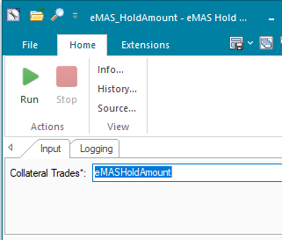

### OPERATING SPECIFICATION

The connection from FrontArena to eMAS server is based on web-based URL. This connection is real time, and the request and response are interchanged in a synchronous manner.

1. The user will generate the trade and set it to *BO-Confirmed* state.
2. The AMBA sender modify script will process all the eligible trades based on the predefined query *eMASHoldAmount*.
3. The hold amount request created from the trade will be sent to the Webserver in the JSON format.
4. The status of the trade changes to BO-BO Confirmed or Pending FO Verification depending on the success or failed response from eMAS. A sequence number received in the response from eMAS is updated on the add info on the trade.

The following settlement filter query will be used.

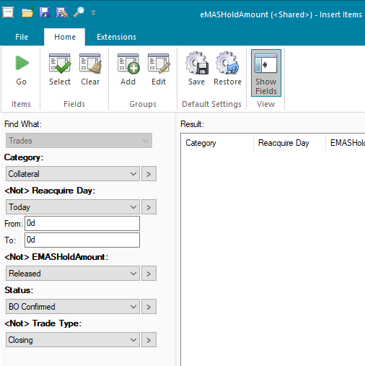

The following AMBA service will be used.



Once the trade is changed to BO-Confirmed, it should change to BO-BO Confirmed after receiving response from eMAS.

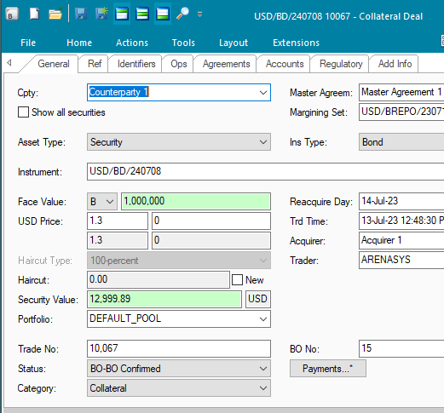

Reponse from eMAS is updated in the add info field.

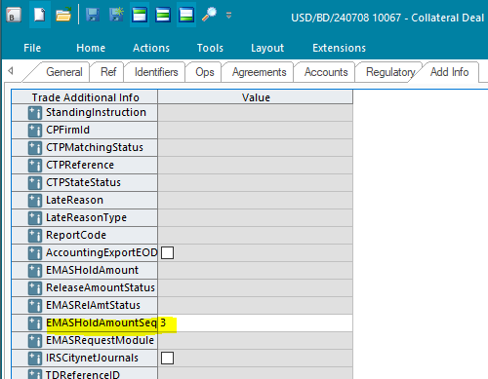

Log similar to following should appear in the AMBA EMAS log.



At the eMAS webserver request like following should be received.



## eMAS – HoldAmountRelease

### DESCRIPTION

|  |  |  |  |
| --- | --- | --- | --- |
| Interface name | Hold Amount Release | | |
| Type of data | Custom | Frequency | Realtime |
| Source | FA | Direction | IN/OUT |
| Format | JSON | Transfer mechanism | Web API |
| Response Required | Yes | Dependencies on other processes | NA |
| Purpose | Please refer Collateral Management Section | | |

For the release of the collateral when the collateral needs to be released in eMAS before Reacquire Day, user will book closing trade of the original collateral, using Close Trade action which will create an offsetting trade. The closing trade is going through the same trade workflow and trigger interface to eMAS.

On the broad level following conditions will be checked to select trade information:

• Trade type – Closing

• Trade category - Collateral

### TECHNICAL ATTRIBUTE

|  |  |
| --- | --- |
| **Attribute** | **Description** |
| Extension Module | PS_eMASHoldAmountRelease  *It contains the code required to send the collateral amount release request and handle the response both in JSON format.* |
| AMBA | AMBA_EMAS  *AMBA sender hook is configured to capture trade update events and send the collateral release details to EMAS.* |

### TECHNICAL ARCHITECTURE

FrontArena eMAS System

Capture trade update and send request to eMAS

Response to FA in

JSON format.

Request from FA in

JSON format.

Handles response from eMAS

AMBA

Generate Trade

Prime

EMAS Webserver

### TECHNICAL FLOW DIAGRAM

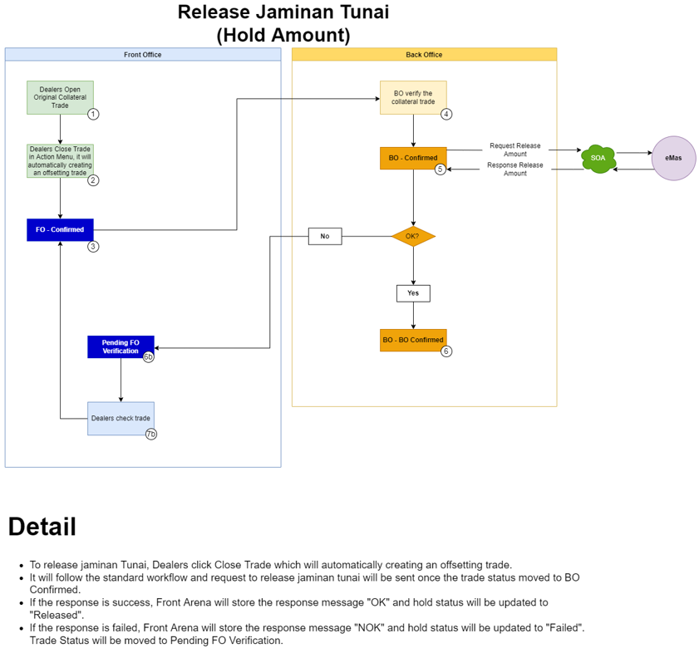

### LOGIC AND CONFIGURATION

#### Flow Logic

1. AMBA sender modify script is used to capture trade information in real-time.

AMBA script checks the eligible trades using the trade filter query *eMASHoldAmountRelease* and processes them further.

1. AMBA captures the trades update in real time and the information is transformed into eMAS Web API JSON format. The value of additional info *EMASHoldAmountSeqNo* is mapped in the release request.
2. Based on response from eMAS, status on Trade in FrontArena (standard field) will be updated to *BO-BO Confirmed* (for success) or *Pending FO Verification* (for failed). Along with the status the additional info *EMASRelAmtStatus* is updated with value *Released* and *Failed* based on the response*.*
3. This module runs continually to send trade information to eMAS in real time. The logs will be written to the AMBA log.

#### Configuration

|  |  |
| --- | --- |
| Delivery Items | |
| Extension Context | +Integration |
| Extension Module | PS_eMASHoldAmountRelease |
|  |  |
| FA Component | |
| AMBA | AMBA service – AMBA_EMAS is used to capture closing collateral trades in *BO-Confirmed* status and send the request to eMAS web service to release the hold amount. |
|  |  |
| Deployment and Manual Configuration | |
| The script and AMBA is deployed through FA standard deployment process.  Manual configuration may be required to update the configuration in FParameter in extension module. | |
|  |  |
| Additional Information | |
| EMASHoldAmountSeqNo | The value is used to send the sequence number in the request to eMAS server. |
| EMASRelAmtStatus | This value is updated depending on the response from eMAS. |
| AEL GUI Task | |
| eMAS_HoldAmountRelease | |
| FParameters | Default values |
| eMASHoldAmountReleaseParams | |
| ApiKey | 638f2361-cd12-4fad-bfc9-d0c14aabf2f9 |
| BranchNumber | 10 |
| ChannelId | 11 |
| DefaultTellerId | 9925503 |
| FailedTradeStatus | Pending FO Verification |
| LogFilename | eMAS_HoldAmountRelease_LOG_{}.txt |
| MessageSender | NTCS |
| SuccessTradeStatus | BO-BO Confirmed |
| Timeout | 30 |
| TradeFilter | eMASHoldAmountRelease |
| TypeOfEntry | SC |
| Url | /gateway/CoreBankHoldRelease/1.0/holdRelease |
| FStoredASQLQuery |  |
| eMASHoldAmountInquiry | This query filters the eligible trades. |
| Pre-requisites |  |
| AMBA service | AMBA service for this interface must be running to work this interface. |
| Query Folder | Query folder with name specified in Parameters, must be available, so that program can extract trades through that query folder. |
| eMAS connection | Connection to eMAS server must be live. |

#### Data Dictionary

Please refer to the section 2.4.3.

#### A Data Model

Please refer AEF Browser document for details about Front Arena Data Model.

Document - FCA4033

#### B Data Entity and Key Elements Definition

All required details are available in AEF Browser document.

#### C Reference Code Table Definition

Please refer AEF Browser document for details about Front Arena Data Model.

Document - FCA4033

### SECURITY AND CONTROL DESIGN

#### Security Requirement Response

|  |  |  |
| --- | --- | --- |
| **Security Domain** | **Security Requirement** | **Response** |
| User Management | The system must identify users using a unique user identification code before allowing a log-on. | It will be controlled through CDCA application |
| The system must suspend access to a user session after a specified interval of inactivity. | Inactivity of user session will not be applicable  as the integration is in Realtime |
| The system must require user authentication before re-enabling the session. | It will be controlled through CDCA application |
| The system must display a warning message indicating that only authorized use is permitted before allowing users to perform a log-on. | It will be controlled through CDCA application |
| The system must display system information to a user, only after a successful log-on. |  |
| After a successful log-on, the system must display information concerning the previous successful attempt to perform a log-on. | It will not be possible in real-time connections. |
| The system must allow a user account to be manually disabled. | NA |
| The system must disable the user account following 3 (three) consecutive failures to perform a successful log-on. | It will be controlled through CDCA application |
| The system must automatically disable the user account following a configurable period (90 days) without use. |  |
| Password Management | The system must authenticate users using a password before allowing access to any system functions. | Not applicable at Front Arena Database side. |
| The system must ensure that passwords used by system users for log-on consist of at least 8 (eight) characters. | Not applicable at Front Arena Database side. |
| The system must enforce the use of complex passwords for all users. (Aplhanumieric & Special Characters) | Not applicable at Front Arena Database side. |
| The system must use cryptographic techniques to protect the confidentiality of user authentication data during transmission. | Not applicable at Front Arena Database side. |
| The system must enforce a password change when a password is first issued or re-issued. |  |
| The system must allow system users to change the password used for log-on. | Not applicable at Front Arena Database side. |
| The system must ensure that passwords do not remain valid for more than 90 (ninety) days. | Not applicable at Front Arena Database side. |
| The system must ensure that passwords may not be changed to any of the last 5 (five) passwords used. | Not applicable at Front Arena Database side. |
| The system must ensure that passwords are not displayed in clear text during entry. | Not applicable at Front Arena Database side. |
| Multi Factor Authentication | The system must enforce dual factor authentication of all users (system that related to financial, faced to customer directly & only use for external purposes) | Not applicable at Front Arena Database side. |
| Data Storage | The system must use cryptographic techniques to protect the storage of authentication data. | NA |
| The system must use cryptographic techniques to protect the integrity of stored critical data. | NA |
| The system must use cryptographic techniques to protect the confidentiality of stored sensitive data. | NA |
| Logging | The system must support the recording of security events in one or multiple specific security event logs. 2 weeks in minimum must be available at the Production Environment | It will be controlled through CDCA application |
| The system must include the Logical Account identity, event type and timestamp in each entry in the security event logs. | It will be controlled through CDCA application |
| The system must record when each security event lo fills to a configurable limit. | It will be controlled through CDCA application |
| The system must protect the integrity of the information in the security event logs | It will be controlled through CDCA application |
| The system must allow access to the security event logs to be limited to the authorised security staff. | It will be controlled through CDCA application |
| The system must record if the integrity of the security event logs is compromised | NA |
| The system must record all instances that system event logs are cleared. | It will be controlled through CDCA application |
| The system must record when a change is made to the system log settings (e.g. logs for certain events are turned off). | It will be controlled through CDCA application |
| The system must record when any system security policy is modified. | NA |
| The system must record all creations of Logical Accounts. | It will be controlled through CDCA application |
| The system must record all deletions of Logical Accounts. |  |
| The system must record all de-activation of Logical Accounts. |  |
| The system must record all unsuccessful attempts to log-on to the system using invalid credentials. |  |
| The system must record all successful attempts to log-on to the system. |  |
| The system must record all successful and unsuccessful attempts to change passwords. |  |
| The system must automatically build and maintain a normal usage pattern for each Logical Account. |  |
| The system must record all activation of disabled Logical Accounts. |  |
| The system must record all attempts to change any account attribute affecting authentication of the Logical Account |  |
| The system must record all allocations of system access rights. |  |
| The system must record all removals of system access rights. |  |
| The system must record all unauthorised attempts to access a system function. |  |
| The system must record when a configurable deviation from a Logical Account's normal pattern is detected. |  |
| The system must record all failures of the check on the timestamp of payment and settlement orders. |  |
| The system must record all attempts to mutually authenticate interface connections that handle critical data |  |
| The system must record all events that may indicate an attempt to cause denial of service. |  |
| The system must record all access to functions processing critical information within the system. |  |
| The system must record all access to sensitive information within the system. |  |
| The system must record all start-up and shut down events. |  |
| The system must have been integrated in the SIEM, Identity Management System & Privilege Identity Management System |  |
| Remote Access | The system logical access control mechanism must be able to discretely grant remote access capability to specific users and user groups. |  |
| The system must strictly limit user access rights to their minimum requirements when they access the system remotely. |  |
| All relevant approvals must be obtained if this application is to be made available for remote use (E.g. on the RCA-portal) by Users |  |
| System Interfaces | The system must use a logical access control mechanism to control system to system data communications, in order to avoid anonymous data transfers (for all interfaces) |  |
| The system must ensure that system to system mutual authentication takes place before data communications are allowed (for all interfaces) |  |
| System to system mutual authentication must be based on cryptographic techniques (for all interfaces) |  |
| The system must use cryptographic techniques to protect the integrity of critical data during transmission (for all interfaces) |  |
| The system must use cryptographic techniques to protect the confidentiality of sensitive data during transmission (for all interfaces) |  |
| All 'critical data' must have been identified, documented and approved by the Business |  |
| All 'confidential data' must have been identified, documented and approved by the Business |  |
| Availability | The system must have a documented and successfully tested disaster recovery plan in place | It will be managed through Front Arena Database DR setup. |
| The system must enforce quotas limiting the maximum resources that an individual user can use simultaneously. |  |
| The system must provide adequate resources to support the required number of users or concurrent users. |  |
| The system should have a documented capacity monitoring process in-place with regular reporting on its use |  |
| Security Testing | The system must be tested for specific technical security flaws where it faces the public internet, prior to release into production. |  |
| The system must only be released into production, where it faces the public internet, once all identified key findings from the security test have been rectified, or if this is not possible, the risks must be formally reviewed and signed off |  |
| The system must be tested for specific technical security flaws prior to release into production. |  |
| The system must only be released into production once all the identified key findings from the security tests have been rectified or if this is not possible, the risks must be formally reviewed and signed off |  |

#### Preventive controls

*<This sub-section describe the technical specification for preventive controls that are specific to this module. This includes logical access control, physical security control, encryption, PIN generation and validation, etc>*

*<Sample of list of Role Table and Authorization Matrix>*

|  |  |  |  |
| --- | --- | --- | --- |
| **No** | **Role** | **Authorization** | **Object** |
| 1 | Role1 | ZXXXX | Maintain |
| 2 | Role2 | ZYYYY | Display |
| 3 |  |  |  |

|  |  |  |  |  |  |  |
| --- | --- | --- | --- | --- | --- | --- |
| **No** | **User Group** | **Role1** | **Role2** | **Role3** | **Role4** | **Role5** |
| 1 | User Group1 | X | X |  | X |  |
| 2 | User Group2 |  | X | X |  | X |
|  |  |  |  |  |  |  |

#### Detective controls

*<This sub-section describe the technical specification for detective controls that are specific to this module. This includes audit trail, exception reports, reconciliation, balancing & control totals, validations, etc>.*

#### Corrective controls

*<This sub-section describe the technical specification for corrective controls that are specific to this module. This includes automated error corrections, backup, recovery & restart, etc>.*

### USER INTERFACE

If required, the user can trigger the collateral trades hold amount request manually by running the task eMAS_HoldAmountRelease.

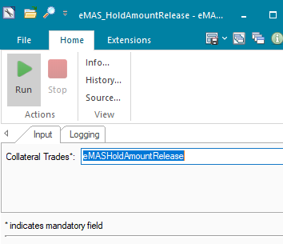

### OPERATING SPECIFICATION

The connection from FrontArena to eMAS server is based on web-based URL. This connection is real time, and the request and response are interchanged in a synchronous manner.

1. The user will generate the closing trade and set it to *BO-Confirmed* state.
2. The AMBA sender modify script will capture this update and check the eligibility of the trade based on the predefined query *eMASHoldAmountRelease*.
3. The hold amount release request created from the trade will be sent to the Webserver in the JSON format.
4. The status of the trade changes to BO-BO Confirmed or Pending FO Verification depending on the success or failed response from eMAS. Along with the status the additional info *EMASRelAmtStatus* is updated with value *Released* and *Failed* based on the response*.*

The following settlement filter query will be used.

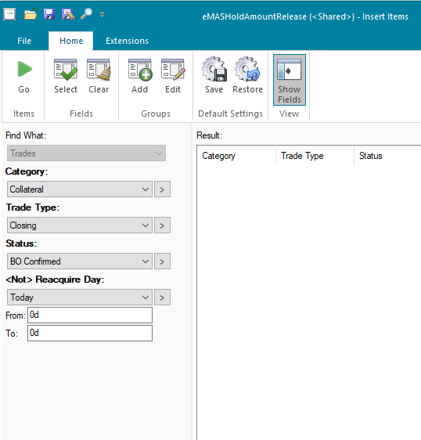

The following AMBA service will be used.



Once the trade is changed to BO-Confirmed, it should change to BO-BO Confirmed after receiving response from eMAS.

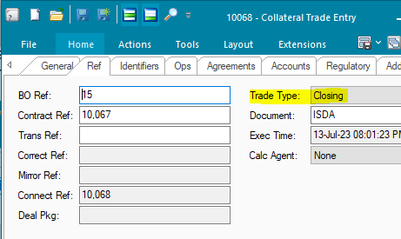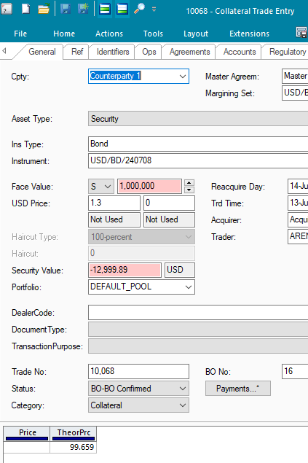

Reponse from eMAS is updated in the add info field.

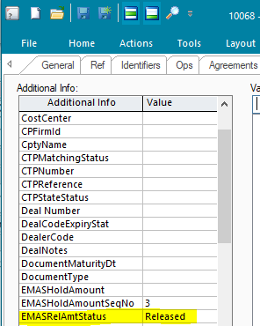

Log similar to following should appear in the AMBA EMAS log.



At the eMAS webserver request like following should be received.

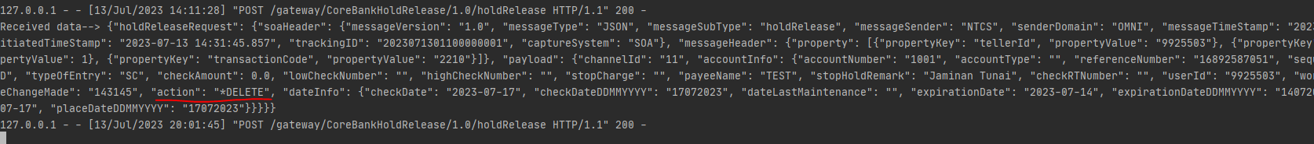

## eMAS - Accounting Export EOD

DESCRIPTION

|  |  |  |  |
| --- | --- | --- | --- |
| Interface name | Accounting Export EOD | | |
| Type of data | Custom – Journal Information | Frequency | EOD/Batch |
| Source | FA | Direction | OUT |
| Format | File | Transfer mechanism | FTP |
| Response Required | N/A | Dependencies on other processes | FA Journals |
| Purpose | Accounting entries generated in Front Arena, needs to be transferred to core banking system - eMAS | | |

Journals information will be transformed into eMAS EOD file format. The transformed journals records for each trade in Front Arena will be recorded in output file in txt format. After uploading output file onto eMAS server the additional info on trade is set with interface status.

### TECHNICAL ATTRIBUTE

|  |  |
| --- | --- |
| **Attribute** | **Description** |
| Extension Module | PS_eMASAccountingExportEOD *It contains code to write journals records into an output file and transfer that file to eMAS server..* |
| ATS | ATS_EOD  *ATS is configured in task mode to automate the process of transferring journal records to eMAS server at EOD* |

### TECHNICAL ARCHITECTURE

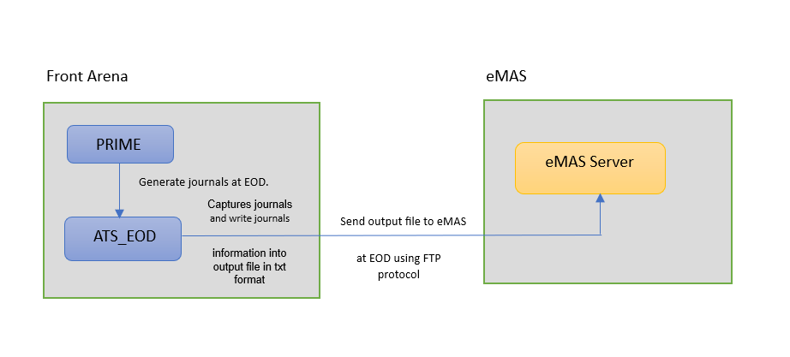

### TECHNICAL FLOW DIAGRAM

u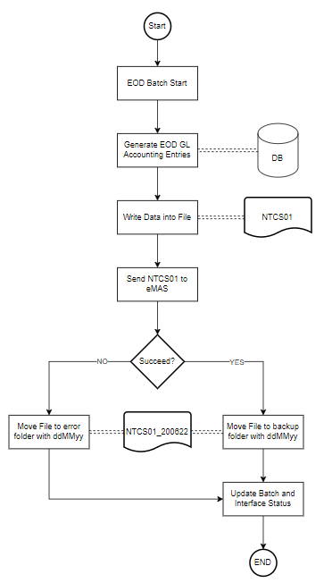

### LOGIC AND CONFIGURATION

#### Flow Logic

1. User generates trade in FrontArena using Prime application.

Once the trade has been approved by various groups, its status is changed to BO-BO Confirmed.

1. Once the status of the trade is changed to BO-BO Confirmed, Realtime journals are generated for the trade. After running EOD batch the EOD journals are generated for the trade.
2. The task is created for module PS_eMASAccountingExportEOD which is used to process EOD journals and create the output file. The task can be run in both automated and manual ways. To automate the task ATS_EOD is configured.
3. Once the ATS_EOD executes task and the journals records output file is created in txt format it is sent to eMAS server using FTP protocol.
4. The interface status of the transfer is set on additional info AccountingExportEOD for the respective trades.

#### Configuration

|  |  |
| --- | --- |
| Delivery Items | |
| Extension Context | +Integration |
| Extension Module | PS_eMASAccountingExportEOD |
| ATS | ATS_EOD |
|  |  |
| FA Component | |
| ATS | ATS_EOD is configured in task mode to execute the process of transfer of journals records output file. |
|  |  |
| Deployment and Manual Configuration | |
| This service is deployed through FA standard deployment process.  Manual configuration may be required to update the configuration in FParameter in extension module. | |
|  | |
| Additional Information | |
| AccountingExportEOD | AdditionalInfo on Trade. |
|  |  |
| FParameters | Default values |
| destination_dir | /BMGPLI |
| host | 10.243.136.172 |
| port | 21 |
| user | FTPNTCS |
| outputFilename | NTCS01 |
| logFilename | eMas_AccntnExport_LOG_{}.txt. |
|  |  |
| Pre-requisites |  |
| Query Folder | Query folder with name specified in Parameters, must be available, so that program can extract trades through that query folder. |
| ATS service | ATS is optional. Totally depends on the mode of task execution. |
|  |  |
| FStoredASQLQuery | Purpose |
| PS_QF_eMasJournals | Filter specifying the eligible Journals. |
|  |  |

#### Data Dictionary

Following are field mapping done for this interface.

Document NTCS02 GL File Specification v2.xlsx



#### A Data Model

Please refer AEF Browser document for details about Front Arena Data Model.

Document - FCA4033

#### B Data Entity and Key Elements Definition

All required details are available in AEF Browser document.

#### C Reference Code Table Definition

Please refer AEF Browser document for details about Front Arena Data Model.

Document - FCA4033

### SECURITY AND CONTROL DESIGN

#### Security Requirement Response

|  |  |  |
| --- | --- | --- |
| **Security Domain** | **Security Requirement** | **Response** |
| User Management | The system must identify users using a unique user identification code before allowing a log-on. | It will be controlled through CDCA application |
| The system must suspend access to a user session after a specified interval of inactivity. | Inactivity of user session will not be applicable  as the integration is in Realtime |
| The system must require user authentication before re-enabling the session. | It will be controlled through CDCA application |
| The system must display a warning message indicating that only authorized use is permitted before allowing users to perform a log-on. | It will be controlled through CDCA application |
| The system must display system information to a user, only after a successful log-on. |  |
| After a successful log-on, the system must display information concerning the previous successful attempt to perform a log-on. | It will not be possible in real-time connections. |
| The system must allow a user account to be manually disabled. | NA |
| The system must disable the user account following 3 (three) consecutive failures to perform a successful log-on. | It will be controlled through CDCA application |
| The system must automatically disable the user account following a configurable period (90 days) without use. |  |
| Password Management | The system must authenticate users using a password before allowing access to any system functions. | Not applicable at Front Arena Database side. |
| The system must ensure that passwords used by system users for log-on consist of at least 8 (eight) characters. | Not applicable at Front Arena Database side. |
| The system must enforce the use of complex passwords for all users. (Aplhanumieric & Special Characters) | Not applicable at Front Arena Database side. |
| The system must use cryptographic techniques to protect the confidentiality of user authentication data during transmission. | Not applicable at Front Arena Database side. |
| The system must enforce a password change when a password is first issued or re-issued. |  |
| The system must allow system users to change the password used for log-on. | Not applicable at Front Arena Database side. |
| The system must ensure that passwords do not remain valid for more than 90 (ninety) days. | Not applicable at Front Arena Database side. |
| The system must ensure that passwords may not be changed to any of the last 5 (five) passwords used. | Not applicable at Front Arena Database side. |
| The system must ensure that passwords are not displayed in clear text during entry. | Not applicable at Front Arena Database side. |
| Multi Factor Authentication | The system must enforce dual factor authentication of all users (system that related to financial, faced to customer directly & only use for external purposes) | Not applicable at Front Arena Database side. |
| Data Storage | The system must use cryptographic techniques to protect the storage of authentication data. | NA |
| The system must use cryptographic techniques to protect the integrity of stored critical data. | NA |
| The system must use cryptographic techniques to protect the confidentiality of stored sensitive data. | NA |
| Logging | The system must support the recording of security events in one or multiple specific security event logs. 2 weeks in minimum must be available at the Production Environment | It will be controlled through CDCA application |
| The system must include the Logical Account identity, event type and timestamp in each entry in the security event logs. | It will be controlled through CDCA application |
| The system must record when each security event lo fills to a configurable limit. | It will be controlled through CDCA application |
| The system must protect the integrity of the information in the security event logs | It will be controlled through CDCA application |
| The system must allow access to the security event logs to be limited to the authorised security staff. | It will be controlled through CDCA application |
| The system must record if the integrity of the security event logs is compromised | NA |
| The system must record all instances that system event logs are cleared. | It will be controlled through CDCA application |
| The system must record when a change is made to the system log settings (e.g. logs for certain events are turned off). | It will be controlled through CDCA application |
| The system must record when any system security policy is modified. | NA |
| The system must record all creations of Logical Accounts. | It will be controlled through CDCA application |
| The system must record all deletions of Logical Accounts. |  |
| The system must record all de-activation of Logical Accounts. |  |
| The system must record all unsuccessful attempts to log-on to the system using invalid credentials. |  |
| The system must record all successful attempts to log-on to the system. |  |
| The system must record all successful and unsuccessful attempts to change passwords. |  |
| The system must automatically build and maintain a normal usage pattern for each Logical Account. |  |
| The system must record all activation of disabled Logical Accounts. |  |
| The system must record all attempts to change any account attribute affecting authentication of the Logical Account |  |
| The system must record all allocations of system access rights. |  |
| The system must record all removals of system access rights. |  |
| The system must record all unauthorised attempts to access a system function. |  |
| The system must record when a configurable deviation from a Logical Account's normal pattern is detected. |  |
| The system must record all failures of the check on the timestamp of payment and settlement orders. |  |
| The system must record all attempts to mutually authenticate interface connections that handle critical data |  |
| The system must record all events that may indicate an attempt to cause denial of service. |  |
| The system must record all access to functions processing critical information within the system. |  |
| The system must record all access to sensitive information within the system. |  |
| The system must record all start-up and shut down events. |  |
| The system must have been integrated in the SIEM, Identity Management System & Privilege Identity Management System |  |
| Remote Access | The system logical access control mechanism must be able to discretely grant remote access capability to specific users and user groups. |  |
| The system must strictly limit user access rights to their minimum requirements when they access the system remotely. |  |
| All relevant approvals must be obtained if this application is to be made available for remote use (E.g. on the RCA-portal) by Users |  |
| System Interfaces | The system must use a logical access control mechanism to control system to system data communications, in order to avoid anonymous data transfers (for all interfaces) |  |
| The system must ensure that system to system mutual authentication takes place before data communications are allowed (for all interfaces) |  |
| System to system mutual authentication must be based on cryptographic techniques (for all interfaces) |  |
| The system must use cryptographic techniques to protect the integrity of critical data during transmission (for all interfaces) |  |
| The system must use cryptographic techniques to protect the confidentiality of sensitive data during transmission (for all interfaces) |  |
| All 'critical data' must have been identified, documented and approved by the Business |  |
| All 'confidential data' must have been identified, documented and approved by the Business |  |
| Availability | The system must have a documented and successfully tested disaster recovery plan in place | It will be managed through Front Arena Database DR setup. |
| The system must enforce quotas limiting the maximum resources that an individual user can use simultaneously. |  |
| The system must provide adequate resources to support the required number of users or concurrent users. |  |
| The system should have a documented capacity monitoring process in-place with regular reporting on its use |  |
| Security Testing | The system must be tested for specific technical security flaws where it faces the public internet, prior to release into production. |  |
| The system must only be released into production, where it faces the public internet, once all identified key findings from the security test have been rectified, or if this is not possible, the risks must be formally reviewed and signed off |  |
| The system must be tested for specific technical security flaws prior to release into production. |  |
| The system must only be released into production once all the identified key findings from the security tests have been rectified or if this is not possible, the risks must be formally reviewed and signed off |  |

#### Preventive controls

*<This sub-section describe the technical specification for preventive controls that are specific to this module. This includes logical access control, physical security control, encryption, PIN generation and validation, etc>*

*<Sample of list of Role Table and Authorization Matrix>*

|  |  |  |  |
| --- | --- | --- | --- |
| **No** | **Role** | **Authorization** | **Object** |
| 1 | Role1 | ZXXXX | Maintain |
| 2 | Role2 | ZYYYY | Display |
| 3 |  |  |  |

|  |  |  |  |  |  |  |
| --- | --- | --- | --- | --- | --- | --- |
| **No** | **User Group** | **Role1** | **Role2** | **Role3** | **Role4** | **Role5** |
| 1 | User Group1 | X | X |  | X |  |
| 2 | User Group2 |  | X | X |  | X |
|  |  |  |  |  |  |  |

#### Detective controls

*<This sub-section describe the technical specification for detective controls that are specific to this module. This includes audit trail, exception reports, reconciliation, balancing & control totals, validations, etc>.*

#### Corrective controls

*<This sub-section describes the technical specification for corrective controls that are specific to this module. This includes automated error corrections, backup, recovery & restart, etc>.*

### USER INTERFACE

If required, the user can trigger the process, by using the task GUI eMAS_AccountingExportEOD*.*

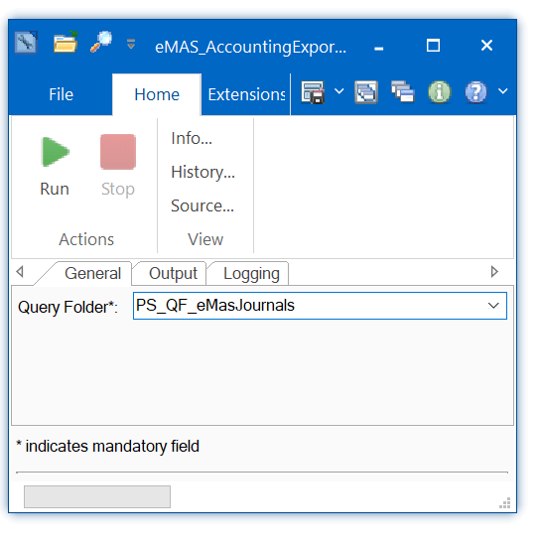

### OPERATING SPECIFICATION

The transfer of EOD Journals output file to eMAS is performed using FTP protocol.

1. Accounting EOD batch generates EOD journals.
2. The predefined query folder will pick up all the EOD journals meeting criteria specified in query folder.
3. The task created for the interface will perform creation of outputfile and sending it to eMAS server.
4. The predefined additional info for the trades on which journals are created is set with the interface status.

The following filter query / query folder will be used.

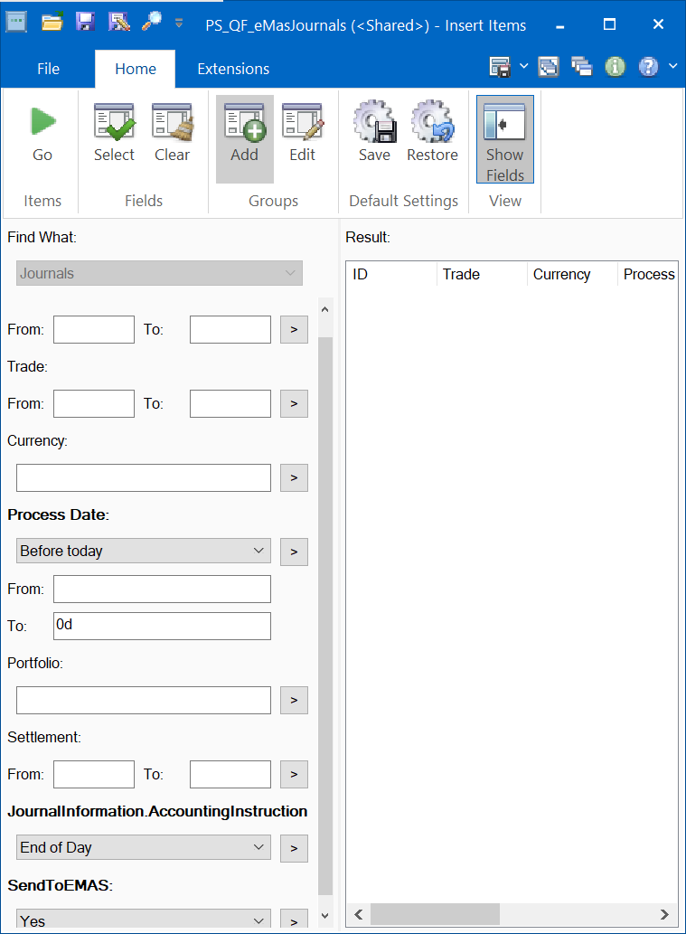

Following additional informations will be used.

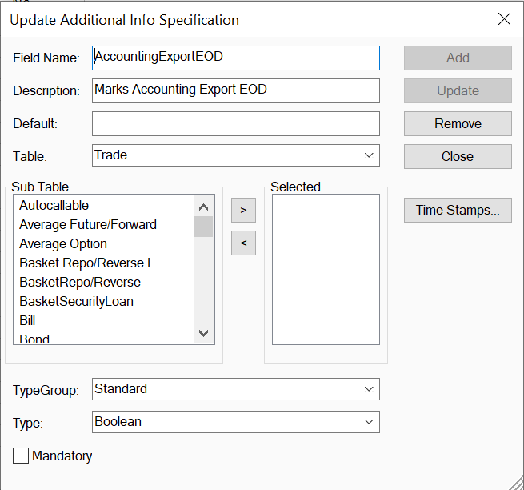

## eMAS – Book Rate

DESCRIPTION

|  |  |
| --- | --- |
| **Interface name** | eMAS – Book Rate |
| **Note:** | The functionality of this interface will be covered by the flow EXIMBILL – Book Rate. A common output file will be delivered to separate destinations corresponding to eMAS and EXIMBILL. The output file will be delivered using FTP and SFTP connections for  eMAS – Book Rate and EXIMBILL – Book Rate respectively. |

### TECHNICAL ATTRIBUTE

Refer to the technical attribute section of EXIMBILL-Book Rate. The same ATS will be used to execute the task.

### TECHNICAL ARCHITECTURE

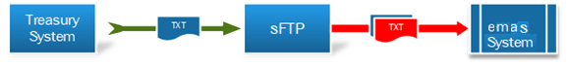

FrontArena

Arena Task Service (ATS)

FTP Server

Module to generate and write the file to FTP.

### TECHNICAL FLOW DIAGRAM

FrontArena receives mid-rate from Refinitiv.

FTP Server.

eMAS System

### LOGIC AND CONFIGURATION

#### Flow Logic

1. The flow is same as the EXIMBILL BookRate, the only exception being that,

once the file has been written to local disk, it is then copied to FTP server instead of SFTP.

#### Configuration

The EXIMBILL BookRate configuration is used.

##### **Additional Configuration**

Task specific configuration can be done by opening the task.

1. General
2. MTM Market: Select the market to which the mid-rate applies.
3. Currency pair: Select all the currency pairs or select the required ones.

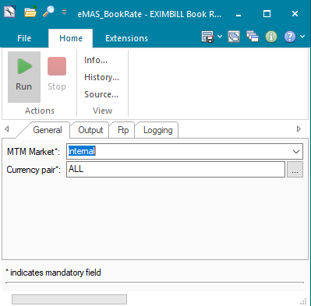

1. Output

Folder Path: Folder where output file and logfile will be created.

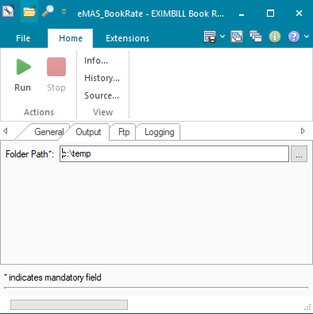

1. Ftp
2. Destination folder: Destination path at the FTP site.
3. Host: FTP address.
4. Port: FTP port.
5. User: FTP user.
6. Password: Encrypted FTP password.

A new encrypted password can be generated by calling following code snippet in Python Editor.

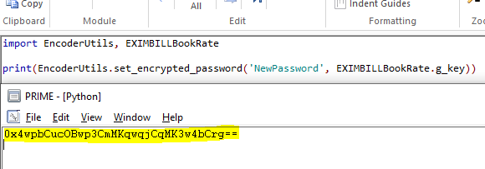

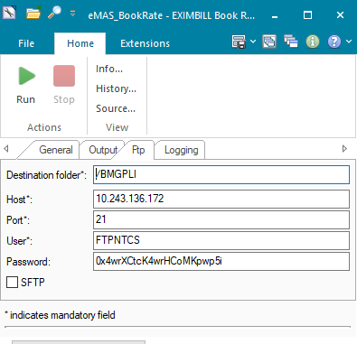

1. Logging

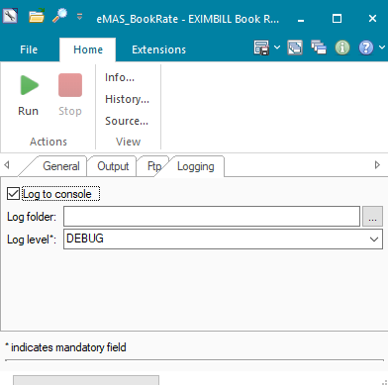

#### Data Dictionary

Refer to the Data Dictionary section for EXIMBILL BookRate.

#### A Data Model

Please refer AEF Browser document for details about Front Arena Data Model.

Document - FCA4033

#### B Data Entity and Key Elements Definition

Refer to the corresponding section for EXIMBILL BookRate.

#### C Reference Code Table Definition

Please refer AEF Browser document for details about Front Arena Data Model.

Document - FCA4033

### SECURITY AND CONTROL DESIGN

#### Security Requirement Response

|  |  |  |
| --- | --- | --- |
| **Security Domain** | **Security Requirement** | **Response** |
| User Management | The system must identify users using a unique user identification code before allowing a log-on. | It will be controlled through CDCA application |
| The system must suspend access to a user session after a specified interval of inactivity. | Inactivity of user session will not be applicable  as the integration is in Realtime |
| The system must require user authentication before re-enabling the session. | It will be controlled through CDCA application |
| The system must display a warning message indicating that only authorized use is permitted before allowing users to perform a log-on. | It will be controlled through CDCA application |
| The system must display system information to a user, only after a successful log-on. |  |
| After a successful log-on, the system must display information concerning the previous successful attempt to perform a log-on. | It will not be possible in real-time connections. |
| The system must allow a user account to be manually disabled. | NA |
| The system must disable the user account following 3 (three) consecutive failures to perform a successful log-on. | It will be controlled through CDCA application |
| The system must automatically disable the user account following a configurable period (90 days) without use. |  |
| Password Management | The system must authenticate users using a password before allowing access to any system functions. | Not applicable at Front Arena Database side. |
| The system must ensure that passwords used by system users for log-on consist of at least 8 (eight) characters. | Not applicable at Front Arena Database side. |
| The system must enforce the use of complex passwords for all users. (Aplhanumieric & Special Characters) | Not applicable at Front Arena Database side. |
| The system must use cryptographic techniques to protect the confidentiality of user authentication data during transmission. | Not applicable at Front Arena Database side. |
| The system must enforce a password change when a password is first issued or re-issued. |  |
| The system must allow system users to change the password used for log-on. | Not applicable at Front Arena Database side. |
| The system must ensure that passwords do not remain valid for more than 90 (ninety) days. | Not applicable at Front Arena Database side. |
| The system must ensure that passwords may not be changed to any of the last 5 (five) passwords used. | Not applicable at Front Arena Database side. |
| The system must ensure that passwords are not displayed in clear text during entry. | Not applicable at Front Arena Database side. |
| Multi Factor Authentication | The system must enforce dual factor authentication of all users (system that related to financial, faced to customer directly & only use for external purposes) | Not applicable at Front Arena Database side. |
| Data Storage | The system must use cryptographic techniques to protect the storage of authentication data. | NA |
| The system must use cryptographic techniques to protect the integrity of stored critical data. | NA |
| The system must use cryptographic techniques to protect the confidentiality of stored sensitive data. | NA |
| Logging | The system must support the recording of security events in one or multiple specific security event logs. 2 weeks in minimum must be available at the Production Environment | It will be controlled through CDCA application |
| The system must include the Logical Account identity, event type and timestamp in each entry in the security event logs. | It will be controlled through CDCA application |
| The system must record when each security event lo fills to a configurable limit. | It will be controlled through CDCA application |
| The system must protect the integrity of the information in the security event logs | It will be controlled through CDCA application |
| The system must allow access to the security event logs to be limited to the authorised security staff. | It will be controlled through CDCA application |
| The system must record if the integrity of the security event logs is compromised | NA |
| The system must record all instances that system event logs are cleared. | It will be controlled through CDCA application |
| The system must record when a change is made to the system log settings (e.g. logs for certain events are turned off). | It will be controlled through CDCA application |
| The system must record when any system security policy is modified. | NA |
| The system must record all creations of Logical Accounts. | It will be controlled through CDCA application |
| The system must record all deletions of Logical Accounts. |  |
| The system must record all de-activation of Logical Accounts. |  |
| The system must record all unsuccessful attempts to log-on to the system using invalid credentials. |  |
| The system must record all successful attempts to log-on to the system. |  |
| The system must record all successful and unsuccessful attempts to change passwords. |  |
| The system must automatically build and maintain a normal usage pattern for each Logical Account. |  |
| The system must record all activation of disabled Logical Accounts. |  |
| The system must record all attempts to change any account attribute affecting authentication of the Logical Account |  |
| The system must record all allocations of system access rights. |  |
| The system must record all removals of system access rights. |  |
| The system must record all unauthorised attempts to access a system function. |  |
| The system must record when a configurable deviation from a Logical Account's normal pattern is detected. |  |
| The system must record all failures of the check on the timestamp of payment and settlement orders. |  |
| The system must record all attempts to mutually authenticate interface connections that handle critical data |  |
| The system must record all events that may indicate an attempt to cause denial of service. |  |
| The system must record all access to functions processing critical information within the system. |  |
| The system must record all access to sensitive information within the system. |  |
| The system must record all start-up and shut down events. |  |
| The system must have been integrated in the SIEM, Identity Management System & Privilege Identity Management System |  |
| Remote Access | The system logical access control mechanism must be able to discretely grant remote access capability to specific users and user groups. |  |
| The system must strictly limit user access rights to their minimum requirements when they access the system remotely. |  |
| All relevant approvals must be obtained if this application is to be made available for remote use (E.g. on the RCA-portal) by Users |  |
| System Interfaces | The system must use a logical access control mechanism to control system to system data communications, in order to avoid anonymous data transfers (for all interfaces) |  |
| The system must ensure that system to system mutual authentication takes place before data communications are allowed (for all interfaces) |  |
| System to system mutual authentication must be based on cryptographic techniques (for all interfaces) |  |
| The system must use cryptographic techniques to protect the integrity of critical data during transmission (for all interfaces) |  |
| The system must use cryptographic techniques to protect the confidentiality of sensitive data during transmission (for all interfaces) |  |
| All 'critical data' must have been identified, documented and approved by the Business |  |
| All 'confidential data' must have been identified, documented and approved by the Business |  |
| Availability | The system must have a documented and successfully tested disaster recovery plan in place | It will be managed through Front Arena Database DR setup. |
| The system must enforce quotas limiting the maximum resources that an individual user can use simultaneously. |  |
| The system must provide adequate resources to support the required number of users or concurrent users. |  |
| The system should have a documented capacity monitoring process in-place with regular reporting on its use |  |
| Security Testing | The system must be tested for specific technical security flaws where it faces the public internet, prior to release into production. |  |
| The system must only be released into production, where it faces the public internet, once all identified key findings from the security test have been rectified, or if this is not possible, the risks must be formally reviewed and signed off |  |
| The system must be tested for specific technical security flaws prior to release into production. |  |
| The system must only be released into production once all the identified key findings from the security tests have been rectified or if this is not possible, the risks must be formally reviewed and signed off |  |

#### Preventive controls

*<This sub-section describe the technical specification for preventive controls that are specific to this module. This includes logical access control, physical security control, encryption, PIN generation and validation, etc>*

*<Sample of list of Role Table and Authorization Matrix>*

|  |  |  |  |
| --- | --- | --- | --- |
| **No** | **Role** | **Authorization** | **Object** |
| 1 | Role1 | ZXXXX | Maintain |
| 2 | Role2 | ZYYYY | Display |
| 3 |  |  |  |

|  |  |  |  |  |  |  |
| --- | --- | --- | --- | --- | --- | --- |
| **No** | **User Group** | **Role1** | **Role2** | **Role3** | **Role4** | **Role5** |
| 1 | User Group1 | X | X |  | X |  |
| 2 | User Group2 |  | X | X |  | X |
|  |  |  |  |  |  |  |

#### Detective controls

*<This sub-section describe the technical specification for detective controls that are specific to this module. This includes audit trail, exception reports, reconciliation, balancing & control totals, validations, etc>.*

#### Corrective controls

*<This sub-section describes the technical specification for corrective controls that are specific to this module. This includes automated error corrections, backup, recovery & restart, etc>.*

### USER INTERFACE

If required, the user can trigger the process, by using the task GUI *eMAS_BookRate.* A new output file will be generated and sent to the FTP server location.

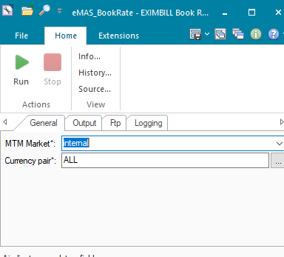

### OPERATING SPECIFICATION

The connection from FrontArena to eMAS is mediated by an FTP site connection. This process is configured in batch mode and will be executed at EOD per day.

1. FrontArena will receive prices from Refinitiv and will map the mid-rate to the price entry records.
2. The eMAS task will select the currency pairs as configured and write the information including the mid-rate, currency, and date in the output file.
3. Once the file has been created it will be copied to the FTP server using FTP protocol.
4. eMAS system can access the output file from the FTP site.

## Communication

*<This section provides the communication line that will be used in this system>*

### New / Existing*) system *) choose one

|  |  |  |  |  |  |  |  |  |  |
| --- | --- | --- | --- | --- | --- | --- | --- | --- | --- |
| **NO** | **NEW / SURROUNDING SYSTEM** | **HOSTNAME SOURCE** | **IP SOURCE** | **PORT SOURCE** | **HOSTNAME DESTINATION** | **IP DESTINATION** | **PORT DESTINATION** | **PROTOCOL (TCP /UDP /ICMP)** | **ALLOW / DENY** |
| 1 | *<new / surrounding status>* | *<isi nama host source>* | *<isi IP source>* | *<isi port source>* | *<isi nama host destination>* | *<isi IP destination>* | *<isi port destination>* | *<isi protocol>* | *<allow / deny status>* |
| 2 |  |  |  |  |  |  |  |  |  |
| 3 |  |  |  |  |  |  |  |  |  |
| 4 |  |  |  |  |  |  |  |  |  |
| 5 |  |  |  |  |  |  |  |  |  |
| 6 |  |  |  |  |  |  |  |  |  |
| 7 |  |  |  |  |  |  |  |  |  |
| 8 |  |  |  |  |  |  |  |  |  |
| … |  | … | … | … | … | … |  | … | … |

*< For a new developed system, if there are some undefined hostnames/ ip addresses/ ports yet, then should be written with* ***TBC*** *notes and will be completely defined in SDN contract review form >*

*< For an existing system and surrounding, please define and write its hostnames/ ip addresses/ ports >*

## OTHERS

*<This section provides other technical specifications that have not been address in previous section>.*

# **EXIMBILL**

## EXIMBILL – Book Rate

DESCRIPTION

|  |  |  |  |
| --- | --- | --- | --- |
| **Interface name** | EXIMBILL – Book Rate | | |
| **Type of data** | Book Rate - Mid rate in FA | **Frequency** | Batch |
| **Source** | FA | **Direction** | OUT |
| **Format** | Text file | **Transfer mechanism** | SFTP |
| **Response Required** | N/A | **Dependencies on other processes** |  |
| **Purpose** | Send Book Rate from Front Arena to EXIMBILL (eMAS System) | | |

Book rate (i.e. mid rate) received from Refinitiv in Front Arena will be sent to EXIMBILL system via SFTP. Currency pair, where base currency is IDR will be considered for this interface.

### TECHNICAL ATTRIBUTE

|  |  |
| --- | --- |
| **Attribute** | **Description** |
| Extension Module | PS_EXIMBILLBookRate  *It contains code required to execute the task to generate the output mapping file with txt extension.* |
| ATS | ATS_INTEGRATIONS  *ATS runs the task mentioned in the extension module above. The task is scheduled to run for EOD. The output file once generated will be written to the FTP server using SFTP protocol.* |

### TECHNICAL ARCHITECTURE

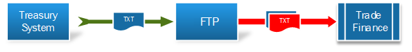

FrontArena

Arena Task Service (ATS)

SFTP Server

Module to generate and write the file to SFTP.

### TECHNICAL FLOW DIAGRAM

FrontArena receives mid-rate from Refinitive.

SFTP Server.

EXIMBILL System

### LOGIC AND CONFIGURATION

#### Flow Logic

1. The task EXIMBILLBookRate is run with the help of the ATS server ATS_INTEGRATIONS. The ATS will run this task at EOD once.
2. The task looks for any existing price record based on the currency pair, market, and date from the price entry.
3. The task extracts the mid-rate from the selected currency pair and writes the rate, currency in a predefined format in the output txt file.
4. The name of the file follows the format of today’s date and time at the time of creating the file.
5. Once the file has been written to local disk, it is then copied to SFTP server.

#### Configuration

|  |  |
| --- | --- |
| Delivery Items | |
| Extension Context | +Integration |
| Extension Module | PS_EXIMBILLBookRate |
| ATS service | ATS_INTEGRATIONS |
|  |  |
| FA Component | |
| ATS | ATS service – ATS_INTEGRATIONS is used to run the task. |
|  |  |
| Deployment and Manual Configuration | |
| This service is deployed through FA standard deployment process.  Manual configuration may be required to update the configuration in FParameter in extension module. | |
|  |  |
| Additional Information | |
| No additional information field is used. | |
| FParameters | Default values |
| logFilename | EXIMBILL_BOOKRATE_LOG_{}.txt |
| outputFilename | BOOKRT_{}_{}.txt |
| Pre-requisites |  |
| ATS service | ATS service for this interface must be running to work this interface. |
| FTP server | The SFTP connection should be active. |

##### **Additional Configuration**

Task specific configuration can be done by opening the task.

1. General
2. MTM Market: Select the market to which the mid-rate applies.
3. Currency pair: Select all the currency pairs or select the required ones.

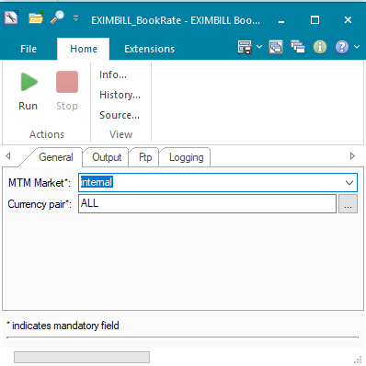

1. Output

Folder Path: Folder where output file and logfile will be created.

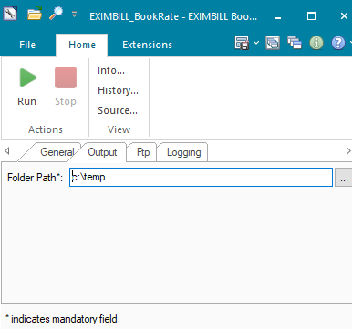

1. Ftp
2. Destination folder: Destination path at the FTP site.
3. Host: SFTP address.
4. Port: SFTP port.
5. User: SFTP user.
6. Password: Encrypted SFTP password.

A new encrypted password can be generated by calling following code snippet in Python Editor.



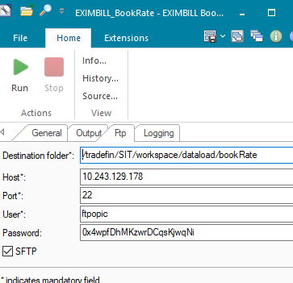

1. Logging

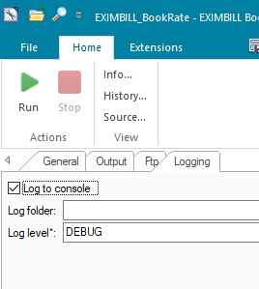

#### Data Dictionary

Following are field mapping done for this interface.

| Field Name | Description | Type | M/  O | Len | SOA Mapping |
| --- | --- | --- | --- | --- | --- |
| Foreign Currency | The currency code | String | M | 3 | Book Rate source currency  Get from first 3 characters (start position is 1 ) |
| Integer part of this rate | Integer part of the book rate | number | M | 6 | Will use to create book rate (integer part).  get it from first 6 digit from the left(start position is 5) |
| Decimal part of this rate | Decimal part of the book rate. | number | M | 7 | Will use to create book rate(decimal part)  Get from last7 digit from the right.(start position is 37) |
| Target currency | Target currency | String | M | 3 | Default to IDR. |

TF Book Rate Desc.docx



#### A Data Model

Please refer AEF Browser document for details about Front Arena Data Model.

Document - FCA4033

#### B Data Entity and Key Elements Definition

| Field Name | Description | Type | M/  O | Len | FrontArena Mapping |
| --- | --- | --- | --- | --- | --- |
| Foreign Currency | The currency code | String | M | 3 | First currency of the acm.FCurrencyPair |
| Integer part of this rate | Integer part of the book rate | number | M | 6 | Price FPrice.Settle will be used use to create book rate (integer part). |
| Decimal part of this rate | Decimal part of the book rate. | number | M | 7 | Price FPrice.Settle will be used use to create book rate (decimal part). |
| Target currency | Target currency | String | M | 3 | Default to IDR. |

#### C Reference Code Table Definition

Please refer AEF Browser document for details about Front Arena Data Model.

Document - FCA4033

### SECURITY AND CONTROL DESIGN

#### Security Requirement Response

|  |  |  |
| --- | --- | --- |
| **Security Domain** | **Security Requirement** | **Response** |
| User Management | The system must identify users using a unique user identification code before allowing a log-on. | It will be controlled through CDCA application |
| The system must suspend access to a user session after a specified interval of inactivity. | Inactivity of user session will not be applicable  as the integration is in Realtime |
| The system must require user authentication before re-enabling the session. | It will be controlled through CDCA application |
| The system must display a warning message indicating that only authorized use is permitted before allowing users to perform a log-on. | It will be controlled through CDCA application |
| The system must display system information to a user, only after a successful log-on. |  |
| After a successful log-on, the system must display information concerning the previous successful attempt to perform a log-on. | It will not be possible in real-time connections. |
| The system must allow a user account to be manually disabled. | NA |
| The system must disable the user account following 3 (three) consecutive failures to perform a successful log-on. | It will be controlled through CDCA application |
| The system must automatically disable the user account following a configurable period (90 days) without use. |  |
| Password Management | The system must authenticate users using a password before allowing access to any system functions. | Not applicable at Front Arena Database side. |
| The system must ensure that passwords used by system users for log-on consist of at least 8 (eight) characters. | Not applicable at Front Arena Database side. |
| The system must enforce the use of complex passwords for all users. (Aplhanumieric & Special Characters) | Not applicable at Front Arena Database side. |
| The system must use cryptographic techniques to protect the confidentiality of user authentication data during transmission. | Not applicable at Front Arena Database side. |
| The system must enforce a password change when a password is first issued or re-issued. |  |
| The system must allow system users to change the password used for log-on. | Not applicable at Front Arena Database side. |
| The system must ensure that passwords do not remain valid for more than 90 (ninety) days. | Not applicable at Front Arena Database side. |
| The system must ensure that passwords may not be changed to any of the last 5 (five) passwords used. | Not applicable at Front Arena Database side. |
| The system must ensure that passwords are not displayed in clear text during entry. | Not applicable at Front Arena Database side. |
| Multi Factor Authentication | The system must enforce dual factor authentication of all users (system that related to financial, faced to customer directly & only use for external purposes) | Not applicable at Front Arena Database side. |
| Data Storage | The system must use cryptographic techniques to protect the storage of authentication data. | NA |
| The system must use cryptographic techniques to protect the integrity of stored critical data. | NA |
| The system must use cryptographic techniques to protect the confidentiality of stored sensitive data. | NA |
| Logging | The system must support the recording of security events in one or multiple specific security event logs. 2 weeks in minimum must be available at the Production Environment | It will be controlled through CDCA application |
| The system must include the Logical Account identity, event type and timestamp in each entry in the security event logs. | It will be controlled through CDCA application |
| The system must record when each security event lo fills to a configurable limit. | It will be controlled through CDCA application |
| The system must protect the integrity of the information in the security event logs | It will be controlled through CDCA application |
| The system must allow access to the security event logs to be limited to the authorised security staff. | It will be controlled through CDCA application |
| The system must record if the integrity of the security event logs is compromised | NA |
| The system must record all instances that system event logs are cleared. | It will be controlled through CDCA application |
| The system must record when a change is made to the system log settings (e.g. logs for certain events are turned off). | It will be controlled through CDCA application |
| The system must record when any system security policy is modified. | NA |
| The system must record all creations of Logical Accounts. | It will be controlled through CDCA application |
| The system must record all deletions of Logical Accounts. |  |
| The system must record all de-activation of Logical Accounts. |  |
| The system must record all unsuccessful attempts to log-on to the system using invalid credentials. |  |
| The system must record all successful attempts to log-on to the system. |  |
| The system must record all successful and unsuccessful attempts to change passwords. |  |
| The system must automatically build and maintain a normal usage pattern for each Logical Account. |  |
| The system must record all activation of disabled Logical Accounts. |  |
| The system must record all attempts to change any account attribute affecting authentication of the Logical Account |  |
| The system must record all allocations of system access rights. |  |
| The system must record all removals of system access rights. |  |
| The system must record all unauthorised attempts to access a system function. |  |
| The system must record when a configurable deviation from a Logical Account's normal pattern is detected. |  |
| The system must record all failures of the check on the timestamp of payment and settlement orders. |  |
| The system must record all attempts to mutually authenticate interface connections that handle critical data |  |
| The system must record all events that may indicate an attempt to cause denial of service. |  |
| The system must record all access to functions processing critical information within the system. |  |
| The system must record all access to sensitive information within the system. |  |
| The system must record all start-up and shut down events. |  |
| The system must have been integrated in the SIEM, Identity Management System & Privilege Identity Management System |  |
| Remote Access | The system logical access control mechanism must be able to discretely grant remote access capability to specific users and user groups. |  |
| The system must strictly limit user access rights to their minimum requirements when they access the system remotely. |  |
| All relevant approvals must be obtained if this application is to be made available for remote use (E.g. on the RCA-portal) by Users |  |
| System Interfaces | The system must use a logical access control mechanism to control system to system data communications, in order to avoid anonymous data transfers (for all interfaces) |  |
| The system must ensure that system to system mutual authentication takes place before data communications are allowed (for all interfaces) |  |
| System to system mutual authentication must be based on cryptographic techniques (for all interfaces) |  |
| The system must use cryptographic techniques to protect the integrity of critical data during transmission (for all interfaces) |  |
| The system must use cryptographic techniques to protect the confidentiality of sensitive data during transmission (for all interfaces) |  |
| All 'critical data' must have been identified, documented and approved by the Business |  |
| All 'confidential data' must have been identified, documented and approved by the Business |  |
| Availability | The system must have a documented and successfully tested disaster recovery plan in place | It will be managed through Front Arena Database DR setup. |
| The system must enforce quotas limiting the maximum resources that an individual user can use simultaneously. |  |
| The system must provide adequate resources to support the required number of users or concurrent users. |  |
| The system should have a documented capacity monitoring process in-place with regular reporting on its use |  |
| Security Testing | The system must be tested for specific technical security flaws where it faces the public internet, prior to release into production. |  |
| The system must only be released into production, where it faces the public internet, once all identified key findings from the security test have been rectified, or if this is not possible, the risks must be formally reviewed and signed off |  |
| The system must be tested for specific technical security flaws prior to release into production. |  |
| The system must only be released into production once all the identified key findings from the security tests have been rectified or if this is not possible, the risks must be formally reviewed and signed off |  |

#### Preventive controls

*<This sub-section describe the technical specification for preventive controls that are specific to this module. This includes logical access control, physical security control, encryption, PIN generation and validation, etc>*

*<Sample of list of Role Table and Authorization Matrix>*

|  |  |  |  |
| --- | --- | --- | --- |
| **No** | **Role** | **Authorization** | **Object** |
| 1 | Role1 | ZXXXX | Maintain |
| 2 | Role2 | ZYYYY | Display |
| 3 |  |  |  |

|  |  |  |  |  |  |  |
| --- | --- | --- | --- | --- | --- | --- |
| **No** | **User Group** | **Role1** | **Role2** | **Role3** | **Role4** | **Role5** |
| 1 | User Group1 | X | X |  | X |  |
| 2 | User Group2 |  | X | X |  | X |
|  |  |  |  |  |  |  |

#### Detective controls

*<This sub-section describe the technical specification for detective controls that are specific to this module. This includes audit trail, exception reports, reconciliation, balancing & control totals, validations, etc>.*

#### Corrective controls

*<This sub-section describes the technical specification for corrective controls that are specific to this module. This includes automated error corrections, backup, recovery & restart, etc>.*

### USER INTERFACE

If required, the user can trigger the process, by using the task GUI *EXIMBILL_BookRate.* A new output file will be generated and sent to the FTP server location.

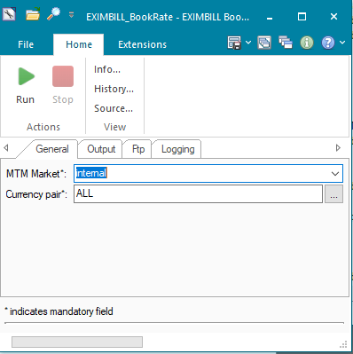

### OPERATING SPECIFICATION

The connection from FrontArena to EXIMBILL is mediated by an FTP site connection. This process is configured in batch mode and will be executed at EOD per day.

1. FrontArena will receive prices from Refinitiv and will map the mid-rate to the price entry records.
2. The EXIMBILL task will select the currency pairs as configured and write the information including the mid-rate, currency, and date in the output file.
3. Once the file has been created it will be copied to the FTP server using SFTP protocol.
4. EXIMBILL system can access the output file from the SFTP site.

## EXIMBILL – Nostro GL Records

|  |  |  |  |
| --- | --- | --- | --- |
| **Interface name** | EXIMBILL - Nostro GL Records | | |
| **Type of data** | Nostro transaction Records | **Frequency** | Batch |
| **Source** | EXIMBILL | **Direction** | IN |
| **Format** | File | **Transfer mechanism** | Shared location |
| **Response Required** | N/A | **Dependencies on other processes** |  |
| **Purpose** | Posting GL record to FA | | |

EXIMBILL will send GL records to Front Arena. FA will create standalone payment, so that it can be sent to IRS Citynet system via MT950.

1. Files from EXIMBILL system will be available at specified shared location.

2. Script will be developed to read the detailed file to get Nostro transactions.

3. That script will create standalone payments in FA from each valid record available in file.

4. Keep the source name in Counterparty field. Party will be created with name of surrounding system (e.g., BPS, TPS, EXIMBILL)

### TECHNICAL ATTRIBUTE

|  |  |
| --- | --- |
| **Attribute** | **Description** |
| Extension Module | PS_EXIMBILLNostroGL  *It contains code required to execute the task to create standalone payment in FrontArena.* |
| ATS | *ATS can be configured to run the task mentioned in the extension module above.* |

### TECHNICAL ARCHITECTURE

**Architectural overview**

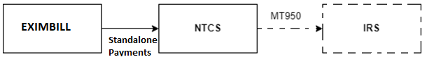

EXIMBILL

Front Arena

Standalone

Payments

Midas account matching with

Account

### TECHNICAL FLOW DIAGRAM

Please refer section - TECHNICAL aRCHITECTURE

### LOGIC AND CONFIGURATION

#### Flow Logic

1. Script reads the EXIMBILL file having Nostro GL records.
2. Identifies the record having Non-Suspense GL Account.
3. For this record, if the Midas account is set as Add Info on the Account of the Acquirer, settlement is created.
4. Type of settlement will be ‘Stand Alone Payment’.
5. The Account for this settlement is the one which has matching Midas account.
6. This payment will have counterparty as EXIMBILL, which is assigned in the FParameters

#### Configuration

|  |  |
| --- | --- |
| Delivery Items | |
| Extension Context | +Integration |
| Extension Module | PS_EXIMBILLNostroGL |
|  |  |
| FA Component | |
| ATS | ATS service – can be used to run the task. |
|  |  |
| Deployment and Manual Configuration | |
| This service is deployed through FA standard deployment process. ATS is not the part of standard installation.  Manual configuration may be required to update the configuration in FParameter in extension module. | |
|  |  |
| Additional Information | |
| No additional information field is used. | |
| FParameters | Default values |
| acquirer | Acquirer 1 |
| counterparty | EXIMBILL |
| Pre-requisites |  |
| ATS service | ATS service for this interface must be running to work this interface. This task can also be run manually. |

#### Data Dictionary

Please refer attached Data Mapping file and sample input file



#### A Data Model

Please refer AEF Browser document for details about Front Arena Data Model.

Document - FCA4033

#### B Data Entity and Key Elements Definition

All required details are available in AEF Browser document.

#### C Reference Code Table Definition

Please refer AEF Browser document for details about Front Arena Data Model.

Document - FCA4033

### SECURITY AND CONTROL DESIGN

#### Security Requirement Response

|  |  |  |
| --- | --- | --- |
| **Security Domain** | **Security Requirement** | **Response** |
| User Management | The system must identify users using a unique user identification code before allowing a log-on. | It will be controlled through CDCA application |
| The system must suspend access to a user session after a specified interval of inactivity. | Inactivity of user session will not be applicable  as the integration is in Realtime |
| The system must require user authentication before re-enabling the session. | It will be controlled through CDCA application |
| The system must display a warning message indicating that only authorized use is permitted before allowing users to perform a log-on. | It will be controlled through CDCA application |
| The system must display system information to a user, only after a successful log-on. |  |
| After a successful log-on, the system must display information concerning the previous successful attempt to perform a log-on. | It will not be possible in real-time connections. |
| The system must allow a user account to be manually disabled. | NA |
| The system must disable the user account following 3 (three) consecutive failures to perform a successful log-on. | It will be controlled through CDCA application |
| The system must automatically disable the user account following a configurable period (90 days) without use. |  |
| Password Management | The system must authenticate users using a password before allowing access to any system functions. | Not applicable at Front Arena Database side. |
| The system must ensure that passwords used by system users for log-on consist of at least 8 (eight) characters. | Not applicable at Front Arena Database side. |
| The system must enforce the use of complex passwords for all users. (Aplhanumieric & Special Characters) | Not applicable at Front Arena Database side. |
| The system must use cryptographic techniques to protect the confidentiality of user authentication data during transmission. | Not applicable at Front Arena Database side. |
| The system must enforce a password change when a password is first issued or re-issued. |  |
| The system must allow system users to change the password used for log-on. | Not applicable at Front Arena Database side. |
| The system must ensure that passwords do not remain valid for more than 90 (ninety) days. | Not applicable at Front Arena Database side. |
| The system must ensure that passwords may not be changed to any of the last 5 (five) passwords used. | Not applicable at Front Arena Database side. |
| The system must ensure that passwords are not displayed in clear text during entry. | Not applicable at Front Arena Database side. |
| Multi Factor Authentication | The system must enforce dual factor authentication of all users (system that related to financial, faced to customer directly & only use for external purposes) | Not applicable at Front Arena Database side. |
| Data Storage | The system must use cryptographic techniques to protect the storage of authentication data. | NA |
| The system must use cryptographic techniques to protect the integrity of stored critical data. | NA |
| The system must use cryptographic techniques to protect the confidentiality of stored sensitive data. | NA |
| Logging | The system must support the recording of security events in one or multiple specific security event logs. 2 weeks in minimum must be available at the Production Environment | It will be controlled through CDCA application |
| The system must include the Logical Account identity, event type and timestamp in each entry in the security event logs. | It will be controlled through CDCA application |
| The system must record when each security event lo fills to a configurable limit. | It will be controlled through CDCA application |
| The system must protect the integrity of the information in the security event logs | It will be controlled through CDCA application |
| The system must allow access to the security event logs to be limited to the authorised security staff. | It will be controlled through CDCA application |
| The system must record if the integrity of the security event logs is compromised | NA |
| The system must record all instances that system event logs are cleared. | It will be controlled through CDCA application |
| The system must record when a change is made to the system log settings (e.g. logs for certain events are turned off). | It will be controlled through CDCA application |
| The system must record when any system security policy is modified. | NA |
| The system must record all creations of Logical Accounts. | It will be controlled through CDCA application |
| The system must record all deletions of Logical Accounts. |  |
| The system must record all de-activation of Logical Accounts. |  |
| The system must record all unsuccessful attempts to log-on to the system using invalid credentials. |  |
| The system must record all successful attempts to log-on to the system. |  |
| The system must record all successful and unsuccessful attempts to change passwords. |  |
| The system must automatically build and maintain a normal usage pattern for each Logical Account. |  |
| The system must record all activation of disabled Logical Accounts. |  |
| The system must record all attempts to change any account attribute affecting authentication of the Logical Account |  |
| The system must record all allocations of system access rights. |  |
| The system must record all removals of system access rights. |  |
| The system must record all unauthorised attempts to access a system function. |  |
| The system must record when a configurable deviation from a Logical Account's normal pattern is detected. |  |
| The system must record all failures of the check on the timestamp of payment and settlement orders. |  |
| The system must record all attempts to mutually authenticate interface connections that handle critical data |  |
| The system must record all events that may indicate an attempt to cause denial of service. |  |
| The system must record all access to functions processing critical information within the system. |  |
| The system must record all access to sensitive information within the system. |  |
| The system must record all start-up and shut down events. |  |
| The system must have been integrated in the SIEM, Identity Management System & Privilege Identity Management System |  |
| Remote Access | The system logical access control mechanism must be able to discretely grant remote access capability to specific users and user groups. |  |
| The system must strictly limit user access rights to their minimum requirements when they access the system remotely. |  |
| All relevant approvals must be obtained if this application is to be made available for remote use (E.g. on the RCA-portal) by Users |  |
| System Interfaces | The system must use a logical access control mechanism to control system to system data communications, in order to avoid anonymous data transfers (for all interfaces) |  |
| The system must ensure that system to system mutual authentication takes place before data communications are allowed (for all interfaces) |  |
| System to system mutual authentication must be based on cryptographic techniques (for all interfaces) |  |
| The system must use cryptographic techniques to protect the integrity of critical data during transmission (for all interfaces) |  |
| The system must use cryptographic techniques to protect the confidentiality of sensitive data during transmission (for all interfaces) |  |
| All 'critical data' must have been identified, documented and approved by the Business |  |
| All 'confidential data' must have been identified, documented and approved by the Business |  |
| Availability | The system must have a documented and successfully tested disaster recovery plan in place | It will be managed through Front Arena Database DR setup. |
| The system must enforce quotas limiting the maximum resources that an individual user can use simultaneously. |  |
| The system must provide adequate resources to support the required number of users or concurrent users. |  |
| The system should have a documented capacity monitoring process in-place with regular reporting on its use |  |
| Security Testing | The system must be tested for specific technical security flaws where it faces the public internet, prior to release into production. |  |
| The system must only be released into production, where it faces the public internet, once all identified key findings from the security test have been rectified, or if this is not possible, the risks must be formally reviewed and signed off |  |
| The system must be tested for specific technical security flaws prior to release into production. |  |
| The system must only be released into production once all the identified key findings from the security tests have been rectified or if this is not possible, the risks must be formally reviewed and signed off |  |

#### Preventive controls

*<This sub-section describe the technical specification for preventive controls that are specific to this module. This includes logical access control, physical security control, encryption, PIN generation and validation, etc>*

*<Sample of list of Role Table and Authorization Matrix>*

|  |  |  |  |
| --- | --- | --- | --- |
| **No** | **Role** | **Authorization** | **Object** |
| 1 | Role1 | ZXXXX | Maintain |
| 2 | Role2 | ZYYYY | Display |
| 3 |  |  |  |

|  |  |  |  |  |  |  |
| --- | --- | --- | --- | --- | --- | --- |
| **No** | **User Group** | **Role1** | **Role2** | **Role3** | **Role4** | **Role5** |
| 1 | User Group1 | X | X |  | X |  |
| 2 | User Group2 |  | X | X |  | X |
|  |  |  |  |  |  |  |

#### Detective controls

*<This sub-section describe the technical specification for detective controls that are specific to this module. This includes audit trail, exception reports, reconciliation, balancing & control totals, validations, etc>.*

#### Corrective controls

*<This sub-section describes the technical specification for corrective controls that are specific to this module. This includes automated error corrections, backup, recovery & restart, etc>.*

### USER INTERFACE

If required, the user can trigger the process, by using the task GUI *EXIMBILL_NOSTRO_GL.*

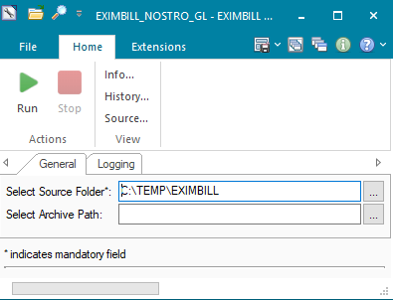

### OPERATING SPECIFICATION

1. Files from EXIMBILL system will be available at specified shared location.
2. Script will be developed to read the detailed file to get Nostro transactions.
3. That script will create standalone payments in FA from each valid record available in file where the Midas account from GL record matches with the add info on the Acquirer account.
4. Keep the source name in Counterparty field. Party will be created with name of surrounding system (e.g., BPS, TPS, EXIMBILL)

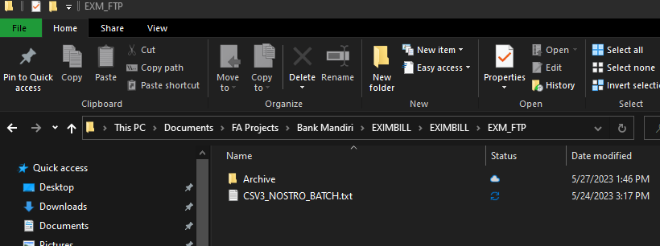

FParameters

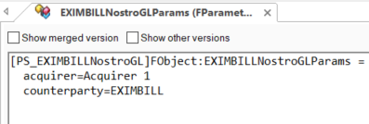

Run script GUI parameters for the task

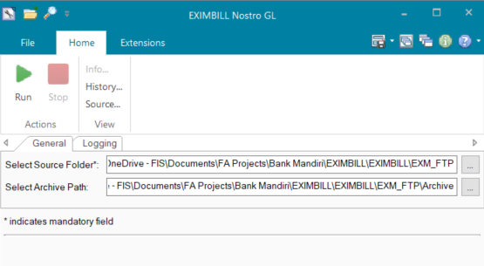

Settlement records created.

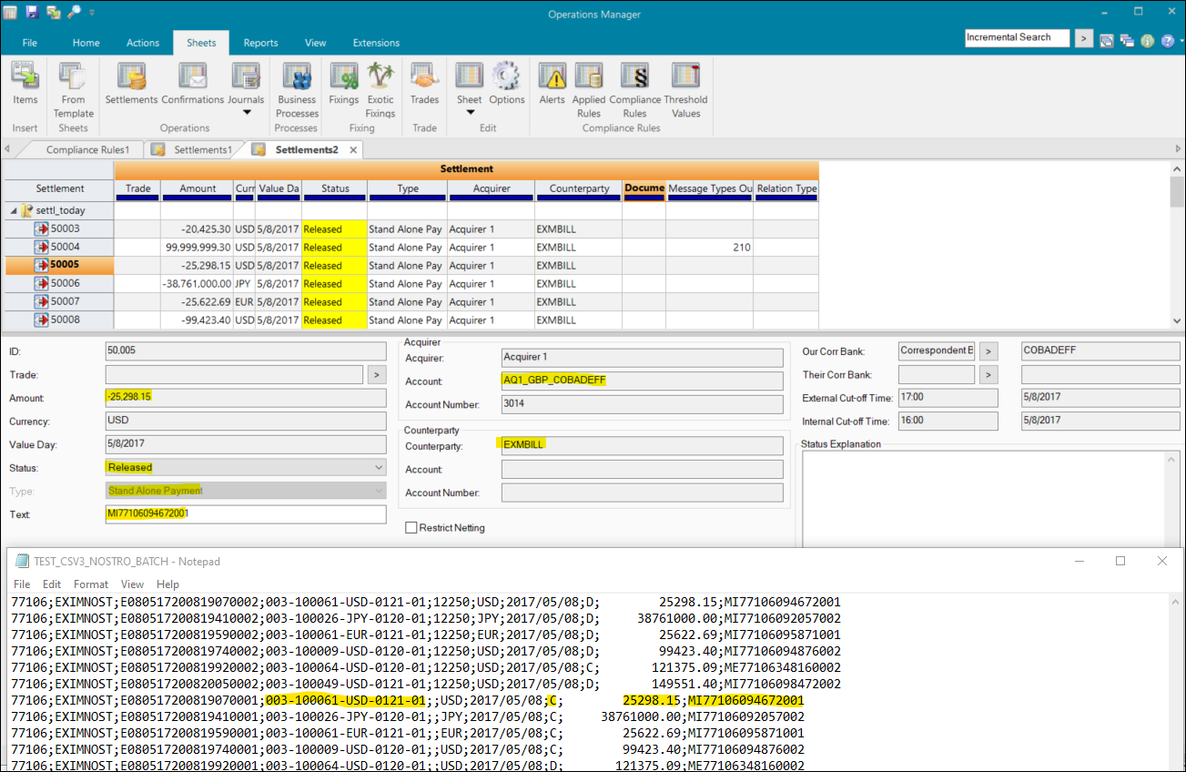

File archived after the task is executed.

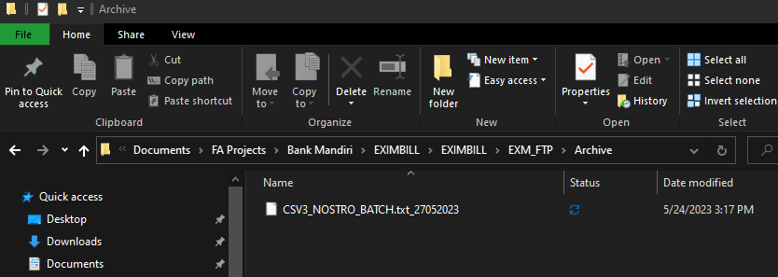

## Communication

*<This section provides the communication line that will be used in this system>*

### New / Existing*) system *) choose one

|  |  |  |  |  |  |  |  |  |  |
| --- | --- | --- | --- | --- | --- | --- | --- | --- | --- |
| **NO** | **NEW / SURROUNDING SYSTEM** | **HOSTNAME SOURCE** | **IP SOURCE** | **PORT SOURCE** | **HOSTNAME DESTINATION** | **IP DESTINATION** | **PORT DESTINATION** | **PROTOCOL (TCP /UDP /ICMP)** | **ALLOW / DENY** |
| 1 | *<new / surrounding status>* | *<isi nama host source>* | *<isi IP source>* | *<isi port source>* | *<isi nama host destination>* | *<isi IP destination>* | *<isi port destination>* | *<isi protocol>* | *<allow / deny status>* |
| 2 |  |  |  |  |  |  |  |  |  |
| 3 |  |  |  |  |  |  |  |  |  |
| 4 |  |  |  |  |  |  |  |  |  |
| 5 |  |  |  |  |  |  |  |  |  |
| 6 |  |  |  |  |  |  |  |  |  |
| 7 |  |  |  |  |  |  |  |  |  |
| 8 |  |  |  |  |  |  |  |  |  |
| … |  | … | … | … | … | … |  | … | … |

*< For a new developed system, if there are some undefined hostnames/ ip addresses/ ports yet, then should be written with* ***TBC*** *notes and will be completely defined in SDN contract review form >*

*< For an existing system and surrounding, please define and write its hostnames/ ip addresses/ ports >*

## OTHERS

*<This section provides other technical specifications that have not been address in previous section>.*

# IAM

## DESCRIPTION

|  |  |  |  |
| --- | --- | --- | --- |
| Interface name | IAM | | |
| Type of data | Custom – User Information | Frequency | Realtime |
| Source | IAM system | Direction | IN |
| Format | JSON | Transfer mechanism | Web API |
| Response Required | N/A | Dependencies on other processes | N/A |
| Purpose | User Management | | |

IAM system sends user details to Front Arena to create FA Users. Based on details from IAM interface will create Users in FA without any profile mapping. Bank Mandiri's Security access Management team will login to FA and manage the profile mapping for those newly create users, manually.

User Role management need to be performed manually by Bank Mandiri Security team,

* Get all role
* Assign role to user
* Update role to user
* Remove role from user
* Remove all role from user

## TECHNICAL ATTRIBUTE

|  |  |
| --- | --- |
| **Attribute** | **Description** |
| Extension Module | BM_IAM  *Module contains the code to be run by the ATS as web service for IAM interface for user management.* |
| ATS | ATS_IAM  *ATS will run in the module mode as a web service for IAM interface for user management.* |

## TECHNICAL ARCHITECTURE

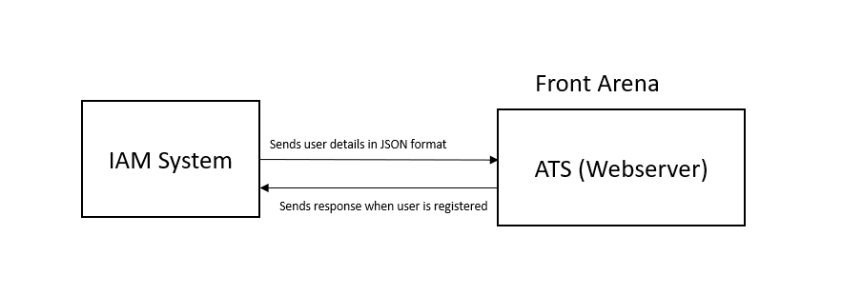

## TECHNICAL FLOW DIAGRAM

### Create User :

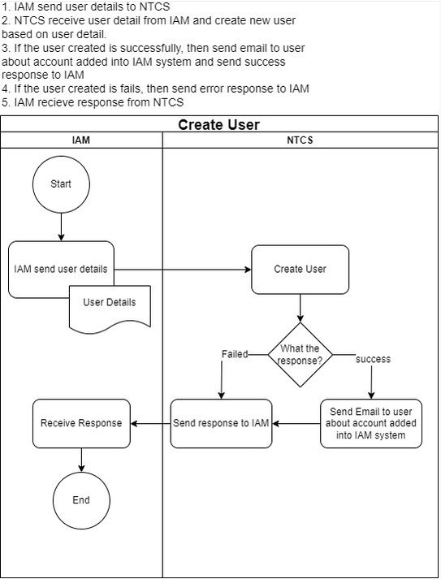

### Update User :

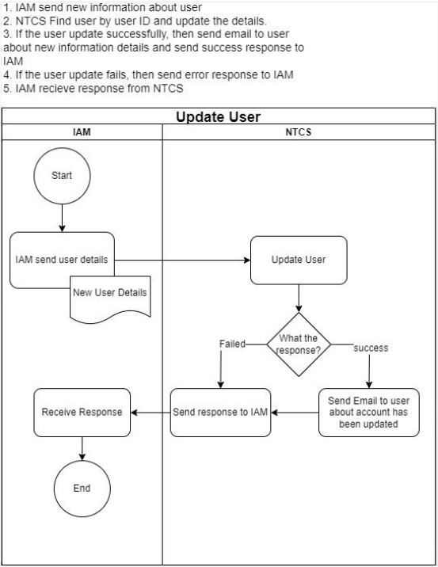

## LOGIC AND CONFIGURATION

### Flow Logic

1. IAM interface sends user details to Front Arena via Web API.
2. ATS which is running as a web server, receive user details and create/update the user in FA.

Front Arena (ATS) supports following functionalities:

**Create/Update user:**

* Web API : <http://localhost:8001/api/v1/user/registerupdate>
* Front arena creates/registers the user when field action code in the Json data received from IAM system as below

**If actionCode =C**, then create/register the user

**If actionCode =U**, then update the user

* If the create/update user is successful, FA send the response to IAM
* If the create/update user is failed, FA send the error response to IAM

**Enable/Disable User:**

* Web API : <http://localhost:8001/api/v1/user/enabledisable>
* Front arena enable/disable the user when field action code in the Json data received from IAM system as below

**If actionCode =E**, then activate the user

**If actionCode =D**, then inactivate the user

* If the enable/disable user is successful, FA send the response to IAM
* If the enable/disable user is failed, FA send the error response to IAM

### Configuration

|  |  |
| --- | --- |
| Delivery Items | |
| Extension Context | +Integration |
| Extension Module | BM_IAM |
| ATS service | ATS_IAM |
|  |  |
|  |  |
| FA Component | |
| ATS | ATS service – ATS_IAM is run as a web server for IAM system for user management. |
|  |  |
|  |  |
| Deployment and Manual Configuration | |
| This service is deployed through FA standard deployment process.  Manual configuration may be required to update the configuration in FParameter in extension module. | |
|  |  |
| Additional Information | |
| Contact | AdditionalInfo on User. |
| Department |
| Directorate |
| Group |
| Role |
| Position |
| Section |
| Subarea |
| SubareaDesc |
| FParameters | Default values |
| Username | User name for authetification |
| Password | password name for authetification |
| Port | 8001 |
|  |  |
| Pre-requisites |  |
| ATS service | ATS service for this interface must be running to work this interface. |
| FStoredASQLQuery | Purpose |
|  |  |

### Data Dictionary

Following are field mapping done for IAM interface.

|  |  |  |
| --- | --- | --- |
| FA Table | **FA Field** | **JSON data** |
| **User** | Name | UserID |
| FullName | NIP |
| Email | Email |
|  | UserGroup | groupFA |
|  | Inactive | actionCode |
| **AdditionalInfo** | Contact | MobileNumber |
| Role | Role |
| Directorate | Directorate |
| Group | Group |
| Department | Department |
| Position | Position |
| Section | Section |
| Subarea | Subarea |
| SubareaDesc | SubareaDesc |

### A Data Model

Please refer AEF Browser document for details about Front Arena Data Model.

Document - FCA4033

### B Data Entity and Key Elements Definition

All required details are available in AEF Browser document.

### C Reference Code Table Definition

Please refer AEF Browser document for details about Front Arena Data Model.

Document - FCA4033

## SECURITY AND CONTROL DESIGN

### Security Requirement Response

|  |  |  |
| --- | --- | --- |
| **Security Domain** | **Security Requirement** | **Response** |
| User Management | The system must identify users using a unique user identification code before allowing a log-on. | It will be controlled through CDCA application |
| The system must suspend access to a user session after a specified interval of inactivity. | Inactivity of user session will not be applicable  as the integration is in Realtime |
| The system must require user authentication before re-enabling the session. | It will be controlled through CDCA application |
| The system must display a warning message indicating that only authorized use is permitted before allowing users to perform a log-on. | It will be controlled through CDCA application |
| The system must display system information to a user, only after a successful log-on. |  |
| After a successful log-on, the system must display information concerning the previous successful attempt to perform a log-on. | It will not be possible in real-time connections. |
| The system must allow a user account to be manually disabled. | NA |
| The system must disable the user account following 3 (three) consecutive failures to perform a successful log-on. | It will be controlled through CDCA application |
| The system must automatically disable the user account following a configurable period (90 days) without use. |  |
| Password Management | The system must authenticate users using a password before allowing access to any system functions. | Not applicable at Front Arena Database side. |
| The system must ensure that passwords used by system users for log-on consist of at least 8 (eight) characters. | Not applicable at Front Arena Database side. |
| The system must enforce the use of complex passwords for all users. (Aplhanumieric & Special Characters) | Not applicable at Front Arena Database side. |
| The system must use cryptographic techniques to protect the confidentiality of user authentication data during transmission. | Not applicable at Front Arena Database side. |
| The system must enforce a password change when a password is first issued or re-issued. |  |
| The system must allow system users to change the password used for log-on. | Not applicable at Front Arena Database side. |
| The system must ensure that passwords do not remain valid for more than 90 (ninety) days. | Not applicable at Front Arena Database side. |
| The system must ensure that passwords may not be changed to any of the last 5 (five) passwords used. | Not applicable at Front Arena Database side. |
| The system must ensure that passwords are not displayed in clear text during entry. | Not applicable at Front Arena Database side. |
| Multi Factor Authentication | The system must enforce dual factor authentication of all users (system that related to financial, faced to customer directly & only use for external purposes) | Not applicable at Front Arena Database side. |
| Data Storage | The system must use cryptographic techniques to protect the storage of authentication data. | NA |
| The system must use cryptographic techniques to protect the integrity of stored critical data. | NA |
| The system must use cryptographic techniques to protect the confidentiality of stored sensitive data. | NA |
| Logging | The system must support the recording of security events in one or multiple specific security event logs. 2 weeks in minimum must be available at the Production Environment | It will be controlled through CDCA application |
| The system must include the Logical Account identity, event type and timestamp in each entry in the security event logs. | It will be controlled through CDCA application |
| The system must record when each security event lo fills to a configurable limit. | It will be controlled through CDCA application |
| The system must protect the integrity of the information in the security event logs | It will be controlled through CDCA application |
| The system must allow access to the security event logs to be limited to the authorised security staff. | It will be controlled through CDCA application |
| The system must record if the integrity of the security event logs is compromised | NA |
| The system must record all instances that system event logs are cleared. | It will be controlled through CDCA application |
| The system must record when a change is made to the system log settings (e.g. logs for certain events are turned off). | It will be controlled through CDCA application |
| The system must record when any system security policy is modified. | NA |
| The system must record all creations of Logical Accounts. | It will be controlled through CDCA application |
| The system must record all deletions of Logical Accounts. |  |
| The system must record all de-activation of Logical Accounts. |  |
| The system must record all unsuccessful attempts to log-on to the system using invalid credentials. |  |
| The system must record all successful attempts to log-on to the system. |  |
| The system must record all successful and unsuccessful attempts to change passwords. |  |
| The system must automatically build and maintain a normal usage pattern for each Logical Account. |  |
| The system must record all activation of disabled Logical Accounts. |  |
| The system must record all attempts to change any account attribute affecting authentication of the Logical Account |  |
| The system must record all allocations of system access rights. |  |
| The system must record all removals of system access rights. |  |
| The system must record all unauthorised attempts to access a system function. |  |
| The system must record when a configurable deviation from a Logical Account's normal pattern is detected. |  |
| The system must record all failures of the check on the timestamp of payment and settlement orders. |  |
| The system must record all attempts to mutually authenticate interface connections that handle critical data |  |
| The system must record all events that may indicate an attempt to cause denial of service. |  |
| The system must record all access to functions processing critical information within the system. |  |
| The system must record all access to sensitive information within the system. |  |
| The system must record all start-up and shut down events. |  |
| The system must have been integrated in the SIEM, Identity Management System & Privilege Identity Management System |  |
| Remote Access | The system logical access control mechanism must be able to discretely grant remote access capability to specific users and user groups. |  |
| The system must strictly limit user access rights to their minimum requirements when they access the system remotely. |  |
| All relevant approvals must be obtained if this application is to be made available for remote use (E.g. on the RCA-portal) by Users |  |
| System Interfaces | The system must use a logical access control mechanism to control system to system data communications, in order to avoid anonymous data transfers (for all interfaces) |  |
| The system must ensure that system to system mutual authentication takes place before data communications are allowed (for all interfaces) |  |
| System to system mutual authentication must be based on cryptographic techniques (for all interfaces) |  |
| The system must use cryptographic techniques to protect the integrity of critical data during transmission (for all interfaces) |  |
| The system must use cryptographic techniques to protect the confidentiality of sensitive data during transmission (for all interfaces) |  |
| All 'critical data' must have been identified, documented and approved by the Business |  |
| All 'confidential data' must have been identified, documented and approved by the Business |  |
| Availability | The system must have a documented and successfully tested disaster recovery plan in place | It will be managed through Front Arena Database DR setup. |
| The system must enforce quotas limiting the maximum resources that an individual user can use simultaneously. |  |
| The system must provide adequate resources to support the required number of users or concurrent users. |  |
| The system should have a documented capacity monitoring process in-place with regular reporting on its use |  |
| Security Testing | The system must be tested for specific technical security flaws where it faces the public internet, prior to release into production. |  |
| The system must only be released into production, where it faces the public internet, once all identified key findings from the security test have been rectified, or if this is not possible, the risks must be formally reviewed and signed off |  |
| The system must be tested for specific technical security flaws prior to release into production. |  |
| The system must only be released into production once all the identified key findings from the security tests have been rectified or if this is not possible, the risks must be formally reviewed and signed off |  |

### Preventive controls

*<This sub-section describe the technical specification for preventive controls that are specific to this module. This includes logical access control, physical security control, encryption, PIN generation and validation, etc>*

*<Sample of list of Role Table and Authorization Matrix>*

|  |  |  |  |
| --- | --- | --- | --- |
| **No** | **Role** | **Authorization** | **Object** |
| 1 | Role1 | ZXXXX | Maintain |
| 2 | Role2 | ZYYYY | Display |
| 3 |  |  |  |

|  |  |  |  |  |  |  |
| --- | --- | --- | --- | --- | --- | --- |
| **No** | **User Group** | **Role1** | **Role2** | **Role3** | **Role4** | **Role5** |
| 1 | User Group1 | X | X |  | X |  |
| 2 | User Group2 |  | X | X |  | X |
|  |  |  |  |  |  |  |

### Detective controls

*<This sub-section describe the technical specification for detective controls that are specific to this module. This includes audit trail, exception reports, reconciliation, balancing & control totals, validations, etc>.*

### Corrective controls

*<This sub-section describes the technical specification for corrective controls that are specific to this module. This includes automated error corrections, backup, recovery & restart, etc>.*

## USER INTERFACE

NA

## OPERATING SPECIFICATION

NA

# **IPS LIMIT**

## IPS - Limits

Description

|  |  |  |  |
| --- | --- | --- | --- |
| **Interface name** | IPS - Limit Onboarding | | |
| **Type of data** | Limit | **Frequency** | Realtime |
| **Source** | IPS | **Direction** | IN |
| **Format** | JSON | **Transfer mechanism** | Webservice |
| **Response Required** | No | **Dependencies on other processes** |  |
| **Purpose** | IPS is external limit management system from where limit details are received in Front Arena to setup the already created ComplianceRules, for limit monitoring system. | | |

IPS is external limit management system. It sends limit details to Front Arena to setup applied rules in ComplianceRules in Front Arena for limit monitoring purpose.

Bank Mandiri should create and setup ComplianceRules manually as per business requirements. Designing Query folder/ Trade filleters will be part of compliance Rule setup.

IPS will send limit details including Party, limit value and compliance rule definitions name. IPS will send these details in JSON format, so interface can upload the details which will get attached to respective ComplianceRules in FA.

Please refer Appendix - 3 - Interface Data Format in Phase 1B PDR, for more details about Applied Rule sample CSV.

* Document - AppliedRule_Sample.csv

### TECHNICAL ATTRIBUTE

|  |  |
| --- | --- |
| **Attribute** | **Description** |
| Extension Module | *PS_IPSLimits* |
| ATS | *ATS_CUSTOMER_LIMIT* |

### TECHNICAL ARCHITECTURE

Refer to the Technical Flow Diagram

### TECHNICAL FLOW DIAGRAM

**Front Arena Webservice**

**https://<server IP>/IPSLimitOnboarding**

ADS

ATS_CUSTOMER_LIMIT

IPS System Client

**Front Arena**

**IPS System**

**JSON format data**

### LOGIC AND CONFIGURATION

#### Flow Logic

1. User sets up ComplianceRules in FrontArena prior to this flow.

2. IPS System client sends JSON request containing the data for applied rules.

3. FrontArena webserver processes the input data and creates/updates the AppliedRules.

4. FrontArena webserver sends response in the JSON format back to the client. If there are

any errors while processing the request, FA will update the same in the response message.

If there are multiple entries in one request and one of them fails, the other entries will be

discarded as well.

#### Configuration

|  |  |
| --- | --- |
| Delivery Items | |
| Extension Context | PS_IPSLimits |
| Extension Module | PS_IPSLimits |
| ATS Service | ATS_CUSTOMER_LIMIT |
|  |  |
| FA Component | |
| ATS | ATS Service- ATS_CUSTOMER_LIMIT is used as webservice to receive the requests from client. |
|  |  |
| Deployment and Manual Configuration | |
| This service is deployed through FA standard deployment process.  Manual configuration may be required to update the configuration in FParameter in extension module. | |
|  |  |
| Additional Information | |
| AgreementNumber, AgreementDate, RenewalNumber, RenewalDate, ApplicationNumber are used to store incoming data on applied rule. | |
| FParameters | Default values |
| CertificateFile | Path to SSL certificate file. |
| KeyFile | Path to SSL key file. |
| listeningURL | IPSLimitOnboarding |
| ServerPort | 8086 |
| Pre-requisites |  |
| 1. The ATS should be running for this flow to work. 2. The Compliance should be present in the FrontArena environment. | |
|  |  |
| FStoredASQLQuery | Purpose |
| No stored query is used. | |

#### Data Dictionary

Following are field mapping done for this interface.

Document – IPS Proposed Specification v1.3



#### A Data Model

FrontArena acm object FAppliedRule is used to update the applied rule

information. Please refer AEF Browser document for details about Front Arena Data

Model. Document - FCA4033

#### B Data Entity and Key Elements Definition

All required details are available in AEF Browser document.

#### C Reference Code Table Definition

Please refer AEF Browser document for details about Front Arena Data Model.

Document - FCA4033

### SECURITY AND CONTROL DESIGN

#### Security Requirement Response

|  |  |  |
| --- | --- | --- |
| **Security Domain** | **Security Requirement** | **Response** |
| User Management | The system must identify users using a unique user identification code before allowing a log-on. | It will be controlled through CDCA application |
| The system must suspend access to a user session after a specified interval of inactivity. | Inactivity of user session will not be applicable  as the integration is in Realtime |
| The system must require user authentication before re-enabling the session. | It will be controlled through CDCA application |
| The system must display a warning message indicating that only authorized use is permitted before allowing users to perform a log-on. | It will be controlled through CDCA application |
| The system must display system information to a user, only after a successful log-on. |  |
| After a successful log-on, the system must display information concerning the previous successful attempt to perform a log-on. | It will not be possible in real-time connections. |
| The system must allow a user account to be manually disabled. | NA |
| The system must disable the user account following 3 (three) consecutive failures to perform a successful log-on. | It will be controlled through CDCA application |
| The system must automatically disable the user account following a configurable period (90 days) without use. |  |
| Password Management | The system must authenticate users using a password before allowing access to any system functions. | Not applicable at Front Arena Database side. |
| The system must ensure that passwords used by system users for log-on consist of at least 8 (eight) characters. | Not applicable at Front Arena Database side. |
| The system must enforce the use of complex passwords for all users. (Aplhanumieric & Special Characters) | Not applicable at Front Arena Database side. |
| The system must use cryptographic techniques to protect the confidentiality of user authentication data during transmission. | Not applicable at Front Arena Database side. |
| The system must enforce a password change when a password is first issued or re-issued. |  |
| The system must allow system users to change the password used for log-on. | Not applicable at Front Arena Database side. |
| The system must ensure that passwords do not remain valid for more than 90 (ninety) days. | Not applicable at Front Arena Database side. |
| The system must ensure that passwords may not be changed to any of the last 5 (five) passwords used. | Not applicable at Front Arena Database side. |
| The system must ensure that passwords are not displayed in clear text during entry. | Not applicable at Front Arena Database side. |
| Multi Factor Authentication | The system must enforce dual factor authentication of all users (system that related to financial, faced to customer directly & only use for external purposes) | Not applicable at Front Arena Database side. |
| Data Storage | The system must use cryptographic techniques to protect the storage of authentication data. | NA |
| The system must use cryptographic techniques to protect the integrity of stored critical data. | NA |
| The system must use cryptographic techniques to protect the confidentiality of stored sensitive data. | NA |
| Logging | The system must support the recording of security events in one or multiple specific security event logs. 2 weeks in minimum must be available at the Production Environment | It will be controlled through CDCA application |
| The system must include the Logical Account identity, event type and timestamp in each entry in the security event logs. | It will be controlled through CDCA application |
| The system must record when each security event lo fills to a configurable limit. | It will be controlled through CDCA application |
| The system must protect the integrity of the information in the security event logs | It will be controlled through CDCA application |
| The system must allow access to the security event logs to be limited to the authorised security staff. | It will be controlled through CDCA application |
| The system must record if the integrity of the security event logs is compromised | NA |
| The system must record all instances that system event logs are cleared. | It will be controlled through CDCA application |
| The system must record when a change is made to the system log settings (e.g. logs for certain events are turned off). | It will be controlled through CDCA application |
| The system must record when any system security policy is modified. | NA |
| The system must record all creations of Logical Accounts. | It will be controlled through CDCA application |
| The system must record all deletions of Logical Accounts. |  |
| The system must record all de-activation of Logical Accounts. |  |
| The system must record all unsuccessful attempts to log-on to the system using invalid credentials. |  |
| The system must record all successful attempts to log-on to the system. |  |
| The system must record all successful and unsuccessful attempts to change passwords. |  |
| The system must automatically build and maintain a normal usage pattern for each Logical Account. |  |
| The system must record all activation of disabled Logical Accounts. |  |
| The system must record all attempts to change any account attribute affecting authentication of the Logical Account |  |
| The system must record all allocations of system access rights. |  |
| The system must record all removals of system access rights. |  |
| The system must record all unauthorised attempts to access a system function. |  |
| The system must record when a configurable deviation from a Logical Account's normal pattern is detected. |  |
| The system must record all failures of the check on the timestamp of payment and settlement orders. |  |
| The system must record all attempts to mutually authenticate interface connections that handle critical data |  |
| The system must record all events that may indicate an attempt to cause denial of service. |  |
| The system must record all access to functions processing critical information within the system. |  |
| The system must record all access to sensitive information within the system. |  |
| The system must record all start-up and shut down events. |  |
| The system must have been integrated in the SIEM, Identity Management System & Privilege Identity Management System |  |
| Remote Access | The system logical access control mechanism must be able to discretely grant remote access capability to specific users and user groups. |  |
| The system must strictly limit user access rights to their minimum requirements when they access the system remotely. |  |
| All relevant approvals must be obtained if this application is to be made available for remote use (E.g. on the RCA-portal) by Users |  |
| System Interfaces | The system must use a logical access control mechanism to control system to system data communications, in order to avoid anonymous data transfers (for all interfaces) |  |
| The system must ensure that system to system mutual authentication takes place before data communications are allowed (for all interfaces) |  |
| System to system mutual authentication must be based on cryptographic techniques (for all interfaces) |  |
| The system must use cryptographic techniques to protect the integrity of critical data during transmission (for all interfaces) |  |
| The system must use cryptographic techniques to protect the confidentiality of sensitive data during transmission (for all interfaces) |  |
| All 'critical data' must have been identified, documented and approved by the Business |  |
| All 'confidential data' must have been identified, documented and approved by the Business |  |
| Availability | The system must have a documented and successfully tested disaster recovery plan in place | It will be managed through Front Arena Database DR setup. |
| The system must enforce quotas limiting the maximum resources that an individual user can use simultaneously. |  |
| The system must provide adequate resources to support the required number of users or concurrent users. |  |
| The system should have a documented capacity monitoring process in-place with regular reporting on its use |  |
| Security Testing | The system must be tested for specific technical security flaws where it faces the public internet, prior to release into production. |  |
| The system must only be released into production, where it faces the public internet, once all identified key findings from the security test have been rectified, or if this is not possible, the risks must be formally reviewed and signed off |  |
| The system must be tested for specific technical security flaws prior to release into production. |  |
| The system must only be released into production once all the identified key findings from the security tests have been rectified or if this is not possible, the risks must be formally reviewed and signed off |  |

#### Preventive controls

*<This sub-section describe the technical specification for preventive controls that are specific to this module. This includes logical access control, physical security control, encryption, PIN generation and validation, etc>*

*<Sample of list of Role Table and Authorization Matrix>*

|  |  |  |  |
| --- | --- | --- | --- |
| **No** | **Role** | **Authorization** | **Object** |
| 1 | Role1 | ZXXXX | Maintain |
| 2 | Role2 | ZYYYY | Display |
| 3 |  |  |  |

|  |  |  |  |  |  |  |
| --- | --- | --- | --- | --- | --- | --- |
| **No** | **User Group** | **Role1** | **Role2** | **Role3** | **Role4** | **Role5** |
| 1 | User Group1 | X | X |  | X |  |
| 2 | User Group2 |  | X | X |  | X |
|  |  |  |  |  |  |  |

#### Detective controls

*<This sub-section describe the technical specification for detective controls that are specific to this module. This includes audit trail, exception reports, reconciliation, balancing & control totals, validations, etc>.*

#### Corrective controls

*<This sub-section describes the technical specification for corrective controls that are specific to this module. This includes automated error corrections, backup, recovery & restart, etc>.*

### USER INTERFACE

NA

### OPERATING SPECIFICATION

Applied Rule information from IPS will be sent to FrontArena Webservice. Interface is developed to capture incoming request to create/update the applied rules in FrontArena.

1. The user will create the Compliance rule in FrontArena.
2. The ATS will run as Webservice to which the IPS Limit client will send the data in JSON format.
3. Webservice will create/update the Applied Rule in FrontArena and send a response to the client.
4. The flow from client to the server is synchronous.

The following ATS will be used.

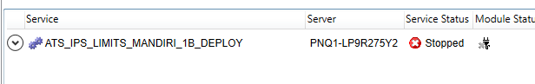

The following additional info fields will be updated.

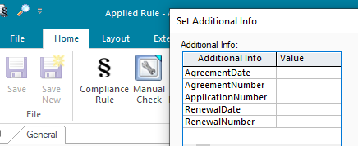

## REPORTING

### 9.1 Inventory of Reports

*<This sub-section provides a list of operational reports relevant to this module. It is assumed that MIS/EIS module will produce the executive management and regulatory related reports>.*

*<Sample of report definition>*

|  |  |  |
| --- | --- | --- |
| **No** | **Report Name** | **Description** |
|  |  | <Description> |
|  |  |  |

*<if there is data integrity checking requirement, please provide any additional supporting information>.*

### 9.2 Report layout and definition

*<This sub-section describes each of the reports in the inventory list. Report Layout and It’s selection screen must be drawn clearly in this subsection>*

*<Sample of Selection Screen:>*

Selection Field 1

Selection Field 2

to

*<Sample of Report Layout>*

**Report Title**

Report Header

LOGO

Report Footer

Page No.

**Column1**

**Column2**

**Column3**

**Column4**

**Column5**

**Column6**

**Total1**

## Communication

*<This section provides the communication line that will be used in this system>*

### New / Existing*) system *) choose one

|  |  |  |  |  |  |  |  |  |  |
| --- | --- | --- | --- | --- | --- | --- | --- | --- | --- |
| **NO** | **NEW / SURROUNDING SYSTEM** | **HOSTNAME SOURCE** | **IP SOURCE** | **PORT SOURCE** | **HOSTNAME DESTINATION** | **IP DESTINATION** | **PORT DESTINATION** | **PROTOCOL (TCP /UDP /ICMP)** | **ALLOW / DENY** |
| 1 | *<new / surrounding status>* | *<isi nama host source>* | *<isi IP source>* | *<isi port source>* | *<isi nama host destination>* | *<isi IP destination>* | *<isi port destination>* | *<isi protocol>* | *<allow / deny status>* |
| 2 |  |  |  |  |  |  |  |  |  |
| 3 |  |  |  |  |  |  |  |  |  |
| 4 |  |  |  |  |  |  |  |  |  |
| 5 |  |  |  |  |  |  |  |  |  |
| 6 |  |  |  |  |  |  |  |  |  |
| 7 |  |  |  |  |  |  |  |  |  |
| 8 |  |  |  |  |  |  |  |  |  |
| … |  | … | … | … | … | … |  | … | … |

*< For a new developed system, if there are some undefined hostnames/ ip addresses/ ports yet, then should be written with* ***TBC*** *notes and will be completely defined in SDN contract review form >*

*< For an existing system and surrounding, please define and write its hostnames/ ip addresses/ ports >*

## OTHERS

*<This section provides other technical specifications that have not been address in previous section>.*

# **IRS**

## IRS MT950 OUT

### DESCRIPTION

|  |  |  |  |
| --- | --- | --- | --- |
| **Interface – IRS Citynet – MT950** | | | |
| **Interface name** | IRS Citynet – MT950 | | |
| **Type of data** | MT950 – file | **Frequency** | EOD |
| **Source** | Front Arena | **Direction** | Out |
| **Format** | MT950 | **Transfer mechanism** | SFTP |
| **Response Required** | NA | **Dependencies on other processes** | NA |
| **Purpose** | Reconciliation at IRS Citynet. | | |

IRS Citynet is Reconciliation system, where Nostro file messages are received from Correspondent Bank and Front Arena. Front Arena receives file(Nostro Account Transactions) from surrounding systems like BPS, TPS,EXIMBILL. Transaction details received will be available in Front Arena in form of standalone Settlements.

There will be separate MT950 message/output file created for each Nostro account in FA. Settlements satisfying below selection criteria will be considered to generate MT950 message.

1. Settlement status: Pending Closure
2. Additional Info on Settlement - 'SentToCitynet' : False

Settlement status should be equal to “Pending Closure.”

AND

Additional Information on Settlement - 'SentToCitynet' should be False

Once Settlement added to MT950 and sent to IRS citynet then Additional information 'SentToCitynet' set to True to make sure that same settlement will not come in queue once delivered.

Each settlement information will be sent only once to IRS citynet. This will be handled through additional information field on Settlement. This Additional information field 'SentToCitynet', will be set to 'True' once the settlement information is sent via MT950.

Front Arena will create MT950 only for transactions that recorded in FA which debit/credit to nostro accounts IDR or Foreign Currencies

MT950 message will send to IRS citynet in file format, through SFTP.

### TECHNICAL ATTRIBUTE

|  |  |
| --- | --- |
| **Attribute** | **Description** |
| Extension Module | PS_MT950Out  *It contains code required to generate MT950 for the settlement in SWIFT format.* |

### TECHNICAL ARCHITECTURE

FrontArena

Generate MT950

and write it to SFTP

Update the write response and

closing balance on

Settlement AddInfo.

SFTP

AEL Task

FTP Location

### TECHNICAL FLOW DIAGRAM

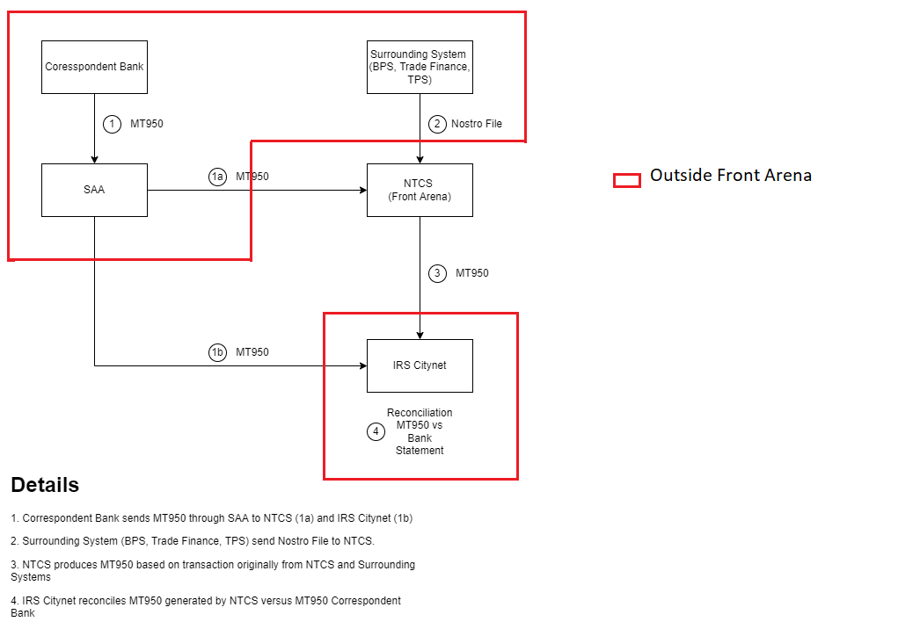

### LOGIC AND CONFIGURATION

#### Flow Logic

1. The Module PS_MT950Out will run on Schedule Time and pick the eligible settlement with the help of account Specific Query – Example for account Acc1 Query should be MT950_Acc1.

User must create Account specific query manually sample query already given with Module.

2. Based on query result the MT950 for that account gets created and uploaded to SFTP.

3. Once it gets uploaded to SFTP the Additional Info field - SentToIRSCitynet gets updated to 1. So, the next time this Settlement will not come in eligible settlement list

Settlement eligibility criteria:

Settlement Status should be – ‘Pending Closure.’

Additional information field – SentToIRSCitynet, should be blank.

To indicate If the settlement is already sent or not:

1. Already sent, field value is “1”.
2. Not sent, field value is empty.

#### Configuration

|  |  |
| --- | --- |
| Delivery Items | |
| Extension Context | +Back Office |
| Extension Module | PS_MT950Out |
| Manual Configuration | |
| Manual configuration may be required to update the configuration in FParameter in extension module. | |
|  |  |
| Additional Information | |
| SentToIRSCitynet | AdditionalInfo on Settlement. |
| FParameters | Default values |
| SFTP_Destination |  |
| SFTP_Host |  |
| SFTP_Password |  |
| SFTP_Port |  |
| SFTP_UserName |  |
| Pre-requisites |  |
| Query - MT950_AccountNumber | Query with name specified in Name, must be available, so that program can extract Settlement through that query. |
| FStoredASQLQuery | Purpose |
| MT950_AccountNumber | Filter specifying the eligible settlements. |

#### Data Dictionary

Please refer attached Data Mapping file in section Appendix - MT950_Field_Mapping.xlsx



#### A Data Model

Please refer AEF Browser document for details about Front Arena Data Model.

Document - FCA4033 Section ADM.Settlement

#### B Data Entity and Key Elements Definition

Refer to Section 6.7.1.4.

#### C Reference Code Table Definition

NA

### SECURITY AND CONTROL DESIGN

#### Security Requirement Response

|  |  |  |
| --- | --- | --- |
| **Security Domain** | **Security Requirement** | **Response** |
| User Management | The system must identify users using a unique user identification code before allowing a log-on. | It will be controlled through CDCA application |
| The system must suspend access to a user session after a specified interval of inactivity. | Inactivity of user session will not be applicable  as the integration is in Realtime |
| The system must require user authentication before re-enabling the session. | It will be controlled through CDCA application |
| The system must display a warning message indicating that only authorized use is permitted before allowing users to perform a log-on. | It will be controlled through CDCA application |
| The system must display system information to a user, only after a successful log-on. |  |
| After a successful log-on, the system must display information concerning the previous successful attempt to perform a log-on. | It will not be possible in real-time connections. |
| The system must allow a user account to be manually disabled. | NA |
| The system must disable the user account following 3 (three) consecutive failures to perform a successful log-on. | It will be controlled through CDCA application |
| The system must automatically disable the user account following a configurable period (90 days) without use. |  |
| Password Management | The system must authenticate users using a password before allowing access to any system functions. | Not applicable at Front Arena Database side. |
| The system must ensure that passwords used by system users for log-on consist of at least 8 (eight) characters. | Not applicable at Front Arena Database side. |
| The system must enforce the use of complex passwords for all users. (Aplhanumieric & Special Characters) | Not applicable at Front Arena Database side. |
| The system must use cryptographic techniques to protect the confidentiality of user authentication data during transmission. | Not applicable at Front Arena Database side. |
| The system must enforce a password change when a password is first issued or re-issued. |  |
| The system must allow system users to change the password used for log-on. | Not applicable at Front Arena Database side. |
| The system must ensure that passwords do not remain valid for more than 90 (ninety) days. | Not applicable at Front Arena Database side. |
| The system must ensure that passwords may not be changed to any of the last 5 (five) passwords used. | Not applicable at Front Arena Database side. |
| The system must ensure that passwords are not displayed in clear text during entry. | Not applicable at Front Arena Database side. |
| Multi Factor Authentication | The system must enforce dual factor authentication of all users (system that related to financial, faced to customer directly & only use for external purposes) | Not applicable at Front Arena Database side. |
| Data Storage | The system must use cryptographic techniques to protect the storage of authentication data. | NA |
| The system must use cryptographic techniques to protect the integrity of stored critical data. | NA |
| The system must use cryptographic techniques to protect the confidentiality of stored sensitive data. | NA |
| Logging | The system must support the recording of security events in one or multiple specific security event logs. 2 weeks in minimum must be available at the Production Environment | It will be controlled through CDCA application |
| The system must include the Logical Account identity, event type and timestamp in each entry in the security event logs. | It will be controlled through CDCA application |
| The system must record when each security event lo fills to a configurable limit. | It will be controlled through CDCA application |
| The system must protect the integrity of the information in the security event logs | It will be controlled through CDCA application |
| The system must allow access to the security event logs to be limited to the authorised security staff. | It will be controlled through CDCA application |
| The system must record if the integrity of the security event logs is compromised | NA |
| The system must record all instances that system event logs are cleared. | It will be controlled through CDCA application |
| The system must record when a change is made to the system log settings (e.g. logs for certain events are turned off). | It will be controlled through CDCA application |
| The system must record when any system security policy is modified. | NA |
| The system must record all creations of Logical Accounts. | It will be controlled through CDCA application |
| The system must record all deletions of Logical Accounts. |  |
| The system must record all de-activation of Logical Accounts. |  |
| The system must record all unsuccessful attempts to log-on to the system using invalid credentials. |  |
| The system must record all successful attempts to log-on to the system. |  |
| The system must record all successful and unsuccessful attempts to change passwords. |  |
| The system must automatically build and maintain a normal usage pattern for each Logical Account. |  |
| The system must record all activation of disabled Logical Accounts. |  |
| The system must record all attempts to change any account attribute affecting authentication of the Logical Account |  |
| The system must record all allocations of system access rights. |  |
| The system must record all removals of system access rights. |  |
| The system must record all unauthorised attempts to access a system function. |  |
| The system must record when a configurable deviation from a Logical Account's normal pattern is detected. |  |
| The system must record all failures of the check on the timestamp of payment and settlement orders. |  |
| The system must record all attempts to mutually authenticate interface connections that handle critical data |  |
| The system must record all events that may indicate an attempt to cause denial of service. |  |
| The system must record all access to functions processing critical information within the system. |  |
| The system must record all access to sensitive information within the system. |  |
| The system must record all start-up and shut down events. |  |
| The system must have been integrated in the SIEM, Identity Management System & Privilege Identity Management System |  |
| Remote Access | The system logical access control mechanism must be able to discretely grant remote access capability to specific users and user groups. |  |
| The system must strictly limit user access rights to their minimum requirements when they access the system remotely. |  |
| All relevant approvals must be obtained if this application is to be made available for remote use (E.g. on the RCA-portal) by Users |  |
| System Interfaces | The system must use a logical access control mechanism to control system to system data communications, in order to avoid anonymous data transfers (for all interfaces) |  |
| The system must ensure that system to system mutual authentication takes place before data communications are allowed (for all interfaces) |  |
| System to system mutual authentication must be based on cryptographic techniques (for all interfaces) |  |
| The system must use cryptographic techniques to protect the integrity of critical data during transmission (for all interfaces) |  |
| The system must use cryptographic techniques to protect the confidentiality of sensitive data during transmission (for all interfaces) |  |
| All 'critical data' must have been identified, documented and approved by the Business |  |
| All 'confidential data' must have been identified, documented and approved by the Business |  |
| Availability | The system must have a documented and successfully tested disaster recovery plan in place | It will be managed through Front Arena Database DR setup. |
| The system must enforce quotas limiting the maximum resources that an individual user can use simultaneously. |  |
| The system must provide adequate resources to support the required number of users or concurrent users. |  |
| The system should have a documented capacity monitoring process in-place with regular reporting on its use |  |
| Security Testing | The system must be tested for specific technical security flaws where it faces the public internet, prior to release into production. |  |
| The system must only be released into production, where it faces the public internet, once all identified key findings from the security test have been rectified, or if this is not possible, the risks must be formally reviewed and signed off |  |
| The system must be tested for specific technical security flaws prior to release into production. |  |
| The system must only be released into production once all the identified key findings from the security tests have been rectified or if this is not possible, the risks must be formally reviewed and signed off |  |

#### Preventive controls

*<This sub-section describe the technical specification for preventive controls that are specific to this module. This includes logical access control, physical security control, encryption, PIN generation and validation, etc>*

*<Sample of list of Role Table and Authorization Matrix>*

|  |  |  |  |
| --- | --- | --- | --- |
| **No** | **Role** | **Authorization** | **Object** |
| 1 | Role1 | ZXXXX | Maintain |
| 2 | Role2 | ZYYYY | Display |
| 3 |  |  |  |

|  |  |  |  |  |  |  |
| --- | --- | --- | --- | --- | --- | --- |
| **No** | **User Group** | **Role1** | **Role2** | **Role3** | **Role4** | **Role5** |
| 1 | User Group1 | X | X |  | X |  |
| 2 | User Group2 |  | X | X |  | X |
|  |  |  |  |  |  |  |

#### Detective controls

*<This sub-section describe the technical specification for detective controls that are specific to this module. This includes audit trail, exception reports, reconciliation, balancing & control totals, validations, etc>.*

#### Corrective controls

*<This sub-section describes the technical specification for corrective controls that are specific to this module. This includes automated error corrections, backup, recovery & restart, etc>.*

### USER INTERFACE

If required, the user can trigger the process, by using the task GUI *GenerateMT950Outgoing.* All the settlements that have not been processed will be sent to IRSCitynet.

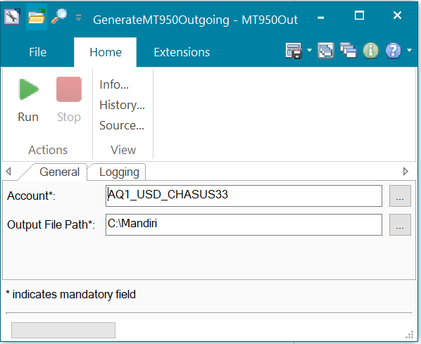

### OPERATING SPECIFICATION

The following filter query is sample query for one account user should create such query for all the accounts for which user wants to generate the MT950 message.

Note- Query name Should be in format – ‘MT950_AccountNumber’

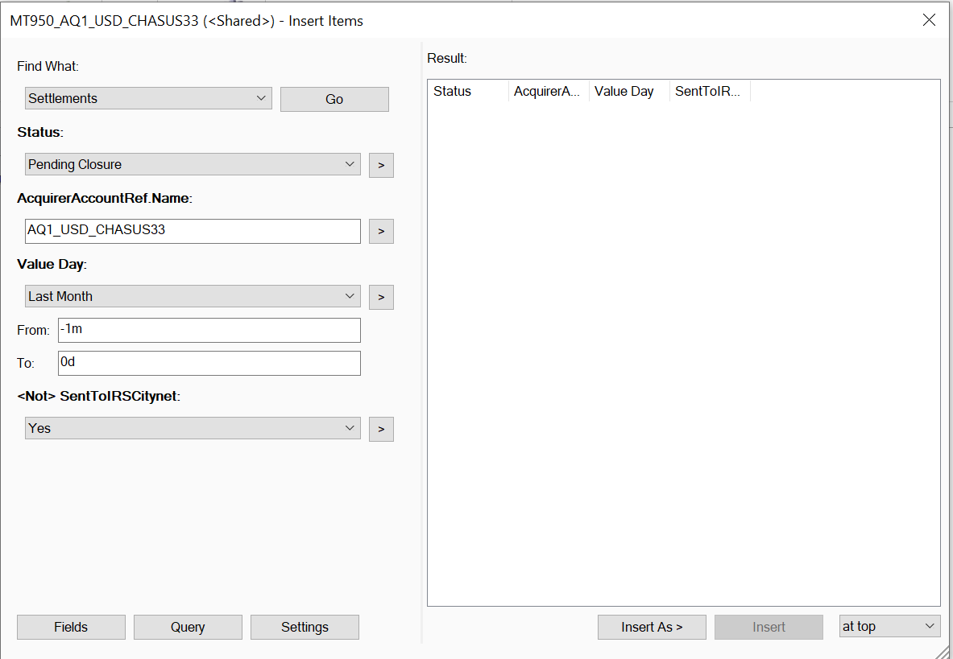

Following additional information will be used.

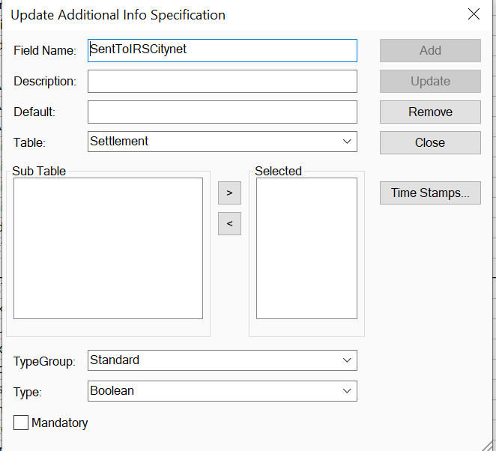

## IRS – MT950 Reconcillation

### DESCRIPTION

|  |  |  |  |
| --- | --- | --- | --- |
| **Interface name** | IRS MT950 Reconciliation | | |
| **Type of data** | CSV File | **Frequency** | Schedule Time(Mostly EOD) |
| **Source** | IRS | **Direction** | IN |
| **Format** | CSV File | **Transfer mechanism** | NA |
| **Response Required** | N/A | **Dependencies on other processes** |  |
| **Purpose** | Use reconciliation file from IRS and use it for updating the status and delivery date on Settlement | | |

IRS Citynet does the reconciliation and send the file to FA.

Once FA task gets trigger it will process the file and update the settlement status and delivery date.

### TECHNICAL ATTRIBUTE

|  |  |
| --- | --- |
| **Attribute** | **Description** |
| Extension Module | IRSSettlementReconciliation  *It contains code required to read the file and update the settlement status and delivery date in Additional info on Settlement.* |

### TECHNICAL ARCHITECTURE

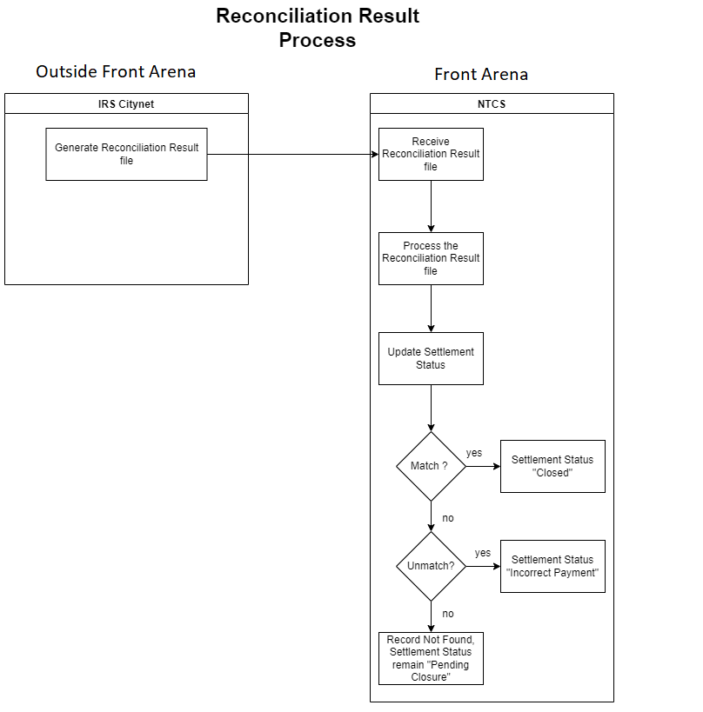

### LOGIC AND CONFIGURATION

#### Flow Logic

1. IRS Citynet do the Reconciliation outside Front Arena
2. Once FA get the file from IRS based on result of reconciliation. It will get processed by this task and Settlement Status and Additional Information ActualSettleDate gets updated.

* If “Matched”, Settlement status is set to “Closed”.
* If “Not Matched”, Settlement status is set to “Incorrect Payment.”
* If record is not found, Settlement status will remain in “Pending Closure.”

1. To process the result file the settlement number for 2nd column is fetch by replacing the fixed text – 9912001. Each row settlement number is having 9912001 at the start.

IRS Citynet send the reconciliation result to FA

#### Configuration

|  |  |
| --- | --- |
| Delivery Items | |
| Extension Context | +IRS |
| Extension Module | PS_IRSSettlementReconciliation |
|  |  |
| Deployment and Manual Configuration | |
| The task is deployed through FA standard deployment process.  Manual configuration may be required to update the configuration in FParameter and task GUI in extension module. | |
|  |  |
| Additional Information | |
| ActualSettleDate on Settlement used to store the date from CSV file | |
|  |  |
| AEL GUI Task | |
| Task Name | IRSSettlementReconciliation_Task |
| FParameters | Default values |
| NA |  |
| Pre-requisites |  |
| ATS service | If the ATS service is configured for this interface it must be running to run this interface. |

#### Data Dictionary

Please refer below table showing mapping between status received in file and in settlement status that needs to updated.

|  |  |
| --- | --- |
| **Status in Reconciliation File** | **Status of Settlement** |
| Match | Closed |
| Unmatch | Incorrect Payment |
| Record not found in FA | Pending Closure |

Please refer attached sample input file



#### A Data Model

Please refer AEF Browser document for details about Front Arena Data Model.

Document - FCA4033 Section ADM.Settlement

#### B Data Entity and Key Elements Definition

Refer to section 6.7.2.4.

#### C Reference Code Table Definition

NA

### SECURITY AND CONTROL DESIGN

#### Security Requirement Response

|  |  |  |
| --- | --- | --- |
| **Security Domain** | **Security Requirement** | **Response** |
| User Management | The system must identify users using a unique user identification code before allowing a log-on. | It will be controlled through CDCA application |
| The system must suspend access to a user session after a specified interval of inactivity. | Inactivity of user session will not be applicable  as the integration is in Realtime |
| The system must require user authentication before re-enabling the session. | It will be controlled through CDCA application |
| The system must display a warning message indicating that only authorized use is permitted before allowing users to perform a log-on. | It will be controlled through CDCA application |
| The system must display system information to a user, only after a successful log-on. |  |
| After a successful log-on, the system must display information concerning the previous successful attempt to perform a log-on. | It will not be possible in real-time connections. |
| The system must allow a user account to be manually disabled. | NA |
| The system must disable the user account following 3 (three) consecutive failures to perform a successful log-on. | It will be controlled through CDCA application |
| The system must automatically disable the user account following a configurable period (90 days) without use. |  |
| Password Management | The system must authenticate users using a password before allowing access to any system functions. | Not applicable at Front Arena Database side. |
| The system must ensure that passwords used by system users for log-on consist of at least 8 (eight) characters. | Not applicable at Front Arena Database side. |
| The system must enforce the use of complex passwords for all users. (Aplhanumieric & Special Characters) | Not applicable at Front Arena Database side. |
| The system must use cryptographic techniques to protect the confidentiality of user authentication data during transmission. | Not applicable at Front Arena Database side. |
| The system must enforce a password change when a password is first issued or re-issued. |  |
| The system must allow system users to change the password used for log-on. | Not applicable at Front Arena Database side. |
| The system must ensure that passwords do not remain valid for more than 90 (ninety) days. | Not applicable at Front Arena Database side. |
| The system must ensure that passwords may not be changed to any of the last 5 (five) passwords used. | Not applicable at Front Arena Database side. |
| The system must ensure that passwords are not displayed in clear text during entry. | Not applicable at Front Arena Database side. |
| Multi Factor Authentication | The system must enforce dual factor authentication of all users (system that related to financial, faced to customer directly & only use for external purposes) | Not applicable at Front Arena Database side. |
| Data Storage | The system must use cryptographic techniques to protect the storage of authentication data. | NA |
| The system must use cryptographic techniques to protect the integrity of stored critical data. | NA |
| The system must use cryptographic techniques to protect the confidentiality of stored sensitive data. | NA |
| Logging | The system must support the recording of security events in one or multiple specific security event logs. 2 weeks in minimum must be available at the Production Environment | It will be controlled through CDCA application |
| The system must include the Logical Account identity, event type and timestamp in each entry in the security event logs. | It will be controlled through CDCA application |
| The system must record when each security event lo fills to a configurable limit. | It will be controlled through CDCA application |
| The system must protect the integrity of the information in the security event logs | It will be controlled through CDCA application |
| The system must allow access to the security event logs to be limited to the authorised security staff. | It will be controlled through CDCA application |
| The system must record if the integrity of the security event logs is compromised | NA |
| The system must record all instances that system event logs are cleared. | It will be controlled through CDCA application |
| The system must record when a change is made to the system log settings (e.g. logs for certain events are turned off). | It will be controlled through CDCA application |
| The system must record when any system security policy is modified. | NA |
| The system must record all creations of Logical Accounts. | It will be controlled through CDCA application |
| The system must record all deletions of Logical Accounts. |  |
| The system must record all de-activation of Logical Accounts. |  |
| The system must record all unsuccessful attempts to log-on to the system using invalid credentials. |  |
| The system must record all successful attempts to log-on to the system. |  |
| The system must record all successful and unsuccessful attempts to change passwords. |  |
| The system must automatically build and maintain a normal usage pattern for each Logical Account. |  |
| The system must record all activation of disabled Logical Accounts. |  |
| The system must record all attempts to change any account attribute affecting authentication of the Logical Account |  |
| The system must record all allocations of system access rights. |  |
| The system must record all removals of system access rights. |  |
| The system must record all unauthorised attempts to access a system function. |  |
| The system must record when a configurable deviation from a Logical Account's normal pattern is detected. |  |
| The system must record all failures of the check on the timestamp of payment and settlement orders. |  |
| The system must record all attempts to mutually authenticate interface connections that handle critical data |  |
| The system must record all events that may indicate an attempt to cause denial of service. |  |
| The system must record all access to functions processing critical information within the system. |  |
| The system must record all access to sensitive information within the system. |  |
| The system must record all start-up and shut down events. |  |
| The system must have been integrated in the SIEM, Identity Management System & Privilege Identity Management System |  |
| Remote Access | The system logical access control mechanism must be able to discretely grant remote access capability to specific users and user groups. |  |
| The system must strictly limit user access rights to their minimum requirements when they access the system remotely. |  |
| All relevant approvals must be obtained if this application is to be made available for remote use (E.g. on the RCA-portal) by Users |  |
| System Interfaces | The system must use a logical access control mechanism to control system to system data communications, in order to avoid anonymous data transfers (for all interfaces) |  |
| The system must ensure that system to system mutual authentication takes place before data communications are allowed (for all interfaces) |  |
| System to system mutual authentication must be based on cryptographic techniques (for all interfaces) |  |
| The system must use cryptographic techniques to protect the integrity of critical data during transmission (for all interfaces) |  |
| The system must use cryptographic techniques to protect the confidentiality of sensitive data during transmission (for all interfaces) |  |
| All 'critical data' must have been identified, documented and approved by the Business |  |
| All 'confidential data' must have been identified, documented and approved by the Business |  |
| Availability | The system must have a documented and successfully tested disaster recovery plan in place | It will be managed through Front Arena Database DR setup. |
| The system must enforce quotas limiting the maximum resources that an individual user can use simultaneously. |  |
| The system must provide adequate resources to support the required number of users or concurrent users. |  |
| The system should have a documented capacity monitoring process in-place with regular reporting on its use |  |
| Security Testing | The system must be tested for specific technical security flaws where it faces the public internet, prior to release into production. |  |
| The system must only be released into production, where it faces the public internet, once all identified key findings from the security test have been rectified, or if this is not possible, the risks must be formally reviewed and signed off |  |
| The system must be tested for specific technical security flaws prior to release into production. |  |
| The system must only be released into production once all the identified key findings from the security tests have been rectified or if this is not possible, the risks must be formally reviewed and signed off |  |

#### Preventive controls

*<This sub-section describe the technical specification for preventive controls that are specific to this module. This includes logical access control, physical security control, encryption, PIN generation and validation, etc>*

*<Sample of list of Role Table and Authorization Matrix>*

|  |  |  |  |
| --- | --- | --- | --- |
| **No** | **Role** | **Authorization** | **Object** |
| 1 | Role1 | ZXXXX | Maintain |
| 2 | Role2 | ZYYYY | Display |
| 3 |  |  |  |

|  |  |  |  |  |  |  |
| --- | --- | --- | --- | --- | --- | --- |
| **No** | **User Group** | **Role1** | **Role2** | **Role3** | **Role4** | **Role5** |
| 1 | User Group1 | X | X |  | X |  |
| 2 | User Group2 |  | X | X |  | X |
|  |  |  |  |  |  |  |

#### Detective controls

*<This sub-section describe the technical specification for detective controls that are specific to this module. This includes audit trail, exception reports, reconciliation, balancing & control totals, validations, etc>.*

#### Corrective controls

*<This sub-section describe the technical specification for corrective controls that are specific to this module. This includes automated error corrections, backup, recovery & restart, etc>.*

### USER INTERFACE

If required, the user can trigger the process again, by using the task GUI *IRSSettlementReconciliation_Task.* All the files that have not been processed will be processed now.

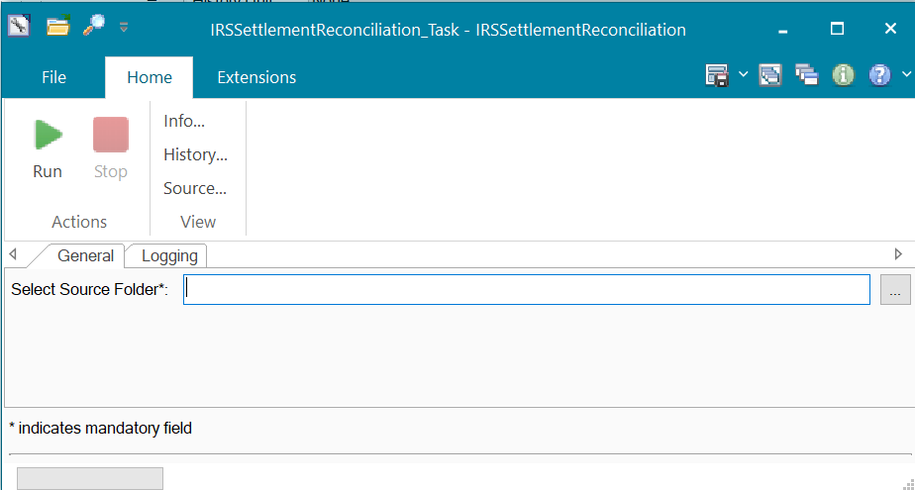

### OPERATING SPECIFICATION

1. Files from IRS system will be available at specified location.
2. Script is developed to read the file from location given in task.
3. From Second Column of Excel sheet will be used to identify the Settlement Number.
4. Based on status in Column 4 the settlement status will be updated
5. The 1st column Transaction date is updated in additional info – ActualSettleDate
6. On Successful processing of file, it will move to Processed folder.

Run task GUI

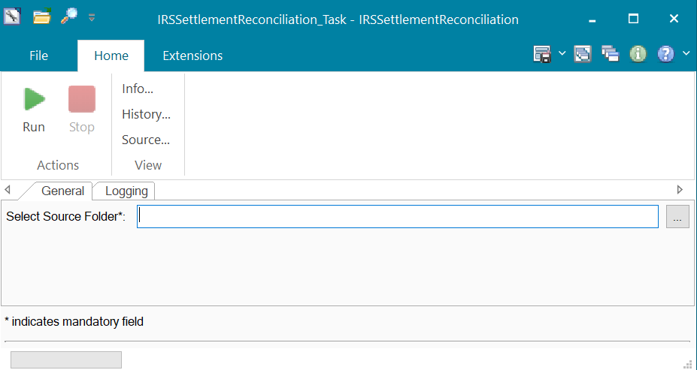

## IRS Citynet – GL System

DESCRIPTION

|  |  |  |  |
| --- | --- | --- | --- |
| Interface name | IRSCitynetGLSystem | | |
| Type of data | FA Journals | Frequency | Batch |
| Source | FA | Direction | OUT |
| Format | File (Txt and pipe separated Txt) | Transfer mechanism | SFTP |
| Response Required | N/A | Dependencies on other processes | N/A |
| Purpose | Front Arena journals which are sent to eMAS system, is also sent to IRS Citynet system for reconciliation purpose. | | |

EOD Journals which are sent to eMAS system are also sent to IRS Citynet system. Additionally, The RealTime Journals are also sent to IRS Citynet system. The journals information will be sent in eMAS interface format with added date and timestamp in output file name. After uploading output file onto IRS citynet system the additional info on trade is set with interface status.

### TECHNICAL ATTRIBUTE

|  |  |
| --- | --- |
| **Attribute** | **Description** |
| Extension Module | PS_IRSGLSytem *It contains code to write journals records into an output file and transfer that file to IRS Citynet system..* |
| ATS | ATS_EOD  *ATS is configured in task mode to automate the process of transferring journal records to IRS Citynet system at EOD* |

### TECHNICAL ARCHITECTURE

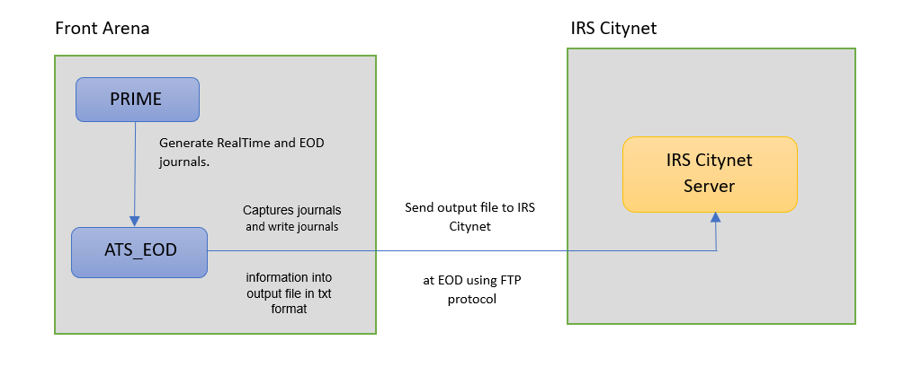

### TECHNICAL FLOW DIAGRAM

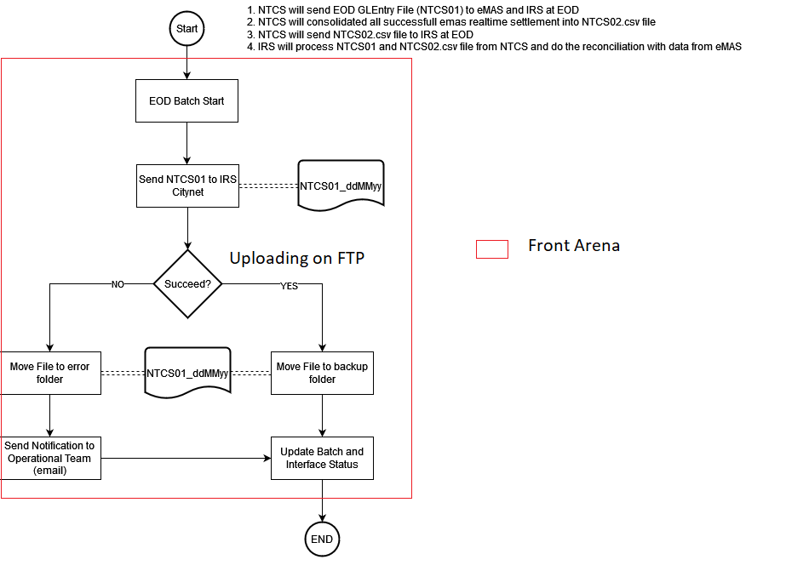

### LOGIC AND CONFIGURATION

#### Flow Logic

1. User generates trade in Front Arena using Prime application.

Once the trade has been approved by various groups, its status is changed to BO-BO Confirmed.

2.Once the status of the trade is changed to BO-BO Confirmed, Realtime journals are generated for the trade. After running EOD batch the EOD journals are generated for the trade.

3.The task is created for module PS_IRSGLSytem which is used to process RealTime and EOD journals and create the output file. The task can be run in both automated and manual ways. To automate the task ATS_EOD is configured.

5.Once the ATS_EOD executes task, and the journals records output file is created in txt format it is sent to IRS Citynet server using FTP protocol.

6.The interface status of the transfer is set on additional info IRSCitynetJournals for the respective trades.

#### Configuration

|  |  |
| --- | --- |
| Delivery Items | |
| Extension Context | +Integration |
| Extension Module | PS_IRSGLSytem |
| ATS | ATS_EOD |
|  |  |
| FA Component | |
| ATS | ATS_EOD is configured in task mode to execute the process of transfer of journals records output file. |
|  |  |
| Deployment and Manual Configuration | |
| This service is deployed through FA standard deployment process.  Manual configuration may be required to update the configuration in FParameters in extension module. | |
|  | |
| Additional Information | |
| IRSCitynetJournals | AdditionalInfo on Trade. |
|  |  |
| FParameters | Default values |
| destination_dir | /BMGPLI |
| host | 10.243.136.172 |
| port | 21 |
| user | FTPNTCS |
| outputFilename | NTCS01 |
| logFilename | IRS_GLSystemExport_LOG_{}.txt |
|  |  |
| Pre-requisites |  |
| Query Folder | Query folder with name specified in Parameters, must be available, so that program can extract trades through that query folder. |
| ATS service | ATS is optional. Totally depends on the mode of task execution. |
|  |  |
| FStoredASQLQuery | Purpose |
| PS_QF_IRSRealTimeJournals | Filter specifying the eligible RealTime Journals. |
| PS_QF_IRSEODJournals | Filter specifying the eligible EOD Journals. |

#### Data Dictionary

Following are field mapping done for this interface.

Document NTCS01 GL File Specification v2.xlsx



#### A Data Model

Please refer AEF Browser document for details about Front Arena Data Model.

Document - FCA4033 ADM.Settlement and ADM.Journal

#### B Data Entity and Key Elements Definition

All required details are available in AEF Browser document.

#### C Reference Code Table Definition

Please refer AEF Browser document for details about Front Arena Data Model.

Document - FCA4033

### SECURITY AND CONTROL DESIGN

#### Security Requirement Response

|  |  |  |
| --- | --- | --- |
| **Security Domain** | **Security Requirement** | **Response** |
| User Management | The system must identify users using a unique user identification code before allowing a log-on. | It will be controlled through CDCA application |
| The system must suspend access to a user session after a specified interval of inactivity. | Inactivity of user session will not be applicable  as the integration is in Realtime |
| The system must require user authentication before re-enabling the session. | It will be controlled through CDCA application |
| The system must display a warning message indicating that only authorized use is permitted before allowing users to perform a log-on. | It will be controlled through CDCA application |
| The system must display system information to a user, only after a successful log-on. |  |
| After a successful log-on, the system must display information concerning the previous successful attempt to perform a log-on. | It will not be possible in real-time connections. |
| The system must allow a user account to be manually disabled. | NA |
| The system must disable the user account following 3 (three) consecutive failures to perform a successful log-on. | It will be controlled through CDCA application |
| The system must automatically disable the user account following a configurable period (90 days) without use. |  |
| Password Management | The system must authenticate users using a password before allowing access to any system functions. | Not applicable at Front Arena Database side. |
| The system must ensure that passwords used by system users for log-on consist of at least 8 (eight) characters. | Not applicable at Front Arena Database side. |
| The system must enforce the use of complex passwords for all users. (Aplhanumieric & Special Characters) | Not applicable at Front Arena Database side. |
| The system must use cryptographic techniques to protect the confidentiality of user authentication data during transmission. | Not applicable at Front Arena Database side. |
| The system must enforce a password change when a password is first issued or re-issued. |  |
| The system must allow system users to change the password used for log-on. | Not applicable at Front Arena Database side. |
| The system must ensure that passwords do not remain valid for more than 90 (ninety) days. | Not applicable at Front Arena Database side. |
| The system must ensure that passwords may not be changed to any of the last 5 (five) passwords used. | Not applicable at Front Arena Database side. |
| The system must ensure that passwords are not displayed in clear text during entry. | Not applicable at Front Arena Database side. |
| Multi Factor Authentication | The system must enforce dual factor authentication of all users (system that related to financial, faced to customer directly & only use for external purposes) | Not applicable at Front Arena Database side. |
| Data Storage | The system must use cryptographic techniques to protect the storage of authentication data. | NA |
| The system must use cryptographic techniques to protect the integrity of stored critical data. | NA |
| The system must use cryptographic techniques to protect the confidentiality of stored sensitive data. | NA |
| Logging | The system must support the recording of security events in one or multiple specific security event logs. 2 weeks in minimum must be available at the Production Environment | It will be controlled through CDCA application |
| The system must include the Logical Account identity, event type and timestamp in each entry in the security event logs. | It will be controlled through CDCA application |
| The system must record when each security event lo fills to a configurable limit. | It will be controlled through CDCA application |
| The system must protect the integrity of the information in the security event logs | It will be controlled through CDCA application |
| The system must allow access to the security event logs to be limited to the authorised security staff. | It will be controlled through CDCA application |
| The system must record if the integrity of the security event logs is compromised | NA |
| The system must record all instances that system event logs are cleared. | It will be controlled through CDCA application |
| The system must record when a change is made to the system log settings (e.g. logs for certain events are turned off). | It will be controlled through CDCA application |
| The system must record when any system security policy is modified. | NA |
| The system must record all creations of Logical Accounts. | It will be controlled through CDCA application |
| The system must record all deletions of Logical Accounts. |  |
| The system must record all de-activation of Logical Accounts. |  |
| The system must record all unsuccessful attempts to log-on to the system using invalid credentials. |  |
| The system must record all successful attempts to log-on to the system. |  |
| The system must record all successful and unsuccessful attempts to change passwords. |  |
| The system must automatically build and maintain a normal usage pattern for each Logical Account. |  |
| The system must record all activation of disabled Logical Accounts. |  |
| The system must record all attempts to change any account attribute affecting authentication of the Logical Account |  |
| The system must record all allocations of system access rights. |  |
| The system must record all removals of system access rights. |  |
| The system must record all unauthorised attempts to access a system function. |  |
| The system must record when a configurable deviation from a Logical Account's normal pattern is detected. |  |
| The system must record all failures of the check on the timestamp of payment and settlement orders. |  |
| The system must record all attempts to mutually authenticate interface connections that handle critical data |  |
| The system must record all events that may indicate an attempt to cause denial of service. |  |
| The system must record all access to functions processing critical information within the system. |  |
| The system must record all access to sensitive information within the system. |  |
| The system must record all start-up and shut down events. |  |
| The system must have been integrated in the SIEM, Identity Management System & Privilege Identity Management System |  |
| Remote Access | The system logical access control mechanism must be able to discretely grant remote access capability to specific users and user groups. |  |
| The system must strictly limit user access rights to their minimum requirements when they access the system remotely. |  |
| All relevant approvals must be obtained if this application is to be made available for remote use (E.g. on the RCA-portal) by Users |  |
| System Interfaces | The system must use a logical access control mechanism to control system to system data communications, in order to avoid anonymous data transfers (for all interfaces) |  |
| The system must ensure that system to system mutual authentication takes place before data communications are allowed (for all interfaces) |  |
| System to system mutual authentication must be based on cryptographic techniques (for all interfaces) |  |
| The system must use cryptographic techniques to protect the integrity of critical data during transmission (for all interfaces) |  |
| The system must use cryptographic techniques to protect the confidentiality of sensitive data during transmission (for all interfaces) |  |
| All 'critical data' must have been identified, documented and approved by the Business |  |
| All 'confidential data' must have been identified, documented and approved by the Business |  |
| Availability | The system must have a documented and successfully tested disaster recovery plan in place | It will be managed through Front Arena Database DR setup. |
| The system must enforce quotas limiting the maximum resources that an individual user can use simultaneously. |  |
| The system must provide adequate resources to support the required number of users or concurrent users. |  |
| The system should have a documented capacity monitoring process in-place with regular reporting on its use |  |
| Security Testing | The system must be tested for specific technical security flaws where it faces the public internet, prior to release into production. |  |
| The system must only be released into production, where it faces the public internet, once all identified key findings from the security test have been rectified, or if this is not possible, the risks must be formally reviewed and signed off |  |
| The system must be tested for specific technical security flaws prior to release into production. |  |
| The system must only be released into production once all the identified key findings from the security tests have been rectified or if this is not possible, the risks must be formally reviewed and signed off |  |

#### Preventive controls

*<This sub-section describe the technical specification for preventive controls that are specific to this module. This includes logical access control, physical security control, encryption, PIN generation and validation, etc>*

*<Sample of list of Role Table and Authorization Matrix>*

|  |  |  |  |
| --- | --- | --- | --- |
| **No** | **Role** | **Authorization** | **Object** |
| 1 | Role1 | ZXXXX | Maintain |
| 2 | Role2 | ZYYYY | Display |
| 3 |  |  |  |

|  |  |  |  |  |  |  |
| --- | --- | --- | --- | --- | --- | --- |
| **No** | **User Group** | **Role1** | **Role2** | **Role3** | **Role4** | **Role5** |
| 1 | User Group1 | X | X |  | X |  |
| 2 | User Group2 |  | X | X |  | X |
|  |  |  |  |  |  |  |

#### Detective controls

*<This sub-section describe the technical specification for detective controls that are specific to this module. This includes audit trail, exception reports, reconciliation, balancing & control totals, validations, etc>.*

#### Corrective controls

*<This sub-section describes the technical specification for corrective controls that are specific to this module. This includes automated error corrections, backup, recovery & restart, etc>.*

### USER INTERFACE

If required, the user can trigger the process, by using the task GUI PS_GLSytemExport

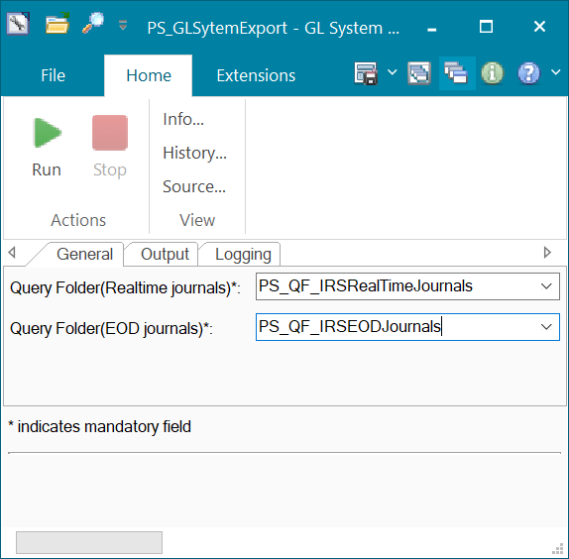

### OPERATING SPECIFICATION

The transfer of RealTime and EOD Journals output file to IRS Citynet system is performed using FTP protocol.

1. Realtime journals get generated real time and Accounting EOD batch generates EOD journals.
2. The predefined query folders will pick up all the Realtime and EOD journals meeting criteria specified in query folder.
3. The task created for the interface will perform creation of outputfile and sending it to IRS Citynet server.
4. The predefined additional info for the trades on which journals are created is set with the interface status.

The following filter queries / query folders will be used.

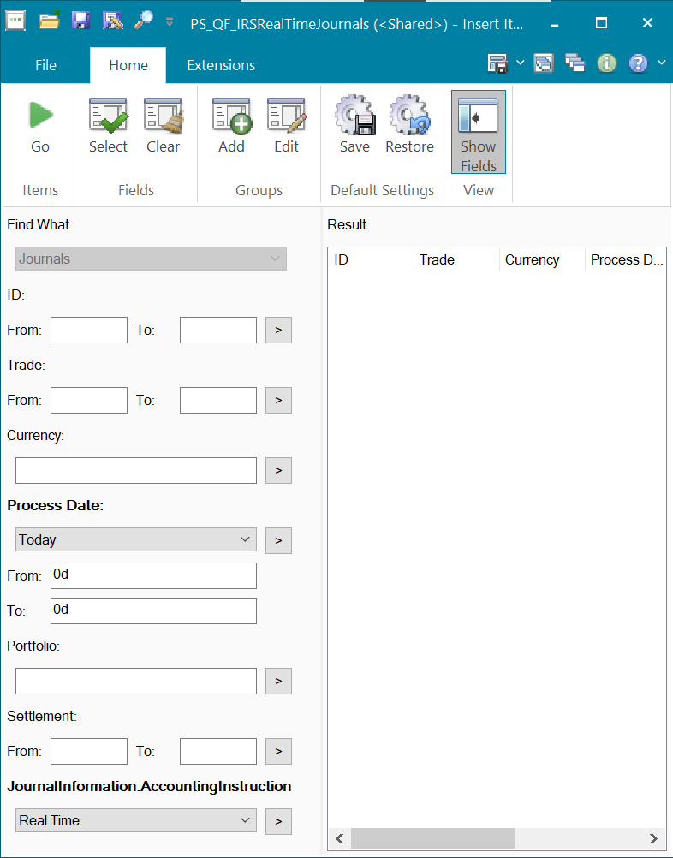

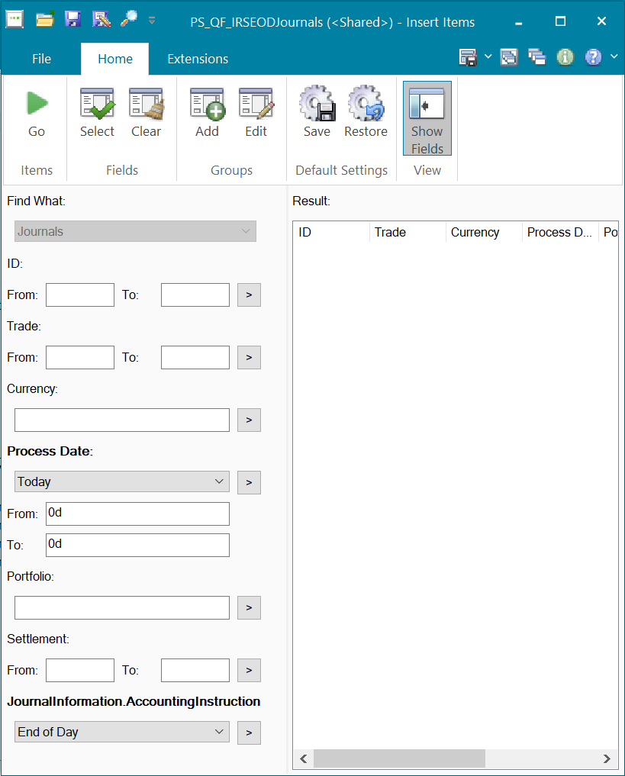

Following additional information will be used.

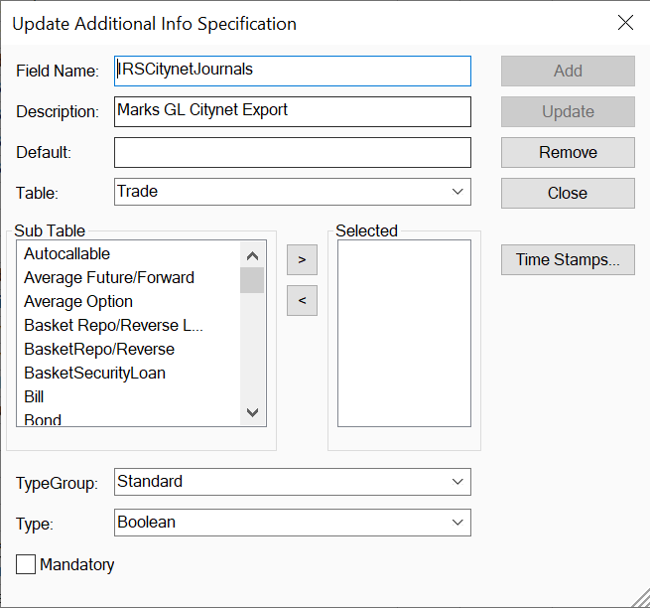

## Communication

*<This section provides the communication line that will be used in this system>*

### New / Existing*) system *) choose one

|  |  |  |  |  |  |  |  |  |  |
| --- | --- | --- | --- | --- | --- | --- | --- | --- | --- |
| **NO** | **NEW / SURROUNDING SYSTEM** | **HOSTNAME SOURCE** | **IP SOURCE** | **PORT SOURCE** | **HOSTNAME DESTINATION** | **IP DESTINATION** | **PORT DESTINATION** | **PROTOCOL (TCP /UDP /ICMP)** | **ALLOW / DENY** |
| 1 | *<new / surrounding status>* | *<isi nama host source>* | *<isi IP source>* | *<isi port source>* | *<isi nama host destination>* | *<isi IP destination>* | *<isi port destination>* | *<isi protocol>* | *<allow / deny status>* |
| 2 |  |  |  |  |  |  |  |  |  |
| 3 |  |  |  |  |  |  |  |  |  |
| 4 |  |  |  |  |  |  |  |  |  |
| 5 |  |  |  |  |  |  |  |  |  |
| 6 |  |  |  |  |  |  |  |  |  |
| 7 |  |  |  |  |  |  |  |  |  |
| 8 |  |  |  |  |  |  |  |  |  |
| … |  | … | … | … | … | … |  | … | … |

*< For a new developed system, if there are some undefined hostnames/ ip addresses/ ports yet, then should be written with* ***TBC*** *notes and will be completely defined in SDN contract review form >*

*< For an existing system and surrounding, please define and write its hostnames/ ip addresses/ ports >*

## OTHERS

*<This section provides other technical specifications that have not been address in previous section>.*

# MBOX

DESCRIPTION

|  |  |  |  |
| --- | --- | --- | --- |
| **Interface name** | MBOX | | |
| **Type of data** | Top 10 customer information | **Frequency** | Batch |
| **Source** | FA / MBOX | **Direction** | OUT/IN |
| **Format** | File | **Transfer mechanism** | SFTP |
| **Response Required** | Yes | **Dependencies on other processes** |  |
| **Purpose** | Get Object ID for top transactions. | | |

MBOX will send report (CSV file) to Front Arena via SFTP. That report contains top 10 customer information. FA interface should read that file and generate output file. The output report from FA will be the 3 files that MBOX sent to FA (MK002_DETAIL, MK005_DETAIL, and MK006_DETAIL) with additional field ObjectID. The format file will be .CSV.

This interface will be initiated by MBOX daily one.

Output file will be same as input file with additional field for document object Id.

Front Arena should return object id for type:

* Underlying
* Deal Ticket

For each Object Ids there will be separate record sent in output file.

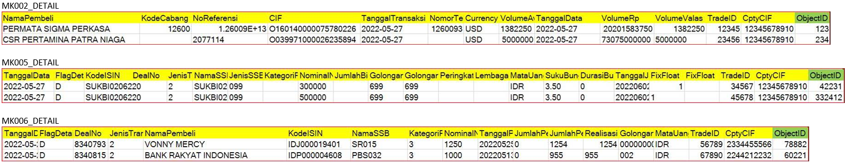

## TECHNICAL ATTRIBUTE

|  |  |
| --- | --- |
| **Attribute** | **Description** |
| Extension Module | PS_MBOX |
| ATS | ATS can be configured by the client. |

## TECHNICAL ARCHITECTURE

Prime

ATS

**Front Arena**

ADS

**MBOX FTP**

Shared input file location

ATS

MBOX-FTP

MBOX_Interface_Task_

Shared output file location

## TECHNICAL FLOW DIAGRAM

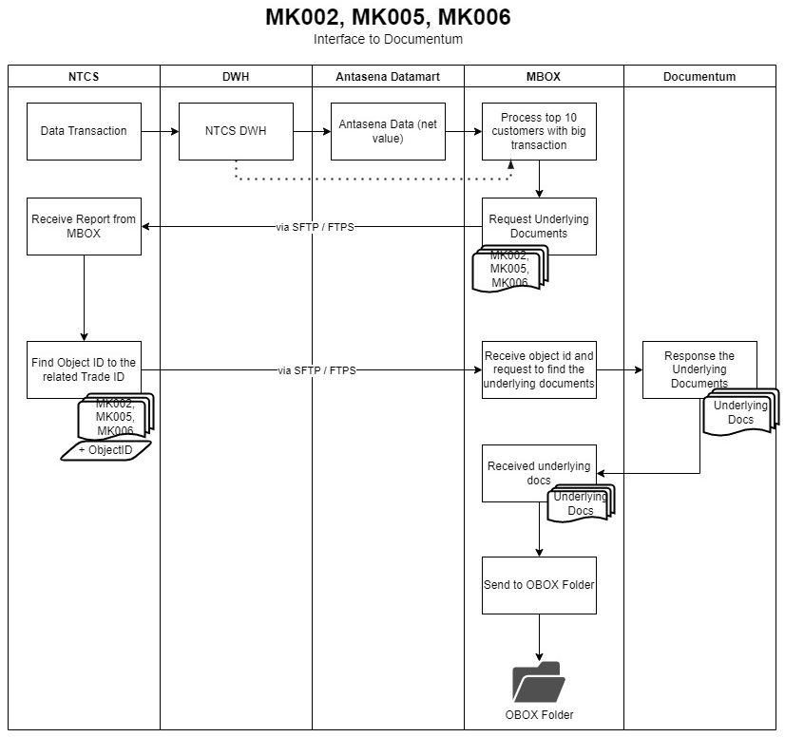

## LOGIC AND CONFIGURATION

### Flow Logic

1. FFTPLib ATS reads the files from MBOX FTP folder and write it to local folder.

2. A python script (MBOX Interface) reads the incoming files for the trade details. It checks for the column ‘'TradeID' from the input file and get the trade number.

3. Using trade number, MBOX gets the list of trade documents. MBOX look for the Object Id of the documents of types listed in FParameter DOC_TYPES.

4. MBOX search for the FCustomTextObject with name as combination of trade number and document type and subtype as document type and reads FCustomTextObject text for the ObjectId = <filename>_<filetype>_<Documentum ObjectId>. MBOX retrieves the Document ObjectId from the Text.

5. MBOX generates output file with the same input file names and adds one record per instrument type for each trade. Output file contains all the columns from the input file and one additional column for the document id. The column name is taken from the FParameter DOCID_HEADER.

5. The MBOX ATS Send the output file to MBOX via SFTP.

6. The ATS can automate the task to read and send report file periodically.

**Type of data**

* MK002: Top 10 total accumulation amount for each non-bank counterparty who buy foreign currency against IDR (the transaction can be less or more than 10)
* MK005: Top 10 total amount for each transaction where counterparty buy bonds.
* MK006: Top 10 total amount for each transaction where counterparty sell bonds.

### Configuration

|  |  |
| --- | --- |
| Delivery Items | |
| Extension Context | +PS_MBOX |
| Extension Module | PS_MBOX |
| ATS Service | ATS for running the MBOX is ATS_INTEGRATIONS. ATS_FTP_TASKS used for MBOX task. |
|  |  |
| FA Component | |
| ATS | ATS_INTEGRATIONS |
| ATS | ATS_FTP_TASKS |
|  |  |
| Deployment and Manual Configuration | |
| This service is deployed through FA standard deployment process.  Manual configuration may be required to update the configuration in FParameter in extension module. | |
|  |  |
| Additional Information | |
| No Add info fields are used. | |
| FParameters | Default values |
| **MBOXOutFTPParams** | |
| destination_dir | . |
| host | 10.243.210.25 |
| password | 0x4wpTCt8K7wrbCm8KlwppoecKJ |
| port | 22 |
| user | MBOX |
| **MBOXParams** | |
| DOC_TYPES | ['Underlying', 'Deal Ticket'] |
| DOCID_HEADER | ObjectID |
| FILES_LIST | ['MK002_DETAIL.csv', 'MK005_DETAIL.csv', 'MK006_DETAIL.csv'] |
| LOG_FILE | MBox_LOG_{}.txt |
| DOC_TYPES | ['Underlying', 'Deal Ticket'] |
|  |  |
| Pre-requisites |  |
| Pre-requisite | Connection to the FTP should live and the ATS services should be running. |
|  |  |
| FStoredASQLQuery |  |
| No FStoredASQLQuery is used. | |

Configuration on the tasks window.

1. The Input and output folders can be configured on the task GUI.

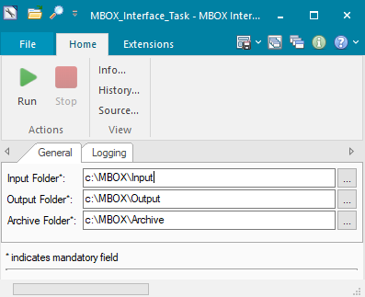

For the configuration of FFTPLIB ATS please refer to the document FCA-4863.

### Data Dictionary

Following is one of the input files from which the TradeID column is used for searching trades in FrontArena.



### A Data Model

Please refer AEF Browser document for details about Front Arena Data Model.

Document - FCA4033

### B Data Entity and Key Elements Definition

All required details are available in AEF Browser document.

### C Reference Code Table Definition

Please refer AEF Browser document for details about Front Arena Data Model.

Document - FCA4033

## SECURITY AND CONTROL DESIGN

### Security Requirement Response

|  |  |  |
| --- | --- | --- |
| **Security Domain** | **Security Requirement** | **Response** |
| User Management | The system must identify users using a unique user identification code before allowing a log-on. | It will be controlled through CDCA application |
| The system must suspend access to a user session after a specified interval of inactivity. | Inactivity of user session will not be applicable  as the integration is in Realtime |
| The system must require user authentication before re-enabling the session. | It will be controlled through CDCA application |
| The system must display a warning message indicating that only authorized use is permitted before allowing users to perform a log-on. | It will be controlled through CDCA application |
| The system must display system information to a user, only after a successful log-on. |  |
| After a successful log-on, the system must display information concerning the previous successful attempt to perform a log-on. | It will not be possible in real-time connections. |
| The system must allow a user account to be manually disabled. | NA |
| The system must disable the user account following 3 (three) consecutive failures to perform a successful log-on. | It will be controlled through CDCA application |
| The system must automatically disable the user account following a configurable period (90 days) without use. |  |
| Password Management | The system must authenticate users using a password before allowing access to any system functions. | Not applicable at Front Arena Database side. |
| The system must ensure that passwords used by system users for log-on consist of at least 8 (eight) characters. | Not applicable at Front Arena Database side. |
| The system must enforce the use of complex passwords for all users. (Aplhanumieric & Special Characters) | Not applicable at Front Arena Database side. |
| The system must use cryptographic techniques to protect the confidentiality of user authentication data during transmission. | Not applicable at Front Arena Database side. |
| The system must enforce a password change when a password is first issued or re-issued. |  |
| The system must allow system users to change the password used for log-on. | Not applicable at Front Arena Database side. |
| The system must ensure that passwords do not remain valid for more than 90 (ninety) days. | Not applicable at Front Arena Database side. |
| The system must ensure that passwords may not be changed to any of the last 5 (five) passwords used. | Not applicable at Front Arena Database side. |
| The system must ensure that passwords are not displayed in clear text during entry. | Not applicable at Front Arena Database side. |
| Multi Factor Authentication | The system must enforce dual factor authentication of all users (system that related to financial, faced to customer directly & only use for external purposes) | Not applicable at Front Arena Database side. |
| Data Storage | The system must use cryptographic techniques to protect the storage of authentication data. | NA |
| The system must use cryptographic techniques to protect the integrity of stored critical data. | NA |
| The system must use cryptographic techniques to protect the confidentiality of stored sensitive data. | NA |
| Logging | The system must support the recording of security events in one or multiple specific security event logs. 2 weeks in minimum must be available at the Production Environment | It will be controlled through CDCA application |
| The system must include the Logical Account identity, event type and timestamp in each entry in the security event logs. | It will be controlled through CDCA application |
| The system must record when each security event lo fills to a configurable limit. | It will be controlled through CDCA application |
| The system must protect the integrity of the information in the security event logs | It will be controlled through CDCA application |
| The system must allow access to the security event logs to be limited to the authorised security staff. | It will be controlled through CDCA application |
| The system must record if the integrity of the security event logs is compromised | NA |
| The system must record all instances that system event logs are cleared. | It will be controlled through CDCA application |
| The system must record when a change is made to the system log settings (e.g. logs for certain events are turned off). | It will be controlled through CDCA application |
| The system must record when any system security policy is modified. | NA |
| The system must record all creations of Logical Accounts. | It will be controlled through CDCA application |
| The system must record all deletions of Logical Accounts. |  |
| The system must record all de-activation of Logical Accounts. |  |
| The system must record all unsuccessful attempts to log-on to the system using invalid credentials. |  |
| The system must record all successful attempts to log-on to the system. |  |
| The system must record all successful and unsuccessful attempts to change passwords. |  |
| The system must automatically build and maintain a normal usage pattern for each Logical Account. |  |
| The system must record all activation of disabled Logical Accounts. |  |
| The system must record all attempts to change any account attribute affecting authentication of the Logical Account |  |
| The system must record all allocations of system access rights. |  |
| The system must record all removals of system access rights. |  |
| The system must record all unauthorised attempts to access a system function. |  |
| The system must record when a configurable deviation from a Logical Account's normal pattern is detected. |  |
| The system must record all failures of the check on the timestamp of payment and settlement orders. |  |
| The system must record all attempts to mutually authenticate interface connections that handle critical data |  |
| The system must record all events that may indicate an attempt to cause denial of service. |  |
| The system must record all access to functions processing critical information within the system. |  |
| The system must record all access to sensitive information within the system. |  |
| The system must record all start-up and shut down events. |  |
| The system must have been integrated in the SIEM, Identity Management System & Privilege Identity Management System |  |
| Remote Access | The system logical access control mechanism must be able to discretely grant remote access capability to specific users and user groups. |  |
| The system must strictly limit user access rights to their minimum requirements when they access the system remotely. |  |
| All relevant approvals must be obtained if this application is to be made available for remote use (E.g. on the RCA-portal) by Users |  |
| System Interfaces | The system must use a logical access control mechanism to control system to system data communications, in order to avoid anonymous data transfers (for all interfaces) |  |
| The system must ensure that system to system mutual authentication takes place before data communications are allowed (for all interfaces) |  |
| System to system mutual authentication must be based on cryptographic techniques (for all interfaces) |  |
| The system must use cryptographic techniques to protect the integrity of critical data during transmission (for all interfaces) |  |
| The system must use cryptographic techniques to protect the confidentiality of sensitive data during transmission (for all interfaces) |  |
| All 'critical data' must have been identified, documented and approved by the Business |  |
| All 'confidential data' must have been identified, documented and approved by the Business |  |
| Availability | The system must have a documented and successfully tested disaster recovery plan in place | It will be managed through Front Arena Database DR setup. |
| The system must enforce quotas limiting the maximum resources that an individual user can use simultaneously. |  |
| The system must provide adequate resources to support the required number of users or concurrent users. |  |
| The system should have a documented capacity monitoring process in-place with regular reporting on its use |  |
| Security Testing | The system must be tested for specific technical security flaws where it faces the public internet, prior to release into production. |  |
| The system must only be released into production, where it faces the public internet, once all identified key findings from the security test have been rectified, or if this is not possible, the risks must be formally reviewed and signed off |  |
| The system must be tested for specific technical security flaws prior to release into production. |  |
| The system must only be released into production once all the identified key findings from the security tests have been rectified or if this is not possible, the risks must be formally reviewed and signed off |  |

### Preventive controls

*<This sub-section describe the technical specification for preventive controls that are specific to this module. This includes logical access control, physical security control, encryption, PIN generation and validation, etc>*

*<Sample of list of Role Table and Authorization Matrix>*

|  |  |  |  |
| --- | --- | --- | --- |
| **No** | **Role** | **Authorization** | **Object** |
| 1 | Role1 | ZXXXX | Maintain |
| 2 | Role2 | ZYYYY | Display |
| 3 |  |  |  |

|  |  |  |  |  |  |  |
| --- | --- | --- | --- | --- | --- | --- |
| **No** | **User Group** | **Role1** | **Role2** | **Role3** | **Role4** | **Role5** |
| 1 | User Group1 | X | X |  | X |  |
| 2 | User Group2 |  | X | X |  | X |
|  |  |  |  |  |  |  |

### Detective controls

*<This sub-section describe the technical specification for detective controls that are specific to this module. This includes audit trail, exception reports, reconciliation, balancing & control totals, validations, etc>.*

### Corrective controls

*<This sub-section describes the technical specification for corrective controls that are specific to this module. This includes automated error corrections, backup, recovery & restart, etc>.*

## USER INTERFACE

If required, the user can trigger the process, by using the task GUI *MBOX_Interface_Task.*



## OPERATING SPECIFICATION

Report documents are received from MBOX over SFTP. Front Arena appends the object id corresponding to the trades present in the input file.

1. A separate ATS downloads the file from MBOX SFTP site.
2. The MBOX main script then reads these files and appends the object id for corresponding trades present in FrontArena.
3. The updated files are written to the SFTP location by the MBOX script.
4. Task for MBOX task can be scheduled using an ATS to generate output file.

Following ATS will be used for downloading the file from SFTP.

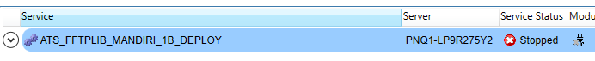

The following task is run to download the files from SFTP.

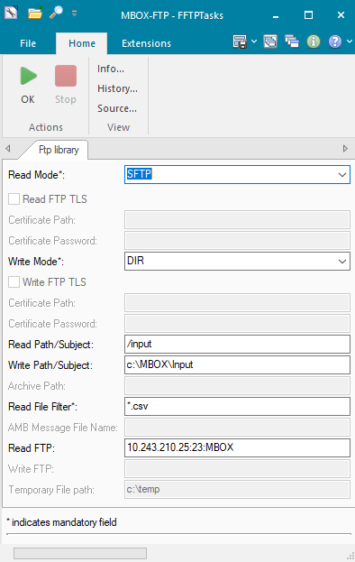

The following schedule to run the task will be used.

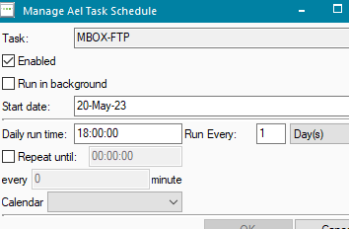

Following task is used to read and generate the output files.

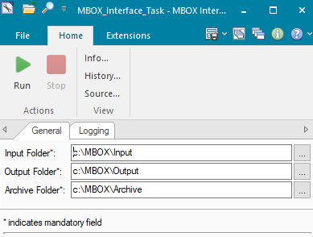

## REPORTING

### 9.1 Inventory of Reports

*<This sub-section provides a list of operational reports relevant to this module. It is assumed that MIS/EIS module will produce the executive management and regulatory related reports>.*

*<Sample of report definition>*

|  |  |  |
| --- | --- | --- |
| **No** | **Report Name** | **Description** |
|  |  | <Description> |
|  |  |  |

*<if there is data integrity checking requirement, please provide any additional supporting information>.*

### 9.2 Report layout and definition

*<This sub-section describes each of the reports in the inventory list. Report Layout and It’s selection screen must be drawn clearly in this subsection>*

*<Sample of Selection Screen:>*

Selection Field 1

Selection Field 2

to

*<Sample of Report Layout>*

**Report Title**

Report Header

LOGO

Report Footer

Page No.

**Column1**

**Column2**

**Column3**

**Column4**

**Column5**

**Column6**

**Total1**

## Communication

*<This section provides the communication line that will be used in this system>*

### New / Existing*) system *) choose one

|  |  |  |  |  |  |  |  |  |  |
| --- | --- | --- | --- | --- | --- | --- | --- | --- | --- |
| **NO** | **NEW / SURROUNDING SYSTEM** | **HOSTNAME SOURCE** | **IP SOURCE** | **PORT SOURCE** | **HOSTNAME DESTINATION** | **IP DESTINATION** | **PORT DESTINATION** | **PROTOCOL (TCP /UDP /ICMP)** | **ALLOW / DENY** |
| 1 | *<new / surrounding status>* | *<isi nama host source>* | *<isi IP source>* | *<isi port source>* | *<isi nama host destination>* | *<isi IP destination>* | *<isi port destination>* | *<isi protocol>* | *<allow / deny status>* |
| 2 |  |  |  |  |  |  |  |  |  |
| 3 |  |  |  |  |  |  |  |  |  |
| 4 |  |  |  |  |  |  |  |  |  |
| 5 |  |  |  |  |  |  |  |  |  |
| 6 |  |  |  |  |  |  |  |  |  |
| 7 |  |  |  |  |  |  |  |  |  |
| 8 |  |  |  |  |  |  |  |  |  |
| … |  | … | … | … | … | … |  | … | … |

*< For a new developed system, if there are some undefined hostnames/ ip addresses/ ports yet, then should be written with* ***TBC*** *notes and will be completely defined in SDN contract review form >*

*< For an existing system and surrounding, please define and write its hostnames/ ip addresses/ ports >*

## OTHERS

*<This section provides other technical specifications that have not been address in previous section>.*

# REFINITIV

## Market Data

Refer to Phase 1A TSD as the interface specifications is the same.

## Arena Trade Capture Interface – Refinitiv Dealing - IN

DESCRIPTION

|  |  |  |  |
| --- | --- | --- | --- |
| **Interface name** | ATCIRD (Arena Trade Capture Interface – Refinitiv Dealing) | | |
| **Type of data** | Trades – FX and MM | **Frequency** | Realtime |
| **Source** | Refinitiv | **Direction** | In |
| **Format** | AMBA message | **Transfer mechanism** | ATCI-RD |
| **Response Required** | N/A | **Dependencies on other processes** | N/A |
| **Purpose** | To capture deals from Refinitiv Dealing using ATCI-RD in TOF format | | |

Trades coming from Refinitiv Dealing will be captured in FA using Arena Trade Capture Interface (ATCI-RD).

Data received from Refinitiv:

|  |  |  |
| --- | --- | --- |
| **Source** | **Instrument type** | **TCID** |
| FXT | FX Spot, FX Outright, NDF, FX Swap, Loan/Depo(MM) | MDRX –  TCID - MDRX  Instrument - FX |
| MDRI –  TCID - MDRI  Instrument - FX/MM |
| JPM | FX Spot, FX Outright, NDF, FX Swap | RTNS –  TCID - RTNS  Instrument - FX |
| EFX (Branches) | FX Spot, FX Outright, NDF, FX Swap | RETM : Customer -  TCID - RETM  Instrument - FX |
| RTNT : InterBank  TCID - RINT  Instrument – FX |
| RETB : Branch  TCID - RETB  Instrument - FX |
| RRTM : RTM  TCID - RRTM  Instrument - FX |

Notes – Refer to FA documentation - FCA1452 (System Administrator: ATCI-RFXT) for product details.

### TECHNICAL ATTRIBUTE

|  |  |
| --- | --- |
| **Attribute** | **Description** |
| Extension Module | ATCI-RFXT  *It is the extension from the core product which implements the basic functionality.* |
|  | PS_ATCI-RFXT  *It contains the customized code for client specific requirements.* |
|  | ATS_ATCIRD_MDRI, ATS_ATCIRD_MDRX, ATS_ATCIRD_RETB, ATS_ATCIRD_RETM, ATS_ATCIRD_RRTM, ATS_ATCIRD_RTNS, ATS_ATCIRD_RTNT  This are the ATS user modules and not available in extension module list by default.  These module gets loaded automatically when the user with the module name logs into FA.  Each of these modules corresponds to one Refinitiv platform connection and one ATS setup where ATS user name is same as the module name. So when ATS instance starts it logs the corresponding user module and use the specific connection credentials from the module. |
| AMBA | AMBA_ATCIRD  *AMBA is configured to capture trades coming from the Refinitiv dealing into FA.* |
| ATS | ATS_ATCIRD_MDRI, ATS_ATCIRD_MDRX, ATS_ATCIRD_RETB, ATS_ATCIRD_RETM, ATS_ATCIRD_RRTM, ATS_ATCIRD_RTNS, ATS_ATCIRD_RTNT |

### TECHNICAL ARCHITECTURE

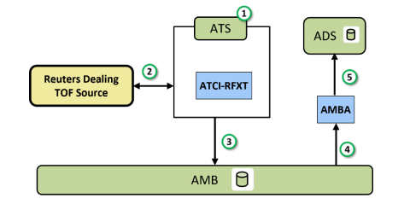

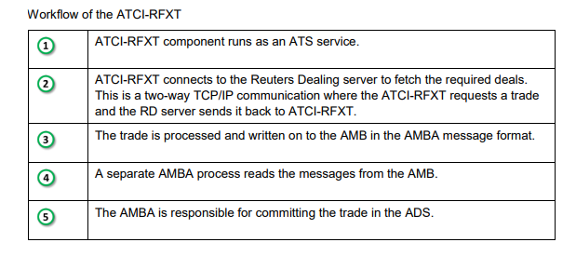

### TECHNICAL FLOW DIAGRAM

Referring to Technical Architecture below is the workflow for trade capture from Refinitiv Dealing.



### LOGIC AND CONFIGURATION

#### Flow Logic

1. Trades will be received by configured ATS from Refinitiv dealing platform. Fields will be mapped from TOF message to FA AMBA message for trades and the AMBA message will be sent to AMB.
2. Trades coming from the respective interface will be marked with interface field as per Refinitiv platform.
3. AMBA_ATCIRD will receive the trades coming from the respective ATS. It will perform field validation and set trade status accordingly for the trade and trade will be updated in ADS.
4. User can check the trades received from Refinitiv with the filter on Interface field where interface will be set to platform e.g. RTNT, RTNS. Sample Workbook ‘Refinitiv Deal Blotter ATCI-RFXT’ provided for the same.

#### Configuration

|  |  |
| --- | --- |
| Delivery Items | |
| Extension Context | +ATCI-RFXT |
| Extension Module | ATCI-RFXT, PS_ATCI-RFXT, ATS_ATCIRD_MDRI, ATS_ATCIRD_MDRX, ATS_ATCIRD_RETB, ATS_ATCIRD_RETM, ATS_ATCIRD_RRTM, ATS_ATCIRD_RTNS, ATS_ATCIRD_RTNT |
| AMBA service | AMBA_ATCIRD |
| ATS services | ATS_ATCIRD_MDRI, ATS_ATCIRD_MDRX, ATS_ATCIRD_RETB, ATS_ATCIRD_RETM, ATS_ATCIRD_RRTM, ATS_ATCIRD_RTNS, ATS_ATCIRD_RTNT |
|  |  |
| FA Component | |
| AMBA | AMBA_ATCIRD – to get Refinitiv trades from AMB. |
| ATS | ATS_ATCIRD_MDRI, ATS_ATCIRD_MDRX, ATS_ATCIRD_RETB, ATS_ATCIRD_RETM, ATS_ATCIRD_RRTM, ATS_ATCIRD_RTNS, ATS_ATCIRD_RTNT – Service per platform to connect to Refinitiv dealing platform |
|  |  |
| Deployment and Manual Configuration | |
| This service is deployed through FA standard deployment process.  Manual configuration may be required to update the configuration in FParameter in extension module for platform connectivity. | |
|  |  |
| Additional Information | |
| TraderPortfolio | AdditionalInfo on User table |
| PartyAlias | |
| ReutersDealing | Party Alias |
| Component Users | |
| AMBA User | AMBA_ATCIRD |
| ATS Users | ATS_ATCIRD_MDRI, ATS_ATCIRD_MDRX, ATS_ATCIRD_RETB, ATS_ATCIRD_RETM, ATS_ATCIRD_RRTM, ATS_ATCIRD_RTNS, ATS_ATCIRD_RTNT |
| Choice list | |
| Interface (Trade.optkey2_chlnbr) | MDRI, MDRX, RETB, RETM, RRTM, RTNS, RTNT |
|  |  |
| FParameters (Customized) | Default values |
| MANDATORY_FIELDS | ['COUNTERPARTY_PTYNBR.PTYID', 'TRADER_USRNBR.USERID', 'PRFNBR.PRFID', 'ACQUIRER_PTYNBR.PTYID', 'VALUE_DAY', 'ACQUIRER_PTYNBR.PTYID'] |
| Note – Other parameters are overwritten from the core. For details refer to FCA1452. | |
| FStoredASQLQuery |  |
| Query Folder | ‘PS_QF_ATCI_Refinitiv_Deal_Blotter’ – filter for trades coming from Refinitiv |
| AMBA service | AMBA service for this interface must be running to work this interface. |
| Pre-requisites | Purpose |
| Refinitiv Dealing | Refinitiv Dealing systems should be up and running. |

#### Data Dictionary

Basic field mapping is done in the core. Additional customized field mapping is as below –

|  |  |
| --- | --- |
| Field | FA Mapping |
| Trade status | Trade Status will be set to ‘Simulated’ if mandatory listed fields are not present in the deal message  Else Trade Status will be set to ‘Reserved’’ |
| Trade Portfolio | It will be taken from user additional info field ‘TraderPortfolio’ |
| Trade Optkey2 (interface) | It will be set to respective Refinitiv platform TCID |

Product Type and Category is set as per below logic provided by Mandiri –

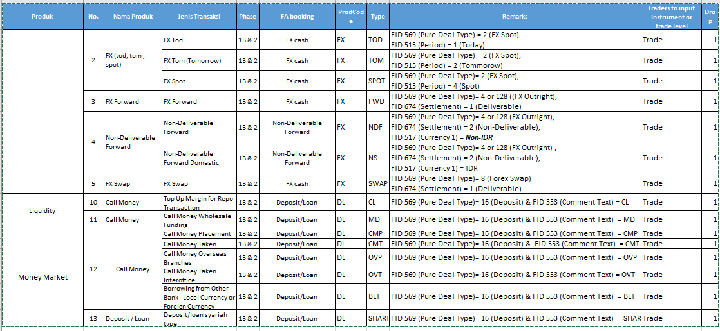

#### A Data Model

Please refer AEF Browser document for details about Front Arena Data Model.

Document - FCA4033

#### B Data Entity and Key Elements Definition

All required details are available in AEF Browser document.

#### C Reference Code Table Definition

Please refer AEF Browser document for details about Front Arena Data Model.

Document - FCA4033 and FCA1452 (System Administrator: ATCI-RFXT).

### SECURITY AND CONTROL DESIGN

#### Security Requirement Response

|  |  |  |
| --- | --- | --- |
| **Security Domain** | **Security Requirement** | **Response** |
| User Management | The system must identify users using a unique user identification code before allowing a log-on. | It will be controlled through CDCA application |
| The system must suspend access to a user session after a specified interval of inactivity. | Inactivity of user session will not be applicable  as the integration is in Realtime |
| The system must require user authentication before re-enabling the session. | It will be controlled through CDCA application |
| The system must display a warning message indicating that only authorized use is permitted before allowing users to perform a log-on. | It will be controlled through CDCA application |
| The system must display system information to a user, only after a successful log-on. |  |
| After a successful log-on, the system must display information concerning the previous successful attempt to perform a log-on. | It will not be possible in real-time connections. |
| The system must allow a user account to be manually disabled. | NA |
| The system must disable the user account following 3 (three) consecutive failures to perform a successful log-on. | It will be controlled through CDCA application |
| The system must automatically disable the user account following a configurable period (90 days) without use. |  |
| Password Management | The system must authenticate users using a password before allowing access to any system functions. | Not applicable at Front Arena Database side. |
| The system must ensure that passwords used by system users for log-on consist of at least 8 (eight) characters. | Not applicable at Front Arena Database side. |
| The system must enforce the use of complex passwords for all users. (Aplhanumieric & Special Characters) | Not applicable at Front Arena Database side. |
| The system must use cryptographic techniques to protect the confidentiality of user authentication data during transmission. | Not applicable at Front Arena Database side. |
| The system must enforce a password change when a password is first issued or re-issued. |  |
| The system must allow system users to change the password used for log-on. | Not applicable at Front Arena Database side. |
| The system must ensure that passwords do not remain valid for more than 90 (ninety) days. | Not applicable at Front Arena Database side. |
| The system must ensure that passwords may not be changed to any of the last 5 (five) passwords used. | Not applicable at Front Arena Database side. |
| The system must ensure that passwords are not displayed in clear text during entry. | Not applicable at Front Arena Database side. |
| Multi Factor Authentication | The system must enforce dual factor authentication of all users (system that related to financial, faced to customer directly & only use for external purposes) | Not applicable at Front Arena Database side. |
| Data Storage | The system must use cryptographic techniques to protect the storage of authentication data. | NA |
| The system must use cryptographic techniques to protect the integrity of stored critical data. | NA |
| The system must use cryptographic techniques to protect the confidentiality of stored sensitive data. | NA |
| Logging | The system must support the recording of security events in one or multiple specific security event logs. 2 weeks in minimum must be available at the Production Environment | It will be controlled through CDCA application |
| The system must include the Logical Account identity, event type and timestamp in each entry in the security event logs. | It will be controlled through CDCA application |
| The system must record when each security event lo fills to a configurable limit. | It will be controlled through CDCA application |
| The system must protect the integrity of the information in the security event logs | It will be controlled through CDCA application |
| The system must allow access to the security event logs to be limited to the authorised security staff. | It will be controlled through CDCA application |
| The system must record if the integrity of the security event logs is compromised | NA |
| The system must record all instances that system event logs are cleared. | It will be controlled through CDCA application |
| The system must record when a change is made to the system log settings (e.g. logs for certain events are turned off). | It will be controlled through CDCA application |
| The system must record when any system security policy is modified. | NA |
| The system must record all creations of Logical Accounts. | It will be controlled through CDCA application |
| The system must record all deletions of Logical Accounts. |  |
| The system must record all de-activation of Logical Accounts. |  |
| The system must record all unsuccessful attempts to log-on to the system using invalid credentials. |  |
| The system must record all successful attempts to log-on to the system. |  |
| The system must record all successful and unsuccessful attempts to change passwords. |  |
| The system must automatically build and maintain a normal usage pattern for each Logical Account. |  |
| The system must record all activation of disabled Logical Accounts. |  |
| The system must record all attempts to change any account attribute affecting authentication of the Logical Account |  |
| The system must record all allocations of system access rights. |  |
| The system must record all removals of system access rights. |  |
| The system must record all unauthorised attempts to access a system function. |  |
| The system must record when a configurable deviation from a Logical Account's normal pattern is detected. |  |
| The system must record all failures of the check on the timestamp of payment and settlement orders. |  |
| The system must record all attempts to mutually authenticate interface connections that handle critical data |  |
| The system must record all events that may indicate an attempt to cause denial of service. |  |
| The system must record all access to functions processing critical information within the system. |  |
| The system must record all access to sensitive information within the system. |  |
| The system must record all start-up and shut down events. |  |
| The system must have been integrated in the SIEM, Identity Management System & Privilege Identity Management System |  |
| Remote Access | The system logical access control mechanism must be able to discretely grant remote access capability to specific users and user groups. |  |
| The system must strictly limit user access rights to their minimum requirements when they access the system remotely. |  |
| All relevant approvals must be obtained if this application is to be made available for remote use (E.g. on the RCA-portal) by Users |  |
| System Interfaces | The system must use a logical access control mechanism to control system to system data communications, in order to avoid anonymous data transfers (for all interfaces) |  |
| The system must ensure that system to system mutual authentication takes place before data communications are allowed (for all interfaces) |  |
| System to system mutual authentication must be based on cryptographic techniques (for all interfaces) |  |
| The system must use cryptographic techniques to protect the integrity of critical data during transmission (for all interfaces) |  |
| The system must use cryptographic techniques to protect the confidentiality of sensitive data during transmission (for all interfaces) |  |
| All 'critical data' must have been identified, documented and approved by the Business |  |
| All 'confidential data' must have been identified, documented and approved by the Business |  |
| Availability | The system must have a documented and successfully tested disaster recovery plan in place | It will be managed through Front Arena Database DR setup. |
| The system must enforce quotas limiting the maximum resources that an individual user can use simultaneously. |  |
| The system must provide adequate resources to support the required number of users or concurrent users. |  |
| The system should have a documented capacity monitoring process in-place with regular reporting on its use |  |
| Security Testing | The system must be tested for specific technical security flaws where it faces the public internet, prior to release into production. |  |
| The system must only be released into production, where it faces the public internet, once all identified key findings from the security test have been rectified, or if this is not possible, the risks must be formally reviewed and signed off |  |
| The system must be tested for specific technical security flaws prior to release into production. |  |
| The system must only be released into production once all the identified key findings from the security tests have been rectified or if this is not possible, the risks must be formally reviewed and signed off |  |

#### Preventive controls

*<This sub-section describe the technical specification for preventive controls that are specific to this module. This includes logical access control, physical security control, encryption, PIN generation and validation, etc>*

*<Sample of list of Role Table and Authorization Matrix>*

|  |  |  |  |
| --- | --- | --- | --- |
| **No** | **Role** | **Authorization** | **Object** |
| 1 | Role1 | ZXXXX | Maintain |
| 2 | Role2 | ZYYYY | Display |
| 3 |  |  |  |

|  |  |  |  |  |  |  |
| --- | --- | --- | --- | --- | --- | --- |
| **No** | **User Group** | **Role1** | **Role2** | **Role3** | **Role4** | **Role5** |
| 1 | User Group1 | X | X |  | X |  |
| 2 | User Group2 |  | X | X |  | X |
|  |  |  |  |  |  |  |

#### Detective controls

*<This sub-section describe the technical specification for detective controls that are specific to this module. This includes audit trail, exception reports, reconciliation, balancing & control totals, validations, etc>.*

#### Corrective controls

*<This sub-section describes the technical specification for corrective controls that are specific to this module. This includes automated error corrections, backup, recovery & restart, etc>.*

### USER INTERFACE

NA

### OPERATING SPECIFICATION

Please refer to and FCA1452 (System Administrator: ATCI-RFXT).

For every Refinitiv platform, there is one ATS setup. Connectivity Parameters needs to be set using the ATS username modules.

#### Preventive controls

Front Arena User management process will ensure the code/ Extension Editor will be accessible for specific user group (e.g. Admin group).

The service will be running on server so it has access to authorized users only.

#### Detective controls

Detective and Investigation process need to be controlled through the service log details. For this integration there will be separate log file to track the interface workflow. Any error or exception details will be available in respective service log on server.

#### Corrective controls

As per of the functionality, the status of respective service will be displayed to user in form of service logs. Based on status details user can take corrective action manually.

## Refinitiv – Price Feed

DESCRIPTION

|  |  |  |  |
| --- | --- | --- | --- |
| **Interface name** | Refinitiv | | |
| **Type of data** | Prices (FX) | **Frequency** | Realtime |
| **Source** | Refinitiv | **Direction** | In |
| **Format** | N/A | **Transfer mechanism** | Through APH |
| **Response Required** | N/A | **Dependencies on other processes** | 1. Refinitiv connection details 2. Refinitiv to FA user mapping |
| **Purpose** | Refinitiv Data Feed interface to receive live prices.  Real-time data for use for pricing and risk management. | | |

FA sends subscription requests and receives data from Refinitiv. The application APH-Refinitiv takes price feed data from a third-party price feed, IDP, and forwards this directly to the ADS.

User mapping: Refinitiv user to FA user

Price Link Definition and Price distributor

Price Semantic mapping as per Refinitiv dictionary

For Bank Mandiri it is expected that Yield Curve for other currencies (AUD, CAD, CHF, CNY, DKK, EUR, GBP, HKD, JPY, NOK, NZD, PHI, SAR, SEK, SGD, THB, USD) will be generated using the real time price feeds from Refinitiv.

Notes – Refer to FA documentation – FCA4800 (System Administrator: APH) for product details.

### TECHNICAL ATTRIBUTE

|  |  |
| --- | --- |
| **Attribute** | **Description** |
| FA Component | APH  *APH connects to the ADS and starts the requests for subscriptions from the IDP* |

### TECHNICAL ARCHITECTURE

Following diagram explains the flow of APH data through various components involved in FrontArena.

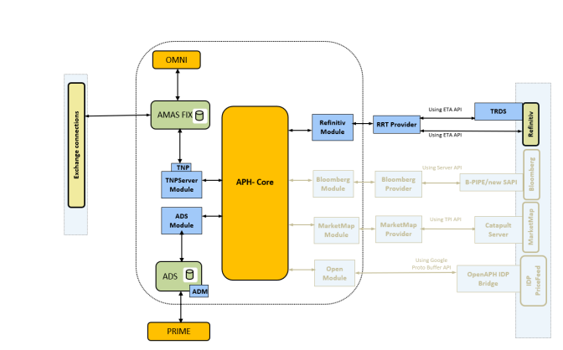

### TECHNICAL FLOW DIAGRAM

Refer to the technical architecture.

### LOGIC AND CONFIGURATION

#### Flow Logic

1. APH connects to the ADS and reads the price link specifications configured in the ADS based on the configuration.
2. Based on the configuration APH starts subscription with Refinitiv platform.
3. Refinitiv sends the price to APH and APH updates the data in the ADS against the price link specifications.

#### Configuration

Refer to the FCA*4800 for details on the configurations, registry settings etc.*

|  |  |
| --- | --- |
| Delivery Items | |
| APH | APH_REFINITIV |

The following registry parameters are used.

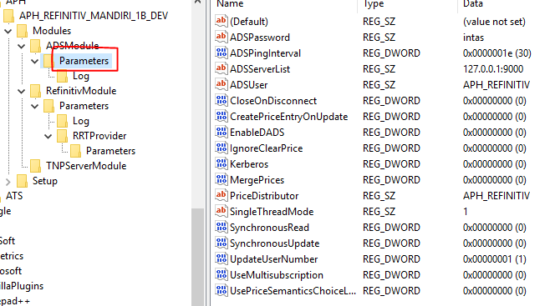

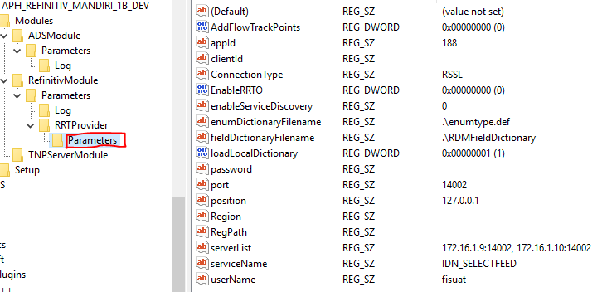

#### Data Dictionary

Refer to the FCA*4800 for details on mappings.*

#### A Data Model

Please refer AEF Browser document for details about Front Arena Data Model.

Document - FCA4033

#### B Data Entity and Key Elements Definition

All required details are available in AEF Browser document.

#### C Reference Code Table Definition

Please refer AEF Browser document for details about Front Arena Data Model.

Document - FCA4033 and FCA1452 (System Administrator: ATCI-RFXT).

### SECURITY AND CONTROL DESIGN

#### Security Requirement Response

|  |  |  |
| --- | --- | --- |
| **Security Domain** | **Security Requirement** | **Response** |
| User Management | The system must identify users using a unique user identification code before allowing a log-on. | It will be controlled through CDCA application |
| The system must suspend access to a user session after a specified interval of inactivity. | Inactivity of user session will not be applicable  as the integration is in Realtime |
| The system must require user authentication before re-enabling the session. | It will be controlled through CDCA application |
| The system must display a warning message indicating that only authorized use is permitted before allowing users to perform a log-on. | It will be controlled through CDCA application |
| The system must display system information to a user, only after a successful log-on. |  |
| After a successful log-on, the system must display information concerning the previous successful attempt to perform a log-on. | It will not be possible in real-time connections. |
| The system must allow a user account to be manually disabled. | NA |
| The system must disable the user account following 3 (three) consecutive failures to perform a successful log-on. | It will be controlled through CDCA application |
| The system must automatically disable the user account following a configurable period (90 days) without use. |  |
| Password Management | The system must authenticate users using a password before allowing access to any system functions. | Not applicable at Front Arena Database side. |
| The system must ensure that passwords used by system users for log-on consist of at least 8 (eight) characters. | Not applicable at Front Arena Database side. |
| The system must enforce the use of complex passwords for all users. (Aplhanumieric & Special Characters) | Not applicable at Front Arena Database side. |
| The system must use cryptographic techniques to protect the confidentiality of user authentication data during transmission. | Not applicable at Front Arena Database side. |
| The system must enforce a password change when a password is first issued or re-issued. |  |
| The system must allow system users to change the password used for log-on. | Not applicable at Front Arena Database side. |
| The system must ensure that passwords do not remain valid for more than 90 (ninety) days. | Not applicable at Front Arena Database side. |
| The system must ensure that passwords may not be changed to any of the last 5 (five) passwords used. | Not applicable at Front Arena Database side. |
| The system must ensure that passwords are not displayed in clear text during entry. | Not applicable at Front Arena Database side. |
| Multi Factor Authentication | The system must enforce dual factor authentication of all users (system that related to financial, faced to customer directly & only use for external purposes) | Not applicable at Front Arena Database side. |
| Data Storage | The system must use cryptographic techniques to protect the storage of authentication data. | NA |
| The system must use cryptographic techniques to protect the integrity of stored critical data. | NA |
| The system must use cryptographic techniques to protect the confidentiality of stored sensitive data. | NA |
| Logging | The system must support the recording of security events in one or multiple specific security event logs. 2 weeks in minimum must be available at the Production Environment | It will be controlled through CDCA application |
| The system must include the Logical Account identity, event type and timestamp in each entry in the security event logs. | It will be controlled through CDCA application |
| The system must record when each security event lo fills to a configurable limit. | It will be controlled through CDCA application |
| The system must protect the integrity of the information in the security event logs | It will be controlled through CDCA application |
| The system must allow access to the security event logs to be limited to the authorised security staff. | It will be controlled through CDCA application |
| The system must record if the integrity of the security event logs is compromised | NA |
| The system must record all instances that system event logs are cleared. | It will be controlled through CDCA application |
| The system must record when a change is made to the system log settings (e.g. logs for certain events are turned off). | It will be controlled through CDCA application |
| The system must record when any system security policy is modified. | NA |
| The system must record all creations of Logical Accounts. | It will be controlled through CDCA application |
| The system must record all deletions of Logical Accounts. |  |
| The system must record all de-activation of Logical Accounts. |  |
| The system must record all unsuccessful attempts to log-on to the system using invalid credentials. |  |
| The system must record all successful attempts to log-on to the system. |  |
| The system must record all successful and unsuccessful attempts to change passwords. |  |
| The system must automatically build and maintain a normal usage pattern for each Logical Account. |  |
| The system must record all activation of disabled Logical Accounts. |  |
| The system must record all attempts to change any account attribute affecting authentication of the Logical Account |  |
| The system must record all allocations of system access rights. |  |
| The system must record all removals of system access rights. |  |
| The system must record all unauthorised attempts to access a system function. |  |
| The system must record when a configurable deviation from a Logical Account's normal pattern is detected. |  |
| The system must record all failures of the check on the timestamp of payment and settlement orders. |  |
| The system must record all attempts to mutually authenticate interface connections that handle critical data |  |
| The system must record all events that may indicate an attempt to cause denial of service. |  |
| The system must record all access to functions processing critical information within the system. |  |
| The system must record all access to sensitive information within the system. |  |
| The system must record all start-up and shut down events. |  |
| The system must have been integrated in the SIEM, Identity Management System & Privilege Identity Management System |  |
| Remote Access | The system logical access control mechanism must be able to discretely grant remote access capability to specific users and user groups. |  |
| The system must strictly limit user access rights to their minimum requirements when they access the system remotely. |  |
| All relevant approvals must be obtained if this application is to be made available for remote use (E.g. on the RCA-portal) by Users |  |
| System Interfaces | The system must use a logical access control mechanism to control system to system data communications, in order to avoid anonymous data transfers (for all interfaces) |  |
| The system must ensure that system to system mutual authentication takes place before data communications are allowed (for all interfaces) |  |
| System to system mutual authentication must be based on cryptographic techniques (for all interfaces) |  |
| The system must use cryptographic techniques to protect the integrity of critical data during transmission (for all interfaces) |  |
| The system must use cryptographic techniques to protect the confidentiality of sensitive data during transmission (for all interfaces) |  |
| All 'critical data' must have been identified, documented and approved by the Business |  |
| All 'confidential data' must have been identified, documented and approved by the Business |  |
| Availability | The system must have a documented and successfully tested disaster recovery plan in place | It will be managed through Front Arena Database DR setup. |
| The system must enforce quotas limiting the maximum resources that an individual user can use simultaneously. |  |
| The system must provide adequate resources to support the required number of users or concurrent users. |  |
| The system should have a documented capacity monitoring process in-place with regular reporting on its use |  |
| Security Testing | The system must be tested for specific technical security flaws where it faces the public internet, prior to release into production. |  |
| The system must only be released into production, where it faces the public internet, once all identified key findings from the security test have been rectified, or if this is not possible, the risks must be formally reviewed and signed off |  |
| The system must be tested for specific technical security flaws prior to release into production. |  |
| The system must only be released into production once all the identified key findings from the security tests have been rectified or if this is not possible, the risks must be formally reviewed and signed off |  |

#### Preventive controls

*<This sub-section describe the technical specification for preventive controls that are specific to this module. This includes logical access control, physical security control, encryption, PIN generation and validation, etc>*

*<Sample of list of Role Table and Authorization Matrix>*

|  |  |  |  |
| --- | --- | --- | --- |
| **No** | **Role** | **Authorization** | **Object** |
| 1 | Role1 | ZXXXX | Maintain |
| 2 | Role2 | ZYYYY | Display |
| 3 |  |  |  |

|  |  |  |  |  |  |  |
| --- | --- | --- | --- | --- | --- | --- |
| **No** | **User Group** | **Role1** | **Role2** | **Role3** | **Role4** | **Role5** |
| 1 | User Group1 | X | X |  | X |  |
| 2 | User Group2 |  | X | X |  | X |
|  |  |  |  |  |  |  |

#### Detective controls

*<This sub-section describe the technical specification for detective controls that are specific to this module. This includes audit trail, exception reports, reconciliation, balancing & control totals, validations, etc>.*

#### Corrective controls

*<This sub-section describes the technical specification for corrective controls that are specific to this module. This includes automated error corrections, backup, recovery & restart, etc>.*

### USER INTERFACE

APH provide the interface to setup up price link specification and price distributor. Refer to the FCA4800 for details on the configurations.

### OPERATING SPECIFICATION

Please refer to and FCA4800 (System Administrator: APH).

APH subscribes to the prices and updates it in the ADS. The Prime users can see it using the PriceEntry.

The following Price semantics will be used. Price semantics define the mapping of the field from Refinitiv to FrontArena database.

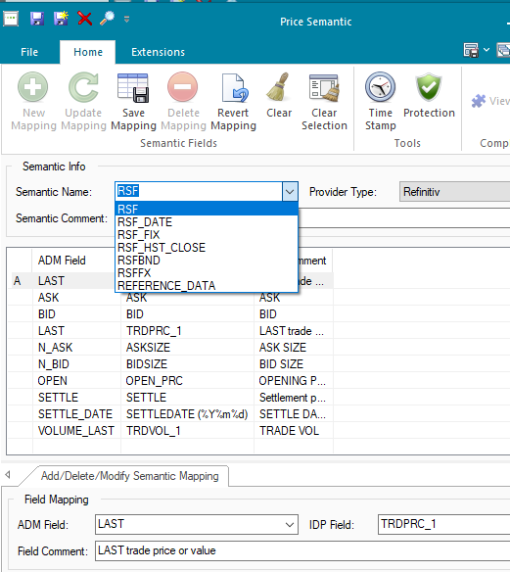

The following Price distributor will be used.

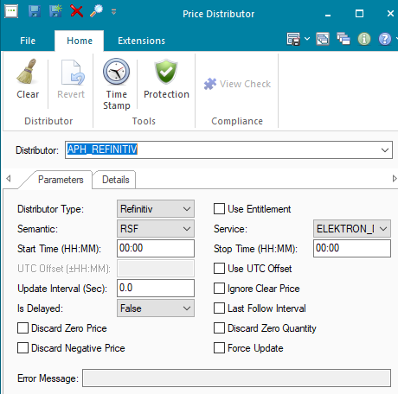

Once the prices have been received from Refinitiv the user can see them in the Price Entry window.

The prices from Refinitiv are updated under following markets.

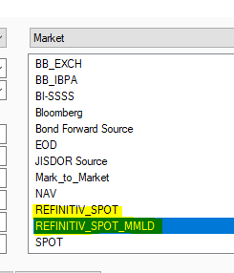

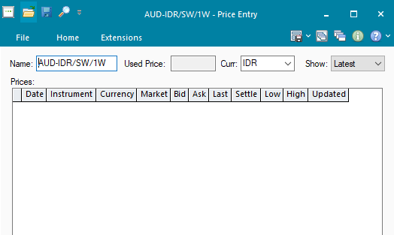

#### Preventive controls

Front Arena User management process will ensure the code/ Extension Editor will be accessible for specific user group (e.g. Admin group).

The service will be running on server so it has access to authorized users only.

#### Detective controls

Detective and Investigation process need to be controlled through the service log details. For this integration there will be separate log file to track the interface workflow. Any error or exception details will be available in respective service log on server.

#### Corrective controls

As per of the functionality, the status of respective service will be displayed to user in form of service logs. Based on status details user can take corrective action manually.

## Communication

*<This section provides the communication line that will be used in this system>*

### New / Existing*) system *) choose one

|  |  |  |  |  |  |  |  |  |  |
| --- | --- | --- | --- | --- | --- | --- | --- | --- | --- |
| **NO** | **NEW / SURROUNDING SYSTEM** | **HOSTNAME SOURCE** | **IP SOURCE** | **PORT SOURCE** | **HOSTNAME DESTINATION** | **IP DESTINATION** | **PORT DESTINATION** | **PROTOCOL (TCP /UDP /ICMP)** | **ALLOW / DENY** |
| 1 | *<new / surrounding status>* | *<isi nama host source>* | *<isi IP source>* | *<isi port source>* | *<isi nama host destination>* | *<isi IP destination>* | *<isi port destination>* | *<isi protocol>* | *<allow / deny status>* |
| 2 |  |  |  |  |  |  |  |  |  |
| 3 |  |  |  |  |  |  |  |  |  |
| 4 |  |  |  |  |  |  |  |  |  |
| 5 |  |  |  |  |  |  |  |  |  |
| 6 |  |  |  |  |  |  |  |  |  |
| 7 |  |  |  |  |  |  |  |  |  |
| 8 |  |  |  |  |  |  |  |  |  |
| … |  | … | … | … | … | … |  | … | … |

*< For a new developed system, if there are some undefined hostnames/ ip addresses/ ports yet, then should be written with* ***TBC*** *notes and will be completely defined in SDN contract review form >*

*< For an existing system and surrounding, please define and write its hostnames/ ip addresses/ ports >*

## OTHERS

*<This section provides other technical specifications that have not been address in previous section>.*

# **SINVEST**

## FA – OUT/In – S-Invest

DESCRIPTION

|  |  |  |  |
| --- | --- | --- | --- |
| **Interface name** | S-Invest | | |
| **Type of data** | Bond Trades | **Frequency** | Batch |
| **Source** | FA | **Direction** | OUT |
| **Format** | txt (pipe separated) | **Transfer mechanism** | SFTP |
| **Response Required** |  | **Dependencies on other processes** |  |
| **Purpose** | FA to send Bond transaction to S-Invest for Mutual Funds. These Bond will be underlying for Mutual Funds. | | |

Mutual Fund Management system in S-Invest system needs Bond transactions from Front Arena. So Bond transaction details should send to S-Invest system.

Counterparty in Front Arena will be setup as Fund Manager. Additional information field will be setup on party and will be used to identify the party as Fund Manager. Additional information field - "Customer Type field" as "M" for mutual fund type.

### TECHNICAL ATTRIBUTE

|  |  |
| --- | --- |
| **Attribute** | **Description** |
| Extension Module | PS_SInvest  *It contains code to generate the S-Invest files and send it to S-Invest on trade updates.* |
| AMBA | AMBA_SINVEST  *AMBA hook is configured to capture trade update events and send the settlement details to SInvest* |

### TECHNICAL ARCHITECTURE

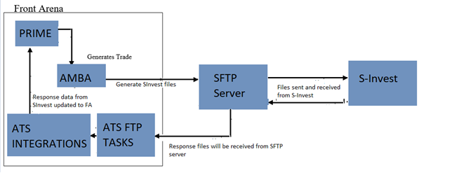

### TECHNICAL FLOW DIAGRAM

Normal Buy/Sell workflow:

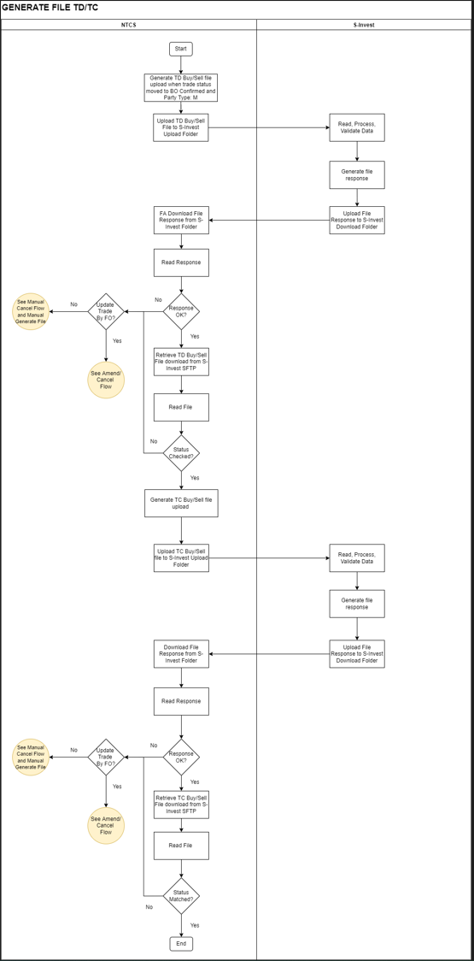

Amendment / Cancellation workflow:

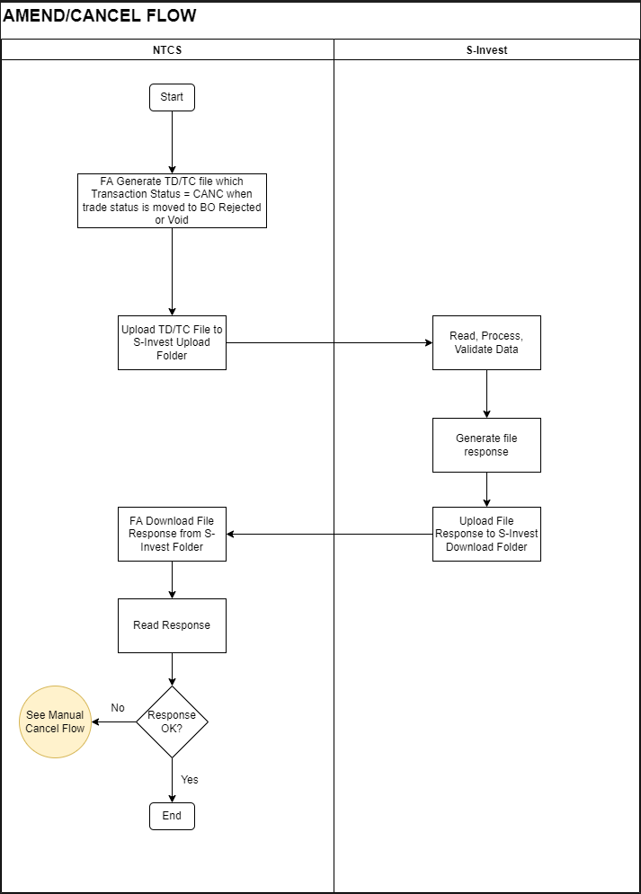

### LOGIC AND CONFIGURATION

#### Flow Logic

This Interface normal workflow is divided in following functionality:

* Send TD information: Generating TD file and send to S-Invest via specified location.
* Read TD Response: Read response from S-Invest from specified location, validate the response, and read TD response from S-Invest SFTP.
* Send TC information: Based on TD response validation TC information will be generated and send to S-Invest via specified location.
* Read TC Response: Read response from S-Invest from specified location, validate the response, and read TC response from S-Invest SFTP.

Workflow from Front Arena:

1. User creates trades in FrontArena using Prime application.
2. AMBA will listen to the updates on the trade. Once the trade satisfies the filter criteria for S-Invest, AMBA will process the trade and generate the SInvest file and send the file to the SFTP server.
3. Scheduled FTP task SInvest-Download_FTP will download the files from SFTP server on the specified locations and SINVEST_DOWNLOAD task will read the SInvest file and update the response to FA.

#### Configuration

|  |  |
| --- | --- |
| Delivery Items | |
| Extension Context | +Integration |
| Extension Module | PS_SInvest |
| AMBA service | AMBA_SINVEST |
| ATS service | ATS_INTEGRATIONS, ATS_FTP_TASKS |
|  |  |
| FA Component | |
| AMBA | AMBA service – AMBA_SINVEST is used to capture updated trades validate it for eligibility criteria to send to SInvest, generate SInvest file and upload to the SFTP server. |
| ATS | ATS service - ATS_FTP_TASKS is a common service which is used to schedule a task to download SInvest files from the SFTP server. ATS_INTEGRATIONS is a common ATS service and is used to schedule a task to process the SInvest response and update the additional info fields on the trade. |
|  |  |
| Deployment and Manual Configuration | |
| These services is deployed through FA standard deployment process.  Manual configuration may be required to update the configuration in FParameter in extension module. | |
|  |  |
| Additional Information | |
| TDReferenceID | AdditionalInfo on Trade |
| TD_DownloadStatus | AdditionalInfo on Trade |
| TD_ResponseStatus | AdditionalInfo on Trade |
| TCReferenceID | AdditionalInfo on Trade |
| TC_DownloadStatus | AdditionalInfo on Trade |
| TC_ResponseStatus | AdditionalInfo on Trade |
| CustomerType | AdditionalInfo on Party |
| FParameters : | Default values |
| SInvestOutFTPParams | FTP connection credentials |
| destination_dir | /upload |
| host | 10.112.6.68 |
| password | 0x4wpzCtcKpwrbCkmVla8KDcn19aw== |
| port | 2222 |
| user | BMAN5 |
| SInvestParams | Parameters for SInvest interface |
| ACQ_INFO_PAYMENT | WHT |
| BRCODE | BMAN5 |
| CUSTOMER_TYPE | M |
| DOWNLOAD_LOG_FILE_NAME | SINVEST_DOWNLOAD_{}.txt |
| LOG_FILE_NAME | SINVEST_TD_UPLOAD_{}.txt |
| LOG_FOLDER | c:\Temp |
| OUTPUT_FOLDER | C:\Temp\SINVEST |
| TC_RESP_DOWNLOAD_PREFIX | FI-TC-TR-DW- |
| TD_RESP_DOWNLOAD_PREFIX | FI-TD-TR-DW- |
| TD_RESPONSE_CODE | "Response Code" |
| TRADE_STATUS | ['BO Confirmed', 'BO Rejected', 'Void'] |
| UPLOAD_LOG_FILE_NAME | SINVEST_UPLOAD_{}.txt |
| Pre-requisites |  |
| AMBA and ATS service | AMBA and ATS services for this interface must be running and the SInvest tasks should be scheduled. |
| FStoredASQLQuery | Purpose |
| SInvest_TransactionsTD | Filter to specify eligible trades for SInvest for Manual handling |

#### Data Dictionary

Following are field mapping done for this interface.



#### A Data Model

Please refer AEF Browser document for details about Front Arena Data Model.

Document - FCA4033

#### B Data Entity and Key Elements Definition

All required details are available in AEF Browser document.

#### C Reference Code Table Definition

Please refer AEF Browser document for details about Front Arena Data Model.

Document - FCA4033

### SECURITY AND CONTROL DESIGN

#### Security Requirement Response

|  |  |  |
| --- | --- | --- |
| **Security Domain** | **Security Requirement** | **Response** |
| User Management | The system must identify users using a unique user identification code before allowing a log-on. | It will be controlled through CDCA application |
| The system must suspend access to a user session after a specified interval of inactivity. | Inactivity of user session will not be applicable  as the integration is in Realtime |
| The system must require user authentication before re-enabling the session. | It will be controlled through CDCA application |
| The system must display a warning message indicating that only authorized use is permitted before allowing users to perform a log-on. | It will be controlled through CDCA application |
| The system must display system information to a user, only after a successful log-on. |  |
| After a successful log-on, the system must display information concerning the previous successful attempt to perform a log-on. | It will not be possible in real-time connections. |
| The system must allow a user account to be manually disabled. | NA |
| The system must disable the user account following 3 (three) consecutive failures to perform a successful log-on. | It will be controlled through CDCA application |
| The system must automatically disable the user account following a configurable period (90 days) without use. |  |
| Password Management | The system must authenticate users using a password before allowing access to any system functions. | Not applicable at Front Arena Database side. |
| The system must ensure that passwords used by system users for log-on consist of at least 8 (eight) characters. | Not applicable at Front Arena Database side. |
| The system must enforce the use of complex passwords for all users. (Aplhanumieric & Special Characters) | Not applicable at Front Arena Database side. |
| The system must use cryptographic techniques to protect the confidentiality of user authentication data during transmission. | Not applicable at Front Arena Database side. |
| The system must enforce a password change when a password is first issued or re-issued. |  |
| The system must allow system users to change the password used for log-on. | Not applicable at Front Arena Database side. |
| The system must ensure that passwords do not remain valid for more than 90 (ninety) days. | Not applicable at Front Arena Database side. |
| The system must ensure that passwords may not be changed to any of the last 5 (five) passwords used. | Not applicable at Front Arena Database side. |
| The system must ensure that passwords are not displayed in clear text during entry. | Not applicable at Front Arena Database side. |
| Multi Factor Authentication | The system must enforce dual factor authentication of all users (system that related to financial, faced to customer directly & only use for external purposes) | Not applicable at Front Arena Database side. |
| Data Storage | The system must use cryptographic techniques to protect the storage of authentication data. | NA |
| The system must use cryptographic techniques to protect the integrity of stored critical data. | NA |
| The system must use cryptographic techniques to protect the confidentiality of stored sensitive data. | NA |
| Logging | The system must support the recording of security events in one or multiple specific security event logs. 2 weeks in minimum must be available at the Production Environment | It will be controlled through CDCA application |
| The system must include the Logical Account identity, event type and timestamp in each entry in the security event logs. | It will be controlled through CDCA application |
| The system must record when each security event lo fills to a configurable limit. | It will be controlled through CDCA application |
| The system must protect the integrity of the information in the security event logs | It will be controlled through CDCA application |
| The system must allow access to the security event logs to be limited to the authorised security staff. | It will be controlled through CDCA application |
| The system must record if the integrity of the security event logs is compromised | NA |
| The system must record all instances that system event logs are cleared. | It will be controlled through CDCA application |
| The system must record when a change is made to the system log settings (e.g. logs for certain events are turned off). | It will be controlled through CDCA application |
| The system must record when any system security policy is modified. | NA |
| The system must record all creations of Logical Accounts. | It will be controlled through CDCA application |
| The system must record all deletions of Logical Accounts. |  |
| The system must record all de-activation of Logical Accounts. |  |
| The system must record all unsuccessful attempts to log-on to the system using invalid credentials. |  |
| The system must record all successful attempts to log-on to the system. |  |
| The system must record all successful and unsuccessful attempts to change passwords. |  |
| The system must automatically build and maintain a normal usage pattern for each Logical Account. |  |
| The system must record all activation of disabled Logical Accounts. |  |
| The system must record all attempts to change any account attribute affecting authentication of the Logical Account |  |
| The system must record all allocations of system access rights. |  |
| The system must record all removals of system access rights. |  |
| The system must record all unauthorised attempts to access a system function. |  |
| The system must record when a configurable deviation from a Logical Account's normal pattern is detected. |  |
| The system must record all failures of the check on the timestamp of payment and settlement orders. |  |
| The system must record all attempts to mutually authenticate interface connections that handle critical data |  |
| The system must record all events that may indicate an attempt to cause denial of service. |  |
| The system must record all access to functions processing critical information within the system. |  |
| The system must record all access to sensitive information within the system. |  |
| The system must record all start-up and shut down events. |  |
| The system must have been integrated in the SIEM, Identity Management System & Privilege Identity Management System |  |
| Remote Access | The system logical access control mechanism must be able to discretely grant remote access capability to specific users and user groups. |  |
| The system must strictly limit user access rights to their minimum requirements when they access the system remotely. |  |
| All relevant approvals must be obtained if this application is to be made available for remote use (E.g. on the RCA-portal) by Users |  |
| System Interfaces | The system must use a logical access control mechanism to control system to system data communications, in order to avoid anonymous data transfers (for all interfaces) |  |
| The system must ensure that system to system mutual authentication takes place before data communications are allowed (for all interfaces) |  |
| System to system mutual authentication must be based on cryptographic techniques (for all interfaces) |  |
| The system must use cryptographic techniques to protect the integrity of critical data during transmission (for all interfaces) |  |
| The system must use cryptographic techniques to protect the confidentiality of sensitive data during transmission (for all interfaces) |  |
| All 'critical data' must have been identified, documented and approved by the Business |  |
| All 'confidential data' must have been identified, documented and approved by the Business |  |
| Availability | The system must have a documented and successfully tested disaster recovery plan in place | It will be managed through Front Arena Database DR setup. |
| The system must enforce quotas limiting the maximum resources that an individual user can use simultaneously. |  |
| The system must provide adequate resources to support the required number of users or concurrent users. |  |
| The system should have a documented capacity monitoring process in-place with regular reporting on its use |  |
| Security Testing | The system must be tested for specific technical security flaws where it faces the public internet, prior to release into production. |  |
| The system must only be released into production, where it faces the public internet, once all identified key findings from the security test have been rectified, or if this is not possible, the risks must be formally reviewed and signed off |  |
| The system must be tested for specific technical security flaws prior to release into production. |  |
| The system must only be released into production once all the identified key findings from the security tests have been rectified or if this is not possible, the risks must be formally reviewed and signed off |  |

#### Preventive controls

*<This sub-section describe the technical specification for preventive controls that are specific to this module. This includes logical access control, physical security control, encryption, PIN generation and validation, etc>*

*<Sample of list of Role Table and Authorization Matrix>*

|  |  |  |  |
| --- | --- | --- | --- |
| **No** | **Role** | **Authorization** | **Object** |
| 1 | Role1 | ZXXXX | Maintain |
| 2 | Role2 | ZYYYY | Display |
| 3 |  |  |  |

|  |  |  |  |  |  |  |
| --- | --- | --- | --- | --- | --- | --- |
| **No** | **User Group** | **Role1** | **Role2** | **Role3** | **Role4** | **Role5** |
| 1 | User Group1 | X | X |  | X |  |
| 2 | User Group2 |  | X | X |  | X |
|  |  |  |  |  |  |  |

#### Detective controls

*<This sub-section describe the technical specification for detective controls that are specific to this module. This includes audit trail, exception reports, reconciliation, balancing & control totals, validations, etc>.*

#### Corrective controls

*<This sub-section describes the technical specification for corrective controls that are specific to this module. This includes automated error corrections, backup, recovery & restart, etc>.*

### USER INTERFACE

If required, the user can generate SInvest files manually by using the task GUI SINVEST_UPLOAD.

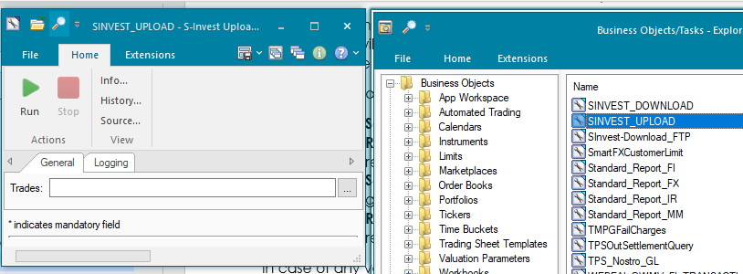

SInvest-Download_FTP task will be used to download SInvest files from SFTP server to application server.

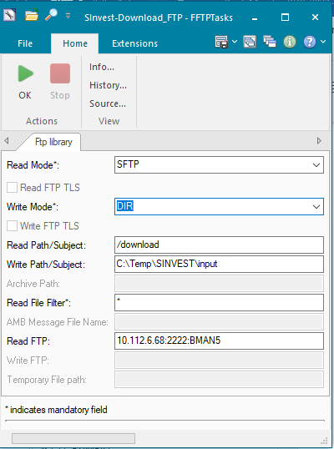

SINVEST_DOWNLOAD task will be used to process the response files from the SInvest System

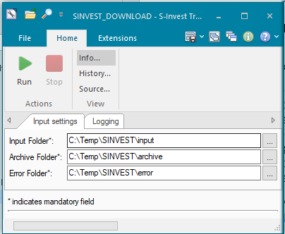

### OPERATING SPECIFICATION

* AMBA service will be running and will keep listening to the Trade updates.
* Once the eligible trade update is received by AMBA it will generate the SInvest output file based on the trade status.
* Generated output files will be sent to SFTP server as per the FTP FParameters settings.
* Scheduled FTP task will check for the response coming from SInvest. Once the files are received, the files will be downloaded the app server as specified location.
* Scheduled SInvest task will check for the SInvest response files and process the response received from the SInvest and update the trade additional info fields accordingly.
* Based on the Trade additional info values, SInvest interface will decide to generate TC or TD files.

## Communication

*<This section provides the communication line that will be used in this system>*

### New / Existing*) system *) choose one

|  |  |  |  |  |  |  |  |  |  |
| --- | --- | --- | --- | --- | --- | --- | --- | --- | --- |
| **NO** | **NEW / SURROUNDING SYSTEM** | **HOSTNAME SOURCE** | **IP SOURCE** | **PORT SOURCE** | **HOSTNAME DESTINATION** | **IP DESTINATION** | **PORT DESTINATION** | **PROTOCOL (TCP /UDP /ICMP)** | **ALLOW / DENY** |
| 1 | *<new / surrounding status>* | *<isi nama host source>* | *<isi IP source>* | *<isi port source>* | *<isi nama host destination>* | *<isi IP destination>* | *<isi port destination>* | *<isi protocol>* | *<allow / deny status>* |
| 2 |  |  |  |  |  |  |  |  |  |
| 3 |  |  |  |  |  |  |  |  |  |
| 4 |  |  |  |  |  |  |  |  |  |
| 5 |  |  |  |  |  |  |  |  |  |
| 6 |  |  |  |  |  |  |  |  |  |
| 7 |  |  |  |  |  |  |  |  |  |
| 8 |  |  |  |  |  |  |  |  |  |
| … |  | … | … | … | … | … |  | … | … |

*< For a new developed system, if there are some undefined hostnames/ ip addresses/ ports yet, then should be written with* ***TBC*** *notes and will be completely defined in SDN contract review form >*

*< For an existing system and surrounding, please define and write its hostnames/ ip addresses/ ports >*

## OTHERS

*<This section provides other technical specifications that have not been address in previous section>.*

# **SMARTFX**

## Static Data

### DESCRIPTION

|  |  |  |  |
| --- | --- | --- | --- |
| **Interface name** | SmartFX – Static Data | | |
| **Type of data** | FA Static data | **Frequency** | Batch |
| **Source** | FA | **Direction** | OUT |
| **Format** | N/A | **Transfer mechanism** | Staging Database |
| **Response Required** | N/A | **Dependencies on other processes** |  |
| **Purpose** | Feed FA data to SmartFX System for trading and Reporting purpose. | | |

Following static data will be sent to SmartFX system

* Counterparty
* Limit static Data
* Portfolio
* Trader
* Broker

**Overview**

Considering the required information for Limits details and Front Arena database table structure, instead of direct database table synchronization, new intermediate database tables will be used to store required data from FA.

Front Arena script will be created to extract data programmatically and insert/update those records in intermediate/Staging database table. SmartFX system will connect to that staging database to fetch required information.

Limit data like Used / Target amount will be changed frequently based on underlying parameters like Prices. So, transferring limit data in real-time is not recommended solution. Instead of that, Front Arena task will be scheduled to extract static data and insert it in staging data base periodically.

### TECHNICAL ATTRIBUTE

|  |  |
| --- | --- |
| **Attribute** | **Description** |
| Extension Module | PS_SmartFXStaticData |
| ATS | ATS_INTEGRATIONS |

### TECHNICAL ARCHITECTURE

Front Arena



SmartFX Staging DB

Data related to the AppliedRule is exported to the DB.

### TECHNICAL FLOW DIAGRAM

StagingDB

Front Arena

### LOGIC AND CONFIGURATION

#### Flow Logic

*1. Script will be created to get required static data from Front Area database*

*2. Store Front Arena extracted static data in staging database.*

*3. Schedule and Setup a script through ATS*

#### Configuration

|  |  |
| --- | --- |
| Delivery Items | |
| Extension Context | +SmartFX |
| Extension Module | PS_SmartFXStaticData |
| ATS Service | ATS for running the static data mapping is ATS_INTEGRATIONS. SmartFXCustomerLimit task used for executing the flow task. |
|  |  |
| FA Component | |
| ATS | ATS_INTEGRATIONS |
|  |  |
| Deployment and Manual Configuration | |
| This service is deployed through FA standard deployment process.  Manual configuration may be required to update the configuration in FParameter in extension module. | |
|  |  |
| Additional Information | |
| No Add info fields are used. | |
| FParameters | Default values |
| **SmartFXStaticDataConfig** | |
| CEMLimits | ['Counterparty CEM Limit'] |
| NotionalLimits | ['USD Notional'] |
| **SmartFXStaticDBParam** | |
| DATABASE | NTCSSTGDB |
| DRIVER | ODBC Driver 17 for SQL Server |
| SERVER | 10.243.212.173 |
| UID | AdminNTCS |
|  |  |
| Pre-requisites |  |
| Pre-requisite | Connection to the database should live and the ATS services should be running. |
|  |  |
| FStoredASQLQuery |  |
| SmartFXAppliedRules | Stored query to filter applied rules. |

#### Data Dictionary

Please refer attached Data Mapping file

Document - SmartFX_StaticData_FieldMapping.xlsx



#### A Data Model

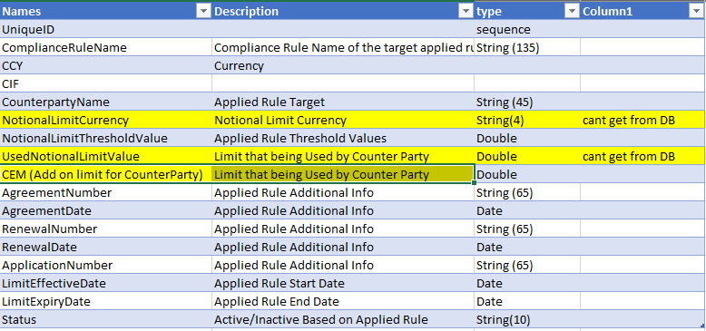

#### B Data Entity and Key Elements Definition

The details of source data from FA is are available in AEF Browser document.

#### C Reference Code Table Definition

*NA*

### USER INTERFACE

*If required user can trigger the flow using the following AEL GUI.*

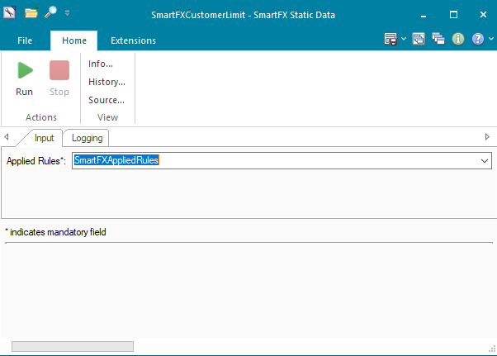

## Deal Posting

### DESCRIPTION

|  |  |  |  |
| --- | --- | --- | --- |
| Interface – SmartFX IN - Deal Posting | | | |
| Interface name | SmartFX - Deal Posting | | |
| Type of data | FX Transactions | Frequency | Realtime |
| Source | SmartFX | Direction | IN |
| Format | JSON | Transfer mechanism | Web API |
| Response Required | NA | Dependencies on other processes | NA |
| Purpose | SmartFX sends FX transactions to Front Arena for position keeping | | |

FX transactions will be happened at SmartFX systems, based on counterparty information from Front Arena. Those FX transactions will be sent to Front Arena.

FX trades will be created in FA in Reserved status for limit checking. All the deals created in FA will be B2B deals.

|  |  |  |
| --- | --- | --- |
| **FX transaction value day** | Source (OptKey2) | Comment |
| Today | SmartFXToday | FX transactions with value day today will have end status as FO Confirmed. There is no need to generate Settlement. |
| Greater than Today | SmartFXForward | Auto BO Check service will move it to BO Confirmed based on Optkey2 |

### TECHNICAL ATTRIBUTE

|  |  |
| --- | --- |
| **Attribute** | **Description** |
| Extension Module | FSmartFXDealHandler  *It contains code required to perform Deal posting activity.* |
| AMBA | AMBA_DEALPOSTING  *AMBA hook is configured to capture trade update events and send the trade details to smartFX* |
| ATS | ATS_DEALPOSTING  *ATS service configured to host Web Service for smart FX integration.*  ATS_DEALRECONCILIATION  *ATS service for reconciliation functionality* |

**Fields**

The following information will be stored on the deal level:

• The reference number from SmartFX will be stored in the External ID field

• The source will be stored as “SmartFX” in a trade Optional Key2.

Source:

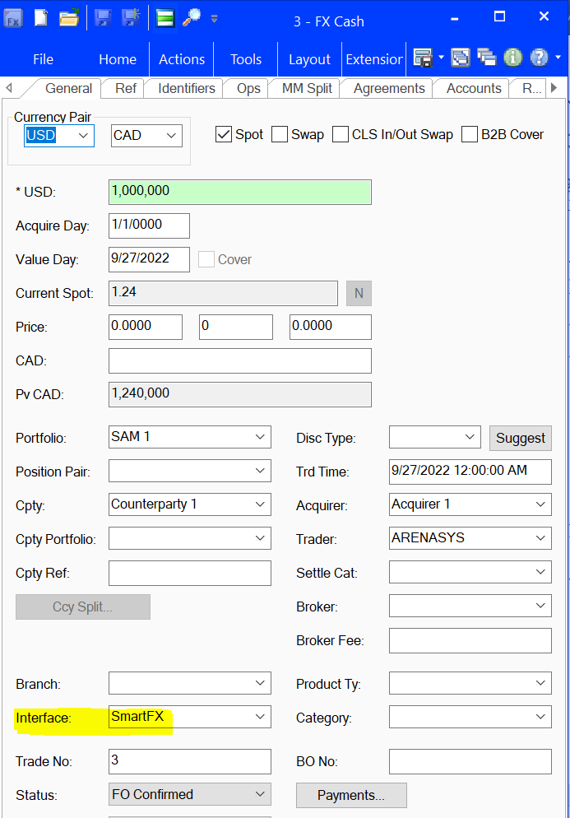

External Id:

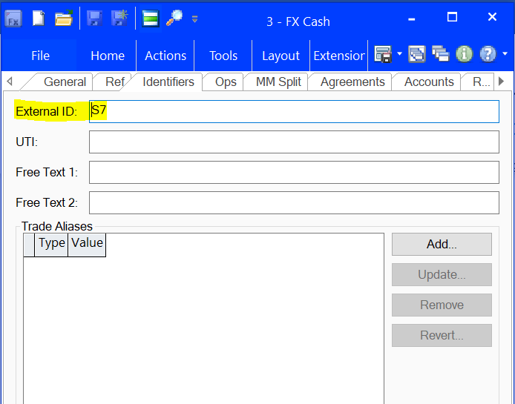

### TECHNICAL ARCHITECTURE

Please refer following workflow for more details -

**New Trade flow**

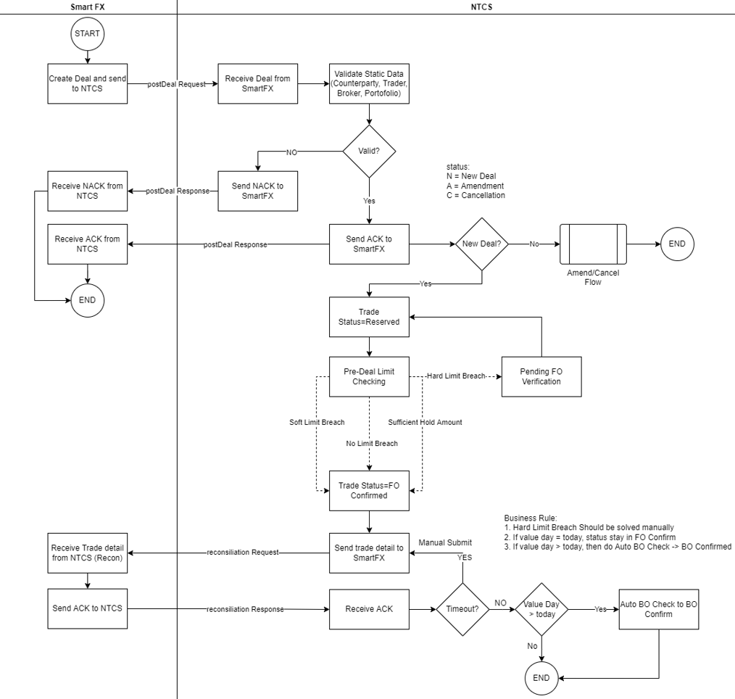

**Amend Trade flow**

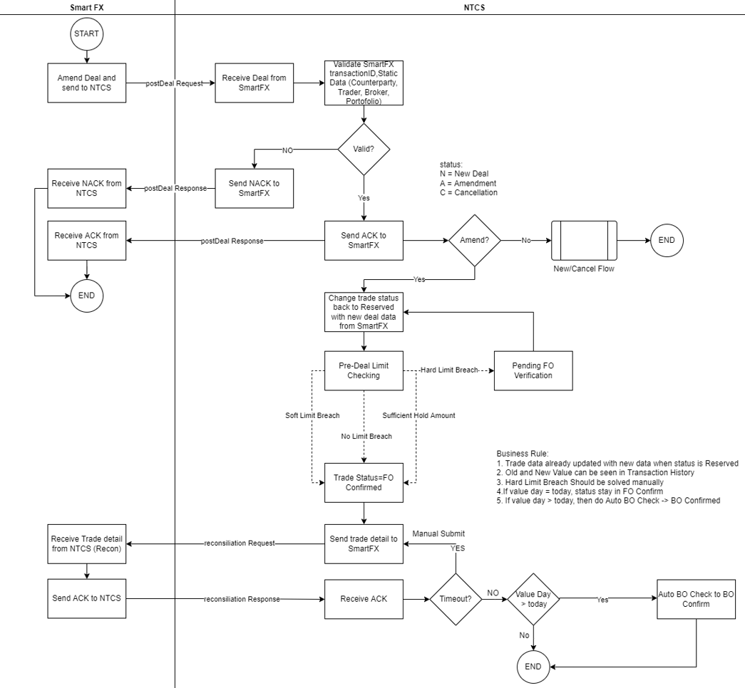

**Cancel Trade flow**

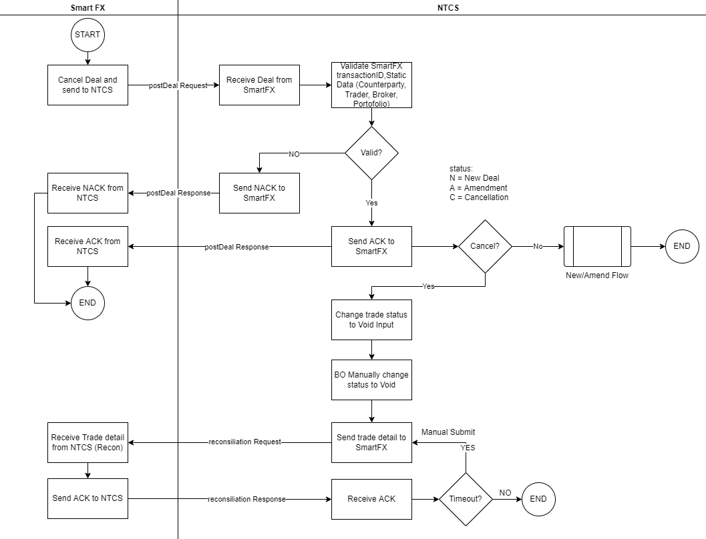

### TECHNICAL FLOW DIAGRAM

Please refer section TECHNICAL ARCHITECTURE

### LOGIC AND CONFIGURATION

#### Flow Logic

1. Front Arena should publish web API that can be consumed by SmartFX to send FX transaction details.

2. Script will be created to read the request and respond with required details.

3. Based on deal posting request from SmatFX, FX trade will be created in FA and reply the status to SmartFX Reply message for Deal Posting will be custom json format containing status and status description.

4. Following static data will be validated (i.e. check if it is already exists in FA) before creating deal in FA:

1. Counterparty
2. Trader
3. Portfolio
4. Broker

In case of Validation failed, NACK reply will be sent to SmartFX.

5. New trade/ Amend(update)/Cancel trade will be based on status field in Deal posting request message.

6. Unique TransactionID from smartFX will be stored in FA trade – ExternalID field. This transaction ID will be used to identify the FA trade in case of Amend or Cancel posting. Also, source of the trade will be stored in FA.

7. Existing trade in FA will be moved to status Reserved in case of Amend Deal posting request So, that it can be considered for pre deal limit checking functionality.

#### Configuration

|  |  |
| --- | --- |
| Component | Description |
| AMBA | Standard configuration, delivered through deployment process. |
| ATS | Standard configuration, delivered through deployment process. |
| Web Service | Deal Posting  *in Extension Editor - FParametes*   * *Certificate File* * *Key File* * *Server Port* |

#### Data Dictionary

Document - Integrasi data SmartEFX - NTCS.xlsx



#### A Data Model

Please refer AEF Browser document for details about Front Arena Data Model.

Document - FCA4033

#### B Data Entity and Key Elements Definition

All required details are available in AEF Browser document.

#### C Reference Code Table Definition

*NA*

### USER INTERFACE

As this interface will be running in background through Web service, any User Interface is not available for this interface.

## Reconciliation

### DESCRIPTION

|  |  |  |  |
| --- | --- | --- | --- |
| Interface – SmartFX OUT - Reconciliation | | | |
| Interface name | SmartFX OUT - Reconciliation | | |
| Type of data | FX Transactions | Frequency | Real-time |
| Source | FA | Direction | OUT |
| Format | JSON | Transfer mechanism | Web API |
| Response Required | NA | Dependencies on other processes | NA |
| Purpose | Front Arena sends FX Transaction details to SmartFX for reconciliation purpose. | | |

**Overview**

In continuation with incoming FX transaction through inbound interface, after creating FX trades in FA. Interface should send FX trade details back to SmartFX system using Bank Mandiri published Web API. This outgoing FX transaction will be used FX transaction reconciliation in SmartFX

### TECHNICAL ATTRIBUTE

|  |  |
| --- | --- |
| **Attribute** | **Description** |
| Extension Module | FSmartFXDealHandler  *It contains code required to performs sending deals for reconciliation activity.* |
| Task | ReconcileSmartFXTrades  *It is task to perform sending FX deals for reconciliation purpose*. |
| Query Folder | ReconcileResponseNack – *to capture trade where SmartFX status is NACK*  ReconcileResponseTimedout – *to capture trade where smartFX status in TIMEOUT* |
| ATS | ATS_DEALRECONCILIATION  *ATS service for reconciliation functionality* |
| Additional Information | SmartFXReconState  *It is choice list of statuses –*   * *Acknowledged* * *NotAcknowledged* * *ResponseAwaited* * *ResponseTimedOut* |

**Query Folder:**

ReconcileResponseNack

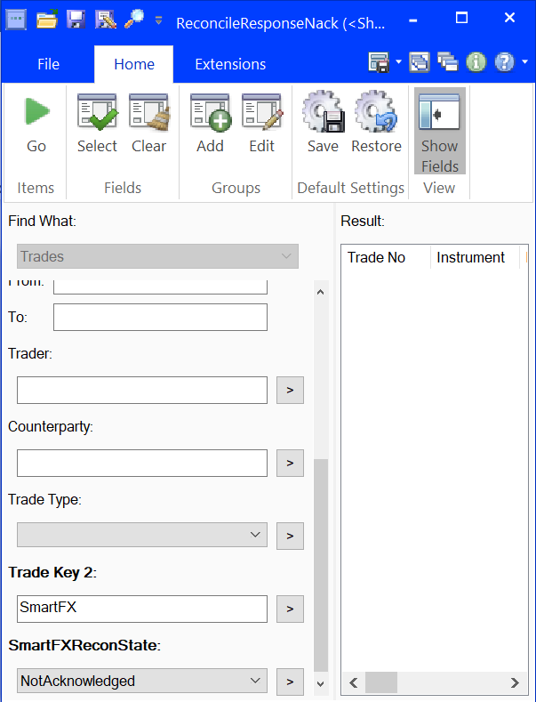

ReconcileResponseTimedout

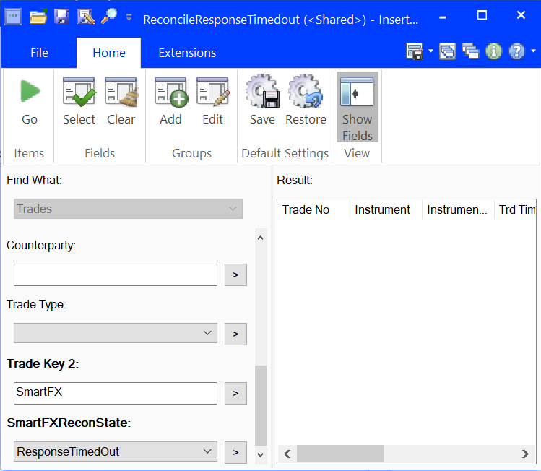

Task:

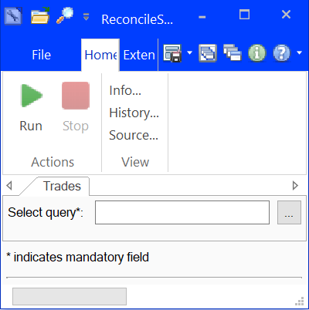

Additional Information fields

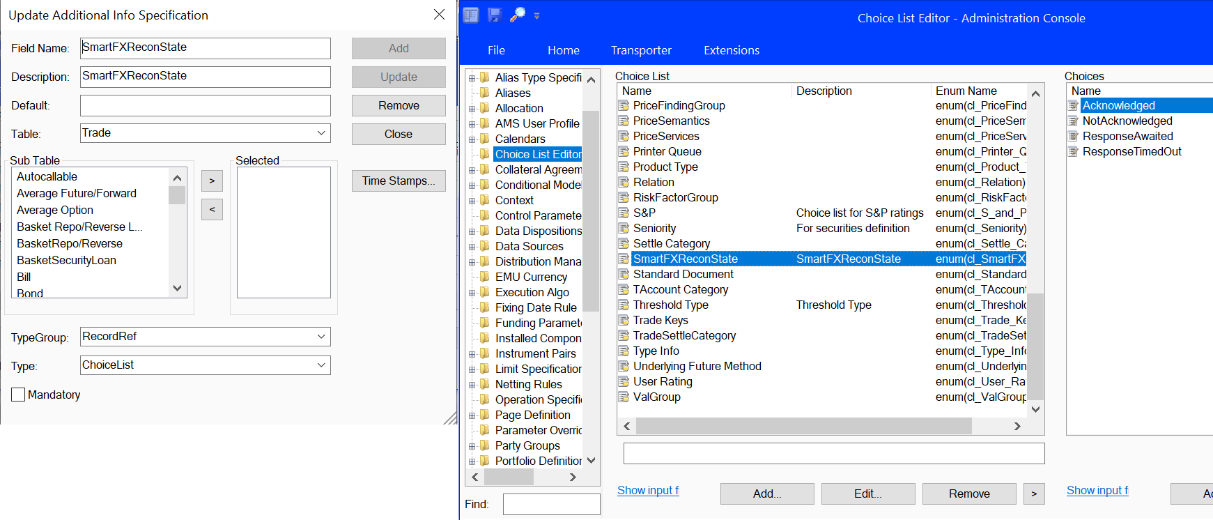

### TECHNICAL ARCHITECTURE

Please refer detailed workflow in section - Deal Posting – TECHNICAL ARCHITECTURE

### TECHNICAL FLOW DIAGRAM

Please refer section TECHNICAL ARCHITECTURE

### LOGIC AND CONFIGURATION

#### Flow Logic

**Workflow**

1. Script will be created FX transaction message for reconciliation purpose.

2. Once the FX transaction received from SmartFX is FO Confirmed, the transaction details will be sent to SmartFX through Web API.

Please refer workflow diagram in SmartFX – Deal Posting

**Trigger**

* Online interface

**Exception Handling**

Front Arena standard logging

**FA Components**

ATS

#### Configuration

|  |  |
| --- | --- |
| Component | Description |
| AMBA | Standard configuration, delivered through deployment process. |
| ATS | Standard configuration, delivered through deployment process. |

#### Data Dictionary

Refer to the data dictionary section 2.5.3

#### A Data Model

Please refer AEF Browser document for details about Front Arena Data Model.

Document - FCA4033

#### B Data Entity and Key Elements Definition

All required details are available in AEF Browser document.

#### C Reference Code Table Definition

*NA*

### USER INTERFACE

**Task**

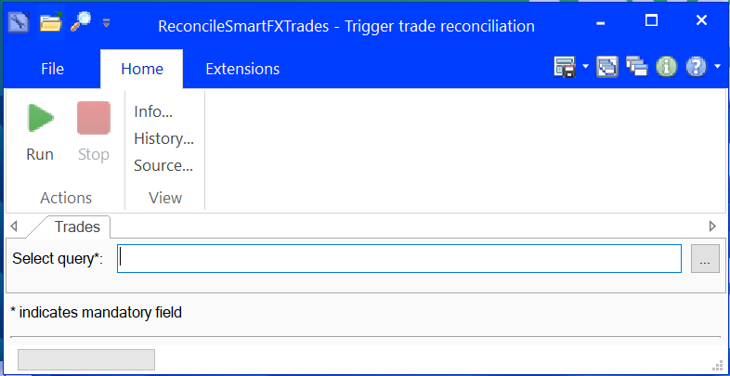

## Transaction Data

### DESCRIPTION

|  |  |  |  |
| --- | --- | --- | --- |
| **Interface – SmartFX OUT - Transaction Data** | | | |
| **Interface name** | SmartFX OUT - Transaction Data | | |
| **Type of data** | FX Transactions | **Frequency** | Real-time |
| **Source** | FA | **Direction** | OUT |
| **Format** | JSON | **Transfer mechanism** | Web API |
| **Response Required** | NA | **Dependencies on other processes** | NA |
| **Purposed** | Front Arena sends FX Transaction details to SmartFX based on inquiry from SmartFX | | |

**Overview**

SmartFX systems send inquiry request to FA to get particular transaction details in FA. This workflow will be similar to BDS workflow. FA should publish web API which can be consumed by SmartFX to inquiry about transactions

### TECHNICAL ATTRIBUTE

|  |  |
| --- | --- |
| **Attribute** | **Description** |
| Extension Module | *PS_SmartFXOutTransactionData* |
| ATS | *ATS service required to Host Webservice to send transaction details based on the request.* |

### TECHNICAL ARCHITECTURE

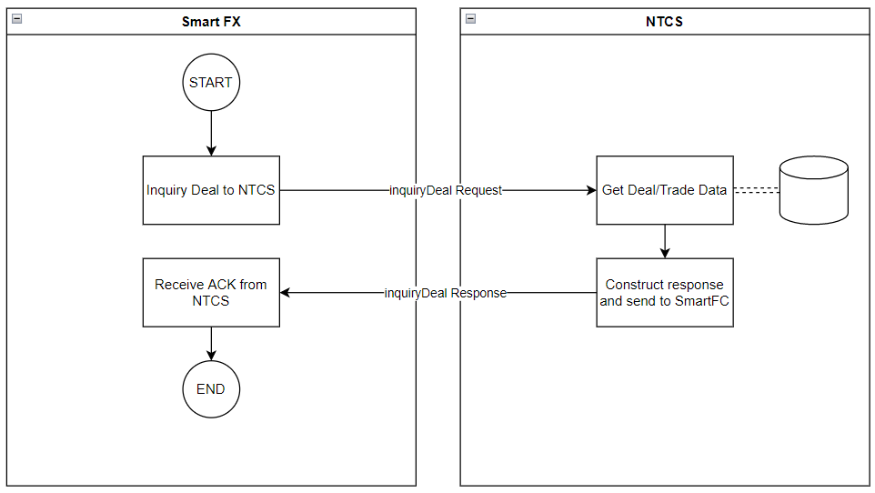

### TECHNICAL FLOW DIAGRAM

Please refer section – TECHNICAL ARCHITECTURE

### LOGIC AND CONFIGURATION

#### Flow Logic

1. FA should publish web API to receive inquiry request. Request format will be similar to BDS deal code interface request format.
2. Script will be created to transform transaction details in response format. And reply to API call.

#### Configuration

|  |  |
| --- | --- |
| Component | Description |
| ATS | Standard configuration, delivered through deployment process. |
| Web Service | SmartFX-TransactionData  *in Extension Editor - FParametes*   * *Certificate File* * *Key File* * *Server Port* |

#### Data Dictionary

Data mapping file : Inquiry Deal API Specification_FieldMapping_v1.1.xlsx



#### A Data Model

Please refer AEF Browser document for details about Front Arena Data Model.

Document - FCA4033

#### B Data Entity and Key Elements Definition

All required details are available in AEF Browser document.

#### C Reference Code Table Definition

*<This sub-section describes the reference code tables and the codes within each table. Only describes those reference code tables that affect the users>.*

*Template is the same as 5.3.B*

### USER INTERFACE

*This interface is online real-time interface, so GUI interface is not available.*

## OPERATING SPECIFICATION

NA

## SECURITY AND CONTROL DESIGN

#### Security Requirement Response

|  |  |  |
| --- | --- | --- |
| **Security Domain** | **Security Requirement** | **Response** |
| User Management | The system must identify users using a unique user identification code before allowing a log-on. | It will be controlled through HTTPS protocol and Certificate  and Key file for web API call. |
| The system must suspend access to a user session after a specified interval of inactivity. | Inactivity of user session will not be applicable  as the integration is in Realtime |
| The system must require user authentication before re-enabling the session. | It will be controlled through HTTPS protocol and Certificate  and Key file for web API call. |
| The system must display a warning message indicating that only authorized use is permitted before allowing users to perform a log-on. | It will display standard HTTPS error. |
| The system must display system information to a user, only after a successful log-on. | This interface will run in back ground in realtime, so workflow  Details will be available in service log file. |
| After a successful log-on, the system must display information concerning the previous successful attempt to perform a log-on. | It will not be possible in real-time connections/ Integration. |
| The system must allow a user account to be manually disabled. | NA |
| The system must disable the user account following 3 (three) consecutive failures to perform a successful log-on. | It can be controlled through certificate files. But it is not required  For such type of integration |
| The system must automatically disable the user account following a configurable period (90 days) without use. |  |
| Password Management | The system must authenticate users using a password before allowing access to any system functions. | Not applicable at Front Arena Database side. |
| The system must ensure that passwords used by system users for log-on consist of at least 8 (eight) characters. | Not applicable at Front Arena Database side. |
| The system must enforce the use of complex passwords for all users. (Aplhanumieric & Special Characters) | Not applicable at Front Arena Database side. |
| The system must use cryptographic techniques to protect the confidentiality of user authentication data during transmission. | Not applicable at Front Arena Database side. |
| The system must enforce a password change when a password is first issued or re-issued. |  |
| The system must allow system users to change the password used for log-on. | Not applicable at Front Arena Database side. |
| The system must ensure that passwords do not remain valid for more than 90 (ninety) days. | Not applicable at Front Arena Database side. |
| The system must ensure that passwords may not be changed to any of the last 5 (five) passwords used. | Not applicable at Front Arena Database side. |
| The system must ensure that passwords are not displayed in clear text during entry. | Not applicable at Front Arena Database side. |
| Multi Factor Authentication | The system must enforce dual factor authentication of all users (system that related to financial, faced to customer directly & only use for external purposes) | Not applicable at Front Arena Database side. |
| Data Storage | The system must use cryptographic techniques to protect the storage of authentication data. | NA |
| The system must use cryptographic techniques to protect the integrity of stored critical data. | NA |
| The system must use cryptographic techniques to protect the confidentiality of stored sensitive data. | NA |
| Logging | The system must support the recording of security events in one or multiple specific security event logs. 2 weeks in minimum must be available at the Production Environment | It can be managed through service log details. |
| The system must include the Logical Account identity, event type and timestamp in each entry in the security event logs. | It can be managed through service log details. |
| The system must record when each security event lo fills to a configurable limit. | It can be managed through service log details. |
| The system must protect the integrity of the information in the security event logs | It can be managed through service log details. |
| The system must allow access to the security event logs to be limited to the authorised security staff. | NA |
| The system must record if the integrity of the security event logs is compromised | NA |
| The system must record all instances that system event logs are cleared. | It can be managed through service log details. |
| The system must record when a change is made to the system log settings (e.g. logs for certain events are turned off). | It can be managed through service log details. |
| The system must record when any system security policy is modified. | NA |
| The system must record all creations of Logical Accounts. | NA |
| The system must record all deletions of Logical Accounts. |  |
| The system must record all de-activation of Logical Accounts. |  |
| The system must record all unsuccessful attempts to log-on to the system using invalid credentials. |  |
| The system must record all successful attempts to log-on to the system. |  |
| The system must record all successful and unsuccessful attempts to change passwords. |  |
| The system must automatically build and maintain a normal usage pattern for each Logical Account. |  |
| The system must record all activation of disabled Logical Accounts. |  |
| The system must record all attempts to change any account attribute affecting authentication of the Logical Account |  |
| The system must record all allocations of system access rights. |  |
| The system must record all removals of system access rights. |  |
| The system must record all unauthorised attempts to access a system function. |  |
| The system must record when a configurable deviation from a Logical Account's normal pattern is detected. |  |
| The system must record all failures of the check on the timestamp of payment and settlement orders. |  |
| The system must record all attempts to mutually authenticate interface connections that handle critical data |  |
| The system must record all events that may indicate an attempt to cause denial of service. |  |
| The system must record all access to functions processing critical information within the system. |  |
| The system must record all access to sensitive information within the system. |  |
| The system must record all start-up and shut down events. |  |
| The system must have been integrated in the SIEM, Identity Management System & Privilege Identity Management System |  |
| Remote Access | The system logical access control mechanism must be able to discretely grant remote access capability to specific users and user groups. |  |
| The system must strictly limit user access rights to their minimum requirements when they access the system remotely. |  |
| All relevant approvals must be obtained if this application is to be made available for remote use (E.g. on the RCA-portal) by Users |  |
| System Interfaces | The system must use a logical access control mechanism to control system to system data communications, in order to avoid anonymous data transfers (for all interfaces) |  |
| The system must ensure that system to system mutual authentication takes place before data communications are allowed (for all interfaces) |  |
| System to system mutual authentication must be based on cryptographic techniques (for all interfaces) |  |
| The system must use cryptographic techniques to protect the integrity of critical data during transmission (for all interfaces) |  |
| The system must use cryptographic techniques to protect the confidentiality of sensitive data during transmission (for all interfaces) |  |
| All 'critical data' must have been identified, documented and approved by the Business |  |
| All 'confidential data' must have been identified, documented and approved by the Business |  |
| Availability | The system must have a documented and successfully tested disaster recovery plan in place | It will be managed through Front Arena Database DR setup. |
| The system must enforce quotas limiting the maximum resources that an individual user can use simultaneously. |  |
| The system must provide adequate resources to support the required number of users or concurrent users. |  |
| The system should have a documented capacity monitoring process in-place with regular reporting on its use |  |
| Security Testing | The system must be tested for specific technical security flaws where it faces the public internet, prior to release into production. |  |
| The system must only be released into production, where it faces the public internet, once all identified key findings from the security test have been rectified, or if this is not possible, the risks must be formally reviewed and signed off |  |
| The system must be tested for specific technical security flaws prior to release into production. |  |
| The system must only be released into production once all the identified key findings from the security tests have been rectified or if this is not possible, the risks must be formally reviewed and signed off |  |

#### Preventive controls

Front Arena User management process will ensure the code/ Extension Editor will be accessible for specific user group (e.g. Admin group).

The service will be running on server so it has access to authorized users only.

#### Detective controls

Detective and Investigation process need to be controlled through the service log details. For this integration there will be separate log file to track the interface workflow. Any error or exception details will be available in respective service log on server.

#### Corrective controls

As per of the functionality, the status of respective service will be displayed to user in form of Additional information field in Front Arena. Based on status details user can take corrective action manually at SmartFX side to resend the request.

## REPORTING

### 9.1 Inventory of Reports

*<This sub-section provides a list of operational reports relevant to this module. It is assumed that MIS/EIS module will produce the executive management and regulatory related reports>.*

*<Sample of report definition>*

|  |  |  |
| --- | --- | --- |
| **No** | **Report Name** | **Description** |
|  |  | <Description> |
|  |  |  |

*<if there is data integrity checking requirement, please provide any additional supporting information>.*

### 9.2 Report layout and definition

*<This sub-section describes each of the reports in the inventory list. Report Layout and It’s selection screen must be drawn clearly in this subsection>*

*<Sample of Selection Screen:>*

Selection Field 1

Selection Field 2

to

*<Sample of Report Layout>*

**Report Title**

Report Header

LOGO

Report Footer

Page No.

**Column1**

**Column2**

**Column3**

**Column4**

**Column5**

**Column6**

**Total1**

## Communication

*<This section provides the communication line that will be used in this system>*

### New / Existing*) system *) choose one

|  |  |  |  |  |  |  |  |  |  |
| --- | --- | --- | --- | --- | --- | --- | --- | --- | --- |
| **NO** | **NEW / SURROUNDING SYSTEM** | **HOSTNAME SOURCE** | **IP SOURCE** | **PORT SOURCE** | **HOSTNAME DESTINATION** | **IP DESTINATION** | **PORT DESTINATION** | **PROTOCOL (TCP /UDP /ICMP)** | **ALLOW / DENY** |
| 1 | *<new / surrounding status>* | *<isi nama host source>* | *<isi IP source>* | *<isi port source>* | *<isi nama host destination>* | *<isi IP destination>* | *<isi port destination>* | *<isi protocol>* | *<allow / deny status>* |
| 2 |  |  |  |  |  |  |  |  |  |
| 3 |  |  |  |  |  |  |  |  |  |
| 4 |  |  |  |  |  |  |  |  |  |
| 5 |  |  |  |  |  |  |  |  |  |
| 6 |  |  |  |  |  |  |  |  |  |
| 7 |  |  |  |  |  |  |  |  |  |
| 8 |  |  |  |  |  |  |  |  |  |
| … |  | … | … | … | … | … |  | … | … |

*< For a new developed system, if there are some undefined hostnames/ ip addresses/ ports yet, then should be written with* ***TBC*** *notes and will be completely defined in SDN contract review form >*

*< For an existing system and surrounding, please define and write its hostnames/ ip addresses/ ports >*

## OTHERS

*<This section provides other technical specifications that have not been address in previous section>.*

# **SWIFT**

## SWIFT - Confirmation

DESCRIPTION

|  |  |  |  |
| --- | --- | --- | --- |
| **Interface name** | SWIFT - Confirmation | | |
| **Type of data** | MT messages | **Frequency** | Realtime |
| **Source** | FA | **Direction** | IN / OUT |
| **Format** | File | **Transfer mechanism** | FTPS |
| **Response Required** | N/A | **Dependencies on other processes** | N/A |
| **Purpose** | Front Arena should send/receive SWIFT MT Messages (text-file per message) to/from FTPS for SWIFT. | | |

### TECHNICAL ATTRIBUTE

|  |  |
| --- | --- |
| **Attribute** | **Description** |
| Extension Module | FSwiftFXMMConfirmation  *It contains the code required to processing incoming and outgoing confirmations messages in SWIFT MT format.* |
| ATS | ATS_SWIFTREADER, ATS_SWIFTWRITER, ATS_FFTPLIB  *The reader and writer ATS handle the processing of incoming and outgoing SWIFT messages respectively.FFTPLIB ATS handles reading writing message to FTPS.* |

### TECHNICAL ARCHITECTURE

Please refer to the technical flow diagram.

### TECHNICAL FLOW DIAGRAM

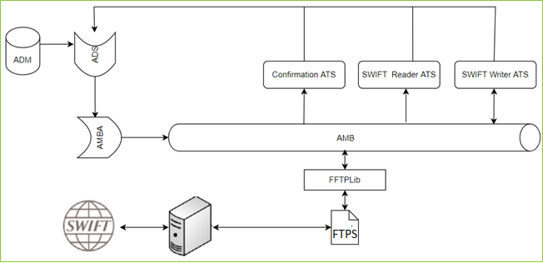

### LOGIC AND CONFIGURATION

#### Flow Logic

1. The ATS runs the entry point of the Swift module. The module reads and write the incoming Swift messages and the generated Swift messages. The module reads and writes the Swift message to the AMB.
2. Another ATS transfers these generated messages from AMB to the FTPS location and similarly reads the Swift messages incoming to FrontArena and write AMB from FTPS location.

#### Configuration

|  |  |
| --- | --- |
| Delivery Items | |
| Extension Context | +Back Office |
| Extension Module | FSwiftFXMMConfirmation, FSwiftSolutionBase, FSwiftColumns, FSwiftInstaller, PS_CustomSwift |
| ATS service | ATS_SWIFTREADER, ATS_SWIFTWRITER |
|  |  |
| FA Component | |
| ATS | ATS service is used to capture confirmation and generate/consume Swift messages. |
|  |  |
| Deployment and Manual Configuration | |
| This service is deployed through FA standard deployment process.  Manual configuration may be required to update the configuration in FParameter in extension module. | |
|  |  |
| Additional Information | |
| Standard additional info field described in the FCA 4947 are used. | |
| FParameters | Default values |
| FFXMMConfirmationOut_Config | |
| LocationCode | ={'BUENOS AIRES' : 'ARBA', 'VIENNA': 'ATVI', 'MELBOURNE' : 'AUME', 'SYDNEY' : 'AUSY', 'BRUSSELS' : 'BEBR', 'SAO PAULO':'BRSP', 'MONTREAL':'CAMO', 'TORONTO':'CATO', 'GENEVA':'CHGE', 'ZURICH':'CHZU', 'SANTIAGO':'CLSA', 'BEIJING':'CNBE', 'PRAGUE':'CZPR', 'EUROPEAN CENTRAL BANK':'DECB', 'FRANKFURT':'DEFR', 'COPENHAGEN':'DKCO', 'TALLINN':'EETA', 'MADRID':'ESMA', 'TARGET':'EUTA', 'HELSINKI':'FIHE', 'PARIS':'FRPA', 'LONDON':'GBLO', 'ATHENS':'GRAT', 'HONG KONG':'HKHK', 'BUDAPEST':'HUBU', 'JAKARTA':'IDJA', 'DUBLIN':'IEDU', 'TEL AVIV':'ILTA', 'MUMBAI':'INMU', 'MILAN':'ITMI', 'ROME':'ITRO', 'TOKYO':'JPTO', 'SEOUL':'KRSE', 'BEIRUT':'LBBE', 'COLOMBO':'LKCO', 'LUXEMBOURG':'LULU', 'MEXICO CITY':'MXMC', 'KUALA LUMPUR':'MYKL', 'AMSTERDAM':'NLAM', 'OSLO':'NOOS', 'NEW YORK FED':'NYFD', 'NEW YORK STOCK EXCHANGE':'NYSE', 'AUCKLAND':'NZAU', 'WELLINGTON':'NZWE', 'PANAMA CITY':'PAPC', 'MANILA':'PHMA', 'WARSAW':'PLWA', 'LISBON':'PTLI', 'BUCHAREST':'ROBU', 'MOSCOW':'RUMO', 'RIYADH':'SARI', 'STOCKHOLM':'SEST', 'SINGAPORE':'SGSI', 'BRATISLAVA':'SKBR', 'BANGKOK':'THBA', 'ANKARA':'TRAN', 'ISTANBUL':'TRIS', 'TAIPEI':'TWTA', 'CHICAGO':'USCH', 'U.S. GOVERNMENT SECURITIES':'USGS', 'LOS ANGELES':'USLA', 'NEW YORK':'USNY', 'HANOI':'VNHA', 'JOHANNESBURG':'ZAJO', 'JAKARTA':'IDJA'} |
| FMT299NarrativeOut_Config | |
| MT299Narrative_Party | {'SettlementTemplate': 'ATTN MONEY TRANSFER DEPT\n\nPLEASE CREDIT OUR ACCOUNT WITH YOU\nFOR AMOUNT <CURRENCY> <AMOUNT> VALUE DATED <VALUE_DATE>\nFOR COVER WE CREDIT YOUR ACCOUNT\nTHRU <CORR_BANK> UNDER OUR REF. <REF>\nVALUE DATED <VALUE_DATE>\n\nTHANK YOU FOR YOUR KIND COOPERATION.\n\nKIND REGARDS,\n\nSETTLEMENT SECTIONS\nTREASURY OPERATIONS DEPT\nBANK MANDIRI HEAD OFFICE'} |
| FMT300In_Config | |
| Match | {'BuyCurrency':{'FLIP_SIDE':['SellCurrency']}, 'BuyAmount':{'FLIP_SIDE':['SellAmount'], 'CMP_FUNC':'precision','ARG':'0.01'}, 'SellCurrency':{'FLIP_SIDE':['BuyCurrency']}, 'SellAmount':{'FLIP_SIDE':['BuyAmount'], 'CMP_FUNC':'precision','ARG':'0.01'}, 'Acquirer':{'FLIP_SIDE':['Counterparty'],'CMP_FUNC':'bic_comparator'}, 'Counterparty':{'FLIP_SIDE':['Acquirer'],'CMP_FUNC':'bic_comparator'}, 'TradeDate':{}, 'ValueDate':{}, 'ExchangeRate':{'CMP_FUNC':'precision','ARG':'0.01'}, 'BuyReceivingAgent':{'FLIP_SIDE':['SellReceivingAgent'],'CMP_FUNC':'bic_comparator'}, 'SellReceivingAgent':{'FLIP_SIDE':['BuyReceivingAgent'], 'CMP_FUNC':'bic_comparator'}, 'BuyIntermediary':{'FLIP_SIDE':['SellIntermediary'], 'CMP_FUNC':'bic_comparator'}, 'SellIntermediary':{'FLIP_SIDE':['BuyIntermediary'], 'CMP_FUNC':'bic_comparator'}} |
| FMT305In_Config | |
| Match | {'IsCallOption':{}, 'ExerciseType':{}, 'DateContractAgreedAmended':{}, 'EarliestExerciseDate':{}, 'ExpiryDate':{}, 'FinalSettlementDate':{}, 'SettlementType':{}, 'UnderlyingCurrency':{}, 'UnderlyingAmount':{'CMP_FUNC':'precision','ARG':'0.01'}, 'StrikePrice':{'CMP_FUNC':'precision','ARG':'0.01'}, 'CounterCurrency':{}, 'CounterAmount':{}, 'Acquirer':{'FLIP_SIDE':['Counterparty'], 'CMP_FUNC':'bic_comparator'},'Counterparty':{'FLIP_SIDE':['Acquirer'],'CMP_FUNC':'bic_comparator'}, 'PremiumPrice':{'CMP_FUNC':'precision','ARG':'0.01'}, 'Premium':{'CMP_FUNC':'precision','ARG':'0.01'}, 'PremiumDate':{}, 'PremiumCurrency':{}, 'SendersCorrespondent':{'CMP_FUNC':'bic_comparator'}, 'AccountWithInstitution':{'CMP_FUNC':'bic_comparator'} } |
| FMT320In_Config | |
| Match | {'Currency':{},'PrincipalAmount':{'CMP_FUNC':'precision','ARG':'0.01'}, 'TradeDate':{}, 'AcquirerRole':{'FLIP_SIDE':['INVERT']},'ValueDate':{}, 'MaturityDate':{}, 'InterestAmount':{'FLIP_SIDE':['NEGATE'], 'CMP_FUNC':'precision','ARG':'0.0'},'InterestRate':{'CMP_FUNC':'precision','ARG':'0.0'},'Acquirer':{'FLIP_SIDE':['Counterparty'], 'CMP_FUNC':'bic_comparator'},'Counterparty':{'FLIP_SIDE':['Acquirer'], 'CMP_FUNC':'bic_comparator'}, 'CounterpartyReceivingAgent':{'FLIP_SIDE':['AcquirerReceivingAgent'], 'CMP_FUNC':'bic_comparator'}, 'AcquirerReceivingAgent':{'FLIP_SIDE':['CounterpartyReceivingAgent'], 'CMP_FUNC':'bic_comparator'}, 'CounterpartyIntermediary':{'FLIP_SIDE':['AcquirerIntermediary'], 'CMP_FUNC':'bic_comparator'}, 'AcquirerIntermediary':{'FLIP_SIDE':['CounterpartyIntermediary'], 'CMP_FUNC':'bic_comparator'}, 'DayCountFraction':{}} |
| FMT518In_Config | |
| Match | {'SettlementDate': {}, 'TradeDate': {}, 'IdentificationOfFinancialInstrument': {}, 'BuySellIndicator': {'FLIP_SIDE':['INVERT']}, 'PaymentIndicator': {}, 'QuantityOfInstrument': {}, 'DealPrice': {}, 'Rate': {}, 'SettlementAmount':{}, 'AccruedInterestAmount':{}, 'Acquirer':{'FLIP_SIDE':['Counterparty'],'CMP_FUNC':'bic_comparator'}, 'Counterparty':{'FLIP_SIDE':['Acquirer'],'CMP_FUNC':'bic_comparator'}} |
| FMT599Out_Config | |
| MT599_Party | {'SettlementTemplate': 'ATTN MONEY TRANSFER DEPT\n\nPLEASE CREDIT OUR ACCOUNT WITH YOU\nFOR AMOUNT <CURRENCY> <AMOUNT> VALUE DATED <VALUE_DATE>\nFOR COVER WE CREDIT YOUR ACCOUNT\nTHRU <CORR_BANK> UNDER OUR REF. <REF>\nVALUE DATED <VALUE_DATE>\n\nTHANK YOU FOR YOUR KIND COOPERATION.\n\nKIND REGARDS,\n\nSETTLEMENT SECTIONS\nTREASURY OPERATIONS DEPT\nBANK MANDIRI HEAD OFFICE'} |
| FSwiftReaderConfig | |
| Modules | ['FFXMMConfirmationInMain', 'FSecuritySettlementInMain'] |
| FSwiftWriterConfig | |
| Modules | ['FFXMMConfirmationOutMain', 'FSecuritySettlementOutMain','FCashOutMain'] |
| FXMMPairingViewEnabler | |
| MTTypes | ['300', '320'] |
|  |  |
| Pre-requisites |  |
| ATS service | ATS service for this interface must be running to work this interface. |
| FStoredASQLQuery | Purpose |
| Standard queries as described in the FCA 4947 have been used. | |

|  |  |
| --- | --- |
| Delivery Items | |
| Extension Context | +FFTPLibrary |
| Extension Module | PS_FFTPLib |
| ATS Service | ATS_FFTPLIB |
|  |  |
| FA Component | |
| ATS | ATS service is used to capture Swift messages and read/write to FTP site. |
|  |  |
| Deployment and Manual Configuration | |
| This service is deployed through FA standard deployment process.  Manual configuration may be required to update the configuration in FParameter in extension module. | |
|  |  |
| Additional Information | |
|  | |
| FParameters | Default values |
| FFTPModeSettings_AMB-FTP | |
| MB_MESSAGE_BODY_ONLY | //MESSAGE/SWIFT_MESSAGE/SWIFT |
| READ_MESSAGE_BROKER | PNQ1-LP9R275Y2:9104/mb |
| READ_SOURCE | SWIFT_WRITER_SUBJECT |
| WRITE_FTPTLS | 1 |
| WRITE_HOST | 10.243.229.85 |
| WRITE_PASSWORD |  |
| WRITE_PORT | 122 |
| WRITE_SOURCE (Folder at source where file will be written) | . |
| WRITE_USER | FTPSNTCSOUT |
| FFTPModeSettings_FTP-AMB | |
| MESSAGE_PROPERTIES | {'SWIFT_MESSAGE':{'TYPE': 'SWIFT_MESSAGE', 'VERSION': '1.0', 'SOURCE':'SWIFT_NETWORK', 'MESSAGE_TAG':'SWIFT_MESSAGE', 'FILE_DATA_TAG':'SWIFT' },'ACKNOWLEDGEMENT':{'TYPE': 'SWIFT_MESSAGE', 'VERSION': '1.0', 'SOURCE':'SWIFT_NETWORK', 'MESSAGE_TAG':'SWIFT_MESSAGE', 'FILE_DATA_TAG':'SWIFT' }} |
| READ_FTPTLS | 1 |
| READ_HOST | 10.243.229.85 |
| READ_PASSWORD |  |
| READ_PORT | 124 |
| READ_SOURCE ( Folders at FTP from where the files will be read) | ./INCOMING/*.*, ./ACK/*.* |
| READ_USER | FTPSNTCSIN |
| WRITE_SOURCE | SWIFT_MESSAGE, ACKNOWLEDGEMENT |

#### Data Dictionary

The standard mapping provided in the FCA 4437 has been used in this interface.

#### A Data Model

Please refer AEF Browser document for details about Front Arena Data Model.

Document - FCA4033

#### B Data Entity and Key Elements Definition

The standard mapping provided in the FCA 4437 has been used in this interface

#### C Reference Code Table Definition

Please refer AEF Browser document for details about Front Arena Data Model.

Document - FCA4033

### SECURITY AND CONTROL DESIGN

#### Security Requirement Response

|  |  |  |
| --- | --- | --- |
| **Security Domain** | **Security Requirement** | **Response** |
| User Management | The system must identify users using a unique user identification code before allowing a log-on. | It will be controlled through CDCA application |
| The system must suspend access to a user session after a specified interval of inactivity. | Inactivity of user session will not be applicable  as the integration is in Realtime |
| The system must require user authentication before re-enabling the session. | It will be controlled through CDCA application |
| The system must display a warning message indicating that only authorized use is permitted before allowing users to perform a log-on. | It will be controlled through CDCA application |
| The system must display system information to a user, only after a successful log-on. |  |
| After a successful log-on, the system must display information concerning the previous successful attempt to perform a log-on. | It will not be possible in real-time connections. |
| The system must allow a user account to be manually disabled. | NA |
| The system must disable the user account following 3 (three) consecutive failures to perform a successful log-on. | It will be controlled through CDCA application |
| The system must automatically disable the user account following a configurable period (90 days) without use. |  |
| Password Management | The system must authenticate users using a password before allowing access to any system functions. | Not applicable at Front Arena Database side. |
| The system must ensure that passwords used by system users for log-on consist of at least 8 (eight) characters. | Not applicable at Front Arena Database side. |
| The system must enforce the use of complex passwords for all users. (Aplhanumieric & Special Characters) | Not applicable at Front Arena Database side. |
| The system must use cryptographic techniques to protect the confidentiality of user authentication data during transmission. | Not applicable at Front Arena Database side. |
| The system must enforce a password change when a password is first issued or re-issued. |  |
| The system must allow system users to change the password used for log-on. | Not applicable at Front Arena Database side. |
| The system must ensure that passwords do not remain valid for more than 90 (ninety) days. | Not applicable at Front Arena Database side. |
| The system must ensure that passwords may not be changed to any of the last 5 (five) passwords used. | Not applicable at Front Arena Database side. |
| The system must ensure that passwords are not displayed in clear text during entry. | Not applicable at Front Arena Database side. |
| Multi Factor Authentication | The system must enforce dual factor authentication of all users (system that related to financial, faced to customer directly & only use for external purposes) | Not applicable at Front Arena Database side. |
| Data Storage | The system must use cryptographic techniques to protect the storage of authentication data. | NA |
| The system must use cryptographic techniques to protect the integrity of stored critical data. | NA |
| The system must use cryptographic techniques to protect the confidentiality of stored sensitive data. | NA |
| Logging | The system must support the recording of security events in one or multiple specific security event logs. 2 weeks in minimum must be available at the Production Environment | It will be controlled through CDCA application |
| The system must include the Logical Account identity, event type and timestamp in each entry in the security event logs. | It will be controlled through CDCA application |
| The system must record when each security event lo fills to a configurable limit. | It will be controlled through CDCA application |
| The system must protect the integrity of the information in the security event logs | It will be controlled through CDCA application |
| The system must allow access to the security event logs to be limited to the authorised security staff. | It will be controlled through CDCA application |
| The system must record if the integrity of the security event logs is compromised | NA |
| The system must record all instances that system event logs are cleared. | It will be controlled through CDCA application |
| The system must record when a change is made to the system log settings (e.g. logs for certain events are turned off). | It will be controlled through CDCA application |
| The system must record when any system security policy is modified. | NA |
| The system must record all creations of Logical Accounts. | It will be controlled through CDCA application |
| The system must record all deletions of Logical Accounts. |  |
| The system must record all de-activation of Logical Accounts. |  |
| The system must record all unsuccessful attempts to log-on to the system using invalid credentials. |  |
| The system must record all successful attempts to log-on to the system. |  |
| The system must record all successful and unsuccessful attempts to change passwords. |  |
| The system must automatically build and maintain a normal usage pattern for each Logical Account. |  |
| The system must record all activation of disabled Logical Accounts. |  |
| The system must record all attempts to change any account attribute affecting authentication of the Logical Account |  |
| The system must record all allocations of system access rights. |  |
| The system must record all removals of system access rights. |  |
| The system must record all unauthorised attempts to access a system function. |  |
| The system must record when a configurable deviation from a Logical Account's normal pattern is detected. |  |
| The system must record all failures of the check on the timestamp of payment and settlement orders. |  |
| The system must record all attempts to mutually authenticate interface connections that handle critical data |  |
| The system must record all events that may indicate an attempt to cause denial of service. |  |
| The system must record all access to functions processing critical information within the system. |  |
| The system must record all access to sensitive information within the system. |  |
| The system must record all start-up and shut down events. |  |
| The system must have been integrated in the SIEM, Identity Management System & Privilege Identity Management System |  |
| Remote Access | The system logical access control mechanism must be able to discretely grant remote access capability to specific users and user groups. |  |
| The system must strictly limit user access rights to their minimum requirements when they access the system remotely. |  |
| All relevant approvals must be obtained if this application is to be made available for remote use (E.g. on the RCA-portal) by Users |  |
| System Interfaces | The system must use a logical access control mechanism to control system to system data communications, in order to avoid anonymous data transfers (for all interfaces) |  |
| The system must ensure that system to system mutual authentication takes place before data communications are allowed (for all interfaces) |  |
| System to system mutual authentication must be based on cryptographic techniques (for all interfaces) |  |
| The system must use cryptographic techniques to protect the integrity of critical data during transmission (for all interfaces) |  |
| The system must use cryptographic techniques to protect the confidentiality of sensitive data during transmission (for all interfaces) |  |
| All 'critical data' must have been identified, documented and approved by the Business |  |
| All 'confidential data' must have been identified, documented and approved by the Business |  |
| Availability | The system must have a documented and successfully tested disaster recovery plan in place | It will be managed through Front Arena Database DR setup. |
| The system must enforce quotas limiting the maximum resources that an individual user can use simultaneously. |  |
| The system must provide adequate resources to support the required number of users or concurrent users. |  |
| The system should have a documented capacity monitoring process in-place with regular reporting on its use |  |
| Security Testing | The system must be tested for specific technical security flaws where it faces the public internet, prior to release into production. |  |
| The system must only be released into production, where it faces the public internet, once all identified key findings from the security test have been rectified, or if this is not possible, the risks must be formally reviewed and signed off |  |
| The system must be tested for specific technical security flaws prior to release into production. |  |
| The system must only be released into production once all the identified key findings from the security tests have been rectified or if this is not possible, the risks must be formally reviewed and signed off |  |

#### Preventive controls

*<This sub-section describe the technical specification for preventive controls that are specific to this module. This includes logical access control, physical security control, encryption, PIN generation and validation, etc>*

*<Sample of list of Role Table and Authorization Matrix>*

|  |  |  |  |
| --- | --- | --- | --- |
| **No** | **Role** | **Authorization** | **Object** |
| 1 | Role1 | ZXXXX | Maintain |
| 2 | Role2 | ZYYYY | Display |
| 3 |  |  |  |

|  |  |  |  |  |  |  |
| --- | --- | --- | --- | --- | --- | --- |
| **No** | **User Group** | **Role1** | **Role2** | **Role3** | **Role4** | **Role5** |
| 1 | User Group1 | X | X |  | X |  |
| 2 | User Group2 |  | X | X |  | X |
|  |  |  |  |  |  |  |

#### Detective controls

*<This sub-section describe the technical specification for detective controls that are specific to this module. This includes audit trail, exception reports, reconciliation, balancing & control totals, validations, etc>.*

#### Corrective controls

*<This sub-section describes the technical specification for corrective controls that are specific to this module. This includes automated error corrections, backup, recovery & restart, etc>.*

### USER INTERFACE

The standard user interface described in the FCA 4947 has been used.

### OPERATING SPECIFICATION

The connection from FrontArena to SWIFT is via the FrontArena and other downstream system.

1. The user will generate the confirmation in FrontArena.
2. The Swift writer will generate the Swift message for it and write it to the AMB.
3. The generated message in textual format will be copied to an FTPS location.
4. The incoming Swift messages will be written to the AMB from FTPS location using an ATS dedicated to FTPS connection.
5. SwiftReader module will read the Swift messages and process it for the purpose of e.g. matching with outgoing messages.

## SWIFT - SETTLEMENT

DESCRIPTION

|  |  |  |  |
| --- | --- | --- | --- |
| Interface name | SWIFT - Settlement | | |
| Type of data | MT messages | Frequency | Realtime |
| Source | FA | Direction | IN / OUT |
| Format | File | Transfer mechanism | FTPS |
| Response Required | N/A | Dependencies on other processes | N/A |
| Purpose | Front Arena should send/receive SWIFT MT Messages (text-file per message) to/from a FTPS for SWIFT. | | |

### TECHNICAL ATTRIBUTE

|  |  |
| --- | --- |
| **Attribute** | **Description** |
| Extension Module | FSwiftSecuritySettlement  *It contains the code required to processing incoming and outgoing settlement messages in SWIFT MT format.* |
| ATS | ATS_SWIFTREADER, ATS_SWIFTWRITER, ATS_FFTPLIB  *The reader and writer ATS handle the processing of incoming and outgoing SWIFT messages respectively.FFTPLIB ATS handles reading writing message to FTPS* |

### TECHNICAL ARCHITECTURE

Please refer to the technical flow diagram.

### TECHNICAL FLOW DIAGRAM



### LOGIC AND CONFIGURATION

#### Flow Logic

1. The ATS runs the entry point of the Swift module. The module reads and write the incoming Swift messages and the generated Swift messages. The module reads and writes the Swift message to the AMB.
2. Another ATS transfers these generated messages from AMB to the FTPS location and similarly reads the Swift messages incoming to FrontArena and write AMB from FTPS location.

#### Configuration

|  |  |
| --- | --- |
| Delivery Items | |
| Extension Context | +Back Office |
| Extension Module | FSwiftCash , FSwiftSecuritySettlement , FSwiftCashConfirmation FSwiftSolutionBase, FSwiftColumns, FSwiftInstaller, PS_CustomSwift |
| ATS service | ATS_SWIFTREADER, ATS_SWIFTWRITER |
|  |  |
| FA Component | |
| ATS | ATS service is used to capture settlement and generate/consume Swift messages. |
|  |  |
| Deployment and Manual Configuration | |
| This service is deployed through FA standard deployment process.  Manual configuration may be required to update the configuration in FParameter in extension module. | |
|  |  |
| Additional Information | |
| Standard additional info field described in the FCA 4947 are used. | |
| FParameters | Default values |
| CashPairingViewEnabler | |
| MTTypes | [] |
| FMT299NarrativeOut_Config | |
| MT299Narrative_Party | {'SettlementTemplate': 'ATTN MONEY TRANSFER DEPT\n\nPLEASE CREDIT OUR ACCOUNT WITH YOU\nFOR AMOUNT <CURRENCY> <AMOUNT> VALUE DATED <VALUE_DATE>\nFOR COVER WE CREDIT YOUR ACCOUNT\nTHRU <CORR_BANK> UNDER OUR REF. <REF>\nVALUE DATED <VALUE_DATE>\n\nTHANK YOU FOR YOUR KIND COOPERATION.\n\nKIND REGARDS,\n\nSETTLEMENT SECTIONS\nTREASURY OPERATIONS DEPT\nBANK MANDIRI HEAD OFFICE'} |
| FMT518In_Config | |
| Match | {'SettlementDate': {}, 'TradeDate': {}, 'IdentificationOfFinancialInstrument': {}, 'BuySellIndicator': {'FLIP_SIDE':['INVERT']}, 'PaymentIndicator': {}, 'QuantityOfInstrument': {}, 'DealPrice': {}, 'Rate': {}, 'SettlementAmount':{}, 'AccruedInterestAmount':{}, 'Acquirer':{'FLIP_SIDE':['Counterparty'],'CMP_FUNC':'bic_comparator'}, 'Counterparty':{'FLIP_SIDE':['Acquirer'],'CMP_FUNC':'bic_comparator'}} |
| FMT599Out_Config | |
| MT599_Party | {'SettlementTemplate': 'ATTN MONEY TRANSFER DEPT\n\nPLEASE CREDIT OUR ACCOUNT WITH YOU\nFOR AMOUNT <CURRENCY> <AMOUNT> VALUE DATED <VALUE_DATE>\nFOR COVER WE CREDIT YOUR ACCOUNT\nTHRU <CORR_BANK> UNDER OUR REF. <REF>\nVALUE DATED <VALUE_DATE>\n\nTHANK YOU FOR YOUR KIND COOPERATION.\n\nKIND REGARDS,\n\nSETTLEMENT SECTIONS\nTREASURY OPERATIONS DEPT\nBANK MANDIRI HEAD OFFICE'} |
| FSwiftReaderConfig | |
| Modules | ['FFXMMConfirmationInMain', 'FSecuritySettlementInMain'] |
| FSwiftWriterConfig | |
| Modules | ['FFXMMConfirmationOutMain', 'FSecuritySettlementOutMain','FCashOutMain'] |
| SecurityPairingViewEnabler | |
| MTTypes | ['518', '544', '545', '546', '547'] |
|  |  |
| Pre-requisites |  |
| ATS service | ATS service for this interface must be running to work this interface. |
| FStoredASQLQuery | Purpose |
| Standard queries as described in the FCA 4947 have been used. | |

|  |  |
| --- | --- |
| Delivery Items | |
| Extension Context | +FFTPLibrary |
| Extension Module | PS_FFTPLib |
| ATS Service | ATS_FFTPLIB |
|  |  |
| FA Component | |
| ATS | ATS service is used to capture Swift messages and read/write to FTP site. |
|  |  |
| Deployment and Manual Configuration | |
| This service is deployed through FA standard deployment process.  Manual configuration may be required to update the configuration in FParameter in extension module. | |
|  |  |
| Additional Information | |
|  | |
| FParameters | Default values |
| FFTPModeSettings_AMB-FTP | |
| MB_MESSAGE_BODY_ONLY | //MESSAGE/SWIFT_MESSAGE/SWIFT |
| READ_MESSAGE_BROKER |  |
| READ_SOURCE | SWIFT_WRITER_SUBJECT |
| WRITE_FTPTLS | 1 |
| WRITE_HOST | 10.243.229.85 |
| WRITE_PASSWORD |  |
| WRITE_PORT | 122 |
| WRITE_SOURCE (Folder at source where file will be written) | . |
| WRITE_USER | FTPSNTCSOUT |
| FFTPModeSettings_FTP-AMB | |
| MESSAGE_PROPERTIES | {'SWIFT_MESSAGE':{'TYPE': 'SWIFT_MESSAGE', 'VERSION': '1.0', 'SOURCE':'SWIFT_NETWORK', 'MESSAGE_TAG':'SWIFT_MESSAGE', 'FILE_DATA_TAG':'SWIFT' },'ACKNOWLEDGEMENT':{'TYPE': 'SWIFT_MESSAGE', 'VERSION': '1.0', 'SOURCE':'SWIFT_NETWORK', 'MESSAGE_TAG':'SWIFT_MESSAGE', 'FILE_DATA_TAG':'SWIFT' }} |
| READ_FTPTLS | 1 |
| READ_HOST | 10.243.229.85 |
| READ_PASSWORD |  |
| READ_PORT | 124 |
| READ_SOURCE ( Folders at FTP from where the files will be read) | ./INCOMING/*.*, ./ACK/*.* |
| READ_USER | FTPSNTCSIN |
| WRITE_SOURCE | SWIFT_MESSAGE, ACKNOWLEDGEMENT |

#### Data Dictionary

The standard mapping provided in the FCA 4437 has been used in this interface.

#### A Data Model

Please refer AEF Browser document for details about Front Arena Data Model.

Document - FCA4033

#### B Data Entity and Key Elements Definition

The standard mapping provided in the FCA 4437 has been used in this interface.

#### C Reference Code Table Definition

Please refer AEF Browser document for details about Front Arena Data Model.

Document - FCA4033

### SECURITY AND CONTROL DESIGN

#### Security Requirement Response

|  |  |  |
| --- | --- | --- |
| **Security Domain** | **Security Requirement** | **Response** |
| User Management | The system must identify users using a unique user identification code before allowing a log-on. | It will be controlled through CDCA application |
| The system must suspend access to a user session after a specified interval of inactivity. | Inactivity of user session will not be applicable  as the integration is in Realtime |
| The system must require user authentication before re-enabling the session. | It will be controlled through CDCA application |
| The system must display a warning message indicating that only authorized use is permitted before allowing users to perform a log-on. | It will be controlled through CDCA application |
| The system must display system information to a user, only after a successful log-on. |  |
| After a successful log-on, the system must display information concerning the previous successful attempt to perform a log-on. | It will not be possible in real-time connections. |
| The system must allow a user account to be manually disabled. | NA |
| The system must disable the user account following 3 (three) consecutive failures to perform a successful log-on. | It will be controlled through CDCA application |
| The system must automatically disable the user account following a configurable period (90 days) without use. |  |
| Password Management | The system must authenticate users using a password before allowing access to any system functions. | Not applicable at Front Arena Database side. |
| The system must ensure that passwords used by system users for log-on consist of at least 8 (eight) characters. | Not applicable at Front Arena Database side. |
| The system must enforce the use of complex passwords for all users. (Aplhanumieric & Special Characters) | Not applicable at Front Arena Database side. |
| The system must use cryptographic techniques to protect the confidentiality of user authentication data during transmission. | Not applicable at Front Arena Database side. |
| The system must enforce a password change when a password is first issued or re-issued. |  |
| The system must allow system users to change the password used for log-on. | Not applicable at Front Arena Database side. |
| The system must ensure that passwords do not remain valid for more than 90 (ninety) days. | Not applicable at Front Arena Database side. |
| The system must ensure that passwords may not be changed to any of the last 5 (five) passwords used. | Not applicable at Front Arena Database side. |
| The system must ensure that passwords are not displayed in clear text during entry. | Not applicable at Front Arena Database side. |
| Multi Factor Authentication | The system must enforce dual factor authentication of all users (system that related to financial, faced to customer directly & only use for external purposes) | Not applicable at Front Arena Database side. |
| Data Storage | The system must use cryptographic techniques to protect the storage of authentication data. | NA |
| The system must use cryptographic techniques to protect the integrity of stored critical data. | NA |
| The system must use cryptographic techniques to protect the confidentiality of stored sensitive data. | NA |
| Logging | The system must support the recording of security events in one or multiple specific security event logs. 2 weeks in minimum must be available at the Production Environment | It will be controlled through CDCA application |
| The system must include the Logical Account identity, event type and timestamp in each entry in the security event logs. | It will be controlled through CDCA application |
| The system must record when each security event lo fills to a configurable limit. | It will be controlled through CDCA application |
| The system must protect the integrity of the information in the security event logs | It will be controlled through CDCA application |
| The system must allow access to the security event logs to be limited to the authorised security staff. | It will be controlled through CDCA application |
| The system must record if the integrity of the security event logs is compromised | NA |
| The system must record all instances that system event logs are cleared. | It will be controlled through CDCA application |
| The system must record when a change is made to the system log settings (e.g. logs for certain events are turned off). | It will be controlled through CDCA application |
| The system must record when any system security policy is modified. | NA |
| The system must record all creations of Logical Accounts. | It will be controlled through CDCA application |
| The system must record all deletions of Logical Accounts. |  |
| The system must record all de-activation of Logical Accounts. |  |
| The system must record all unsuccessful attempts to log-on to the system using invalid credentials. |  |
| The system must record all successful attempts to log-on to the system. |  |
| The system must record all successful and unsuccessful attempts to change passwords. |  |
| The system must automatically build and maintain a normal usage pattern for each Logical Account. |  |
| The system must record all activation of disabled Logical Accounts. |  |
| The system must record all attempts to change any account attribute affecting authentication of the Logical Account |  |
| The system must record all allocations of system access rights. |  |
| The system must record all removals of system access rights. |  |
| The system must record all unauthorised attempts to access a system function. |  |
| The system must record when a configurable deviation from a Logical Account's normal pattern is detected. |  |
| The system must record all failures of the check on the timestamp of payment and settlement orders. |  |
| The system must record all attempts to mutually authenticate interface connections that handle critical data |  |
| The system must record all events that may indicate an attempt to cause denial of service. |  |
| The system must record all access to functions processing critical information within the system. |  |
| The system must record all access to sensitive information within the system. |  |
| The system must record all start-up and shut down events. |  |
| The system must have been integrated in the SIEM, Identity Management System & Privilege Identity Management System |  |
| Remote Access | The system logical access control mechanism must be able to discretely grant remote access capability to specific users and user groups. |  |
| The system must strictly limit user access rights to their minimum requirements when they access the system remotely. |  |
| All relevant approvals must be obtained if this application is to be made available for remote use (E.g. on the RCA-portal) by Users |  |
| System Interfaces | The system must use a logical access control mechanism to control system to system data communications, in order to avoid anonymous data transfers (for all interfaces) |  |
| The system must ensure that system to system mutual authentication takes place before data communications are allowed (for all interfaces) |  |
| System to system mutual authentication must be based on cryptographic techniques (for all interfaces) |  |
| The system must use cryptographic techniques to protect the integrity of critical data during transmission (for all interfaces) |  |
| The system must use cryptographic techniques to protect the confidentiality of sensitive data during transmission (for all interfaces) |  |
| All 'critical data' must have been identified, documented and approved by the Business |  |
| All 'confidential data' must have been identified, documented and approved by the Business |  |
| Availability | The system must have a documented and successfully tested disaster recovery plan in place | It will be managed through Front Arena Database DR setup. |
| The system must enforce quotas limiting the maximum resources that an individual user can use simultaneously. |  |
| The system must provide adequate resources to support the required number of users or concurrent users. |  |
| The system should have a documented capacity monitoring process in-place with regular reporting on its use |  |
| Security Testing | The system must be tested for specific technical security flaws where it faces the public internet, prior to release into production. |  |
| The system must only be released into production, where it faces the public internet, once all identified key findings from the security test have been rectified, or if this is not possible, the risks must be formally reviewed and signed off |  |
| The system must be tested for specific technical security flaws prior to release into production. |  |
| The system must only be released into production once all the identified key findings from the security tests have been rectified or if this is not possible, the risks must be formally reviewed and signed off |  |

#### Preventive controls

*<This sub-section describe the technical specification for preventive controls that are specific to this module. This includes logical access control, physical security control, encryption, PIN generation and validation, etc>*

*<Sample of list of Role Table and Authorization Matrix>*

|  |  |  |  |
| --- | --- | --- | --- |
| **No** | **Role** | **Authorization** | **Object** |
| 1 | Role1 | ZXXXX | Maintain |
| 2 | Role2 | ZYYYY | Display |
| 3 |  |  |  |

|  |  |  |  |  |  |  |
| --- | --- | --- | --- | --- | --- | --- |
| **No** | **User Group** | **Role1** | **Role2** | **Role3** | **Role4** | **Role5** |
| 1 | User Group1 | X | X |  | X |  |
| 2 | User Group2 |  | X | X |  | X |
|  |  |  |  |  |  |  |

#### Detective controls

*<This sub-section describe the technical specification for detective controls that are specific to this module. This includes audit trail, exception reports, reconciliation, balancing & control totals, validations, etc>.*

#### Corrective controls

*<This sub-section describes the technical specification for corrective controls that are specific to this module. This includes automated error corrections, backup, recovery & restart, etc>.*

### USER INTERFACE

The standard user interface described in the FCA 4947 has been used.

### OPERATING SPECIFICATION

The connection from FrontArena to SWIFT is via the FrontArena and other downstream system.

1. The user will generate the settlement in FrontArena.
2. The Swift writer will generate the Swift message for it and write it to the AMB.
3. The generated message in textual format will be copied to an FTPS location.
4. The incoming Swift messages will be written to the AMB from FTPS location using an ATS dedicated to FTPS connection.
5. SwiftReader module will read the Swift messages and process it for the purpose of e.g. matching with outgoing messages.

## Communication

*<This section provides the communication line that will be used in this system>*

### New / Existing*) system *) choose one

|  |  |  |  |  |  |  |  |  |  |
| --- | --- | --- | --- | --- | --- | --- | --- | --- | --- |
| **NO** | **NEW / SURROUNDING SYSTEM** | **HOSTNAME SOURCE** | **IP SOURCE** | **PORT SOURCE** | **HOSTNAME DESTINATION** | **IP DESTINATION** | **PORT DESTINATION** | **PROTOCOL (TCP /UDP /ICMP)** | **ALLOW / DENY** |
| 1 | *<new / surrounding status>* | *<isi nama host source>* | *<isi IP source>* | *<isi port source>* | *<isi nama host destination>* | *<isi IP destination>* | *<isi port destination>* | *<isi protocol>* | *<allow / deny status>* |
| 2 |  |  |  |  |  |  |  |  |  |
| 3 |  |  |  |  |  |  |  |  |  |
| 4 |  |  |  |  |  |  |  |  |  |
| 5 |  |  |  |  |  |  |  |  |  |
| 6 |  |  |  |  |  |  |  |  |  |
| 7 |  |  |  |  |  |  |  |  |  |
| 8 |  |  |  |  |  |  |  |  |  |
| … |  | … | … | … | … | … |  | … | … |

*< For a new developed system, if there are some undefined hostnames/ ip addresses/ ports yet, then should be written with* ***TBC*** *notes and will be completely defined in SDN contract review form >*

*< For an existing system and surrounding, please define and write its hostnames/ ip addresses/ ports >*

## OTHERS

*<This section provides other technical specifications that have not been address in previous section>.*

# **TPS**

## TPS - OUT - RTGS

DESCRIPTION

|  |  |  |  |
| --- | --- | --- | --- |
| Interface name | TPS - OUT - RTGS | | |
| Type of data | Settlement | Frequency | Realtime |
| Source | FA | Direction | OUT |
| Format | JSON | Transfer mechanism | Web API |
| Response Required | N/A | Dependencies on other processes | N/A |
| Purpose | Payment information to Central Payment system. CPS will be replaced with TPS | | |

RTGS settlement records from Front Area will be sent to TPS. Once the settlement is Released, interface will check if the settlement is eligible to send to TPS and send the settlement records JSON format using TPS published web API.

Document - TPS OUT.postman_collection.json



### TECHNICAL ATTRIBUTE

|  |  |
| --- | --- |
| **Attribute** | **Description** |
| Extension Module | PS_TPSOutRTGS  *It contains code required to generate the settlement output mapping in JSON format.* |
| AMBA | AMBA_EMAS  *AMBA hook is configured to capture settlement update events and send the settlement details to TPS* |

### TECHNICAL ARCHITECTURE

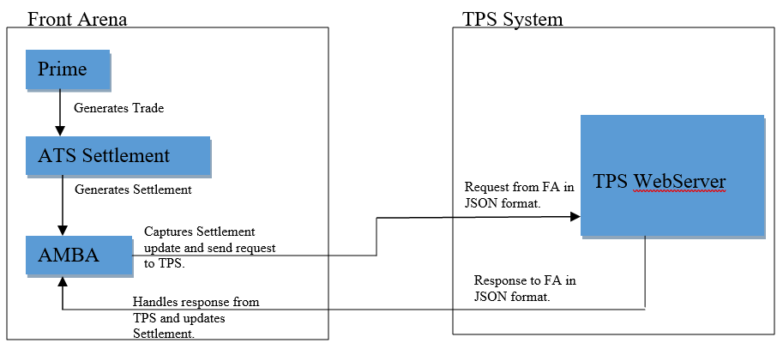

### TECHNICAL FLOW DIAGRAM

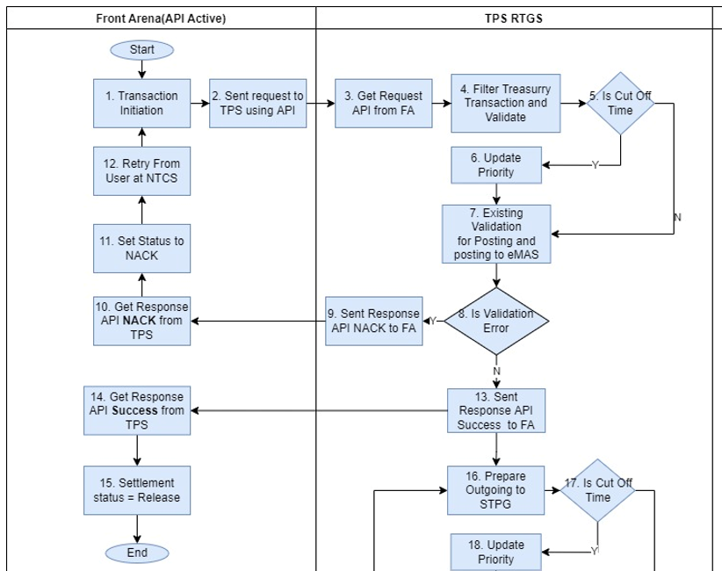

### LOGIC AND CONFIGURATION

#### Flow Logic

1. User generates trade in FrontArena using Prime application.

Once the trade has been approved by various groups, its status is changed to BO-BO Confirmed.

1. Once the status of the trade is changed to BO-BO Confirmed, settlement is generated on the trade. The settlement is released using Operation Manager in Prime.
2. The module PS_TPSOutRTGS is used to process the request and response from TPS service. The AMBA hook provides an entry point for the module.
3. Once the settlement is Released, the PS_TPSOutRTGS module will check if the settlement is eligible to send to TPS and send the settlement records JSON format using TPS published web API.

The following eligibility criteria if evaluated.

Settlement eligibility criteria:

Settlement counterparty network should be RTGS

Settlement status should be Released.

Additional information field – SentToTPS, should be blank.

To indicate If the settlement is already sent or not:

1. Already sent, field value is “1”.
2. Not sent, field value is empty.
3. Once the response from the TPS server is received the AdditionalInfo *SentToTPS* is set.
4. If required, the user can trigger the process again, by using the task GUI *TPSOutSettlements.* All the settlements that have not been processed will be sent to TPS server again.
5. When the transaction is facing to "Bank Indonesia" with IDR currency through BI-RTGS/BI-SSSS, for several condition Bank Indonesia will be active to execute in payment system and the settlement will not be released. The task *AutoReleaseSettlements* will control the automatic release of settlement. The following query will be used to hold the settlements from releasing automatically.

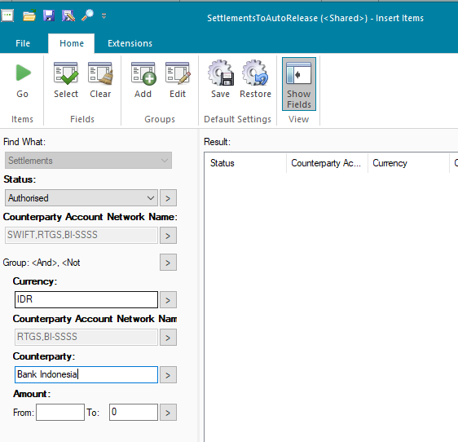

#### Configuration

|  |  |
| --- | --- |
| Delivery Items | |
| Extension Context | +Integration |
| Extension Module | PS_TPSOutRTGS |
| AMBA service | AMBA_EMAS |
|  |  |
|  |  |
| FA Component | |
| AMBA | AMBA service – AMBA_EMAS is used to capture settlements with released status and send the request to TPS web service. |
|  |  |
|  |  |
| Deployment and Manual Configuration | |
| This service is deployed through FA standard deployment process.  Manual configuration may be required to update the configuration in FParameter in extension module. | |
|  |  |
| Additional Information | |
| SentToTPS | AdditionalInfo on Settlement. |
| FParameters | Default values |
| BranchOfTrxn | 99120 |
| CUID | NTC |
| DefaultTellerId | 9925505 |
| LogFilename | TPSOutSettlementLog_{}.txt |
| SettlementFilter | TPSSettlementOutRTGS  This parameter is used to filter the settlements which are eligible for sending to TPS. |
| SuspenseAccount | ALL AKUN SUSPEND TRANSAKSI TREASURY |
| Timeout | 30 |
| TTC_AccountMap | {'330': {'From': ['GWM Mandiri'], 'To': ['BI FAST Mandiri']}, '331': {'From': ['BI FAST Mandiri'], 'To': ['GWM Mandiri']}}  This map maintains the relation between TTC to Account name |
| Url | http://10.243.229.160:9443/opfrest/webapi/rtgs/channel |
| OrderCustName | BMRI - Treasury Operations |
| Pre-requisites |  |
| Query Folder | Query folder with name specified in Parameters, must be available, so that program can extract trades through that query folder. |
| AMBA service | AMBA service for this interface must be running to work this interface. |
| FStoredASQLQuery | Purpose |
| TPSSettlementOutRTGS | Filter specifying the eligible settlements. |

#### Data Dictionary

Following are field mapping done for this interface.

Document - TTC FINAL_Revisi1.9 (Transaction Type Code mapped with product)



#### A Data Model

Please refer AEF Browser document for details about Front Arena Data Model.

Document - FCA4033

#### B Data Entity and Key Elements Definition

All required details are available in AEF Browser document.

#### C Reference Code Table Definition

This section contains any future changes about any additional database.

### SECURITY AND CONTROL DESIGN

#### Security Requirement Response

|  |  |  |
| --- | --- | --- |
| **Security Domain** | **Security Requirement** | **Response** |
| User Management | The system must identify users using a unique user identification code before allowing a log-on. | It will be controlled through CDCA application |
| The system must suspend access to a user session after a specified interval of inactivity. | Inactivity of user session will not be applicable  as the integration is in Realtime |
| The system must require user authentication before re-enabling the session. | It will be controlled through CDCA application |
| The system must display a warning message indicating that only authorized use is permitted before allowing users to perform a log-on. | It will be controlled through CDCA application |
| The system must display system information to a user, only after a successful log-on. |  |
| After a successful log-on, the system must display information concerning the previous successful attempt to perform a log-on. | It will not be possible in real-time connections. |
| The system must allow a user account to be manually disabled. | NA |
| The system must disable the user account following 3 (three) consecutive failures to perform a successful log-on. | It will be controlled through CDCA application |
| The system must automatically disable the user account following a configurable period (90 days) without use. |  |
| Password Management | The system must authenticate users using a password before allowing access to any system functions. | Not applicable at Front Arena Database side. |
| The system must ensure that passwords used by system users for log-on consist of at least 8 (eight) characters. | Not applicable at Front Arena Database side. |
| The system must enforce the use of complex passwords for all users. (Aplhanumieric & Special Characters) | Not applicable at Front Arena Database side. |
| The system must use cryptographic techniques to protect the confidentiality of user authentication data during transmission. | Not applicable at Front Arena Database side. |
| The system must enforce a password change when a password is first issued or re-issued. |  |
| The system must allow system users to change the password used for log-on. | Not applicable at Front Arena Database side. |
| The system must ensure that passwords do not remain valid for more than 90 (ninety) days. | Not applicable at Front Arena Database side. |
| The system must ensure that passwords may not be changed to any of the last 5 (five) passwords used. | Not applicable at Front Arena Database side. |
| The system must ensure that passwords are not displayed in clear text during entry. | Not applicable at Front Arena Database side. |
| Multi Factor Authentication | The system must enforce dual factor authentication of all users (system that related to financial, faced to customer directly & only use for external purposes) | Not applicable at Front Arena Database side. |
| Data Storage | The system must use cryptographic techniques to protect the storage of authentication data. | NA |
| The system must use cryptographic techniques to protect the integrity of stored critical data. | NA |
| The system must use cryptographic techniques to protect the confidentiality of stored sensitive data. | NA |
| Logging | The system must support the recording of security events in one or multiple specific security event logs. 2 weeks in minimum must be available at the Production Environment | It will be controlled through CDCA application |
| The system must include the Logical Account identity, event type and timestamp in each entry in the security event logs. | It will be controlled through CDCA application |
| The system must record when each security event lo fills to a configurable limit. | It will be controlled through CDCA application |
| The system must protect the integrity of the information in the security event logs | It will be controlled through CDCA application |
| The system must allow access to the security event logs to be limited to the authorised security staff. | It will be controlled through CDCA application |
| The system must record if the integrity of the security event logs is compromised | NA |
| The system must record all instances that system event logs are cleared. | It will be controlled through CDCA application |
| The system must record when a change is made to the system log settings (e.g. logs for certain events are turned off). | It will be controlled through CDCA application |
| The system must record when any system security policy is modified. | NA |
| The system must record all creations of Logical Accounts. | It will be controlled through CDCA application |
| The system must record all deletions of Logical Accounts. |  |
| The system must record all de-activation of Logical Accounts. |  |
| The system must record all unsuccessful attempts to log-on to the system using invalid credentials. |  |
| The system must record all successful attempts to log-on to the system. |  |
| The system must record all successful and unsuccessful attempts to change passwords. |  |
| The system must automatically build and maintain a normal usage pattern for each Logical Account. |  |
| The system must record all activation of disabled Logical Accounts. |  |
| The system must record all attempts to change any account attribute affecting authentication of the Logical Account |  |
| The system must record all allocations of system access rights. |  |
| The system must record all removals of system access rights. |  |
| The system must record all unauthorised attempts to access a system function. |  |
| The system must record when a configurable deviation from a Logical Account's normal pattern is detected. |  |
| The system must record all failures of the check on the timestamp of payment and settlement orders. |  |
| The system must record all attempts to mutually authenticate interface connections that handle critical data |  |
| The system must record all events that may indicate an attempt to cause denial of service. |  |
| The system must record all access to functions processing critical information within the system. |  |
| The system must record all access to sensitive information within the system. |  |
| The system must record all start-up and shut down events. |  |
| The system must have been integrated in the SIEM, Identity Management System & Privilege Identity Management System |  |
| Remote Access | The system logical access control mechanism must be able to discretely grant remote access capability to specific users and user groups. |  |
| The system must strictly limit user access rights to their minimum requirements when they access the system remotely. |  |
| All relevant approvals must be obtained if this application is to be made available for remote use (E.g. on the RCA-portal) by Users |  |
| System Interfaces | The system must use a logical access control mechanism to control system to system data communications, in order to avoid anonymous data transfers (for all interfaces) |  |
| The system must ensure that system to system mutual authentication takes place before data communications are allowed (for all interfaces) |  |
| System to system mutual authentication must be based on cryptographic techniques (for all interfaces) |  |
| The system must use cryptographic techniques to protect the integrity of critical data during transmission (for all interfaces) |  |
| The system must use cryptographic techniques to protect the confidentiality of sensitive data during transmission (for all interfaces) |  |
| All 'critical data' must have been identified, documented and approved by the Business |  |
| All 'confidential data' must have been identified, documented and approved by the Business |  |
| Availability | The system must have a documented and successfully tested disaster recovery plan in place | It will be managed through Front Arena Database DR setup. |
| The system must enforce quotas limiting the maximum resources that an individual user can use simultaneously. |  |
| The system must provide adequate resources to support the required number of users or concurrent users. |  |
| The system should have a documented capacity monitoring process in-place with regular reporting on its use |  |
| Security Testing | The system must be tested for specific technical security flaws where it faces the public internet, prior to release into production. |  |
| The system must only be released into production, where it faces the public internet, once all identified key findings from the security test have been rectified, or if this is not possible, the risks must be formally reviewed and signed off |  |
| The system must be tested for specific technical security flaws prior to release into production. |  |
| The system must only be released into production once all the identified key findings from the security tests have been rectified or if this is not possible, the risks must be formally reviewed and signed off |  |

#### Preventive controls

*<This sub-section describe the technical specification for preventive controls that are specific to this module. This includes logical access control, physical security control, encryption, PIN generation and validation, etc>*

*<Sample of list of Role Table and Authorization Matrix>*

|  |  |  |  |
| --- | --- | --- | --- |
| **No** | **Role** | **Authorization** | **Object** |
| 1 | Role1 | ZXXXX | Maintain |
| 2 | Role2 | ZYYYY | Display |
| 3 |  |  |  |

|  |  |  |  |  |  |  |
| --- | --- | --- | --- | --- | --- | --- |
| **No** | **User Group** | **Role1** | **Role2** | **Role3** | **Role4** | **Role5** |
| 1 | User Group1 | X | X |  | X |  |
| 2 | User Group2 |  | X | X |  | X |
|  |  |  |  |  |  |  |

#### Detective controls

*<This sub-section describe the technical specification for detective controls that are specific to this module. This includes audit trail, exception reports, reconciliation, balancing & control totals, validations, etc>.*

#### Corrective controls

*<This sub-section describes the technical specification for corrective controls that are specific to this module. This includes automated error corrections, backup, recovery & restart, etc>.*

### USER INTERFACE

If required, the user can trigger the process, by using the task GUI *TPSOutSettlements.* All the settlements that have not been processed will be sent to TPS server again.

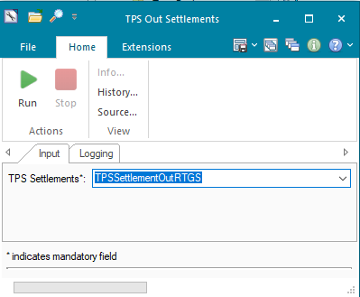

### OPERATING SPECIFICATION

The connection from FrontArena to TPS is web-based URL. This connection is real time connection, and the request and response are interchanged in a synchronous manner.

1. The user will generate the settlements and release it.
2. The script will process all the eligible settlements based on the predefined query.
3. The settlement request in the JSON format will be sent to the Webserver.
4. Webserver send the response the script in FrontArena updates the settlement.

The following filter query will be used

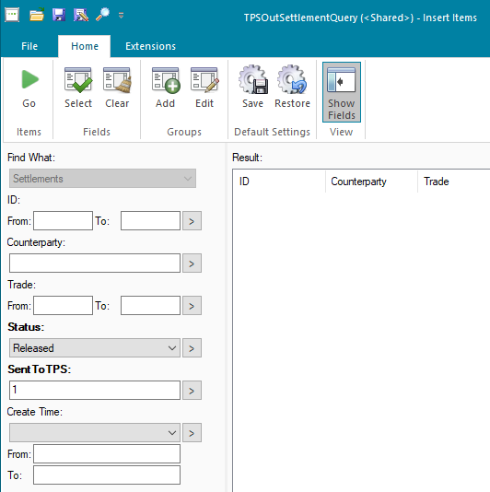

Following additional information will be used.

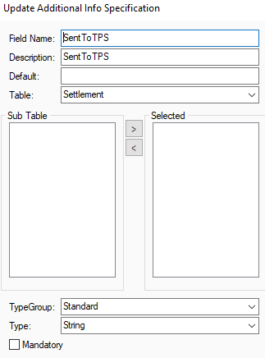

## TPS – Nostro GL Records

### DESCRIPTION

|  |  |  |  |
| --- | --- | --- | --- |
| **Interface name** | TPS - Nostro GL Records | | |
| **Type of data** | Nostro transaction Records | **Frequency** | Batch |
| **Source** | TPS | **Direction** | IN |
| **Format** | File | **Transfer mechanism** | Shared location |
| **Response Required** | N/A | **Dependencies on other processes** |  |
| **Purpose** | Posting GL record to FA and MT950 Reconciliation | | |

TPS will send nostro transaction records to Front Arena. FA will create standalone payment, so that it can be sent to IRS Citynet system via MT950

### TECHNICAL ATTRIBUTE

|  |  |
| --- | --- |
| **Attribute** | **Description** |
| Extension Module | PS_TPSNostroGL  *It contains code required to read the file and generate the standalone payment.* |

### TECHNICAL ARCHITECTURE

TPS

Front Arena

Standalone

Payments

GL account matching with Acquirer Account

### TECHNICAL FLOW DIAGRAM

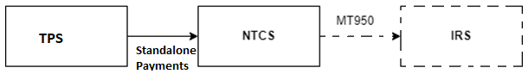

### LOGIC AND CONFIGURATION

#### Flow Logic

1. Script reads the TPS file having Nostro GL records.
2. Identifies the record having Non-Suspense GL Account.
3. For this record, if the GL account matches with the Account of the Acquirer, settlement is created.
4. Type of settlement will be ‘Stand Alone Payment’.
5. The settlement status is set to ‘Pending Closure’.
6. The Account for this settlement is the one which has matching GL Account in the file record.
7. This payment will have counterparty as TPS, which is assigned in the FParameters.
8. The Acquirer is assigned in the FParameters.

#### Configuration

|  |  |
| --- | --- |
| Delivery Items | |
| Extension Context | +Integration |
| Extension Module | PS_TPSNostroGL |
|  |  |
| FA Component | |
| ATS | The ATS can be installed and configured for this interface manually. The ATS is not include in the standard configuration, delivered through deployment process. |
|  |  |
| Deployment and Manual Configuration | |
| The task is deployed through FA standard deployment process.  Manual configuration may be required to update the configuration in FParameter and task GUI in extension module. | |
|  |  |
| Additional Information | |
| No Additional information field is used in this service. | |
|  |  |
| Scheduling the task | |
| The AEL Task can be scheduled by opening the task using the context menu “Open with -> Task Management”. Enter a new schedule and save it create task schedule object. The name of the task can then be used to run it via ATS. | |
|  | |
| AEL GUI Task | |
| Task Name | TPS_Nostro_GL |
| FParameters | Default values |
| acquirer | Acquirer 1 |
| counterparty | TPS |
| suspense_account_list | 12240 |
| Pre-requisites |  |
| ATS service | If the ATS service is configured for this interface it must be running to run this interface. |

#### Data Dictionary

Please refer attached Data Mapping file and sample input file



Following are field mapping done for this interface.

#### A Data Model

Please refer AEF Browser document for details about Front Arena Data Model.

Document - FCA4033

#### B Data Entity and Key Elements Definition

All required details are available in AEF Browser document.

#### C Reference Code Table Definition

Please refer AEF Browser document for details about Front Arena Data Model.

Document - FCA4033

### SECURITY AND CONTROL DESIGN

#### Security Requirement Response

|  |  |  |
| --- | --- | --- |
| **Security Domain** | **Security Requirement** | **Response** |
| User Management | The system must identify users using a unique user identification code before allowing a log-on. | It will be controlled through CDCA application |
| The system must suspend access to a user session after a specified interval of inactivity. | Inactivity of user session will not be applicable  as the integration is in Realtime |
| The system must require user authentication before re-enabling the session. | It will be controlled through CDCA application |
| The system must display a warning message indicating that only authorized use is permitted before allowing users to perform a log-on. | It will be controlled through CDCA application |
| The system must display system information to a user, only after a successful log-on. |  |
| After a successful log-on, the system must display information concerning the previous successful attempt to perform a log-on. | It will not be possible in real-time connections. |
| The system must allow a user account to be manually disabled. | NA |
| The system must disable the user account following 3 (three) consecutive failures to perform a successful log-on. | It will be controlled through CDCA application |
| The system must automatically disable the user account following a configurable period (90 days) without use. |  |
| Password Management | The system must authenticate users using a password before allowing access to any system functions. | Not applicable at Front Arena Database side. |
| The system must ensure that passwords used by system users for log-on consist of at least 8 (eight) characters. | Not applicable at Front Arena Database side. |
| The system must enforce the use of complex passwords for all users. (Aplhanumieric & Special Characters) | Not applicable at Front Arena Database side. |
| The system must use cryptographic techniques to protect the confidentiality of user authentication data during transmission. | Not applicable at Front Arena Database side. |
| The system must enforce a password change when a password is first issued or re-issued. |  |
| The system must allow system users to change the password used for log-on. | Not applicable at Front Arena Database side. |
| The system must ensure that passwords do not remain valid for more than 90 (ninety) days. | Not applicable at Front Arena Database side. |
| The system must ensure that passwords may not be changed to any of the last 5 (five) passwords used. | Not applicable at Front Arena Database side. |
| The system must ensure that passwords are not displayed in clear text during entry. | Not applicable at Front Arena Database side. |
| Multi Factor Authentication | The system must enforce dual factor authentication of all users (system that related to financial, faced to customer directly & only use for external purposes) | Not applicable at Front Arena Database side. |
| Data Storage | The system must use cryptographic techniques to protect the storage of authentication data. | NA |
| The system must use cryptographic techniques to protect the integrity of stored critical data. | NA |
| The system must use cryptographic techniques to protect the confidentiality of stored sensitive data. | NA |
| Logging | The system must support the recording of security events in one or multiple specific security event logs. 2 weeks in minimum must be available at the Production Environment | It will be controlled through CDCA application |
| The system must include the Logical Account identity, event type and timestamp in each entry in the security event logs. | It will be controlled through CDCA application |
| The system must record when each security event lo fills to a configurable limit. | It will be controlled through CDCA application |
| The system must protect the integrity of the information in the security event logs | It will be controlled through CDCA application |
| The system must allow access to the security event logs to be limited to the authorised security staff. | It will be controlled through CDCA application |
| The system must record if the integrity of the security event logs is compromised | NA |
| The system must record all instances that system event logs are cleared. | It will be controlled through CDCA application |
| The system must record when a change is made to the system log settings (e.g. logs for certain events are turned off). | It will be controlled through CDCA application |
| The system must record when any system security policy is modified. | NA |
| The system must record all creations of Logical Accounts. | It will be controlled through CDCA application |
| The system must record all deletions of Logical Accounts. |  |
| The system must record all de-activation of Logical Accounts. |  |
| The system must record all unsuccessful attempts to log-on to the system using invalid credentials. |  |
| The system must record all successful attempts to log-on to the system. |  |
| The system must record all successful and unsuccessful attempts to change passwords. |  |
| The system must automatically build and maintain a normal usage pattern for each Logical Account. |  |
| The system must record all activation of disabled Logical Accounts. |  |
| The system must record all attempts to change any account attribute affecting authentication of the Logical Account |  |
| The system must record all allocations of system access rights. |  |
| The system must record all removals of system access rights. |  |
| The system must record all unauthorised attempts to access a system function. |  |
| The system must record when a configurable deviation from a Logical Account's normal pattern is detected. |  |
| The system must record all failures of the check on the timestamp of payment and settlement orders. |  |
| The system must record all attempts to mutually authenticate interface connections that handle critical data |  |
| The system must record all events that may indicate an attempt to cause denial of service. |  |
| The system must record all access to functions processing critical information within the system. |  |
| The system must record all access to sensitive information within the system. |  |
| The system must record all start-up and shut down events. |  |
| The system must have been integrated in the SIEM, Identity Management System & Privilege Identity Management System |  |
| Remote Access | The system logical access control mechanism must be able to discretely grant remote access capability to specific users and user groups. |  |
| The system must strictly limit user access rights to their minimum requirements when they access the system remotely. |  |
| All relevant approvals must be obtained if this application is to be made available for remote use (E.g. on the RCA-portal) by Users |  |
| System Interfaces | The system must use a logical access control mechanism to control system to system data communications, in order to avoid anonymous data transfers (for all interfaces) |  |
| The system must ensure that system to system mutual authentication takes place before data communications are allowed (for all interfaces) |  |
| System to system mutual authentication must be based on cryptographic techniques (for all interfaces) |  |
| The system must use cryptographic techniques to protect the integrity of critical data during transmission (for all interfaces) |  |
| The system must use cryptographic techniques to protect the confidentiality of sensitive data during transmission (for all interfaces) |  |
| All 'critical data' must have been identified, documented and approved by the Business |  |
| All 'confidential data' must have been identified, documented and approved by the Business |  |
| Availability | The system must have a documented and successfully tested disaster recovery plan in place | It will be managed through Front Arena Database DR setup. |
| The system must enforce quotas limiting the maximum resources that an individual user can use simultaneously. |  |
| The system must provide adequate resources to support the required number of users or concurrent users. |  |
| The system should have a documented capacity monitoring process in-place with regular reporting on its use |  |
| Security Testing | The system must be tested for specific technical security flaws where it faces the public internet, prior to release into production. |  |
| The system must only be released into production, where it faces the public internet, once all identified key findings from the security test have been rectified, or if this is not possible, the risks must be formally reviewed and signed off |  |
| The system must be tested for specific technical security flaws prior to release into production. |  |
| The system must only be released into production once all the identified key findings from the security tests have been rectified or if this is not possible, the risks must be formally reviewed and signed off |  |

#### Preventive controls

*<This sub-section describe the technical specification for preventive controls that are specific to this module. This includes logical access control, physical security control, encryption, PIN generation and validation, etc>*

*<Sample of list of Role Table and Authorization Matrix>*

|  |  |  |  |
| --- | --- | --- | --- |
| **No** | **Role** | **Authorization** | **Object** |
| 1 | Role1 | ZXXXX | Maintain |
| 2 | Role2 | ZYYYY | Display |
| 3 |  |  |  |

|  |  |  |  |  |  |  |
| --- | --- | --- | --- | --- | --- | --- |
| **No** | **User Group** | **Role1** | **Role2** | **Role3** | **Role4** | **Role5** |
| 1 | User Group1 | X | X |  | X |  |
| 2 | User Group2 |  | X | X |  | X |
|  |  |  |  |  |  |  |

#### Detective controls

*<This sub-section describe the technical specification for detective controls that are specific to this module. This includes audit trail, exception reports, reconciliation, balancing & control totals, validations, etc>.*

#### Corrective controls

*<This sub-section describe the technical specification for corrective controls that are specific to this module. This includes automated error corrections, backup, recovery & restart, etc>.*

### USER INTERFACE

If required, the user can trigger the process again, by using the task GUI *TPS Nostro GL.* All the files that have not been processed will be processed now.

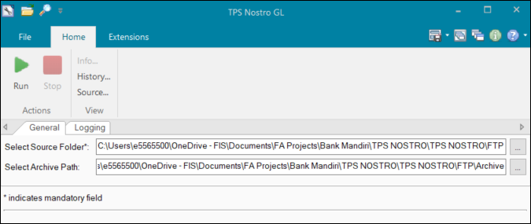

### OPERATING SPECIFICATION

1. Files from TPS system will be available at specified shared location.
2. Script will be developed to read the detailed file to get Nostro transactions.
3. That script will create standalone payments in FA from each valid record available in file where the midas account from GL record matches with the add info on the Acquirer account
4. Keep the source name in Counterparty field. Party will be created with name of surrounding system (e.g. BPS, TPS, TPS)

Sample input shared folder for TPS Nostro GL file processing

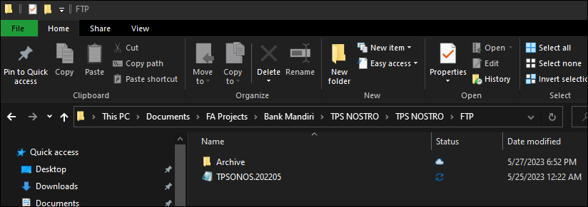

Run task GUI



Settlement records samples after task run

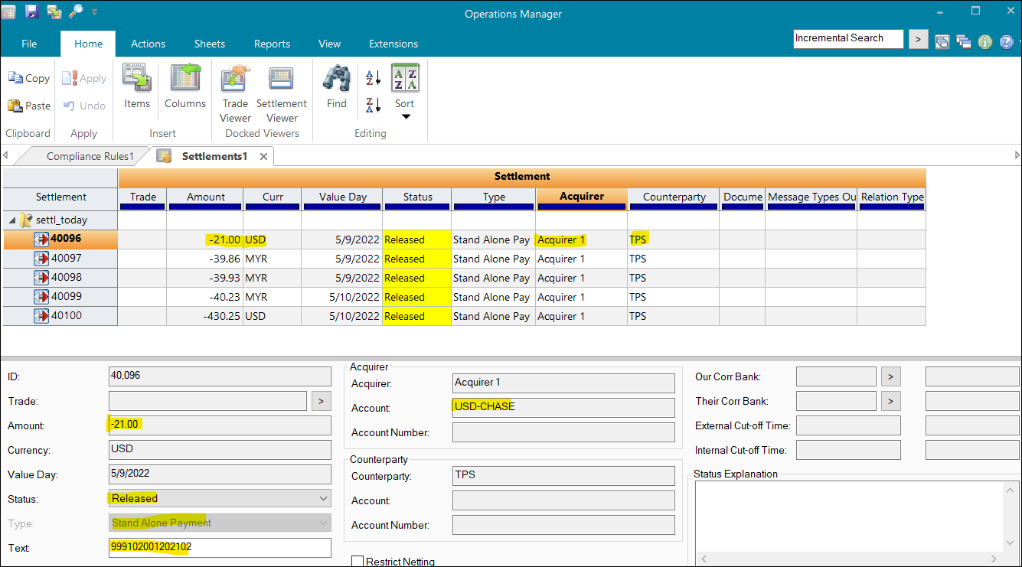

File Archived at mentioned location

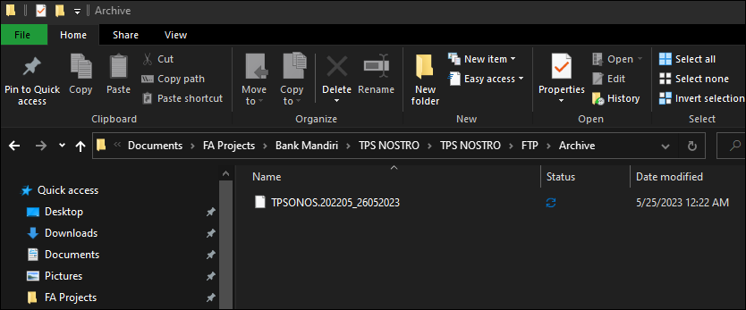

## TPS – OUT - Settlements – Status Inquiry

### DESCRIPTION

|  |  |  |  |
| --- | --- | --- | --- |
| **Interface name** | **TPS - OUT – Settlement – Status Inquiry** | | |
| **Type of data** | Settlement | **Frequency** | Batch |
| **Source** | FA | **Direction** | OUT/IN |
| **Format** | Query | **Transfer mechanism** | Database connection |
| **Response Required** | N/A | **Dependencies on other processes** | DB Connection details |
| **Purpose** | After sending settlement information to TPS, FA need to inquiry about the settlement status. FA will inquiry the status in TPS to update FA settlement status | | |

Front Arena will connect to TPS database to inquiry about status of settlement. Based on the query to TPS database, FA settlement will be changed to ACK if query result is success only, otherwise FA settlement status remain unchanged. The settlements which are already Released and sent to TPS will be considered to TPS status inquiry process. FA task will be created to capture desired set of settlements to do inquiry with TPS, at specific intervals.

Settlement selection criteria:

• Status - Released

• Additional information – SentToTPS

Already sent, field value is “1”.

Not sent, field value is empty.

### TECHNICAL ATTRIBUTE

|  |  |
| --- | --- |
| **Attribute** | **Description** |
| Extension Module | PS_TPSOutSettlementStatusInquiry  *It contains code required to perform Settlement status inquiry.* |
| ATS | ATS_TPS_INQUIRY  *ATS service configured to run the task of settlement status inquiry.* |

### TECHNICAL ARCHITECTURE

Please refer following workflow for more details -

**FrontArena TPS System**

Connects and runs query on TPS DB

ATS_TPS_INQUIRY

TPS

Database

Updates the Settlement to Acknowledged with the response.

### TECHNICAL FLOW DIAGRAM

The following diagram shows the technical flow of the interface.

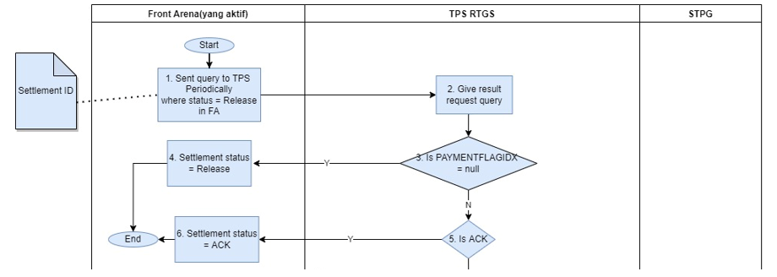

### LOGIC AND CONFIGURATION

#### Flow Logic

1. Script will be created to get settlements status by querying TPS database.

The script connects to the database specified in the FParameters.

1. The settlement status is updated with Acknowledged status, if the result of the query contains an ACK, otherwise the settlement status is left unchanged.
2. The ATS_TPS_INQUIRY runs a scheduled task ‘TPSOutSettlementQuery’ every 5 minutes. This task run the script to inquire the settlement status.

#### Configuration

|  |  |
| --- | --- |
| Delivery Items | |
| Extension Context | +Integration |
| Extension Module | PS_TPSOutSettlementStatusInquiry |
| ATS service | ATS_TPS_INQUIRY |
|  |  |
| FA Component | |
| ATS | ATS service – ATS_TPS_INQUIRY is used to run the task that connects to the database and updates the settlement status. |
| Deployment and Manual Configuration | |
| This service is deployed through FA standard deployment process.  Manual configuration may be required to update the configuration in FParameter in extension module. | |
|  |  |
| Additional Information | |
| No Additional information field is used in this service. | |
| FASQLQuery | |
| Query Name | TPSOutSettlementQuery |
| FParameters | Default values |
| DATABASE | BM_TPS_Settlement |
| DRIVER | ODBC Driver 17 for SQL Server |
| PWD | Complex55Password |
| SERVER | MSSQLSERVER01 |
| UID | sa |
| TaskSchedule |  |
| TPSOutSettlementQuery | Scheduled task. Any changes to timings can be done here. |
| Task |  |
| TPSOutSettlementQuery | Task that runs the script to connect to DB and update settlement status. |
| Pre-requisites |  |
| Query Folder | Query folder with name specified in task, must be available, so that program can extract trades through that query folder. |
| ATS service | ATS service for this interface must be running to work this interface. |

#### Data Dictionary

|  |  |
| --- | --- |
| Parameter Name | Description |
| TTADMIN.PAYMENTTRANSACTION. PAYMENTFLAGIDX | Database table attribute |

#### A Data Model

Please refer AEF Browser document for details about Front Arena Data Model.

Document - FCA4033

#### B Data Entity and Key Elements Definition

|  |  |
| --- | --- |
| Parameter Name | Description |
| TTADMIN.PAYMENTTRANSACTION. PAYMENTFLAGIDX | FSettlement status is mapped to this value. |

#### C Reference Code Table Definition

*NA*

### SECURITY AND CONTROL DESIGN

#### Security Requirement Response

|  |  |  |
| --- | --- | --- |
| **Security Domain** | **Security Requirement** | **Response** |
| User Management | The system must identify users using a unique user identification code before allowing a log-on. | It will be controlled through HTTPS protocol and Certificate  and Key file for web API call. |
| The system must suspend access to a user session after a specified interval of inactivity. | Inactivity of user session will not be applicable  as the integration is in Realtime |
| The system must require user authentication before re-enabling the session. | It will be controlled through HTTPS protocol and Certificate  and Key file for web API call. |
| The system must display a warning message indicating that only authorised use is permitted before allowing users to perform a log-on. | It will display standard HTTPS error. |
| The system must display system information to a user, only after a successful log-on. | This interface will run in back ground in realtime, so workflow  Details will be available in service log file. |
| After a successful log-on, the system must display information concerning the previous successful attempt to perform a log-on. | It will not be possible in real-time connections/ Integration. |
| The system must allow a user account to be manually disabled. | NA |
| The system must disable the user account following 3 (three) consecutive failures to perform a successful log-on. | It can be controlled through certificate files. But it is not required  For such type of integration |
| The system must automatically disable the user account following a configurable period (90 days) without use. |  |
| Password Management | The system must authenticate users using a password before allowing access to any system functions. | Not applicable at Front Arena Database side. |
| The system must ensure that passwords used by system users for log-on consist of at least 8 (eight) characters. | Not applicable at Front Arena Database side. |
| The system must enforce the use of complex passwords for all users. (Aplhanumieric & Special Characters) | Not applicable at Front Arena Database side. |
| The system must use cryptographic techniques to protect the confidentiality of user authentication data during transmission. | Not applicable at Front Arena Database side. |
| The system must enforce a password change when a password is first issued or re-issued. |  |
| The system must allow system users to change the password used for log-on. | Not applicable at Front Arena Database side. |
| The system must ensure that passwords do not remain valid for more than 90 (ninety) days. | Not applicable at Front Arena Database side. |
| The system must ensure that passwords may not be changed to any of the last 5 (five) passwords used. | Not applicable at Front Arena Database side. |
| The system must ensure that passwords are not displayed in clear text during entry. | Not applicable at Front Arena Database side. |
| Multi Factor Authentication | The system must enforce dual factor authentication of all users (system that related to financial, faced to customer directly & only use for external purposes) | Not applicable at Front Arena Database side. |
| Data Storage | The system must use cryptographic techniques to protect the storage of authentication data. | NA |
| The system must use cryptographic techniques to protect the integrity of stored critical data. | NA |
| The system must use cryptographic techniques to protect the confidentiality of stored sensitive data. | NA |
| Logging | The system must support the recording of security events in one or multiple specific security event logs. 2 weeks in minimum must be available at the Production Environment | It can be managed through service log details. |
| The system must include the Logical Account identity, event type and timestamp in each entry in the security event logs. | It can be managed through service log details. |
| The system must record when each security event lo fills to a configurable limit. | It can be managed through service log details. |
| The system must protect the integrity of the information in the security event logs | It can be managed through service log details. |
| The system must allow access to the security event logs to be limited to the authorised security staff. | NA |
| The system must record if the integrity of the security event logs is compromised | NA |
| The system must record all instances that system event logs are cleared. | It can be managed through service log details. |
| The system must record when a change is made to the system log settings (e.g. logs for certain events are turned off). | It can be managed through service log details. |
| The system must record when any system security policy is modified. | NA |
| The system must record all creations of Logical Accounts. | NA |
| The system must record all deletions of Logical Accounts. |  |
| The system must record all de-activation of Logical Accounts. |  |
| The system must record all unsuccessful attempts to log-on to the system using invalid credentials. |  |
| The system must record all successful attempts to log-on to the system. |  |
| The system must record all successful and unsuccessful attempts to change passwords. |  |
| The system must automatically build and maintain a normal usage pattern for each Logical Account. |  |
| The system must record all activation of disabled Logical Accounts. |  |
| The system must record all attempts to change any account attribute affecting authentication of the Logical Account |  |
| The system must record all allocations of system access rights. |  |
| The system must record all removals of system access rights. |  |
| The system must record all unauthorised attempts to access a system function. |  |
| The system must record when a configurable deviation from a Logical Account's normal pattern is detected. |  |
| The system must record all failures of the check on the timestamp of payment and settlement orders. |  |
| The system must record all attempts to mutually authenticate interface connections that handle critical data |  |
| The system must record all events that may indicate an attempt to cause denial of service. |  |
| The system must record all access to functions processing critical information within the system. |  |
| The system must record all access to sensitive information within the system. |  |
| The system must record all start-up and shut down events. |  |
| The system must have been integrated in the SIEM, Identity Management System & Privilege Identity Management System |  |
| Remote Access | The system logical access control mechanism must be able to discretely grant remote access capability to specific users and user groups. |  |
| The system must strictly limit user access rights to their minimum requirements when they access the system remotely. |  |
| All relevant approvals must be obtained if this application is to be made available for remote use (E.g. on the RCA-portal) by Users |  |
| System Interfaces | The system must use a logical access control mechanism to control system to system data communications, in order to avoid anonymous data transfers (for all interfaces) |  |
| The system must ensure that system to system mutual authentication takes place before data communications are allowed (for all interfaces) |  |
| System to system mutual authentication must be based on cryptographic techniques (for all interfaces) |  |
| The system must use cryptographic techniques to protect the integrity of critical data during transmission (for all interfaces) |  |
| The system must use cryptographic techniques to protect the confidentiality of sensitive data during transmission (for all interfaces) |  |
| All 'critical data' must have been identified, documented and approved by the Business |  |
| All 'confidential data' must have been identified, documented and approved by the Business |  |
| Availability | The system must have a documented and successfully tested disaster recovery plan in place | It will be managed through Front Arena Database DR setup. |
| The system must enforce quotas limiting the maximum resources that an individual user can use simultaneously. |  |
| The system must provide adequate resources to support the required number of users or concurrent users. |  |
| The system should have a documented capacity monitoring process in-place with regular reporting on its use |  |
| Security Testing | The system must be tested for specific technical security flaws where it faces the public internet, prior to release into production. |  |
| The system must only be released into production, where it faces the public internet, once all identified key findings from the security test have been rectified, or if this is not possible, the risks must be formally reviewed and signed off |  |
| The system must be tested for specific technical security flaws prior to release into production. |  |
| The system must only be released into production once all the identified key findings from the security tests have been rectified or if this is not possible, the risks must be formally reviewed and signed off |  |

#### Preventive controls

Front Arena User management process will ensure the code/ Extension Editor will be accessible for specific user group (e.g. Admin group).

The service will be running on server so it has access to authorized users only.

#### Detective controls

Detective and Investigation process need to be controlled through the service log details. For this integration there will be separate log file to track the interface workflow. Any error or exception details will be available in respective service log on server.

#### Corrective controls

As per of the functionality, the status of respective service will be displayed to user in form of Additional information field in Front Arena. Based on status details user can take corrective action manually at SmartFX side to resend the request.

### USER INTERFACE

If required, the user can trigger the process, by using the task GUI TPSOutSettlementQuery. All the settlements that have not been processed will be processed again.

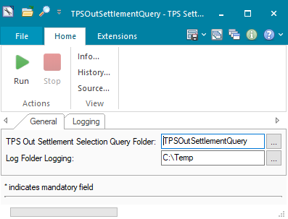

### OPERATING SPECIFICATION

1. The connection between FrontArena and TPS is based on the database table SQL query.
2. The ATS ATS_TPS_INQUIRY executes the task TPSOutSettlementQuery periodically.
3. The task executes the following query to extract the result from the database table.

SELECT ptrc.PAYMENTFLAGIDX FROM TTADMIN.PAYMENTTRANSACTION ptrc WHERE ptrc.SETTLEMENTREFERENCEIDX={settl.Oid()}

1. Start the following ATS. The ATS will run the task TPSOutSettlementQuery periodically.

If the status flag in TPS database is ACK, settlement in FrontArena is set to Acknowledged, else it is left unchanged.



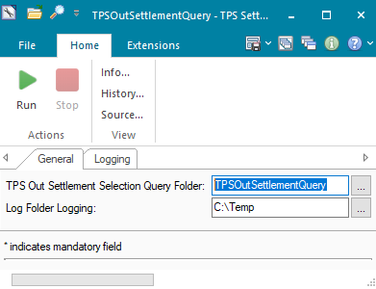



Following filter query is used to find eligible settlement to initiate the inquiry.

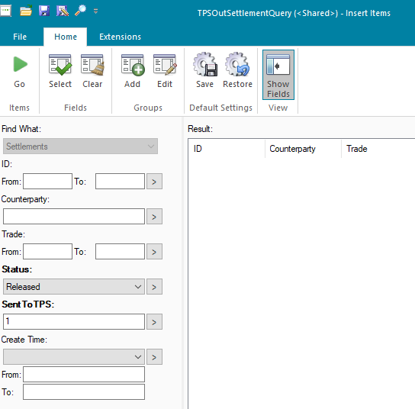

## Communication

*<This section provides the communication line that will be used in this system>*

### New / Existing*) system *) choose one

|  |  |  |  |  |  |  |  |  |  |
| --- | --- | --- | --- | --- | --- | --- | --- | --- | --- |
| **NO** | **NEW / SURROUNDING SYSTEM** | **HOSTNAME SOURCE** | **IP SOURCE** | **PORT SOURCE** | **HOSTNAME DESTINATION** | **IP DESTINATION** | **PORT DESTINATION** | **PROTOCOL (TCP /UDP /ICMP)** | **ALLOW / DENY** |
| 1 | *<new / surrounding status>* | *<isi nama host source>* | *<isi IP source>* | *<isi port source>* | *<isi nama host destination>* | *<isi IP destination>* | *<isi port destination>* | *<isi protocol>* | *<allow / deny status>* |
| 2 |  |  |  |  |  |  |  |  |  |
| 3 |  |  |  |  |  |  |  |  |  |
| 4 |  |  |  |  |  |  |  |  |  |
| 5 |  |  |  |  |  |  |  |  |  |
| 6 |  |  |  |  |  |  |  |  |  |
| 7 |  |  |  |  |  |  |  |  |  |
| 8 |  |  |  |  |  |  |  |  |  |
| … |  | … | … | … | … | … |  | … | … |

*< For a new developed system, if there are some undefined hostnames/ ip addresses/ ports yet, then should be written with* ***TBC*** *notes and will be completely defined in SDN contract review form >*

*< For an existing system and surrounding, please define and write its hostnames/ ip addresses/ ports >*

## OTHERS

*<This section provides other technical specifications that have not been address in previous section>.*

# **WEBEAI**

## 1. DESCRIPTION

|  |  |  |  |
| --- | --- | --- | --- |
| Interface name | WebEAI | | |
| Type of data | FA Transaction and Settlement | Frequency | Realtime/Batch |
| Source | FA | Direction | OUT |
| Format | N/A | Transfer mechanism | Staginf |
| Response Required | N/A | Dependencies on other processes | N/A |
| Purpose | Feed Front Arena data to Web EAI application for reporting purpose | | |

WEBEAI is an application used as middleware to communicate with surrounding systems, also this application is used for reporting and monitoring purposes.

Front Arena scripts are created to extract required data programmatically and store it in intermediate / staging databases tables for each WebEAI module listed below –

|  |  |  |
| --- | --- | --- |
| No | Module WEB EAI | Mode |
| 1 | Posisi Devisa Netto (PDN) | Realtime |
| 2 | Monitoring GWM | Realtime |
| 3 | Liquidity Monitoring | Realtime |
| 4 | GWM AVERGAE VALAS | Realtime |
| 5 | TREASURY MONITORING SYSTEM (TMS) | Realtime |
| 6 | SISMONTAVAR | Realtime |

From above module, Transaction data is needed for the creation of dashboard monitoring & reporting in Web EAI.

Notes: Transaction data are trades, instrument, MTM (PNL) (if required), Exercise (if required), Cash flow (if required), and Fixing (if  required)

* + 1. Posisi Devisa Netto (Net Open Position) this module will provide net open position data to user. It will use all transaction data for the purpose of reporting. Those data will be FX today, FX Tomorrow, FX Spot, FX Forward, FX Option, DCI, Call Spread, Par Forward, FX Commodity (Bank Notes). All transaction sends to EAI every 10 until 20 minutes.
    2. Monitoring GWM (Rupiah Reserve Requirement) this module will provide data to calculate reserve requirement and provide supporting data for regulatory reporting. It will use transaction data for the purpose of reporting. Those data will be Fixed Income, all FX Transaction & Money Market with their respective status. The transaction data will be taken for IDR and All Foreign Currency.  All transaction will send real-time.
    3. Liquidity Monitoring is module to provide data for the Bank to manage liquidity. will use transaction data for Fixed income, Bonds, Money Market, Repo, Reverse Repo Transaction, FX today, FX Tomorrow, FX Spot, FX Forward, Swap, and Nostro Transaction, this transaction is main to use IDR & Foreign Currency.  All transaction will send real-time.
    4. GWM Average Valas will use trades data and instrument for the purpose of monitoring and reporting. Those data will all SBBI USD product in Bank Mandiri, and Credit and Debit of Nostro Account Mandiri Bank & Central Bank of Indonesia. All transaction sends to EAI within 10 until 20 minutes.
    5. Treasury Monitoring is the module to provide data for the dashboard monitoring the FX transaction. It will use transaction data for the purpose of dashboard monitoring and reporting. The data will be FX today, FX Tom, FX Forward, FX Option, Fix Income, CCS, IRS, Deposit Swap, DCI, Call Spread, Par Forward, FX Commodity (Bank Notes), Money Market, and Derivative. All transaction will send real-time.
    6. Sismontavar is the module to provide FX Data reporting to regulator. It will send all trades data and instrument for All Non-Bank FX Transaction (FX Today, FX Tom, FX Spot, FX Swap, FX Forward), CCS, DNDF,NDF, Par Forward, Bank Notes Transaction.  All transaction will send real-time.
    7. Customer information party general, party broker, and portfolios for EAI monitoring & reporting above.

## 2. TECHNICAL ATTRIBUTE

|  |  |
| --- | --- |
| **Attribute** | **Description** |
| Extension Module | ICT_WEBEAIStagingDB  *It contains code required to transfer the data from Front Arena to Staging DB* |
| ATS | ATS_WEBEAI  *ATS is configured to schedule the tasks which helps in data transfer from Front Arena to staging DB.* |

## 3. TECHNICAL ARCHITECTURE

The connection between WebEAI and FA is database to database integration using CDC Agent, the interface is for extract data from FA to WebEAI.

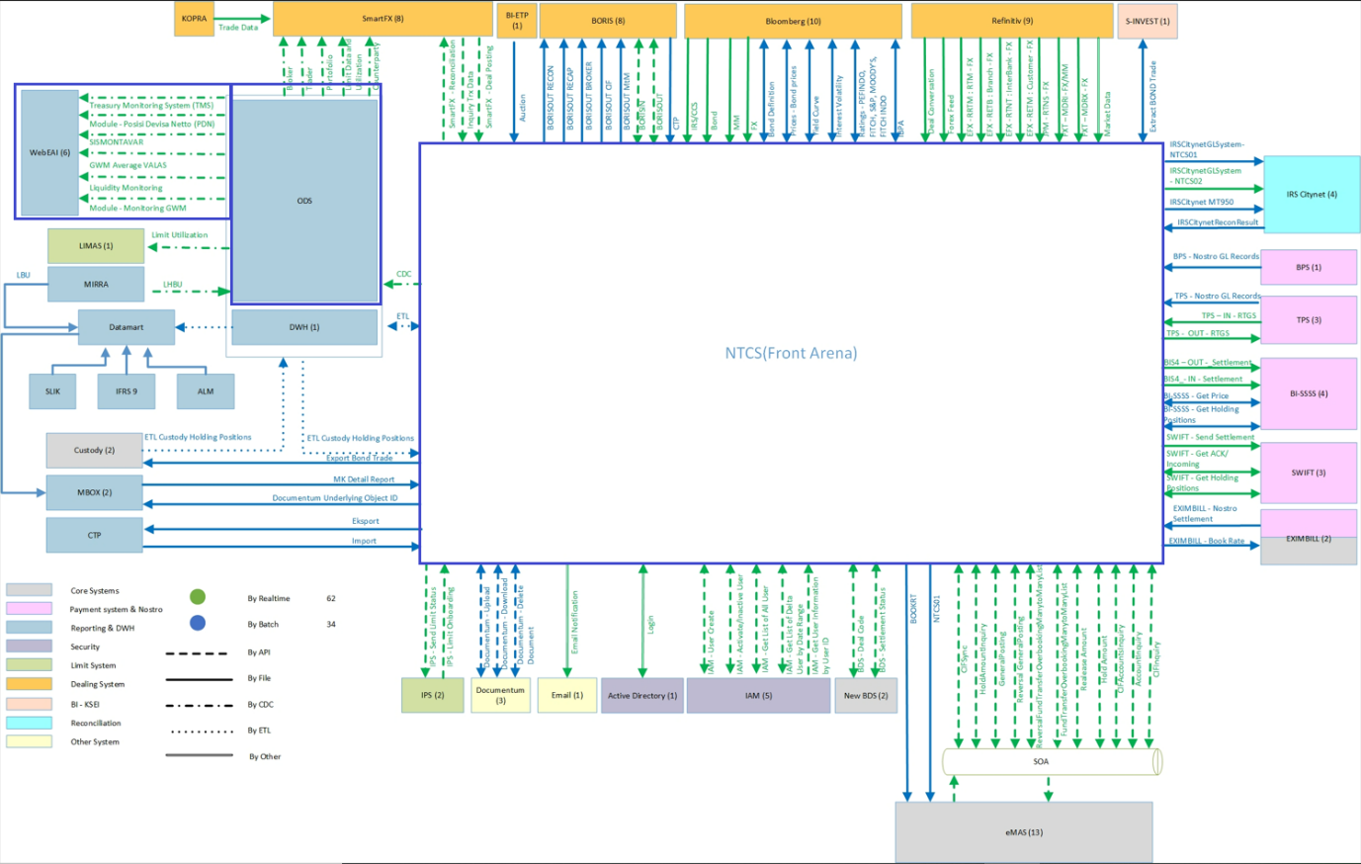

## TECHNICAL FLOW DIAGRAM

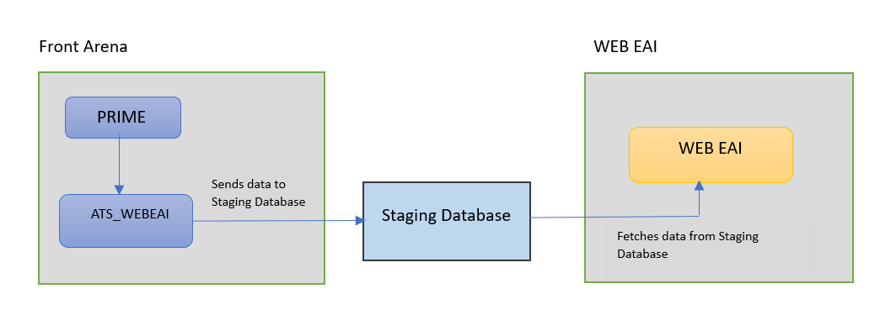

## 5. LOGIC AND CONFIGURATION

### Flow Logic

1.Firstly, a Staging Database is created using SQL script.

2. According to the data objects various tasks are created in Front Arena.

3. Those tasks are scheduled using ATS which feed data from Front Arena to Staging database tables according to their object types.

### 5.2 Configuration

|  |  |
| --- | --- |
| Delivery Items | |
| Extension Context | +Integrations |
| Extension Module | ICT_WEBEAIStagingDB |
|  |  |
| FA Component | |
| ATS | ATS Service – ATS_WEBEAI is configured to schedule the tasks which helps in data transfer from Front Arena to Staging Database. |
|  |  |
|  |  |
| Deployment and Manual Configuration | |
| This service is deployed through FA standard deployment process.  Manual configuration may be required to update the configuration in FParameter in extension module. | |
|  |  |
| FParameters | Default values |
| DB_NAME | WEBEAI_DB_STAGING |
| DRIVER | {SQL Server} |
|  | 9925505 |
| PASSWORD | ### |
| PORT | 1433 |
| SERVER_NAME | localhost |
| USER | sa |
| Pre-requisites |  |
| Query Folder | Query folder with name specified in Parameters, must be available, so that program can extract trades through that query folder. |

### 5.3 Data Dictionary

Following are field mapping done for this interface.

Document - INITIAL DATA WEBEAI_1.0_120922  
  


### 5.3.A Data Model

Please refer AEF Browser document for details about Front Arena Data Model.

Document - FCA4033

### 5.3.B Data Entity and Key Elements Definition

All required details are available in AEF Browser document.

### 5.3.C Reference Code Table Definition

*<This sub-section describes the reference code tables and the codes within each table. Only describes those reference code tables that affect the users>.*

*Template is the same as 5.3.B*

## 6. SECURITY AND CONTROL DESIGN

### 6.1 Security Requirement Response

|  |  |  |
| --- | --- | --- |
| **Security Domain** | **Security Requirement** | **Response** |
| User Management | The system must identify users using a unique user identification code before allowing a log-on. | It will be controlled through CDCA application |
| The system must suspend access to a user session after a specified interval of inactivity. | Inactivity of user session will not be applicable  as the integration is in Realtime |
| The system must require user authentication before re-enabling the session. | It will be controlled through CDCA application |
| The system must display a warning message indicating that only authorised use is permitted before allowing users to perform a log-on. | It will be controlled through CDCA application |
| The system must display system information to a user, only after a successful log-on. |  |
| After a successful log-on, the system must display information concerning the previous successful attempt to perform a log-on. | It will not be possible in real-time connections. |
| The system must allow a user account to be manually disabled. | NA |
| The system must disable the user account following 3 (three) consecutive failures to perform a successful log-on. | It will be controlled through CDCA application |
| The system must automatically disable the user account following a configurable period (90 days) without use. |  |
| Password Management | The system must authenticate users using a password before allowing access to any system functions. | Not applicable at Front Arena Database side. |
| The system must ensure that passwords used by system users for log-on consist of at least 8 (eight) characters. | Not applicable at Front Arena Database side. |
| The system must enforce the use of complex passwords for all users. (Aplhanumieric & Special Characters) | Not applicable at Front Arena Database side. |
| The system must use cryptographic techniques to protect the confidentiality of user authentication data during transmission. | Not applicable at Front Arena Database side. |
| The system must enforce a password change when a password is first issued or re-issued. |  |
| The system must allow system users to change the password used for log-on. | Not applicable at Front Arena Database side. |
| The system must ensure that passwords do not remain valid for more than 90 (ninety) days. | Not applicable at Front Arena Database side. |
| The system must ensure that passwords may not be changed to any of the last 5 (five) passwords used. | Not applicable at Front Arena Database side. |
| The system must ensure that passwords are not displayed in clear text during entry. | Not applicable at Front Arena Database side. |
| Multi Factor Authentication | The system must enforce dual factor authentication of all users (system that related to financial, faced to customer directly & only use for external purposes) | Not applicable at Front Arena Database side. |
| Data Storage | The system must use cryptographic techniques to protect the storage of authentication data. | NA |
| The system must use cryptographic techniques to protect the integrity of stored critical data. | NA |
| The system must use cryptographic techniques to protect the confidentiality of stored sensitive data. | NA |
| Logging | The system must support the recording of security events in one or multiple specific security event logs. 2 weeks in minimum must be available at the Production Environment | It will be controlled through CDCA application |
| The system must include the Logical Account identity, event type and timestamp in each entry in the security event logs. | It will be controlled through CDCA application |
| The system must record when each security event lo fills to a configurable limit. | It will be controlled through CDCA application |
| The system must protect the integrity of the information in the security event logs | It will be controlled through CDCA application |
| The system must allow access to the security event logs to be limited to the authorised security staff. | It will be controlled through CDCA application |
| The system must record if the integrity of the security event logs is compromised | NA |
| The system must record all instances that system event logs are cleared. | It will be controlled through CDCA application |
| The system must record when a change is made to the system log settings (e.g. logs for certain events are turned off). | It will be controlled through CDCA application |
| The system must record when any system security policy is modified. | NA |
| The system must record all creations of Logical Accounts. | It will be controlled through CDCA application |
| The system must record all deletions of Logical Accounts. |  |
| The system must record all de-activation of Logical Accounts. |  |
| The system must record all unsuccessful attempts to log-on to the system using invalid credentials. |  |
| The system must record all successful attempts to log-on to the system. |  |
| The system must record all successful and unsuccessful attempts to change passwords. |  |
| The system must automatically build and maintain a normal usage pattern for each Logical Account. |  |
| The system must record all activation of disabled Logical Accounts. |  |
| The system must record all attempts to change any account attribute affecting authentication of the Logical Account |  |
| The system must record all allocations of system access rights. |  |
| The system must record all removals of system access rights. |  |
| The system must record all unauthorised attempts to access a system function. |  |
| The system must record when a configurable deviation from a Logical Account's normal pattern is detected. |  |
| The system must record all failures of the check on the timestamp of payment and settlement orders. |  |
| The system must record all attempts to mutually authenticate interface connections that handle critical data |  |
| The system must record all events that may indicate an attempt to cause denial of service. |  |
| The system must record all access to functions processing critical information within the system. |  |
| The system must record all access to sensitive information within the system. |  |
| The system must record all start-up and shut down events. |  |
| The system must have been integrated in the SIEM, Identity Management System & Privilege Identity Management System |  |
| Remote Access | The system logical access control mechanism must be able to discretely grant remote access capability to specific users and user groups. |  |
| The system must strictly limit user access rights to their minimum requirements when they access the system remotely. |  |
| All relevant approvals must be obtained if this application is to be made available for remote use (E.g. on the RCA-portal) by Users |  |
| System Interfaces | The system must use a logical access control mechanism to control system to system data communications, in order to avoid anonymous data transfers (for all interfaces) |  |
| The system must ensure that system to system mutual authentication takes place before data communications are allowed (for all interfaces) |  |
| System to system mutual authentication must be based on cryptographic techniques (for all interfaces) |  |
| The system must use cryptographic techniques to protect the integrity of critical data during transmission (for all interfaces) |  |
| The system must use cryptographic techniques to protect the confidentiality of sensitive data during transmission (for all interfaces) |  |
| All 'critical data' must have been identified, documented and approved by the Business |  |
| All 'confidential data' must have been identified, documented and approved by the Business |  |
| Availability | The system must have a documented and successfully tested disaster recovery plan in place | It will be managed through Front Arena Database DR setup. |
| The system must enforce quotas limiting the maximum resources that an individual user can use simultaneously. |  |
| The system must provide adequate resources to support the required number of users or concurrent users. |  |
| The system should have a documented capacity monitoring process in-place with regular reporting on its use |  |
| Security Testing | The system must be tested for specific technical security flaws where it faces the public internet, prior to release into production. |  |
| The system must only be released into production, where it faces the public internet, once all identified key findings from the security test have been rectified, or if this is not possible, the risks must be formally reviewed and signed off |  |
| The system must be tested for specific technical security flaws prior to release into production. |  |
| The system must only be released into production once all the identified key findings from the security tests have been rectified or if this is not possible, the risks must be formally reviewed and signed off |  |

### 6.2 Preventive controls

*<This sub-section describe the technical specification for preventive controls that are specific to this module. This includes logical access control, physical security control, encryption, PIN generation and validation, etc>*

*<Sample of list of Role Table and Authorization Matrix>*

|  |  |  |  |
| --- | --- | --- | --- |
| **No** | **Role** | **Authorization** | **Object** |
| 1 | Role1 | ZXXXX | Maintain |
| 2 | Role2 | ZYYYY | Display |
| 3 |  |  |  |

|  |  |  |  |  |  |  |
| --- | --- | --- | --- | --- | --- | --- |
| **No** | **User Group** | **Role1** | **Role2** | **Role3** | **Role4** | **Role5** |
| 1 | User Group1 | X | X |  | X |  |
| 2 | User Group2 |  | X | X |  | X |
|  |  |  |  |  |  |  |

### 6.3 Detective controls

*<This sub-section describe the technical specification for detective controls that are specific to this module. This includes audit trail, exception reports, reconciliation, balancing & control totals, validations, etc>.*

### 6.4 Corrective controls

*<This sub-section describe the technical specification for corrective controls that are specific to this module. This includes automated error corrections, backup, recovery & restart, etc>.*

## 7. USER INTERFACE

If required, the user can trigger the processes, by using the tasks GUI

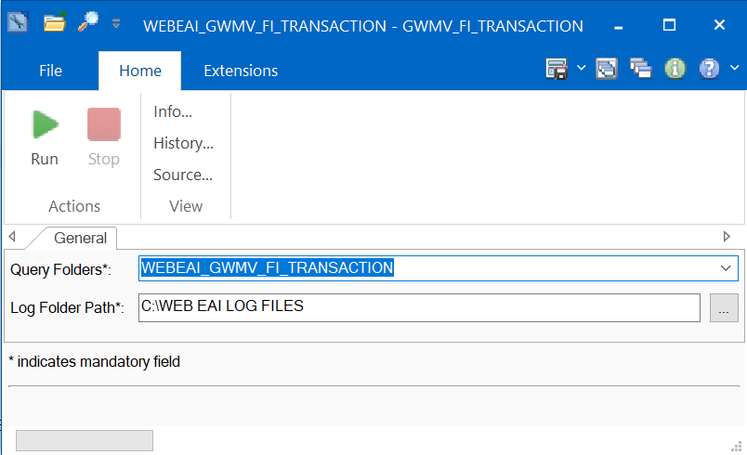

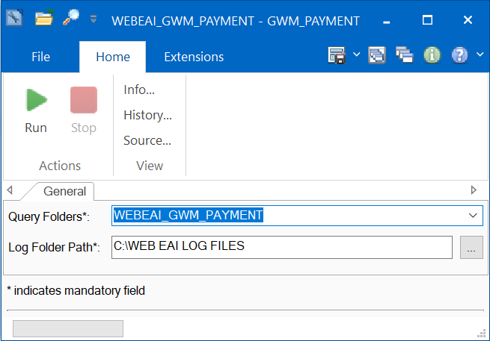

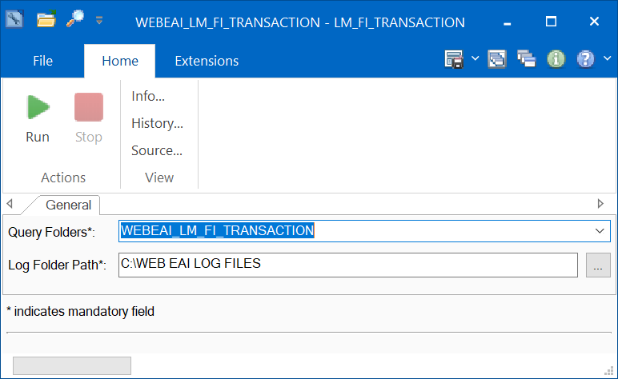

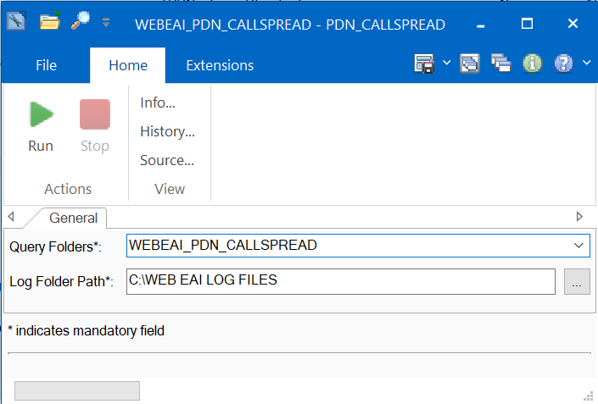

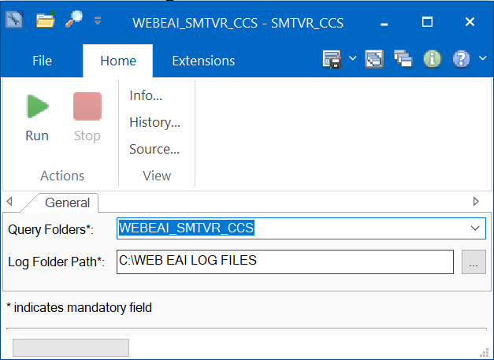

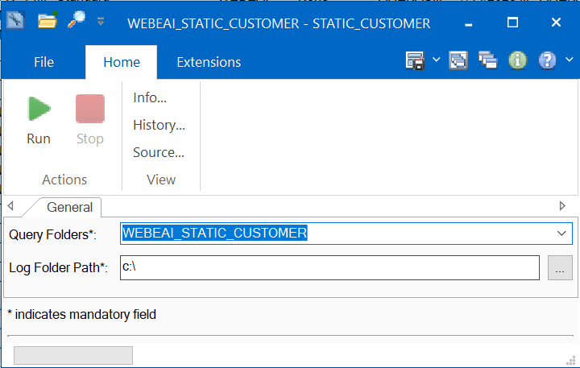

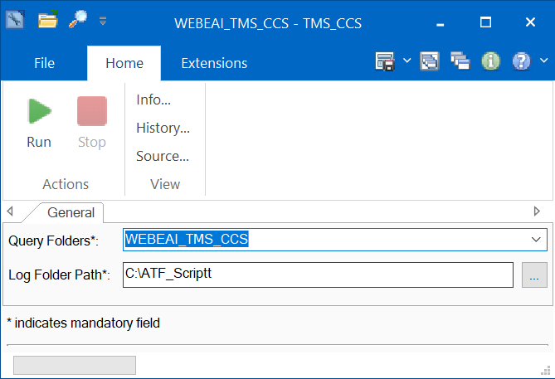

## 8. OPERATING SPECIFICATION

The following Query Folders will be used

|  |  |
| --- | --- |
| No | Query Folder names |
| 1 | WEBEAI_GWMV_FI_TRANSACTION |
| 2 | WEBEAI_GWM_PAYMENT |
| 3 | WEBEAI_LM_FI_TRANSACTION |
| 4 | WEBEAI_PDN_CALLSPREAD |
| 5 | WEBEAI_SMTVR_CCS |
| 6 | WEBEAI_STATIC_CUSTOMER |
| 7 | WEBEAI_TMS_CCS |

## REPORTING

### 9.1 Inventory of Reports

*<This sub-section provides a list of operational reports relevant to this module. It is assumed that MIS/EIS module will produce the executive management and regulatory related reports>.*

*<Sample of report definition>*

|  |  |  |
| --- | --- | --- |
| **No** | **Report Name** | **Description** |
|  |  | <Description> |
|  |  |  |

*<if there is data integrity checking requirement, please provide any additional supporting information>.*

### 9.2 Report layout and definition

*<This sub-section describes each of the reports in the inventory list. Report Layout and It’s selection screen must be drawn clearly in this subsection>*

*<Sample of Selection Screen:>*

Selection Field 1

Selection Field 2

to

*<Sample of Report Layout>*

**Report Title**

Report Header

LOGO

Report Footer

Page No.

**Column1**

**Column2**

**Column3**

**Column4**

**Column5**

**Column6**

**Total1**

## Communication

*<This section provides the communication line that will be used in this system>*

### New / Existing*) system *) choose one

|  |  |  |  |  |  |  |  |  |  |
| --- | --- | --- | --- | --- | --- | --- | --- | --- | --- |
| **NO** | **NEW / SURROUNDING SYSTEM** | **HOSTNAME SOURCE** | **IP SOURCE** | **PORT SOURCE** | **HOSTNAME DESTINATION** | **IP DESTINATION** | **PORT DESTINATION** | **PROTOCOL (TCP /UDP /ICMP)** | **ALLOW / DENY** |
| 1 | *<new / surrounding status>* | *<isi nama host source>* | *<isi IP source>* | *<isi port source>* | *<isi nama host destination>* | *<isi IP destination>* | *<isi port destination>* | *<isi protocol>* | *<allow / deny status>* |
| 2 |  |  |  |  |  |  |  |  |  |
| 3 |  |  |  |  |  |  |  |  |  |
| 4 |  |  |  |  |  |  |  |  |  |
| 5 |  |  |  |  |  |  |  |  |  |
| 6 |  |  |  |  |  |  |  |  |  |
| 7 |  |  |  |  |  |  |  |  |  |
| 8 |  |  |  |  |  |  |  |  |  |
| … |  | … | … | … | … | … |  | … | … |

*< For a new developed system, if there are some undefined hostnames/ ip addresses/ ports yet, then should be written with* ***TBC*** *notes and will be completely defined in SDN contract review form >*

*< For an existing system and surrounding, please define and write its hostnames/ ip addresses/ ports >*

## OTHERS

*<This section provides other technical specifications that have not been address in previous section>.*

## Appendix



# DOCUMENTUM

## DESCRIPTION

|  |  |  |  |
| --- | --- | --- | --- |
| **Interface name** | Documentum | | |
| **Type of data** | Document | **Frequency** | On demand |
| **Source** | FA | **Direction** | OUT |
| **Format** | JSON | **Transfer mechanism** | WebAPI |
| **Response Required** | Yes | **Dependencies on other processes** |  |
| **Purpose** | To Upload, Download, and Delete the documents from trade GUI | | |

Users need to store extra information related to trades. User can upload the document using custom GUI available in FA- Document Viewer panel.

Users need to select the document type and click on Upload button to select the document and upload it to Documentum system, using web APIs of Documentum system. On successful upload of document, Documentum system returns ObjectId of that document. Object Id will be stored in FA at respective trade level. Same document ObjectId and document type will be responded to MBOX interface as per of the MBOX interface workflow.

Following functionality will be provided:

Upload

View (Using browser)

Delete

After uploading document to Documentum system, object id should be extracted from response message and store it in FA at trade level.

Object Id storage convention: <Document Name>_<Document Type>_<Object Id>

**Note – Document type here will refer to the file type.**

**Upload document type**

* Underlying
* Deal Ticket
* Agreement
* Conversation
* Others

**Note – Please don’t use ‘_’ character in document type and keep folder name same as document type.**

## TECHNICAL ATTRIBUTE

|  |  |
| --- | --- |
| **Attribute** | **Description** |
| Extension Module | PS_Documentum |

## TECHNICAL ARCHITECTURE

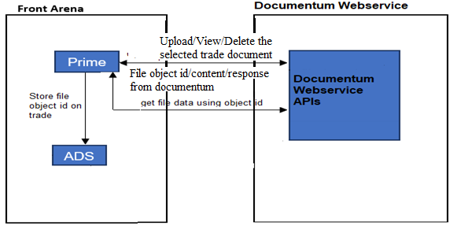

## TECHNICAL FLOW DIAGRAM

NA

## LOGIC AND CONFIGURATION

### Flow Logic

* 1. Users will open the trade window and open the saved trade. To upload the trade document user will click Tools->Panes->Document Viewer Panel.
  2. User should select Document Type and click upload to upload the document. One the document is uploaded to Documentum then the document details will be added to the Trade Documents List.
  3. Trade document section will list the documents already linked to the trade. So, user can select the document and perform Delete/Download operation.

### Configuration

|  |  |
| --- | --- |
| Delivery Items | |
| Extension Context | +Integrations |
| Extension Module | PS_Documentum |
|  |  |
| FA Component | |
| PRIME | PRIME Trade UI |
|  |  |
| Deployment and Manual Configuration | |
| This service is deployed through FA standard deployment process.  Manual configuration is required to set document type folder id from documentum. The folder id for the specific document type should be updated in the choice list manually. Also, Documentum configuration details needs to be updated in **DocumentViewerParam.** | |
|  |  |
| Additional Information | |
| No Add info fields are used. | |
| FParameters | Default values |
| **DocumentViewerParam** | |
| AUTH_PASS | Authorisation password for Documentum |
| AUTH_USER | Authorisation username for Documentum (admin_ntcs) |
| BASE_URL | https://10.243.249.22:443/dctm-rest/repositories/MANDIRI_UAT_REPO |
| CERT_PATH | C:\Users\AdminNTCS\Desktop\Team\Shital\10.243.249.22.documentum.crt |
| DOWNLOAD_DIRECTORY | c:\temp |
| FONT | Consolas |
| FONT_SIZE | 8 |
| MAX_PREVIEW_LENGTH | 999 |
|  |  |
| Pre-requisites |  |
| Pre-requisite | Documentum WEBAPI connection credentials should be properly specified in parameters and the Choice list DocumentumDocType needs to be updated with folder object id for each document type. |
|  |  |
| FStoredASQLQuery |  |
| No FStoredASQLQuery is used. | |

### Data Dictionary

NA

### A Data Model

Documentum server object id of the document is stored as extension object on trade

in FA, using FCustomTextObject object and its corresponding table.

Please refer AEF Browser document for details about Front Arena Data Model.

Document - FCA4033

### B Data Entity and Key Elements Definition

All required details are available in AEF Browser document.

### C Reference Code Table Definition

Please refer AEF Browser document for details about Front Arena Data Model.

Document - FCA4033

## SECURITY AND CONTROL DESIGN

### Security Requirement Response

|  |  |  |
| --- | --- | --- |
| Security Domain | Security Requirement | Response |
| User Management | The system must identify users using a unique user identification code before allowing a log-on. | It will be controlled through CDCA application |
| The system must suspend access to a user session after a specified interval of inactivity. | Inactivity of user session will not be applicable  as the integration is in Realtime |
| The system must require user authentication before re-enabling the session. | It will be controlled through CDCA application |
| The system must display a warning message indicating that only authorized use is permitted before allowing users to perform a log-on. | It will be controlled through CDCA application |
| The system must display system information to a user, only after a successful log-on. |  |
| After a successful log-on, the system must display information concerning the previous successful attempt to perform a log-on. | It will not be possible in real-time connections. |
| The system must allow a user account to be manually disabled. | NA |
| The system must disable the user account following 3 (three) consecutive failures to perform a successful log-on. | It will be controlled through CDCA application |
| The system must automatically disable the user account following a configurable period (90 days) without use. |  |
| Password Management | The system must authenticate users using a password before allowing access to any system functions. | Not applicable at Front Arena Database side. |
| The system must ensure that passwords used by system users for log-on consist of at least 8 (eight) characters. | Not applicable at Front Arena Database side. |
| The system must enforce the use of complex passwords for all users. (Aplhanumieric & Special Characters) | Not applicable at Front Arena Database side. |
| The system must use cryptographic techniques to protect the confidentiality of user authentication data during transmission. | Not applicable at Front Arena Database side. |
| The system must enforce a password change when a password is first issued or re-issued. |  |
| The system must allow system users to change the password used for log-on. | Not applicable at Front Arena Database side. |
| The system must ensure that passwords do not remain valid for more than 90 (ninety) days. | Not applicable at Front Arena Database side. |
| The system must ensure that passwords may not be changed to any of the last 5 (five) passwords used. | Not applicable at Front Arena Database side. |
| The system must ensure that passwords are not displayed in clear text during entry. | Not applicable at Front Arena Database side. |
| Multi Factor Authentication | The system must enforce dual factor authentication of all users (system that related to financial, faced to customer directly & only use for external purposes) | Not applicable at Front Arena Database side. |
| Data Storage | The system must use cryptographic techniques to protect the storage of authentication data. | NA |
| The system must use cryptographic techniques to protect the integrity of stored critical data. | NA |
| The system must use cryptographic techniques to protect the confidentiality of stored sensitive data. | NA |
| Logging | The system must support the recording of security events in one or multiple specific security event logs. 2 weeks in minimum must be available at the Production Environment | It will be controlled through CDCA application |
| The system must include the Logical Account identity, event type and timestamp in each entry in the security event logs. | It will be controlled through CDCA application |
| The system must record when each security event lo fills to a configurable limit. | It will be controlled through CDCA application |
| The system must protect the integrity of the information in the security event logs | It will be controlled through CDCA application |
| The system must allow access to the security event logs to be limited to the authorised security staff. | It will be controlled through CDCA application |
| The system must record if the integrity of the security event logs is compromised | NA |
| The system must record all instances that system event logs are cleared. | It will be controlled through CDCA application |
| The system must record when a change is made to the system log settings (e.g. logs for certain events are turned off). | It will be controlled through CDCA application |
| The system must record when any system security policy is modified. | NA |
| The system must record all creations of Logical Accounts. | It will be controlled through CDCA application |
| The system must record all deletions of Logical Accounts. |  |
| The system must record all de-activation of Logical Accounts. |  |
| The system must record all unsuccessful attempts to log-on to the system using invalid credentials. |  |
| The system must record all successful attempts to log-on to the system. |  |
| The system must record all successful and unsuccessful attempts to change passwords. |  |
| The system must automatically build and maintain a normal usage pattern for each Logical Account. |  |
| The system must record all activation of disabled Logical Accounts. |  |
| The system must record all attempts to change any account attribute affecting authentication of the Logical Account |  |
| The system must record all allocations of system access rights. |  |
| The system must record all removals of system access rights. |  |
| The system must record all unauthorised attempts to access a system function. |  |
| The system must record when a configurable deviation from a Logical Account's normal pattern is detected. |  |
| The system must record all failures of the check on the timestamp of payment and settlement orders. |  |
| The system must record all attempts to mutually authenticate interface connections that handle critical data |  |
| The system must record all events that may indicate an attempt to cause denial of service. |  |
| The system must record all access to functions processing critical information within the system. |  |
| The system must record all access to sensitive information within the system. |  |
| The system must record all start-up and shut down events. |  |
| The system must have been integrated in the SIEM, Identity Management System & Privilege Identity Management System |  |
| Remote Access | The system logical access control mechanism must be able to discretely grant remote access capability to specific users and user groups. |  |
| The system must strictly limit user access rights to their minimum requirements when they access the system remotely. |  |
| All relevant approvals must be obtained if this application is to be made available for remote use (E.g. on the RCA-portal) by Users |  |
| System Interfaces | The system must use a logical access control mechanism to control system to system data communications, in order to avoid anonymous data transfers (for all interfaces) |  |
| The system must ensure that system to system mutual authentication takes place before data communications are allowed (for all interfaces) |  |
| System to system mutual authentication must be based on cryptographic techniques (for all interfaces) |  |
| The system must use cryptographic techniques to protect the integrity of critical data during transmission (for all interfaces) |  |
| The system must use cryptographic techniques to protect the confidentiality of sensitive data during transmission (for all interfaces) |  |
| All 'critical data' must have been identified, documented and approved by the Business |  |
| All 'confidential data' must have been identified, documented and approved by the Business |  |
| Availability | The system must have a documented and successfully tested disaster recovery plan in place | It will be managed through Front Arena Database DR setup. |
| The system must enforce quotas limiting the maximum resources that an individual user can use simultaneously. |  |
| The system must provide adequate resources to support the required number of users or concurrent users. |  |
| The system should have a documented capacity monitoring process in-place with regular reporting on its use |  |
| Security Testing | The system must be tested for specific technical security flaws where it faces the public internet, prior to release into production. |  |
| The system must only be released into production, where it faces the public internet, once all identified key findings from the security test have been rectified, or if this is not possible, the risks must be formally reviewed and signed off |  |
| The system must be tested for specific technical security flaws prior to release into production. |  |
| The system must only be released into production once all the identified key findings from the security tests have been rectified or if this is not possible, the risks must be formally reviewed and signed off |  |

### Preventive controls

<This sub-section describe the technical specification for preventive controls that are specific to this module. This includes logical access control, physical security control, encryption, PIN generation and validation, etc>

<Sample of list of Role Table and Authorization Matrix>

|  |  |  |  |
| --- | --- | --- | --- |
| No | Role | Authorization | Object |
| 1 | Role1 | ZXXXX | Maintain |
| 2 | Role2 | ZYYYY | Display |
| 3 |  |  |  |

|  |  |  |  |  |  |  |
| --- | --- | --- | --- | --- | --- | --- |
| No | User Group | Role1 | Role2 | Role3 | Role4 | Role5 |
| 1 | User Group1 | X | X |  | X |  |
| 2 | User Group2 |  | X | X |  | X |
|  |  |  |  |  |  |  |

### Detective controls

*<This sub-section describe the technical specification for detective controls that are specific to this module. This includes audit trail, exception reports, reconciliation, balancing & control totals, validations, etc>.*

### Corrective controls

*<This sub-section describes the technical specification for corrective controls that are specific to this module. This includes automated error corrections, backup, recovery & restart, etc>.*

## USER INTERFACE

User can upload the trade documents using the Trade UI.

User first needs to create/select a trade for which document needs to be uploaded.

Once the trade is open user can click On Tools tab.

Under tools tab, to open the Documentum UI click on Panes->Document Viewer Panel.

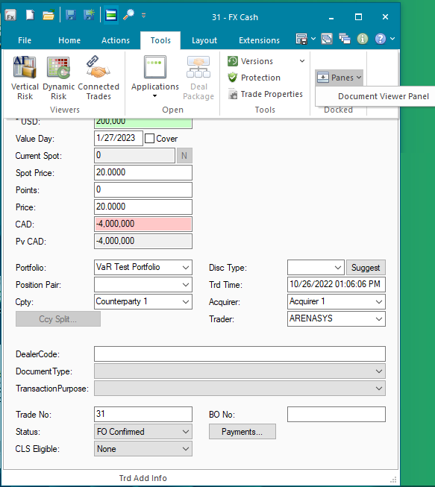

On the Documentum UI user can see the list of documents linked with the trade.

* User can add new document using Upload. First user need to select the Document Type and then click Upload. It will show the file selection dialog. On file selection, Documentum UI will upload the document to Documentum server and the received file object ID will be linked to the trade and also visible in the Trade Documents list.
* User can delete the existing document by selecting the document from the lisk and click Delete. On Delete, Documentum UI will remove the trade linking to the document and delete the document from the documentum server.
* User can see the file content by selecting the document from list and click Show Content. On Show Content, Documentum UI will get the file content from the server and show it in preview box.
* User can also get the copy of the file by selecting the document from the list and Download from the UI. The copy of the file will be creted under the Download Path from the FParameters with File object id as name.

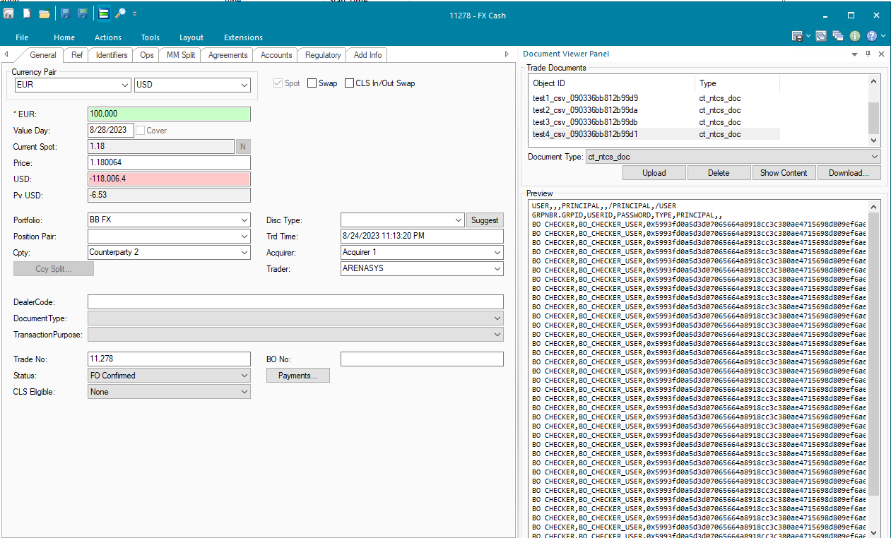

## OPERATING SPECIFICATION

On the Trade UI user Add/Remove the trade documents and on button click, FA will connect to Documentum to process the requested operation.

## REPORTING

### 9.1 Inventory of Reports

*NA.*

### 9.2 Report layout and definition

*NA*

# Email Notification

## DESCRIPTION

|  |  |  |  |
| --- | --- | --- | --- |
| **Interface name** | Email Notification | | |
| **Type of data** | Workbook report | **Frequency** | Once a Day |
| **Source** | FA | **Direction** | NA |
| **Format** | xls | **Transfer mechanism** | Email |
| **Response Required** | N/A | **Dependencies on other processes** | NA |
| **Purpose** | To send notifications for the applicable events | | |

Generic email notification functionality has been developed. This functionality is used for sending email notification for the workbook reports. User will create views in trading manager and configure the task using the workbook and email address of the required email receivers and sender.

## TECHNICAL ATTRIBUTE

|  |  |
| --- | --- |
| **Attribute** | **Description** |
| Extension Module | *ExtractsEngine* |
| ATS | *ATS EOD* |

## TECHNICAL FLOW DIAGRAM

## LOGIC AND CONFIGURATION

### 4.1 Flow Logic

1. Generic email notification functionality has been developed based on FWorksheet reporting.
2. User need to create a view in trading manager with different criteria. Example create a view in in trade sheet for the options which are going to expire and save this workbook with name OptionExpiry.
3. Create a task using the script ExtractsEngine and set the workbook name in the task and set the expected output format. Set the smtp server, subject, email sender and receiver on the Extract Setting tab.
4. Save the task and schedule it.

Task will be run by the EOD ATS as per the task schedule and a report will be generated for the workbook and same report will be sent on email to the users.

### 4.2 Configuration

|  |  |
| --- | --- |
| Delivery Items | |
| Extension Context | +Reports |
| Extension Module | ExtractsEngine |
| ATS Service | ATS EOD |
|  |  |
| FA Component | |
| ATS | ATS EOD |
|  |  |
| Deployment and Manual Configuration | |
| This service is deployed through FA standard deployment process.  Manual configuration may be required to update the configuration in FParameter in extension module. | |
|  |  |
| Additional Information | |
| Add info |  |
| FParameters | Default values |
| email_pwd | aaSF4c7j! |
| email_user | ntcs_sit |
| Tasks | Workbook Name |
| BankNotes | BankNotes |
| DNDFFixing | DNDFFixing |
| NonIDRRepoMaturity | NonIDRRepoMaturity |
| OptionExpiry | OptionExpiry |
| OutstandingMMPosition | OutstandingMMPosition |
| Wholesalefundingpayment | Wholesalefundingpayment |

### 4.3 Data Dictionary

### 4.4 A Data Model

Please refer AEF Browser document for details about Front Arena Data Model.

Document - FCA4033

### 4.5 B Data Entity and Key Elements Definition

All required details are available in AEF Browser document.

### 4.6 C Reference Code Table Definition

Please refer AEF Browser document for details about Front Arena Data Model.

Document - FCA4033

## SECURITY AND CONTROL DESIGN

### Security Requirement Response

|  |  |  |
| --- | --- | --- |
| Security Domain | Security Requirement | Response |
| User Management | The system must identify users using a unique user identification code before allowing a log-on. | It will be controlled through CDCA application |
| The system must suspend access to a user session after a specified interval of inactivity. | Inactivity of user session will not be applicable  as the integration is in Realtime |
| The system must require user authentication before re-enabling the session. | It will be controlled through CDCA application |
| The system must display a warning message indicating that only authorized use is permitted before allowing users to perform a log-on. | It will be controlled through CDCA application |
| The system must display system information to a user, only after a successful log-on. |  |
| After a successful log-on, the system must display information concerning the previous successful attempt to perform a log-on. | It will not be possible in real-time connections. |
| The system must allow a user account to be manually disabled. | NA |
| The system must disable the user account following 3 (three) consecutive failures to perform a successful log-on. | It will be controlled through CDCA application |
| The system must automatically disable the user account following a configurable period (90 days) without use. |  |
| Password Management | The system must authenticate users using a password before allowing access to any system functions. | Not applicable at Front Arena Database side. |
| The system must ensure that passwords used by system users for log-on consist of at least 8 (eight) characters. | Not applicable at Front Arena Database side. |
| The system must enforce the use of complex passwords for all users. (Aplhanumieric & Special Characters) | Not applicable at Front Arena Database side. |
| The system must use cryptographic techniques to protect the confidentiality of user authentication data during transmission. | Not applicable at Front Arena Database side. |
| The system must enforce a password change when a password is first issued or re-issued. |  |
| The system must allow system users to change the password used for log-on. | Not applicable at Front Arena Database side. |
| The system must ensure that passwords do not remain valid for more than 90 (ninety) days. | Not applicable at Front Arena Database side. |
| The system must ensure that passwords may not be changed to any of the last 5 (five) passwords used. | Not applicable at Front Arena Database side. |
| The system must ensure that passwords are not displayed in clear text during entry. | Not applicable at Front Arena Database side. |
| Multi Factor Authentication | The system must enforce dual factor authentication of all users (system that related to financial, faced to customer directly & only use for external purposes) | Not applicable at Front Arena Database side. |
| Data Storage | The system must use cryptographic techniques to protect the storage of authentication data. | NA |
| The system must use cryptographic techniques to protect the integrity of stored critical data. | NA |
| The system must use cryptographic techniques to protect the confidentiality of stored sensitive data. | NA |
| Logging | The system must support the recording of security events in one or multiple specific security event logs. 2 weeks in minimum must be available at the Production Environment | It will be controlled through CDCA application |
| The system must include the Logical Account identity, event type and timestamp in each entry in the security event logs. | It will be controlled through CDCA application |
| The system must record when each security event lo fills to a configurable limit. | It will be controlled through CDCA application |
| The system must protect the integrity of the information in the security event logs | It will be controlled through CDCA application |
| The system must allow access to the security event logs to be limited to the authorised security staff. | It will be controlled through CDCA application |
| The system must record if the integrity of the security event logs is compromised | NA |
| The system must record all instances that system event logs are cleared. | It will be controlled through CDCA application |
| The system must record when a change is made to the system log settings (e.g. logs for certain events are turned off). | It will be controlled through CDCA application |
| The system must record when any system security policy is modified. | NA |
| The system must record all creations of Logical Accounts. | It will be controlled through CDCA application |
| The system must record all deletions of Logical Accounts. |  |
| The system must record all de-activation of Logical Accounts. |  |
| The system must record all unsuccessful attempts to log-on to the system using invalid credentials. |  |
| The system must record all successful attempts to log-on to the system. |  |
| The system must record all successful and unsuccessful attempts to change passwords. |  |
| The system must automatically build and maintain a normal usage pattern for each Logical Account. |  |
| The system must record all activation of disabled Logical Accounts. |  |
| The system must record all attempts to change any account attribute affecting authentication of the Logical Account |  |
| The system must record all allocations of system access rights. |  |
| The system must record all removals of system access rights. |  |
| The system must record all unauthorised attempts to access a system function. |  |
| The system must record when a configurable deviation from a Logical Account's normal pattern is detected. |  |
| The system must record all failures of the check on the timestamp of payment and settlement orders. |  |
| The system must record all attempts to mutually authenticate interface connections that handle critical data |  |
| The system must record all events that may indicate an attempt to cause denial of service. |  |
| The system must record all access to functions processing critical information within the system. |  |
| The system must record all access to sensitive information within the system. |  |
| The system must record all start-up and shut down events. |  |
| The system must have been integrated in the SIEM, Identity Management System & Privilege Identity Management System |  |
| Remote Access | The system logical access control mechanism must be able to discretely grant remote access capability to specific users and user groups. |  |
| The system must strictly limit user access rights to their minimum requirements when they access the system remotely. |  |
| All relevant approvals must be obtained if this application is to be made available for remote use (E.g. on the RCA-portal) by Users |  |
| System Interfaces | The system must use a logical access control mechanism to control system to system data communications, in order to avoid anonymous data transfers (for all interfaces) |  |
| The system must ensure that system to system mutual authentication takes place before data communications are allowed (for all interfaces) |  |
| System to system mutual authentication must be based on cryptographic techniques (for all interfaces) |  |
| The system must use cryptographic techniques to protect the integrity of critical data during transmission (for all interfaces) |  |
| The system must use cryptographic techniques to protect the confidentiality of sensitive data during transmission (for all interfaces) |  |
| All 'critical data' must have been identified, documented and approved by the Business |  |
| All 'confidential data' must have been identified, documented and approved by the Business |  |
| Availability | The system must have a documented and successfully tested disaster recovery plan in place | It will be managed through Front Arena Database DR setup. |
| The system must enforce quotas limiting the maximum resources that an individual user can use simultaneously. |  |
| The system must provide adequate resources to support the required number of users or concurrent users. |  |
| The system should have a documented capacity monitoring process in-place with regular reporting on its use |  |
| Security Testing | The system must be tested for specific technical security flaws where it faces the public internet, prior to release into production. |  |
| The system must only be released into production, where it faces the public internet, once all identified key findings from the security test have been rectified, or if this is not possible, the risks must be formally reviewed and signed off |  |
| The system must be tested for specific technical security flaws prior to release into production. |  |
| The system must only be released into production once all the identified key findings from the security tests have been rectified or if this is not possible, the risks must be formally reviewed and signed off |  |

### Preventive controls

<This sub-section describe the technical specification for preventive controls that are specific to this module. This includes logical access control, physical security control, encryption, PIN generation and validation, etc>

<Sample of list of Role Table and Authorization Matrix>

|  |  |  |  |
| --- | --- | --- | --- |
| No | Role | Authorization | Object |
| 1 | Role1 | ZXXXX | Maintain |
| 2 | Role2 | ZYYYY | Display |
| 3 |  |  |  |

|  |  |  |  |  |  |  |
| --- | --- | --- | --- | --- | --- | --- |
| No | User Group | Role1 | Role2 | Role3 | Role4 | Role5 |
| 1 | User Group1 | X | X |  | X |  |
| 2 | User Group2 |  | X | X |  | X |
|  |  |  |  |  |  |  |

### Detective controls

*<This sub-section describe the technical specification for detective controls that are specific to this module. This includes audit trail, exception reports, reconciliation, balancing & control totals, validations, etc>.*

### Corrective controls

*<This sub-section describes the technical specification for corrective controls that are specific to this module. This includes automated error corrections, backup, recovery & restart, etc>.*

## USER INTERFACE

Below is the interface to configure the email notification for any workbook created in Trading Manager.

Go to Explorer -> Scripts -> All ->ExtractTemplate. Right click on the script and click run.

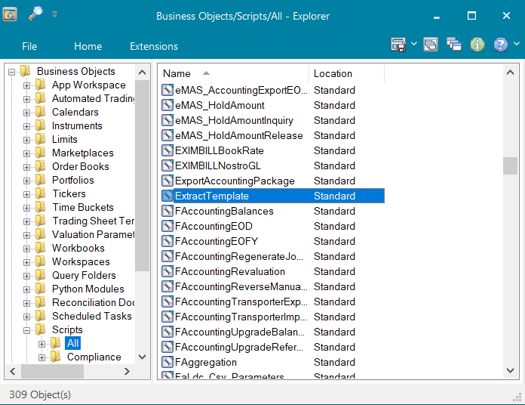

Task configuration for Option expiry. Similar configuration done for all other email notifications.

1. **General Tab** : Option expiry work book name OptionExpiry is set below.

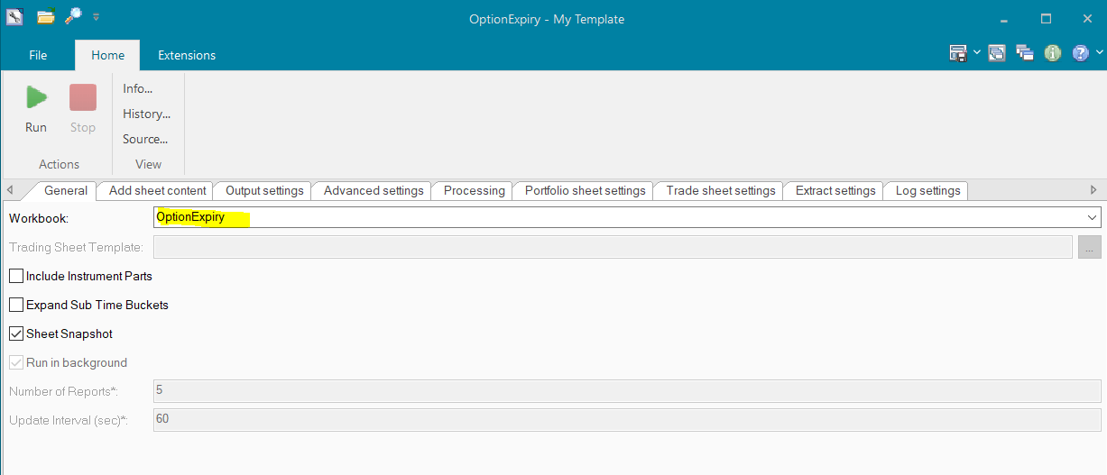

1. **Output Setting: Below fields are set for generating the report and its format**

File Path : Directory where the report will be renerated

File Name : Report name

Secondary Template : A template is selected for the excel report.

Secondary File Extension : file format is selected here as xls.

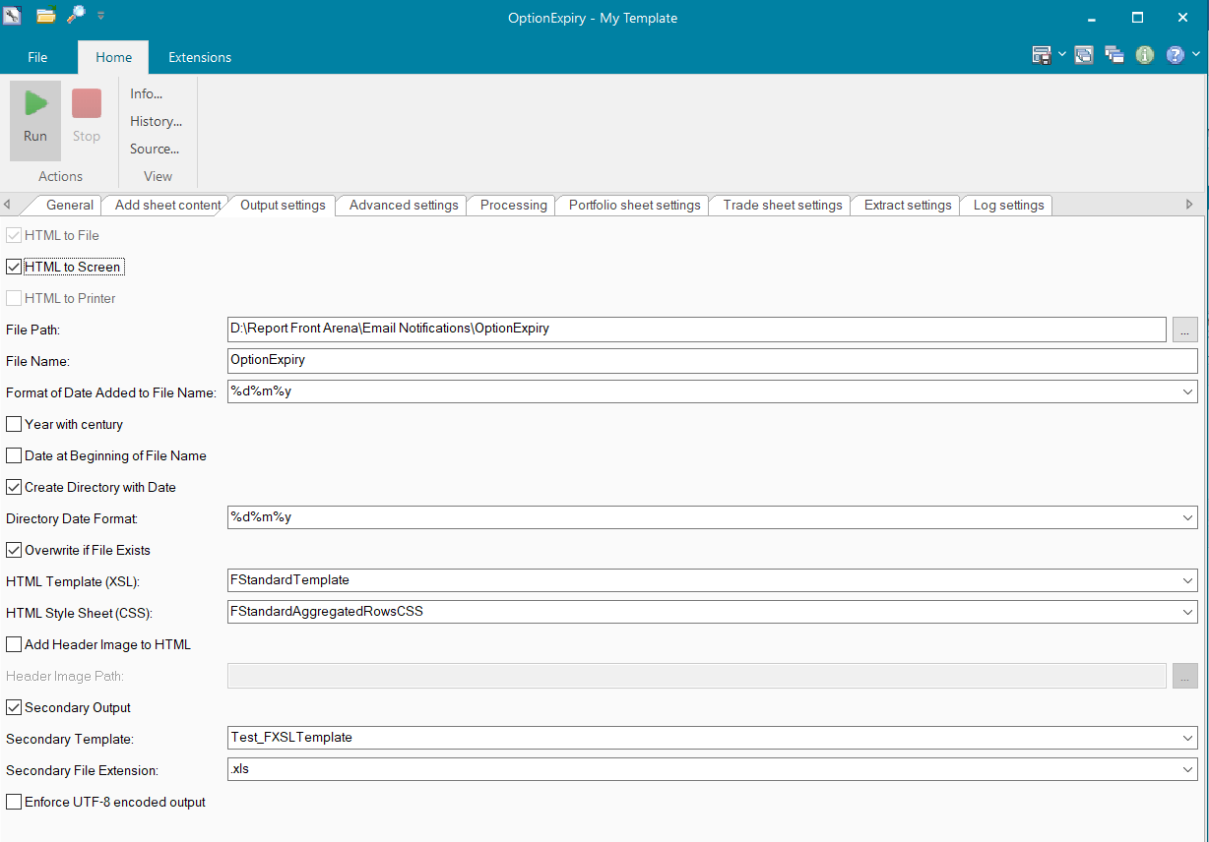

1. **Extract Settings:** Required fields are configured for email notification .

**Extract Name :** This is the email subject. Subject for option expiry email will is set as OptionExpiry.

**SMTP Server :** Configured sptm server for sending email. Email and password are configured in FParameter.

**Sender Address :** Configured the sender address provided by bank mandiri.

Email Address : Receiver email address are configured.

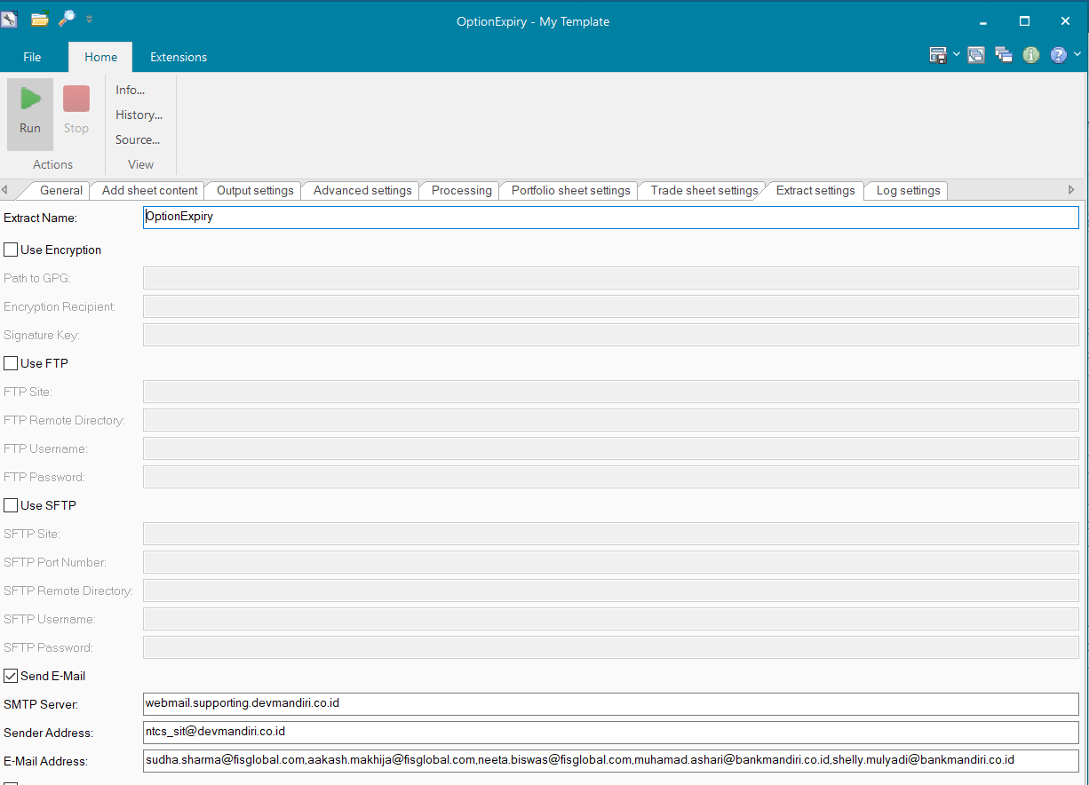

## OPERATING SPECIFICATION

Generic email notification functionality has been developed. This functionality can be used in various custom functionality to send notifications for the applicable events mentioned in Email Notification document.

1. The user will open appropriate task.
2. Script has been developed to send email notification to specified user.
3. Script will send the email with output file to be specified user.

**Trading Manager Workbook for Option Expiry**

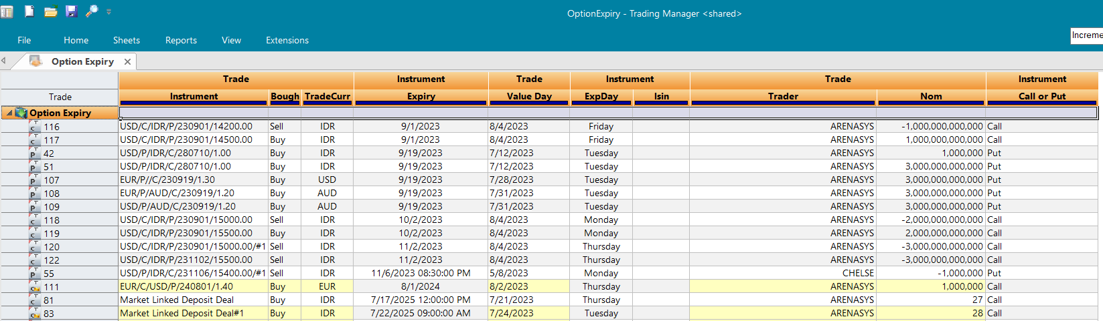

## Communication

*<This section provides the communication line that will be used in this system>*

### New / Existing*) system *) choose one

|  |  |  |  |  |  |  |  |  |  |
| --- | --- | --- | --- | --- | --- | --- | --- | --- | --- |
| **NO** | **NEW / SURROUNDING SYSTEM** | **HOSTNAME SOURCE** | **IP SOURCE** | **PORT SOURCE** | **HOSTNAME DESTINATION** | **IP DESTINATION** | **PORT DESTINATION** | **PROTOCOL (TCP /UDP /ICMP)** | **ALLOW / DENY** |
| 1 | *<new / surrounding status>* | *<isi nama host source>* | *<isi IP source>* | *<isi port source>* | *<isi nama host destination>* | *<isi IP destination>* | *<isi port destination>* | *<isi protocol>* | *<allow / deny status>* |
| 2 |  |  |  |  |  |  |  |  |  |
| 3 |  |  |  |  |  |  |  |  |  |
| 4 |  |  |  |  |  |  |  |  |  |
| 5 |  |  |  |  |  |  |  |  |  |
| 6 |  |  |  |  |  |  |  |  |  |
| 7 |  |  |  |  |  |  |  |  |  |
| 8 |  |  |  |  |  |  |  |  |  |
| … |  | … | … | … | … | … |  | … | … |

*< For a new developed system, if there are some undefined hostnames/ ip addresses/ ports yet, then should be written with* ***TBC*** *notes and will be completely defined in SDN contract review form >*

*< For an existing system and surrounding, please define and write its hostnames/ ip addresses/ ports >*

## OTHERS

*<This section provides other technical specifications that have not been address in previous section>.*